|  |  |  |
| --- | --- | --- |
| Project | **IEEE 802.16** **Broadband Wireless Access Working Group <**<http://ieee802.org/16>**>** | |
| Title | ***Proposed Statement to External Organizations on IEEE P802.16r Activity regarding Small Cell Backhaul*** | |
| Date Submitted | **2013-01-16** | |
| Source(s) | Roger B. Marks  EthAirNet Associates  4040 Montview Blvd  Denver, CO 80207 USA | Voice: +1 619 393 1913 E-mail: roger@ethair.net  *<<http://standards.ieee.org/faqs/affiliationFAQ.html>> |
| Re: |  | |
| Abstract | This document proposes a statement to several external organizations providing notification of IEEE P802.16r Activity regarding Small Cell Backhaul. | |
| Purpose | This contribution requests that the HetNet Study Group review the attached proposal and, on that basis, prepare and forward a proposed statement to IEEE 802.16 Working Group for approval at the Session #83 Closing Plenary. | |
| Notice | *This document does not represent the agreed views of the IEEE 802.16 Working Group or any of its subgroups*. It represents only the views of the participants listed in the “Source(s)” field above. It is offered as a basis for discussion. It is not binding on the contributor(s), who reserve(s) the right to add, amend or withdraw material contained herein. | |
| Copyright Policy | The contributor is familiar with the IEEE-SA Copyright Policy <http://standards.ieee.org/IPR/copyrightpolicy.html>. | |
| Patent Policy | The contributor is familiar with the IEEE-SA Patent Policy and Procedures:  <<http://standards.ieee.org/guides/bylaws/sect6-7.html#6>> and <<http://standards.ieee.org/guides/opman/sect6.html#6.3>>.  Further information is located at <<http://standards.ieee.org/board/pat/pat-material.html>> and <<http://standards.ieee.org/board/pat>>. | |

PROPOSED DRAFT

**IEEE 802.16 Working Group on Broadband Wireless Access**

**http://WirelessMAN.org**

Roger B. Marks

Chair, IEEE 802.16 Working Group

r.b.marks@ieee.org

17 January 2013

To: Kevin Vachon, Chief Operating Officer, Metro Ethernet Forum

Peter Meissner, Operating Officer, NGMN Alliance

Gordon Mansfield, Chair, Small Cell Forum

Declan Byrne, President, WiMAX Forum

cc: Paul Nikolich, Chair, IEEE 802 Executive Committee

Subj: Update on IEEE P802.16r Activity regarding Small Cell Backhaul as of Session #83

the IEEE 802.16 Working Group (WG) on Broadband Wireless Access is writing to provide an update on our progress on amending IEEE Std 802.16-2012 for enhancements to better address Small Cell Backhaul (SCB) Applications and to seek your views.

As noted in our prior statement of 16 November 2012, a Project Authorization Request (PAR) was completed during our Session #82. On 5 December, the IEEE-SA Standards Board approved the request and formally initiated Project P802.16r ([IEEE 802.16-12-0587-05](http://doc.wirelessman.org/16-12-0587-05)).

Meeting this week in our Session #83, the project has considered several contributions toward the advancement of that work. We have particularly focused on how best to model a deployment architecture based on Carrier Ethernet 2.0. We are interested in supporting a Carrier Ethernet interface to the small cell; in addition, we are interested in exploiting the potential of Carrier Ethernet to support connectivity from our backhaul base station to the access network and core network as well. We have identified some possible architectural models and are seeking comments. We would, in particular, like to seek the views of the Metro Ethernet Forum regarding the feasibility of these choices with regarding to the existing Carrier Ethernet specifications and certification options. For instance, we would like to understand the certification possibilities for an 802.16r system as contained within the magenta dashed rectangle drawn in the figures.

We welcome your further input. We draw your attention to the relevant [Call for Contributions](http://doc.wirelessman.org/16-12-XXXX). The Working Group would appreciate your inputs prior to the deadline of 13 March. Our next opportunity to respond to a formal communication will occur at [IEEE 802.16 Session #84](http://ieee802.org/16/meetings/mtg84) (18-21 March 2013 in Orlando, FL, USA). For information on our future meeting schedules, see <http://ieee802.org/16/calendar.html>.

Sincerely,

Roger B. Marks

Chair, IEEE 802.16 Working Group on Broadband Wireless Access

**Annex 1: Architectural Models under Consideration**

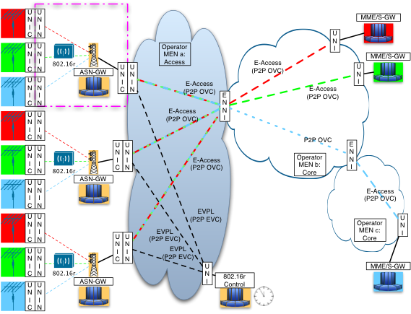

Figure 1: Architectural Model with UNI interface to 802.16r base station.

Squares on the left represent small cells, colored to represent different small cell operators.

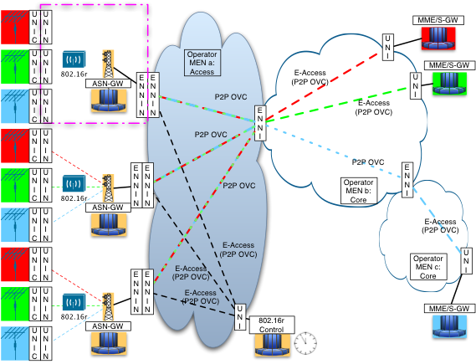

Figure 2: Architectural Model with ENNI interface to 802.16r base station.

Squares on the left represent small cells, colored to represent different small cell operators