|  |  |  |
| --- | --- | --- |
| Project | **IEEE 802.16 Broadband Wireless Access Working Group <**<http://ieee802.org/16>**>** | |
| Title | ***Carrier Ethernet 2.0 Requirements for P802.16r*** | |
| Date Submitted | **2013-01-16** | |
| Source(s) | Roger B. Marks  EthAirNet Associates  4040 Montview Blvd  Denver, CO 80207 USA | Voice: +1 619 393 1913 E-mail: roger@consensii.com  *<<http://standards.ieee.org/faqs/affiliationFAQ.html>> |
| Re: | *Call for Contributions: IEEE* *P802.16r Amendment for Small Cell Backhaul (SCB)* (IEEE 802.16-12-0678-02) for IEEE 802.16’s Session #83 of 14-17 January 2013 | |
| Abstract | This document discusses Carrier Ethernet 2.0 requirements for P802.16r. | |
| Purpose | To provide informative background useful in the development of the P802.16r Amendment, particularly into establishing Carrier Ethernet 2.0 requirements. | |
| Notice | *This document does not represent the agreed views of the IEEE 802.16 Working Group or any of its subgroups*. It represents only the views of the participants listed in the “Source(s)” field above. It is offered as a basis for discussion. It is not binding on the contributor(s), who reserve(s) the right to add, amend or withdraw material contained herein. | |
| Copyright Policy | The contributor is familiar with the IEEE-SA Copyright Policy <http://standards.ieee.org/IPR/copyrightpolicy.html>. | |
| Patent Policy | The contributor is familiar with the IEEE-SA Patent Policy and Procedures:  <<http://standards.ieee.org/guides/bylaws/sect6-7.html#6>> and <<http://standards.ieee.org/guides/opman/sect6.html#6.3>>.  Further information is located at <<http://standards.ieee.org/board/pat/pat-material.html>> and <<http://standards.ieee.org/board/pat>>. | |

*Carrier Ethernet 2.0 Requirements for P802.16r*

Roger B. Marks

Consensii LLC

# Abstract

This document discusses Carrier Ethernet 2.0 requirements for P802.16r.

# Background

On 5 December 2012, the IEEE-SA Standards Board approved PAR P802.16r ([IEEE 802.16-12-0587-05](http://doc.wirelessman.org/16-12-0587-05)).

[IEEE 802.16-12-0678-02](http://doc.wirelessman.org/16-12-0678-02) (“*Call for Contributions: IEEE P802.16r Amendment for Small Cell Backhaul (SCB)*”) requested views regarding the development of the project, particularly on application requirements to establish the technical requirements to be attained in the new standard.

The scope of PAR P802.16r requires capabilities related to Carrier Ethernet 2.0. In order to ensure that these capabilities are included in the eventual standard, it is essential to understanding the Carrier Ethernet 2.0 requirements.

# Carrier Ethernet in P802.16r

In PAR P802.16r, the “Scope of the project” is:

*This project will develop an amendment specifying enhancements to the WirelessMAN-OFDMA air interface for effective use in* ***wireless fixed and nomadic Ethernet transport****, including small cell backhaul applications, providing core network services to radio access networks. It will focus on backhaul operating in licensed bands below 6 GHz, in which the backhaul radio operates far enough outside the band of the small cells that interference is negligible. It will add 256QAM, 512QAM, and 1024QAM options in both uplink and downlink, with optional 4x4 MIMO in both directions, along with further enhancements that address small cell backhaul efficiency. Significant latency improvements will be attained.* ***Enhancements to the Convergence Sublayer specifications will be incorporated as necessary for support of*** ***Carrier Ethernet 2.0*** ***backhaul*** ***requirements.*** *The functionalities required for small cell backhaul support, including new functionalities but not necessarily all those included the baseline standard, will be specified explicitly.*

Three Annex 2 References are from the Metro Ethernet Forum (MEF):

* Metro Ethernet Forum, “Microwave Technologies For Carrier Ethernet Services,” January 2011
* Metro Ethernet Forum, Implementation Agreement MEF 22.1, “Mobile Backhaul Phase 2,” January 2012
* Metro Ethernet Forum, Implementation Agreement MEF 23.1, “Carrier Ethernet Class of Service – Phase 2,” January 2012

The language of the scope (“Carrier Ethernet 2.0 backhaul requirements”) indicates that the backhaul specification MEF 22.1 is included.

# Carrier Ethernet 2.0 Requirements

The MEF [Carrier Ethernet 2.0 program](http://metroethernetforum.org/page_loader.php?p_id=2031) Forum is described in a complex set of documentation. Most of the underlying technical specifications, along with some explanatory materials, are available at the [MEF Technical Specifications](http://metroethernetforum.org/page_loader.php?p_id=29) web page.

The description of the [Carrier Ethernet 2.0 Certification Program](http://metroethernetforum.org/page_loader.php?p_id=2262) provides useful details, particular in the [Carrier Ethernet 2.0 Certification Blueprint](http://metroethernetforum.org/ce20/Materials/Carrier_Ethernet_2.0_Certification_Blueprint_-_VERSION_1_1.pdf), the “foundation document that specifies the complete list of attributes to be verified in order to certify each Carrier Ethernet 2.0 service.”

The Carrier Ethernet 2.0 Certification Blueprint includes requirements for implementation of CoS, via reference to MEF 23.1 (“Carrier Ethernet Class of Service – Phase 2”).

The Carrier Ethernet 2.0 Certification Blueprint includes requirements for implementation of Service Operations, Administration, and Maintenance (OAM), via reference to MEF 30 (“Carrier Ethernet 2.0 Service OAM”).

# Carrier Ethernet 2.0 Backhaul Requirements

The MEF [Carrier Ethernet for Mobile Backhaul](http://metroethernetforum.org/page_loader.php?p_id=2031) Initiative is based on Carrier Ethernet 2.0 but introduces additional requirements specifically for backhaul purposes. MEF 22.1 (“Mobile Backhaul Phase 2”) is specifically included. Details are described in “[New Mobile Backhaul Initiative to Resolve 4G/LTE Backhaul’s Most Costly Challenge](http://metroethernetforum.org/PPT_Documents/MEF-for-Mobile/MEF_MBH_Analyst_deck_final-1.pptx),” which calls out MEF 22.1 as well as 23.1. It also indicates the importance of network-based synchronization support, providing guidance through the paper “[Packet Synchronization over Carrier Ethernet Networks for Mobile Backhaul ­– A Formula for Deploying IEEE 1588v2 and Synchronous Ethernet: Investigate – Test – Deploy](http://metroethernetforum.org/PDF_Documents/MEF-for-Mobile/Packet%20Synchronization%20over%20Carrier%20Ethernet%20Networks%20for%20MBH%202012021.pdf).”

MEF 22.1 specifies requirements on Service OAM, Ethernet OAM, and synchronization, along with other issues.

# Itemizing Carrier Ethernet 2.0 Backhaul Requirements

It appears that most Carrier Ethernet backhaul requirements are derived from Carrier Ethernet 2.0. The Carrier Ethernet 2.0 Certification Program is documented in the Carrier Ethernet 2.0 Certification Blueprint, which therefore appears to be the best starting point for an itemization of Carrier Ethernet 2.0 backhaul requirements. Beyond the Carrier Ethernet 2.0 Certification Blueprint, an itemization requires in addition an analysis of MEF 22.1 for additional backhaul requirements, particularly regarding OAM and synchronization. Some of the attributes may lie outside the scope of IEEE P802.16r.

# Carrier Ethernet 2.0 Services

The MEF specifies eight different Carrier Ethernet 2.0 Services: point-to-point E-Line Services (EPL and EVPL), multipoint-to-multipoint E-LAN Services (EP-LAN and EVP-LAN), rooted multi-point E-Tree Services (EP-Tree and EVP-Tree), and E-Access Services (Access EPL and Access EVPL). Per the Carrier Ethernet 2.0 Certification Blueprint, the services “require different combinations of service and performance attributes defined in MEF technical specifications.” Consequently, “the Carrier Ethernet 2.0 services certification program is designed to verify the conformance of each of these services independently.” In other words, each service is supported by a separate set of conformance specifications, although many of the details are identical.

The P802.16r Carrier Ethernet 2.0 Backhaul Requirements cannot be established without first establishing the Carrier Ethernet 2.0 Services to be supported by the standard. These services are all related to architecture of the deployment. Therefore, an understanding of the deployment architecture is a precursor to establishing an itemization of the Carrier Ethernet 2.0 Backhaul Requirements.

# Potential Deployment Architectures

An understanding of the deployment architecture is relevant to the understanding of the Carrier Ethernet 2.0 Requirements and may be relevant to establish other general aspects of the required functionality to be specified in the P802.16r project. Figures 1-4 below indicate a possible architectural frameworks from which requirements can be derived. In the figures, the squares on the left represent small cells, colored to represent different small cell operators. Magenta dashed rectangles indicate the domain of the 802.16r system.

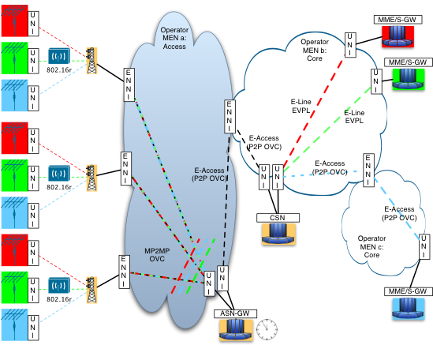

Figure 1: Potential Deployment Architecture with ENNI base station interface

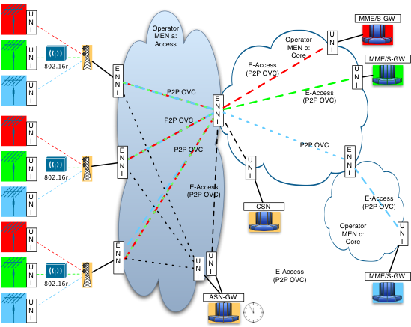

Figure 2: Potential Deployment Architecture with ENNI base station interface and separated data path

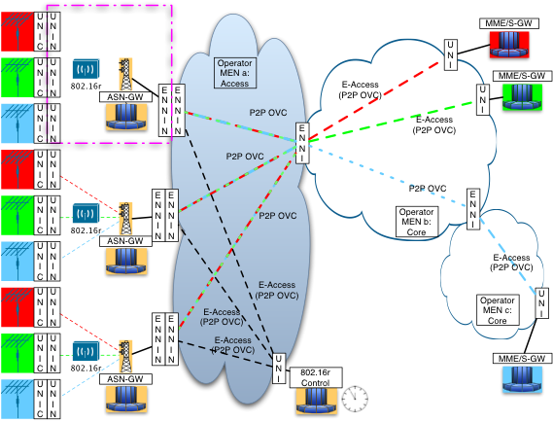

Figure 3: Potential Deployment Architecture with ENNI base station interface and collapsed ASNs

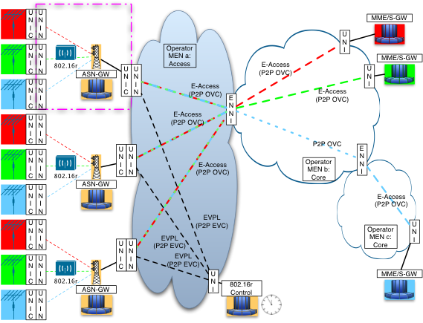

Figure 4: Potential Deployment Architecture with UNI base station interface and collapsed ASNs