Project | IEEE 802.16 Broadband Wireless Access Working Group <http://ieee802.org/16>
Title | Device-to-Device Terminal Discovery Mechanism and Initial Synchronization Based on Pseudo PRACH
Date Submitted | 2012-12-02
Source(s) | Tian Gaohui, Zhang Zhongpei, Wei Ning, Cui Ling, Ran Xiaogang  University of Electronic Science and Technology of China | Voice: +8613350057305  E-mail: zhangzp@uestc.edu.cn  *<http://standards.ieee.org/faqs/affiliationFAQ.html>
Re: | Unsolicited contribution intended for Project Planning Committee
Abstract | This article describes one D2D terminal discovery mechanism and initial synchronization based on pseudo PRACH, and gives some proposals about this mechanism.
Purpose | To instigate discussion about BS-controlled D2D communication terminal discovery and initial synchronization based on pseudo PRACH
Notice | This document does not represent the agreed views of the IEEE 802.16 Working Group or any of its subgroups. It represents only the views of the participants listed in the “Source(s)” field above. It is offered as a basis for discussion. It is not binding on the contributor(s), who reserve(s) the right to add, amend or withdraw material contained herein.
Copyright Policy | The contributor is familiar with the IEEE-SA Copyright Policy <http://standards.ieee.org/IPR/copyrightpolicy.html>.
Patent Policy | The contributor is familiar with the IEEE-SA Patent Policy and Procedures:  <http://standards.ieee.org/guides/bylaws/sect6-7.html#6> and <http://standards.ieee.org/guides/opman/sect6.html#6.3>.  Further information is located at <http://standards.ieee.org/board/pat/pat-material.html> and <http://standards.ieee.org/board/pat>.

Device-to-Device Terminal Discovery Mechanism and Initial Synchronization Based on Pseudo PRACH
Tian Gaohui, Zhang Zhongpei, Wei Ning, Cui Ling, Ran Xiaogang
University of Electronic Science and Technology of China

ABSTRACT
In this article device-to-device (D2D) Terminal Discovery mechanism and initial synchronization is studied with limited interference impact on the primary cellular users. Aimed at being compatible with existing LTE system, D2D terminal discovery mechanism and initial synchronization based on pseudo PRACH is proposed, which can reduce interference impact on the primary cellular users effectively. Moreover, we present numerical results based on single cell. The proposed mechanism can reduce the interference impact on the primary cellular users effectively, as well as improve the scope of terminal discovery.

IMPLEMENTATION PROCESS
To fulfill the proposed mechanism and initial synchronization, following steps are required for one successful terminal discovery, assuming user A (UEA) calls user B (UEB) to establish D2D link:
- UEA sends message to evolved NodeB (eNB) calling for UEB, through normal Long Term Evolution (LTE) Physical Random Access Channel (PRACH).
- eNB looks for location information of UEB to judge whether it meets D2D Communication Initial Criterion (eNB can be set different D2D Communication Initial Criterion, see note 1). If the criterion is met, go on step 3 for further implementation of D2D terminal discovery. Otherwise, eNB setups normal cellular link between UEA and UEB.
- eNB informs D2D called party (UEB) and D2D calling party (UEA) in turn that they can start the proposed terminal discovery in PRACH (D2D calling party send preamble signal, and D2D called party detect preamble signal). Meanwhile, eNB send relevant parameters.
Parameters to called party:
- Random access channel parameters, determining the position in time slot and frequency, etc.
- Preamble sequence generation relevant parameters, determining the preamble sequence.
- D2D Called Party Time Window size (see note 2), as mentioned in step 4.
Parameters to calling party:
- Random access channel parameters, determining the position in time slot and frequency, etc.
- Preamble sequence generation relevant parameters, determining the preamble sequence.
- Timing Alignment (TA) with regard to eNB
- Initial transmission power, transmission power increasing step and maximum transmission power of preamble sequence during the proposed mechanism, that are calculated based on TA. (The above power relevant parameters should be big if the TA is big. See the next part for more detail)
- D2D Calling Party Time Window size (see note 2), as mentioned in step 4.
- After receiving the configuration information above, D2D calling party UEA) adjusts the TA and then sends the selected preamble sequence by initial power. If receiving no response about D2D link setup information from eNB within the given D2D Calling Party Time Window, UEA resends the preamble sequence after increasing transmission power by the given power increasing step. UEA repeat that until it receives response about D2D link setup information from eNB or it increases transmission power to the maximum transmission power and then gives up the D2D terminal discovery. Once it gives up the D2D terminal discovery, UEA requires eNB changing the D2D communication to normal cellular communication.
After receiving the configuration information, D2D called party (UEB) detect the selected preamble sequence in the given PRACH. If detecting no given preamble sequence within the D2D Called Party Window, UEB requires eNB changing the D2D communication to normal cellular communication. If detecting the given preamble sequence within the D2D Called Party Window, UEB informs eNB that D2D communication can be set up, and attaches received power of preamble sequence as well as UEA’s TA relevant to UEB.
During the process above, UEA should store its last transmission power of preamble sequence, which is useful in determining parameters of D2D link power and parameters relevant to channel quality (e.g. MCS) as mentioned in step 6.
- Once eNB receives above acknowledgement signal and relevant parameters from UEB, it will allocate and register the resource for this D2D link (see note 3). Firstly, eNB informs UEB the allocated D2D resource, requiring UEB to be ready for D2D communication. Then, eNB calculates the relationship between D2D link power relevant parameters (including initial transmission power, transmission power increasing step and maximum transmission power) and last transmission power of UEA as mention in step 4. Lastly, eNB informs UEA the allocated resource, TA relevant to UEB and above power parameters relationship.
- After UEA receives the parameters above from eNB, it calculates the D2D link power relevant parameters based on the power parameters relationship and stored last transmission power. UEA also determines Modulation and Coding Scheme (MCS) and so on based on the calculated power parameters. Firstly, UEA adjusts the TA relevant to UEB, which means UEA realizes the initial synchronization with UEB. UEA then sets up D2D link in the given source and informs UEB the above parameters.

Notes:
- D2D Communication Initial Criterion can be set differently. For example, it can be that whether UEB is in the same cell of UEA or in the neighbor cells or not.
- D2D Called Party Time Window and D2D Calling Party Time Window should be set and maintained by eNB based on the range of the cell and eNB’s load.
- D2D source allocation method is not researched here, it can be set differently.

The aforementioned D2D terminal discovery flow diagram is as follows.

Fig. 1. Flow diagram of proposed mechanism for one successful D2D terminal discovery and initial synchronization

Simulation, Analysis and Proposals
- Simulation Scenario
To test the proposed mechanism, we make a single cell simulation. In our simulation, the radius of cell is set to be 250m. As the UEs don’t occupy PRACH usually and PRACH resources are large enough, we assume there are one D2D Calling Party and two normal cellular UES occupying one same PRACH resource. We adopt the TS25814 model [1] as path loss model, which is the following formula.
$P_{L}\left(dB\right)=I+37.6*\log_{10}\left(R\right)$ (1)
Where I is 128.1 when system carrier is 2 GHz , and R is the distance in km. Claussen model [2] is our shadow fading model. It generates a lognormal-distributed 2D space-correlated shadow fading map. The mean of shadow fading lognormal distribution is set to be 0, while the standard deviation is set to be 10dB. In the claussen model, the number of neighbors taking into account is 8 and the correlation between the UEs is set to be 0.7. The transmission power of normal communication user is set to be 200mW. Thermal noise density is -174dBm/Hz, while the system bandwidth is 5MHz. BS’s receiver noise figure is set to be 9dB, while users’ noise figure is set to be 0dB. Region Of Interest (ROI) includes x range of -250m to 250m and includes y range of -250m to 250, while the resolution is set to be 3m/pixel. The SINR-to-CQI mapping adopts the following SNR-CQI mapping model by taking the 10% points of the BLER curves, obtaining the mapping shown in Figure 2.
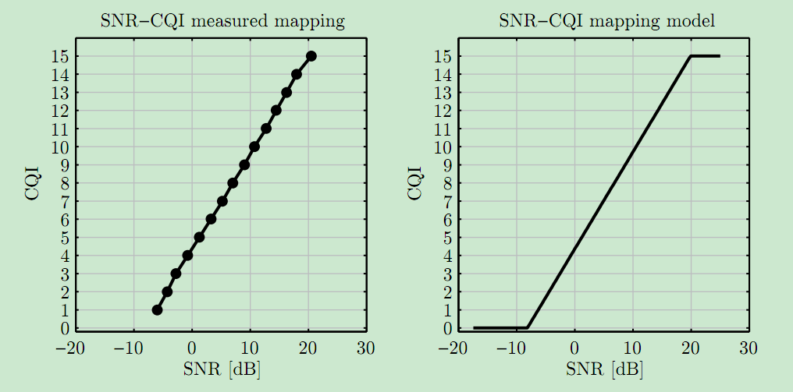
Fig.2. CQI mapping. BLER=10% points from the BLER curves (left) and SINR-to-CQI mapping function(right)
- Results and Analysis
We just simulate one single cell scenario so far, and system simulation is our next work. So, there are only two respects to measure performance: one is the impact on normal PRACH cellular user results from D2D terminal discovery, another one is the scope of D2D terminal discovery. The first respect is to measure how much does D2D user impact normal user, the later respect is to measure how far does D2D user can reach using the proposed mechanism. In the future, system simulation will be done to measure more about the whole system resource and so on.
- Impact on normal PRACH user
From the theoretical analysis, impact on normal PRACH user of D2D user during the proposed mechanism mainly comes from two factors: one is the power of D2D user, another one is the distance between BS and D2D user. The two factors both can impact the received power of normal PRACH user at BS. So, we set range of both two factors, and we run the simulation. Results are as followed.
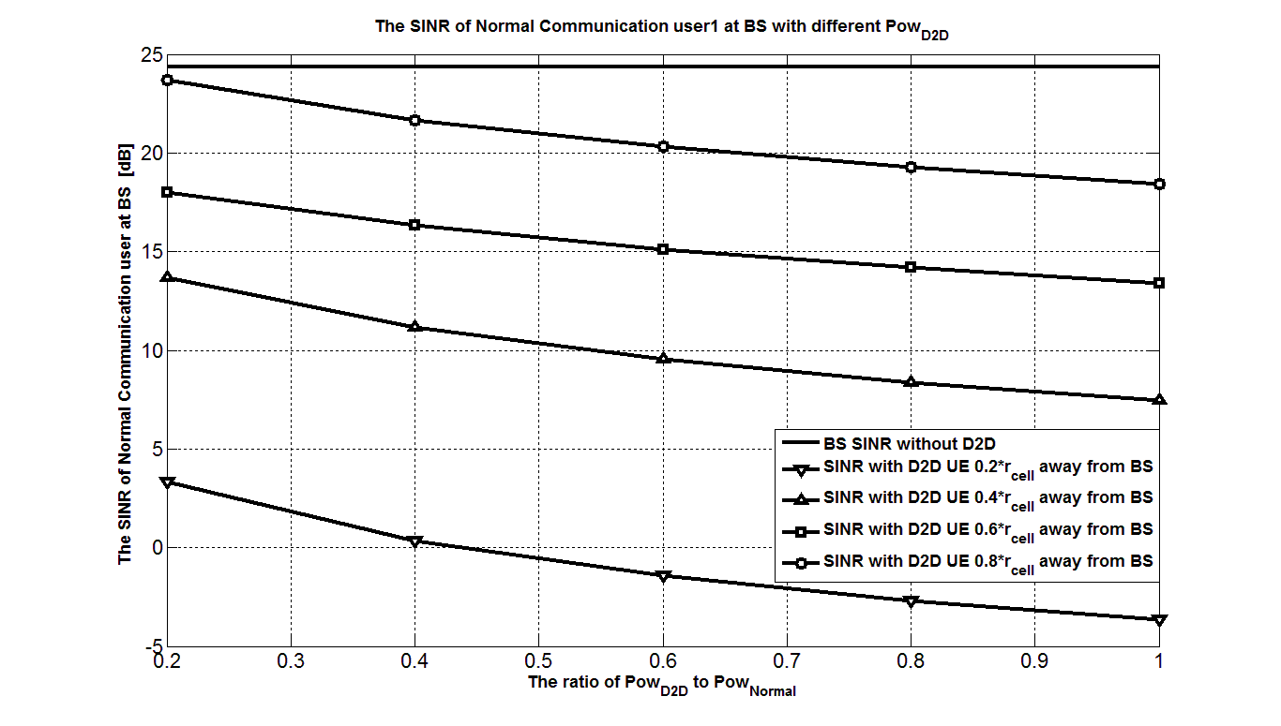
Fig. 3. The SINR of normal user1 at BS with different power of D2D user
From top to bottom, the curves are SINR without D2D, SINR with D2D UE
$0.2r_{cell}$ away from BS, SINR with D2D UE $0.4r_{cell}$ away from BS, SINR with D2D UE $0.6r_{cell}$ away from BS, and SINR with D2D UE $0.8r_{cell}$ away from BS. Apparently, the impact becomes more serious when D2D UE uses bigger power and distance between BS and D2D UE gets smaller.
- Scope of D2D terminal discovery
From the theoretical analysis, scope of D2D terminal discovery mainly depends on the power of D2D UE. Set the range of D2D UE’s power, and we get the results as followed.
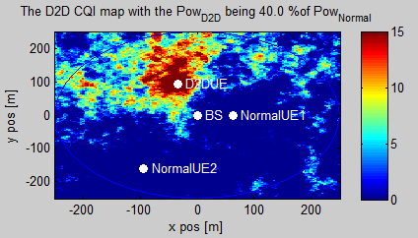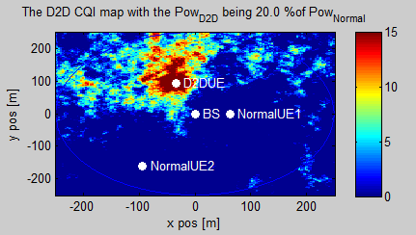

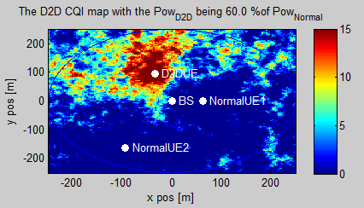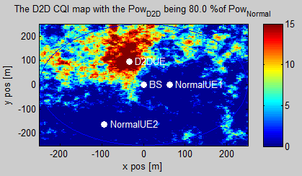

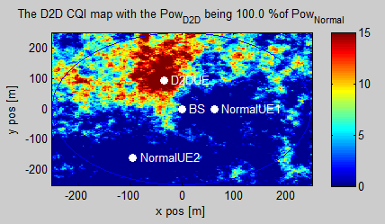

Fig.4. Scope of D2D terminal discovery with different power of D2D UE when D2D UE is $0.4r_{cell}$ away from BS

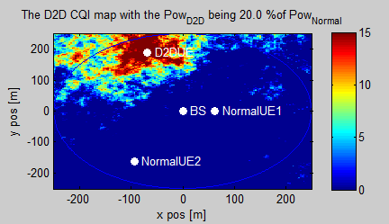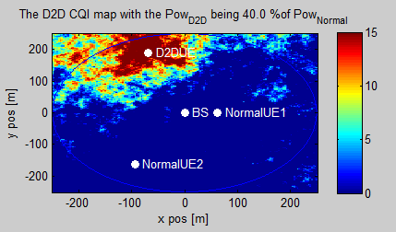

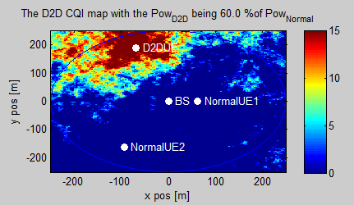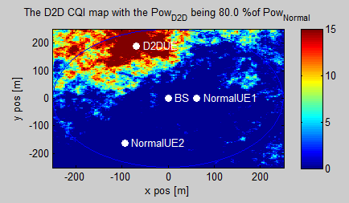

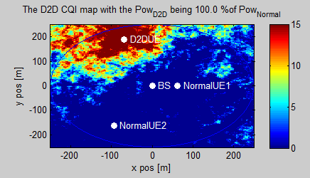

Fig.5. Scope of D2D terminal discovery with different power of D2D UE when D2D UE is $0.8r_{cell}$ away from BS

From results above, it is apparently that the scope of D2D terminal discovery mainly depends on the power of D2D UE. So, to enlarge the scope of D2D terminal discovery, power of D2D UE should be bigger.

- Proposals
Just like the Results and Analysis part shows, on the one hand, it is suggested to reduce the power of D2D UE for the purpose of reducing the impact on cellular UEs, on the other hand, it is suggested to increase the power of D2D UE for the purpose of enlarging the scope of D2D terminal discovery. In fact, we can reach a compromise by the following proposal.
Proposal 1: When adopting the proposed D2D terminal discovery mechanism and initial synchronization based on pseudo RRACH, D2D UE near BS should send signal in low power, and D2D UE far away from BS can send signal in high power. In practical, it can be realized according to TA of D2D UE relevant to BS.
To further reduce the impact on normal PRACH user, it is suggested that during the proposed mechanism, D2D UE should occupy the PRACH resources, which are occupied rarely in the statistical sense. For example, if the preamble formats [3] in the frame structure type 1 are adopted uniformly. Then, every subframe’s occupation frequency is showed as followed.
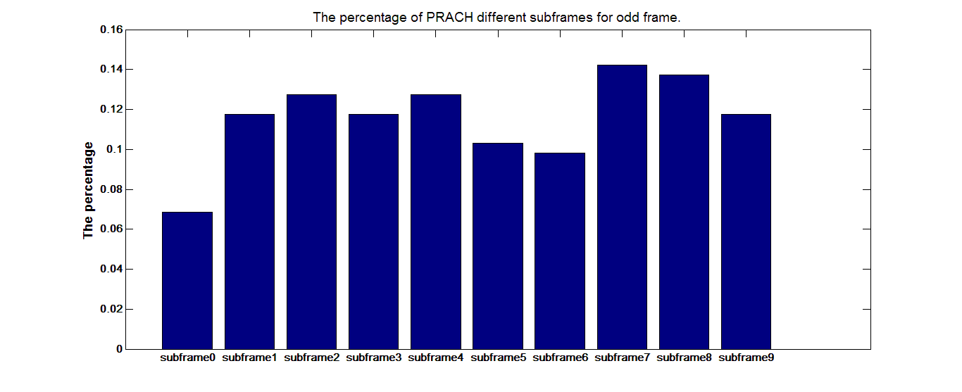
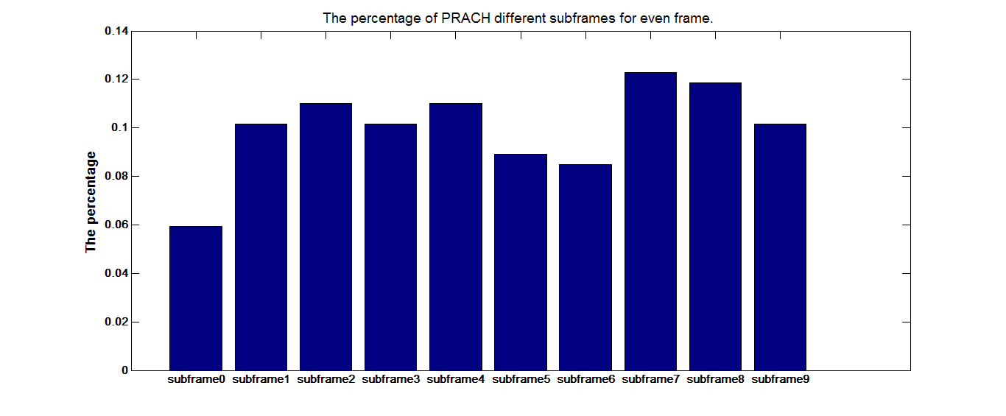
Fig. 6. The occupation frequency of different subframe in statistical sense
In the figure 6, subframe0 and subframe6 is occupied rarely compared to other subframes in statistical sense. It is suggested to adopt those subframes to reduce the impact on cellular users.
Proposal 2: When adopting the proposed D2D terminal discovery mechanism and initial synchronization based on pseudo RRACH, it is suggested to allocate preamble sequence in PRACH resources which are occupied rarely in the statistical sense.

CONCLUSIONS
This article discusses one effective D2D terminal discovery mechanism and initial synchronization based on pseudo PRACH, which is compatible with existing LTE system, and whose impact on normal PRACH user is limited.
Proposal 1: When adopting the proposed D2D terminal discovery mechanism and initial synchronization based on pseudo RRACH, D2D UE near BS should send signal in low power, and D2D UE far away from BS can send signal in high power. In practical, it can be realized according to TA of D2D UE relevant to BS.
Proposal 2: When adopting the proposed D2D terminal discovery mechanism and initial synchronization based on pseudo RRACH, it is suggested to allocate preamble sequence in PRACH resources which are occupied rarely in the statistical sense.

REFERENCES
[1] “Physical layer aspects for evolved universal terrestrial radio access (UTRA),” 3rd Generation Partnership Project (3GPP), Tech. Rep. TS 25.814,2006.
[2] H. Claussen, “Efﬁcient modelling of channel maps with correlated shadow fading in mobile radio systems,” Sept. 2005.
[3] Technical Specification Group RAN, “E-UTRA; Physical Channels and Modulation”, 3rd Generation Partnership Project (3GPP), Tech. Rep. TS 36.211, 2009-12

