|  |  |  |
| --- | --- | --- |
| Project | **IEEE 802.16 Broadband Wireless Access Working Group <**<http://ieee802.org/16>**>** | |
| Title | **Clarification on base station function of HR-MS over IEEE 802.16n** | |
| Date Submitted | **2012-07-09** | |
| Source(s) | Won-Ik Kim, Eunkyung Kim, Miyoung Yun, Seokki Kim, Sungkyung Kim, Hyun Lee, Chulsik Yoon, Sungcheol Chang  ETRI  Seokjoo Shin  Chosun University | E-mail:  [woniks@etri.re.kr](mailto:woniks@etri.re.kr)  [scchang@etri.re.kr](mailto:scchang@etri.re.kr)  [sjshin@chosun.ac.kr](mailto:sjshin@chosun.ac.kr) |
| Re: | “IEEE 802.16-12-400-00-Gdoc,” in response to Letter Ballot Recirc #37b on P802.16n/D3 | |
| Abstract | This provides AWD text proposals for clarification on base station function of HR-MS over IEEE 802.16n | |
| Purpose | To discuss and adopt the proposed text in the draft amendment document on GRIDMAN | |
| Notice | *This document does not represent the agreed views of the IEEE 802.16 Working Group or any of its subgroups*. It represents only the views of the participants listed in the “Source(s)” field above. It is offered as a basis for discussion. It is not binding on the contributor(s), who reserve(s) the right to add, amend or withdraw material contained herein. | |
| Copyright Policy | The contributor is familiar with the IEEE-SA Copyright Policy <http://standards.ieee.org/IPR/copyrightpolicy.html>. | |
| Patent Policy | The contributor is familiar with the IEEE-SA Patent Policy and Procedures:  <<http://standards.ieee.org/guides/bylaws/sect6-7.html#6>> and <<http://standards.ieee.org/guides/opman/sect6.html#6.3>>.  Further information is located at <<http://standards.ieee.org/board/pat/pat-material.html>> and <<http://standards.ieee.org/board/pat>>. | |

**Clarification on base station function of HR-MS over IEEE 802.16n**

Won-Ik Kim, Eunkyung Kim, Miyoung Yun, Seokki Kim, Sungkyung Kim, Hyun Lee, Chulsik Yoon, Sungcheol Chang

ETRI

Seokjoo Shin

Chosun University

# Introduction

In this contribution, we suggest the modifications of the sentences in Section 16.1.3 Base station function for HR-MS over IEEE P802.16n/D3. The major suggestions are listed in below.

* Rewrite a paragraph in subsection
* Remove a few informative sentences
* Add additional information of control message
* Change figure

# References

[1] IEEE P802.16nTM/D3, Air Interface for Broadband Wireless Access Systems - Draft Amendment: Higher Reliability Networks, June 2012.

[2] IEEE P802.16.1aTM/D3, WirelessMAN-Advanced Air Interface for Broadband Access Systems - Draft Amendment: Higher Reliability Networks, June 2012.

[3] EEE P802.16Rev3/D6, IEEE Draft Standard for Local and metropolitan area networks; Part 16: Air Interface for Fixed and Mobile Broadband Wireless Access Systems,” June 2012.

[4] IEEE P802.16.1TM/D6, IEEE Draft for WirelessMAN-Advanced Air Interface for Broadband Wireless Access Systems, June 2012.

# Proposed Text for the 802.16n AWD

Note:

The text in **BLACK** color: the existing text in the 802.16n AWD

The text in **~~RED~~** color: the removal of existing 802.16n AWD

The text in **BLUE** color: the new text added to the 802.16n AWD

[-------------------------------------------------Start of Text Proposal---------------------------------------------------]

**16. Support for HR-Networks**

**16.1 Multi-mode operation**

**…**

**16.1.3 Base station function for HR-MS**

***[Remedy1: Modify the sentences in Section 16.1.3 in IEEE P802.16n/D3.]***

***[Page# 73, Line# 36]***

~~An HR-MS may operate as an HR-BS to provide connectivity for itself and other HR-MSs. During basic capability negotiation at network entry, an HR-MS that is capable of role change to HR-BS shall report such capability to the super-ordinate HR-BS/HR-RS.~~

~~While operating as an HR-BS, the station may maintain certain HR-MS functionalities~~

~~The HR-MS may start operating as an HR-BS in a Proactive operation or a Reactive operation. For proactive operation, the mode switch is directed by the superordinate HR-BS of the HR-MS; In reactive operation, the mode switch is initiated by the HR-MS itself.~~

An HR-MS may operate as an HR-BS to provide connectivity for itself and other HR-MSs. The HR-MS may start operating as an HR-BS in a Proactive operation or a Reactive operation.

In proactive operation, the mode change is directed by a superordinate HR-BS of the HR-MS. During basic capability negotiation at network entry, an HR-MS that is capable of role change to HR-BS shall report such capability to the super-ordinate HR-BS/HR-RS.

In reactive operation, the mode switch is initiated by the HR-MS itself.

While operating as an HR-BS, the station may maintain certain MS functionalities.

***[Remedy2: Modify the sentences in Section 16.1.3.1 in IEEE P802.16n/D3.]***

***[Page# 74, Line# 2]***

**16.1.3.1 Proactive Operation**

A superordinate HR-BS may select a target HR-MS among its subordinate HR-MSs which are capable of role changing to HR-BS, according to the measured signal power at HR-BS and/or subordinate HR-MS’ status information such as the battery level. ~~The superordinate HR-BS may transmit MM-ADV message with trigger condition for which the subordinate HR-MSs capable of role changing to HR-BS shall report its status information.~~ The superordinate HR-BS shall transmit MM-ADV message with action type set to 0b1000 for obtaining the status information of the subordinate HR-MSs. ~~When the trigger condition is met,~~ Upon receiving the MM-ADV message with action type set to 0b1000, the subordinate HR-MS capable of role changing to HR-BS ~~may report~~ reports its status information to the superordinate HR-BS via MM-STAT-REP message as described in 6.3.2.3.99.10. In addition, the subordinate HR-MS may transmit MOB_SCN-REP message according to the scanning request by the superordinate HR-BS.

…

***[Remedy3: Modify the sentences in Section 16.1.3.2.1 in IEEE P802.16n/D3.]***

***[Page# 74, Line# 35]***

**16.1.3.2.1 Collision resolution**

~~When multiple HR-MSs try to change their mode to HR-BS, the collision in the sense of multiple BS operations in the same coverage area may occur. It causes serious interference each other.~~ When multiple HR-MSs try to change their mode to HR-BS in the same coverage area, the interference to each other may occur. ~~In order to avoid this situation, the HR-MS who wants to perform BS operation tries to transmit preamble in a certain time period before changing the mode.~~ In order to avoid it, an HR-MS who tries to perform BS mode operation should transmit preamble in a certain time period before changing the mode.

To resolve a collision occurred in preamble transmissions by multiple HR-MSs, HR-MS who can act as HR-BS changes its mode to HR-BS after going through 2 phases: initial access phase and collision resolution phase. Basic channel access mechanism is based on CSMA/CA (Carrier Sense Multiple Access/Collision Avoidance) protocol with backoff algorithm. Backoff slot time is defined 5ms which is identical to the frame size.

Initial access phase:

* HR-MS who can act as HR-BS calculates the value of backoff timer from a window [0, ~~CW1~~ CW1].
* If a preamble from other HR-MS is detected prior to expiration of the backoff timer, the HR-MS gives up its mode change.
* HR-MS transmits a preamble at the first OFDM symbol duration in 5ms frame once its backoff timer is expired.
* After transmitting a preamble, HR-MS goes into the collision resolution phase.

Collision resolution phase:

* HR-MS who has transmitted preamble successfully in the initial access phase selects the value of backoff timer from a window [0, ~~CW2~~ CW2] randomly in the manner of uniform distribution.
* If preamble from other HR-MS is detected prior to expiration of the backoff timer, the HR-MS gives up its mode change.
* Since its backoff timer is expired the HR-MS starts BS mode operation.

~~CW1~~ CW1 and ~~CW2~~ CW2 may be predefined or regularly assigned by the previous serving HR-BS ~~before corruption~~. The range of ~~CW1~~ CW1 and ~~CW2~~ CW2 is between 0 and 1024.

The conceptual description of the collision resolution method is illustrated in Figure 516.

***[Remedy5: Change the Figure 516 in Section 6.12.1.3.2.1 in IEEE P802.16n/D3.]***

***[Page# 76, Line# 1]***

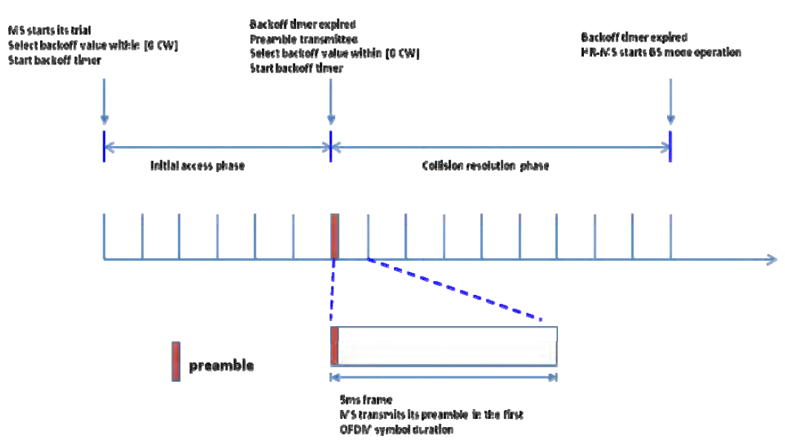



Figure 516 — Collision resolution method for HR-MS reactive operation