Project | IEEE 802.16 Broadband Wireless Access Working Group <http://ieee802.org/16>
Title | Initial ranging for priority access in IEEE 802.16.1a
Date Submitted | 2012-05-04
Source(s) | Seokjoo Shin  Chosun University  Won-Ik Kim, Seokki Kim, Eunkyung Kim, Sungkyung Kim, Miyoung Yun, Hyun Lee, Chulsik Yoon, Sungcheol Chang  ETRI | E-mail:  sjshin@chosun.ac.kr  woniks@etri.re.kr  scchang@etri.re.kr
Re: | “IEEE 802.16-12-271,” in response to Letter Ballot Recirc #38a on P802.16.1a/D2
Abstract | This provides AWD text proposals for priority access operation of HR-MS in IEEE p802.16.1a.
Purpose | To discuss and adopt the proposed text in the draft amendment document on GRIDMAN
Notice | This document does not represent the agreed views of the IEEE 802.16 Working Group or any of its subgroups. It represents only the views of the participants listed in the “Source(s)” field above. It is offered as a basis for discussion. It is not binding on the contributor(s), who reserve(s) the right to add, amend or withdraw material contained herein.
Copyright Policy | The contributor is familiar with the IEEE-SA Copyright Policy <http://standards.ieee.org/IPR/copyrightpolicy.html>.
Patent Policy | The contributor is familiar with the IEEE-SA Patent Policy and Procedures:  <http://standards.ieee.org/guides/bylaws/sect6-7.html#6> and <http://standards.ieee.org/guides/opman/sect6.html#6.3>.  Further information is located at <http://standards.ieee.org/board/pat/pat-material.html> and <http://standards.ieee.org/board/pat>.
Initial ranging for priority access in IEEE 802.16.1a

Seokjoo Shin
Chosun University

Won-Ik Kim, Seokki Kim, Eunkyung Kim, Sungkyung Kim, Miyoung Yun, Hyun Lee, Chulsik Yoon, Sungcheol Chang
ETRI

Introduction
This contribution is for subsection 6.12.8 which is ‘Support for priority access operation’.
According to the role of HR-MS user or HR-MS device, various priority levels can be assigned to HR-MSs. The purpose of this contribution is to propose a method for priority HR-MSs access to a HR-BS in initial ranging phase with taking precedence over the non-priority HR-MS and AMS. In the method, access opportunity of higher priority users will be higher than that of lower priority users with differentiating initial ranging window size for each priority group. In the current standards, S-SFH SP3 specifies the initial ranging window size with setting ‘initial ranging backoff start’ and ‘initial ranging backoff end’ values in periodic manner. However, S-SFH SP3 does not deliver any priority related information of such user. Therefore, we insert new initial ranging window size parameters into AAI-SCD message in order for high priority users to take precedence.
According to the degree of congestion in initial ranging phase, initial access control can be done in two modes described in below.
In normal (or light congestion) mode, all users including non-priority and priority users try to do initial ranging to an HR-BS with given contention window size parameters received through S-SFH SP3.
In heavy congestion mode, an HR-BS broadcasts different range of contention window size to non-priority users and priority users by sending S-SFH SP3 and AAI-SCD message, respectively. An HR-BS transmits S-SFH SP3 with setting larger contention window size for non-priority users while transmitting AAI-SCD with setting smaller contention window size for priority users.
The conceptual figure illustrating our proposed priority access method is shown in Fig. 1.
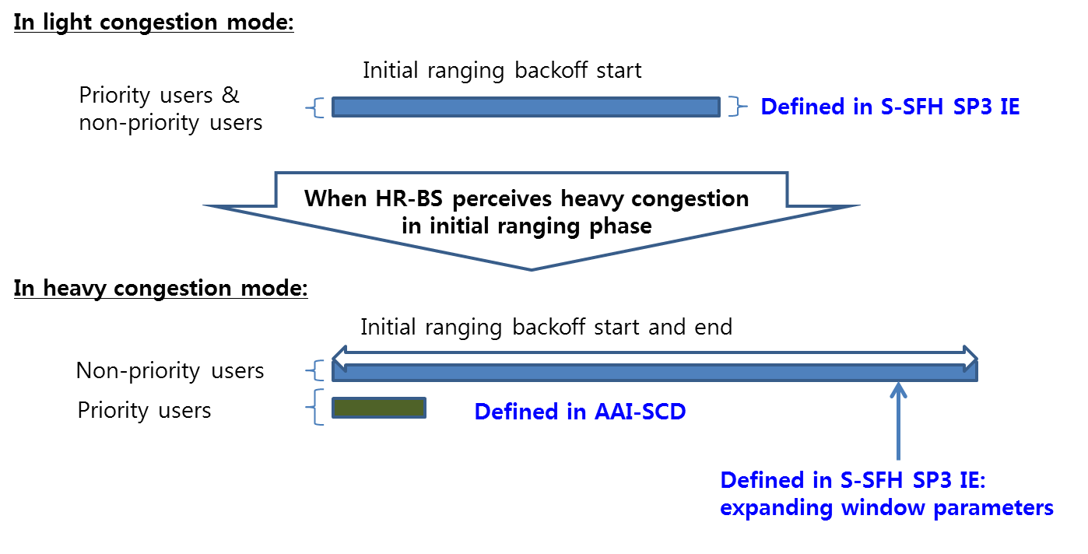
Fig. 1. Priority access in initial ranging

References
[1] IEEE P802.16nTM/D2, Air Interface for Broadband Wireless Access Systems - Draft Amendment: Higher Reliability Networks, April 2012.
[2] IEEE P802.16.1aTM/D2, WirelessMAN-Advanced Air Interface for Broadband Access Systems - Draft Amendment: Higher Reliability Networks, April 2012.
[3] EEE P802.16Rev3/D6, IEEE Draft Standard for Local and metropolitan area networks; Part 16: Air Interface for Fixed and Mobile Broadband Wireless Access Systems,” April 2012.
[4] IEEE P802.16.1TM/D6, IEEE Draft for WirelessMAN-Advanced Air Interface for Broadband Wireless Access Systems, April 2012.

Proposed Text for the 802.16.1a AWD
Note:
The text in BLACK color: the existing text in the 802.16.1a AWD
The text in RED color: the removal of existing 802.16.1a AWD
The text in BLUE color: the new text added to the 802.16.1a AWD

[-------------------------------------------------Start of Text Proposal---------------------------------------------------]

[Remedy1: Insert a new subsection in Section 6.12.8 in IEEE P802.16.1a/D2.]
[Page# 189, Line# 28]

6.12.8 Support for priority access operation

6.12.8.1 Priority access operation in initial ranging

An HR-MS may have higher priority than others due to its role of communication in PPDR. A priority HR-MS shall be served prior to non-priority stations. In order for priority HR-MSs to take precedence over the non-priority HR-MSs or AMSs, an HR-BS may assign different contention window size parameters to priority and non-priority users by sending S-SFH SP3 and AAI-SCD, respectively.

According to the degree of congestion in initial ranging phase, initial access control can be done in two modes described in below.

In normal (or light congestion) mode, all users including non-priority and priority users try to do initial ranging to an HR-BS with given contention window size parameters received through S-SFH SP3.

In heavy congestion mode, an HR-BS broadcasts different range of contention window size to non-priority users and priority users by sending S-SFH SP3 and AAI-SCD message, respectively. An HR-BS transmits S-SFH SP3 with setting larger contention window size for non-priority users while transmitting AAI-SCD with setting smaller contention window size for priority users.

[Remedy2: Adopt the following fields in Table 57of Section 6.2.3.31 in IEEE P802.16.1a/D2.]
[Page# 28, Line# 8]

- —AAI-SCD message field description
Field | Size (bits) | Value/Description | Condition
… | … | … | …
Initial ranging backoff start | 4 | Initial backoff window size for initial ranging contention of priority HR-MS, expressed as a power of 2. Values of n range 0–15 | Shall be present for priority access in HR-Network
Initial ranging backoff end | 4 | Final backoff window size for initial ranging contention, expressed as a power of 2. Values of n range 0–15 | Shall be present for priority access in HR-Network
Multicast Group Zone ID | 12 | Indicates a Multicast Group Zone ID provided by this BS.  Shall not be set to “0.” | In HR-Network
Multicast Indication cycle | 8 | Start of multicast indication cycle.  The first superframe is the multicast available interval and rest superframes are the multicast unavailable interval.  8 LSB of superframe number | Shall be present unless Multicast Group Zone is set to “0” in HR-Network
HR Multimode indication | 2 | Indicates whether current BR/RS is HR-MS acting as BS/RS or HR-BS acting as RS  0b00: current BS/RS is neither HR-MS acting as BS/RS nor HR-BS acting as RS  0b01: current BS/RS is HR-MS acting as BS/RS  0b10: current BS/RS is HR-BS acting as RS  0b11: reserved | HR Multimode indication  Shall be present in HR- Networks
Offset_{MAX_FWD_C} | 6 | Offset_{MAX_FWD_C} is the maximum of allowed transmit power adjustment value for control channels for forwarded to forwarding or forwarding to forwarded links. It represents the value among -15.5 to 16 dB with 0.5 dB step | Sent if the HR-MS has an associated forwarded HR-MS
Offset_{MIN_FWD_C} | 6 | Offset_{MIN_FWD_C} is the maximum of allowed transmit power adjustment value for control channels for forwarded to forwarding or forwarding to forwarded links. It represents the value among -15.5 to 16 dB with 0.5 dB step | Sent if the HR-MS has an associated forwarded HR-MS
Offset_{MAX_FWD_D} | 6 | Offset_{MAX_FWD_D} is the maximum of allowed transmit power adjustment value for data channels for forwarded to forwarding or forwarding to forwarded links. It represents the value among -15.5 to 16 dB with 0.5 dB step | Sent if the HR-MS has an associated forwarded HR-MS
Offset_{MIN_FWD_D} | 6 | Offset_{MIN_FWD_D} is the maximum of allowed transmit power adjustment value for data channels for forwarded to forwarding or forwarding to forwarded links. It represents the value among -15.5 to 16 dB with 0.5 dB step | Sent if the HR-MS has an associated forwarded HR-MS
DeltaXL_T | 4 | DeltaXL_T is the fairness and interference control factor of the MS-BS link to MS-MS links. It is broadcast by the HR_BS.  It has 4 bits to represent the value among {0, 0.1, 0.2, 0.3, 0.4, 0.5, 0.6, 0.7, 0.8, 0.9, 1.0, 1.1, 1.2, 1.3, 1.4, 1.5}. It is different for each frequency partition (FP0, FP1, FP2, FP3).  It may be transmitted only for those frequency partitions where HR-MS to HR-MS transmissions are scheduled | Sent if the HR-MS has an associated forwarded HR-MS
DeltaXL_X | 4 | DeltaXL_X is the fairness and interference control factor of the MS-MS link to MS-MS links. It is broadcast by the HR_BS.  It has 4 bits to represent the value among {0, 0.1, 0.2, 0.3, 0.4, 0.5, 0.6, 0.7, 0.8, 0.9, 1.0, 1.1,  1.2, 1.3, 1.4, 1.5}. It is different for each frequency partition (FP0, FP1, FP2, FP3).  It may be transmitted only for those frequency partitions where HR-MS to HR-MS transmissions are scheduled | Sent if the HR-MS has an associated forwarded HR-MS
Blind Paging Offset | 12 | Indicates the number of TDC frames used for blind paging offset | Present if need in HR-Networks
Blind Paging Cycle | 4 | Indicates the number of TDC frames with that a blind paging listening interval repeats | Present if need in HR-Networks
N_SIZE_LOG | TBD | Indicates the number of distinct sizes of logical channels, measured in terms of number of physical channels associated with them | Included if multicast feedback is supported
For( i=0; i< N_SIZE_LOG; i++) {
p, Log base 2 of the number of physical channel per logical channel | 3 | The number is 2^{p}
N_of_Size | TBD | Indicates number of logical channels that have size 2^{p}
}
N_frame | TBD | Delay in frames between starting frame for the reception of multicast and the first frame of the feedback channel associated with it
K_subframe | 3 | Subframe indicator
Feedback_ranging_format | 2 | 00b: S-RCH, 01b: NS-RCH format 0, 10b: NS-RCH format 1, 11b: reserved
Subcarrier start | TBD | The starting sub-carrier for the ranging preamble
Starting code index | TBD | The first code used
Code spacing | 4 | The spacing between codes that are used for feedback
Total number of codes | TBD | The total number of channels used (note that the number of codes may span multiple subbands and sub-frames) which implicitly defines the number of subbands

