|  |  |  |
| --- | --- | --- |
| Project | **IEEE 802.16 Broadband Wireless Access Working Group <**<http://ieee802.org/16>**>** | |
| Title | **Clarification of section 6.12.2.3 Talk-around direct communication in IEEE 802.16.1a** | |
| Date Submitted | **2012-05-04** | |
| Source(s) | Hyun Lee, Miyoung Yun, Seokki Kim, Won-Ik Kim, Eunkyung Kim, Sungkyung Kim, Chulsik Yoon, Sungcheol Chang  ETRI | E-mail:  [hyunlee@etri.re.kr](mailto:hyunlee@etri.re.kr)  [scchang@etri.re.kr](mailto:scchang@etri.re.kr) |
| Re: | “IEEE 802.16-12-271,” in response to Letter Ballot Recirc #38a on P802.16.1a/D2 | |
| Abstract | Changes are provided to accommodate corrections on section 6.12.2.3 Talk-around direct communication in IEEE 802.16.1a | |
| Purpose | To discuss and adopt the proposed text in the draft amendment document on GRIDMAN | |
| Notice | *This document does not represent the agreed views of the IEEE 802.16 Working Group or any of its subgroups*. It represents only the views of the participants listed in the “Source(s)” field above. It is offered as a basis for discussion. It is not binding on the contributor(s), who reserve(s) the right to add, amend or withdraw material contained herein. | |
| Copyright Policy | The contributor is familiar with the IEEE-SA Copyright Policy <http://standards.ieee.org/IPR/copyrightpolicy.html>. | |
| Patent Policy | The contributor is familiar with the IEEE-SA Patent Policy and Procedures:  <<http://standards.ieee.org/guides/bylaws/sect6-7.html#6>> and <<http://standards.ieee.org/guides/opman/sect6.html#6.3>>.  Further information is located at <<http://standards.ieee.org/board/pat/pat-material.html>> and <<http://standards.ieee.org/board/pat>>. | |

**Clarification of section 6.12.2.3 Talk-around direct communication in IEEE 802.16.1a**

Hyun Lee, Miyoung Yun, Seokki Kim, Won-Ik Kim, Eunkyung Kim, Sungkyung Kim, Chulsik Yoon, Sungcheol Chang

ETRI

# Introduction

This document provides Clarification of section 6.12.2.3 Talk-around direct communication in IEEE 802.16.1a.

Changes are provided to accommodate corrections for figures and typos on section 6.12.2.3 Talk-around direct communication as the following proposed texts.

# References

[1] IEEE 802.16-12-0132-00, GRIDMAN System Requirement Document including SARM annex, January 2012.

[2] IEEE P802.16.1aTM/D2, WirelessMAN-Advanced Air Interface for Broadband Access Systems - Draft Amendment: Higher Reliability Networks, April 2012.

# Proposed Text for the 802.16.1a AWD

Note:

The text in **BLACK** color: the existing text in the 802.16.1a AWD

The text in **~~RED~~** color: the removal of existing 802.16.1a AWD

The text in **BLUE** color: the new text added to the 802.16.1a AWD

[-----------------------------------------------Start of Text Proposal----------------------------------------------]

**[Remedy #1: Replace the Figure 235 in page 127 with the following proposed figure]**



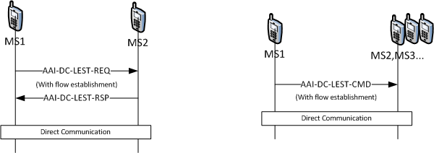

**Figure 235 —Link establishment for unicast (left) and multicast (right) one-way links**

**[Remedy #2: Replace the Figure 236 in page 127 with the following proposed figure]**



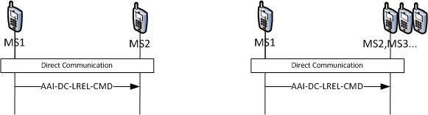

**Figure 236 —Link release for unicast (left) and multicast (right) one-way links**

**[Remedy #3: Replace the Figure 237 in page 128 with the following proposed figure]**



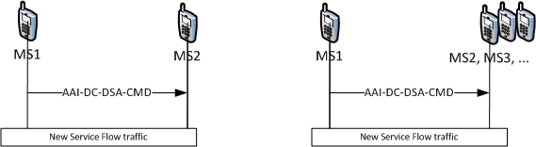

**Figure 237 — Message procedures of dynamic service flow addition for unicast (left) and**

**multicast (right) one-way links**

**[Remedy #4: Replace the Figure 238 in page 128 with the following proposed figure]**



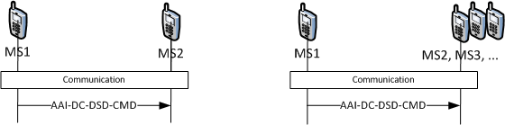

**Figure 238 —Message procedures of dynamic service flow deletion for unicast (left) and**

**multicast (right) one-way links**

**[Remedy #5: Replace the Figure 239 in page 129 with the following proposed figure]**



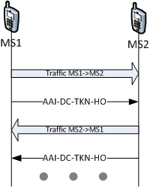

**Figure 239 —Message procedures of token management for unicast one-way link**

**[Remedy #6: Replace the Figure 240 in page 129 with the following proposed figure]**



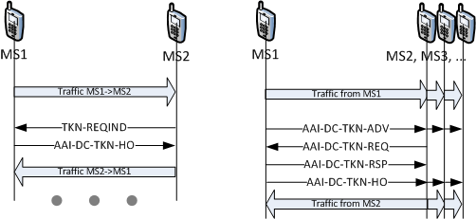

**Figure 240 —Procedures of token management with token request for unicast (left) and multicast (right) one-way links**

**[Remedy #7: Correct the typos in Section 6.12.2.3]**

* ***Page 125 line 22:* in → between**
* ***Page 129 line 3:* TKN-REQIND code → Token Request Indication**
* ***Page 129 line 5:* TKN-REQIND code → Token Request Indication**
* ***Page 134 line 21:* Nsubframe_per_fame → Nsubframe_per_frame (3 times)**
* ***Page 136 line 6:* Nsubframe_per_fame → Nsubframe_per_frame**
* ***Page 136 line 7:* Nsubframe_per_fame → Nsubframe_per_frame**
* ***Page 136 line 10:* Nsubframe_per_fame → Nsubframe_per_frame**
* ***Page 136 column 1 in Table 195:* Nsubframe_per_fame → Nsubframe_per_frame**
* ***Page 137 line 2:* Nsubframe_per_fame → Nsubframe_per_frame**
* **P*age 137 column 1 in Table 196:* Nsubframe_per_fame → Nsubframe_per_frame**
* ***Page 137 line 12:* Nsubframe_per_fame → Nsubframe_per_frame**
* ***Page 139 line 2:* Nsubframe_per_fame → Nsubframe_per_frame**
* ***Page 142 line 7:* IEc → IE**
* ***Page 146 line 10:* proposed → ~~proposed~~ (*be deleted)***
* ***Page 148 line 9:* Table yy1 → Table 198**
* ***Page 149 line 4:* AMS → HR-MS**

[----------------------------------------------End of Text Proposal------------------------------------------------]