IEEE P802.15
Wireless Personal Area Networks

Project | IEEE P802.15 Working Group for Wireless Personal Area Networks (WPANs)
Title | Resolution of LB225 comment index 199
Date Submitted | 16 October 2025
Source | Billy Verso (Qorvo), | billy dot verso at qorvo dot com
Re: | IEEE P802.15.4ab
Abstract | Comment Resolutions for selected comments on the LB225 / P802.15.4ab D03, as captured in the consolidated comments spread sheet, DCN:15-25-0509.
Purpose | This document provides text changes intended to be part of the final IEEE Std 802.15.4ab (amendment to IEEE Std 802.15.4), as part of resolving selected comments that have been assigned to the author.
Notice | This document does not represent the agreed views of the IEEE 802.15 Working Group or IEEE 802.15.4ab Task Group. It represents only the views of the participants listed in the “Source(s)” field above. It is offered as a basis for discussion and is not binding on the contributing individual(s) or organization(s). The material in this document is subject to change in form and content after further study. The contributor(s) reserve(s) the right to add, amend or withdraw material contained herein.
Release | The contributor acknowledges and accepts that this contribution becomes the property of IEEE and may be made publicly available by P802.15.
Patent Policy | The contributor is familiar with the IEEE-SA Patent Policy and Procedures.  <https://standards.ieee.org/about/sasb/patcom/materials/>

Comments addressed here:

1 Comment Index # 199 2

Comment Index # 199
Ind | pg | clause | line | Comment | Proposed Change
199  (Alex) | 67 | 10.39.3.2 Session initialization | 14-15 | Add a MLME sequence chart here. | Add sentence after line 14: "Figure <editor's choice> shows the message sequence chart for the initialization handshake for one-to-one ranging as illustrated in Figure 26. " Copy & paste Figure 28 to after this sentence and remove the following 5 messages surrounding the ADV-CONF message:  MLME-RX-ENABLE.request  MCPS-DATA.request  Advertising Confirmation  (RPA Hash responder IRK, SOR Time Offset)  MCPS-DATA.indication  MLME-SET.request
Discussion:
The commenter is asking for a new MSC to cover the one-to-one NBA MMS UWB session initialisation illustrated in Figure 26, (screenshot from D03 below).
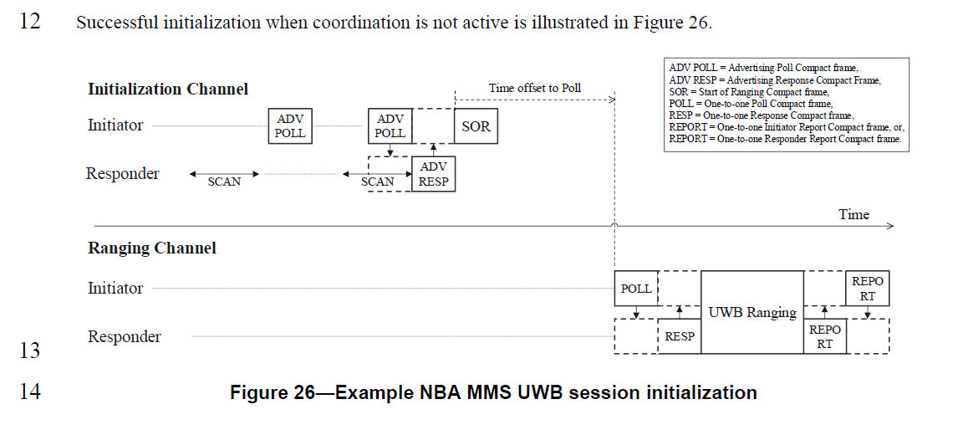
This seems a reasonable request, and the commenter has facilitated this by providing details of how to create the MSC based on the one in Figure 28.
The result is given in the disposition detail below as part of a “Revised” disposition proposal for the resolution of this comment.

Proposed Disposition: Revised.

Disposition Detail: Editor to make the changes as described below:

After line #14 on page 67 insert the following text and figure, (where <X> is the new figure number):
Figure <X> shows the message sequence chart for the one-to-one ranging initialization handshake that is illustrated in Figure 26. The responder periodically enables the receiver to scan for Advertising Poll Compact frame from the initiator. The initiator periodically sends the Advertising Poll Compact frame and then enables its receiver to look for the Advertising Response Compact frame from the responder. When this is received the initiator proceeds to send the Start of Ranging Compact frame, after which both sides update their long-term operating parameters and proceed to the ranging phase.

Figure <X>—Example message sequence chart for one-to-one ranging initialization

<END>

