IEEE 802.15
Wireless Specialty Networks (WSN)

Project | IEEE P802.15 Working Group for Wireless Specialty Networks (WSN)
Title | IEEE 802.16me PtMP MAC changes
Date Submitted | [16 September 2025]
Source | [Menashe Shahar]  [Ondas Networks] | Email: [menashe.shahar@ondas.com]
Re: | []
Abstract | [Optimization of the Allocation IE message]
Purpose | [Changes and corrections in 802.16me PtMP MAC]
Notice | This document has been prepared to assist the IEEE 802.15. It is offered as a basis for discussion and is not binding on the contributing individual(s) or organization(s). The material in this document is subject to change in form and content after further study. The contributor(s) reserve(s) the right to add, amend or withdraw material contained herein.
Release | The contributor acknowledges and accepts that this contribution becomes the property of IEEE and may be made publicly available by 802.15.
This document outlines proposed changes to the ieee802.16t standard
- Allocation Message Format Changes – Modified to reduce overhead.
- Super frame and Scheduling Window

Allocation Message Format changes to reduce Overhead

Bit-Size reduction of Slot Offset and Slots fields in Allocation IE format
The 802.16t standard specifies fixed bit-sizes for the Slotoffset and Slots fields in the Allocation IE format. According to Table 6-330—Allocation IE format, both Slot Offset and Slots fields are represented using 10 bits each, regardless of the actual number of addressable slots in the subframe.

Extract From P802.16t_D7.0 1.pdf draft
Table 6-330 Allocation IE format.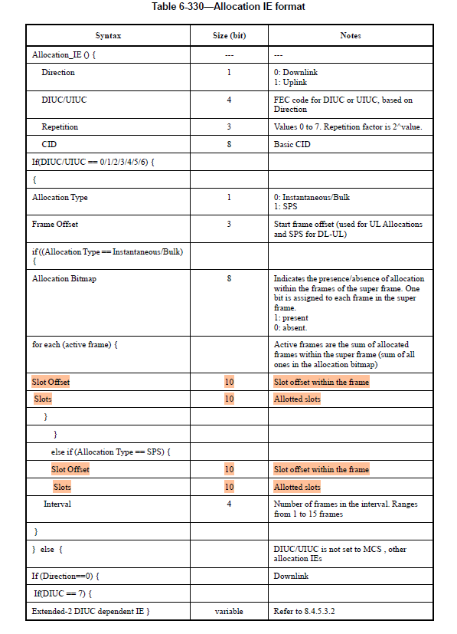
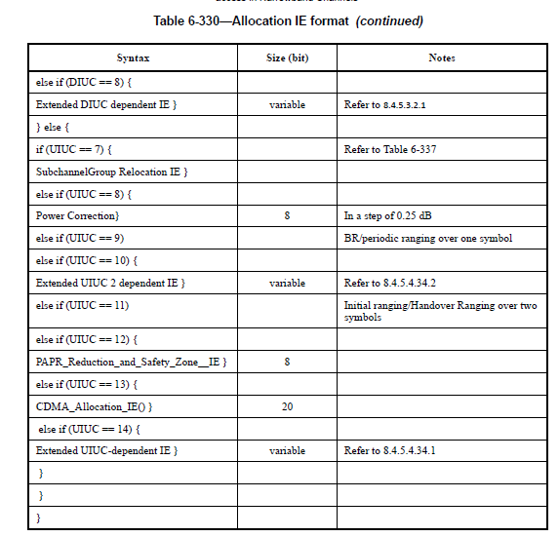

Proposed change
The proposed change employs a dynamic bit-width mechanism for encoding the Slot Offset and Slots fields. Both the BS and MS compute the minimum number of bits required to represent these fields based on the total number of addressable slots in the subframe.
This approach significantly reduces signaling overhead by allocating only the necessary number of bits for these fields.
Calculation Logic
Definitions:
S = Number of slots per subframe (either DL or UL)
C = Number of subchannels in the subchannel group
N = Total number of addressable slots in the group = S × C

Bit Width Formula:
Bits_required = ceil(log2​(N))
Both BS and MS compute this identically, ensuring consistent decoding and encoding.

Examples
1. Single Subchannel (C = 1), 10 Slots (S = 10):
N = 10×1 = 10
Bits required = ceil(log2(10)) = 4

2. Two Subchannels (C = 2), 10 Slots (S = 10):
N = 10×2 = 20
Bits required = ceil(log2(20)) = 5

3. General Case:
For C = 15, S = 4:
N = 15×4 = 60
Bits required = ceil(log2(60)) = 6

Proposed Allocation IE format (proposed change are highlighted RED)
Syntax | Size  (Bit) | Notes
Allocation _IE () { | __ | __
Direction | 1 | 0: Downlink, 1: Uplink  1: Uplink
DIUC/UIUC | 4 | DIUC or UIUC, based on Direction
Repetition | 3 | Values 0 to 7. Repetition factor is 2^value.
CID | 8 | Connection Identifier
If(DIUC/UIUC == 0/1/2/3/4/5/6) { |  | DIUC/UIUC is set to MCS , Data allocations
{
Allocation Type | 1 | 0: Instantaneous/Bulk  1: SPS
Frame offset | 3 | Start frame offset (used for UL Allocations and SPS for DL-UL)
if ((Allocation Type == Instantaneous) || (Allocation Type == Bulk) {
Allocation bitmap | 8 | Indicates the presence/absence of allocation within the frames of the super frame. One bit is assigned to each frame in the super frame.  1: present  0: absent.  MSB Bit 7 is mapped to the first frame of the super frame and bit 0 is mapped to the last frame.
for each (active frame) { |  | Active frames are the sum of allocated frames within the super frame (sum of all 1s in the allocation bitmap)
Slot offset | variable | Slot offset within the frame.  variable bits size = CEIL(LOG2 (N)) , where N = total addressable slots
Slots | variable | Allocated slots.  variable bits size = CEIL(LOG2 (N)) , where N = total addressable slots
}
}
else if (Allocation Type == SPS) {
Slot offset | variable | Slot offset within the frame.  variable bits size = CEIL(LOG2 (N)) , where N = total addressable slots
Slots | variable | Allocated slots.  variable bits size = CEIL(LOG2 (N)) , where N = total addressable slots
Interval | 4 | Number of frames in the interval. Ranges from 1 to 15 frames
}
} else { |  | DIUC/UIUC is not set to MCS , other allocation IEs
If (Direction==0) { |  | Downlink
If(DIUC == 7) {
Extended-2 DIUC dependent IE }
else if (DIUC == 8) {
Extended DIUC dependent IE } | variable | See 8.4.5.3.2 and 8.4.5.3.2.1
} else { |  | Uplink
if (UIUC == 7) {
SubchannelGroup Relocation IE } |  | Table 6-334
else if (UIUC == 8) {
Power Correction} | 8 | In a step of 0.25 dB
else if (UIUC == 9) |  | BR/periodic ranging over one symbol
else if (UIUC == 10) {
Extended UIUC 2 dependent IE } | variable | See 8.4.5.4.34.2
else if (UIUC == 11) |  | Initial ranging/Handover Ranging over two  symbols
else if (UIUC == 12) {
PAPR_Reduction_and_Safety_Zone__IE } | 8
else if (UIUC == 13) {
CDMA_Allocation_IE() } | 20
else if (UIUC == 14) {
Extended UIUC-dependent IE } | variable | See 8.4.5.4.34.1
}
}
}

Summary
Both BS and MS use the same logic to compute the number of bits required for slotoffset and slots, ensuring consistency and compatibility.
Since these parameters (Slotoffset and Slots) are repeated across multiple IEs—and repeated within each Allocation IE for every active frame in the case of Bulk or Instantaneous allocation—reducing their bit-width can result in significant overall bandwidth savings.
By making the bit-width adaptive to the actual number of slots in the configuration, this approach optimizes bandwidth usage, especially when there are large number of IEs.

Super frame and Scheduling window
The 802.16t standard does not mention a Scheduling Window; instead, it uses the term Superframe, which serves a similar purpose of looking ahead into multiple frames for scheduling and control. Refer to section 6.3.37.4.3 Frame duration and Super-frame duration and 6.3.37.4.6 BS Scheduler of P802.16t_D7.0 1.pdf document.

Extract From P802.16t_D7.0 1.pdf draft
6.3.37.4.6 BS Scheduler
The BS scheduler shall schedule future frames as follows:
— Instantaneous allocations within a time spanning one super-frame.
— NB-UGS/SPS occurring across superframes within the validity period.
— Bulk allocations within an interval that spans one superframe may be one-time or repetitive with
validity period.

Proposed Change
By defining the term 'scheduling window', we can revise the paragraph to reflect this terminology.
Here is the revised paragraph.
6.3.37.4.6 BS Scheduler
The BS scheduler is capable of scheduling into the future. The number of future frames over which the BS scheduler allocates resources is called the scheduling window. The Allocation message shall carry the DL and UL allocation information for all the frames in the scheduling window.
The BS scheduler shall schedule future frames as follows:
— Instantaneous allocations that occur within the duration of the scheduling window.
— NB-UGS/SPS allocations that occur within their defined validity period.
— Bulk allocations that occur within the scheduling window, which may be either one-time or repetitive, with a specified validity period.

Description of Proposed implementation
Super frame is fixed one second in duration and it’s used for synchronization between AIRM (BSC) and the BSs. Between BS and remotes , proposed implementation uses a different term called “scheduling window”. The scheduling window size or duration can be dynamically varying depending on the traffic scenarios.
Even though both Superframe and Scheduling Window both involve looking into multiple frames in the future, they are indeed fundamentally different in purpose in proposed implementation.

Summary
Term | Duration | Purpose | Flexibility | Used Between
Superframe | Static (1 second) | System synchronization , interference management and resource assignment planning over frames lasting for a second. | Fixed | AIRM ↔ BS
Scheduling Window | Dynamic and adaptive | Resource allocation planning over multiple frames | Dynamic | BS ↔ Remotes

