IEEE P802.15
Wireless Personal Area Networks

Project | IEEE P802.15 Working Group for Wireless Personal Area Networks (WPANs)
Title | Proposed Resolution for CID 595 on 15.4ab D2.0
Date Submitted | September 2025
Sources | Pooria Pakrooh (Qualcomm)
Abstract | Resolution to comment 595 on D2.0
Purpose | To propose comments resolution for “P802.15.4ab™/D (pre-ballot) C Draft Standard for Low-Rate Wireless Networks”
Notice | This document does not represent the agreed views of the IEEE 802.15 Working Group or IEEE 802.15.4ab Task Group. It represents only the views of the participants listed in the “Sources” field above. It is offered as a basis for discussion and is not binding on the contributing individuals. The material in this document is subject to change in form and content after further study. The contributors reserve the right to add, amend or withdraw material contained herein.

CIDs addressed: 595

CID | Sub-Clause | Page | Line | Comment | Proposed Change
595 | 10.40.4.5.3.2 | 151 | 1 | The threshold is relative to and below the peak, to help with understanding this, a figure to explain this might be good. | Consider adding a figure to show how/where this threshold applies.

Discussion:
Suggest using Figure 144 for the purpose of clarifying the threshold.

Resolution: Revise

Notes to the editor:
1. Change page 151 line 2 as below:
The sensing controlee reports those taps whose magnitude are no more than T below the magnitude of the strongest tap. If the sensing controller does not want the CIR report to be thresholded, it specifies a very high value for T, as shown in Figure 144.

2. Change page 150, Figure 144 as below:
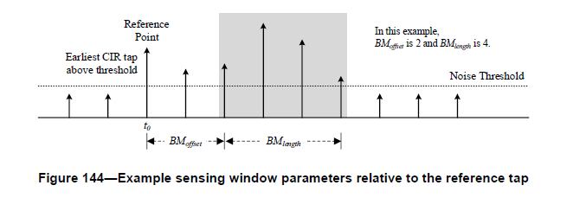
Strongest tap magnitude
Taps with magnitude above this threshold are reported
T (dB)

