**IEEE P802.15**

**Wireless Personal Area Networks**

|  |  |
| --- | --- |
| Project | IEEE P802.15 Working Group for Wireless Personal Area Networks (WPANs) |
| Title | **Proposed resolutions for 15.4ab D02 CIDs 612, 613, 614** |
| Date Submitted | Sep 2nd, 2025 |
| Sources | Ankur Bansal (Samsung) |
| Abstract | Comment resolution proposals for 15.4ab D02 comments 612, 613, 614. |
| Purpose | Propose resolutions to comments received on IEEE P802.15.4ab/D02 |
| Notice | This document does not represent the agreed views of the IEEE 802.15 Working Group or IEEE 802.15.4ab Task Group. It represents only the views of the participants listed in the “Sources” field above.It is offered as a basis for discussion and is not binding on the contributing individuals. The material in this document is subject to change in form and content after further study. The contributors reserve the right to add, amend or withdraw material contained herein. |

Table of Contents

1. CID #612, 613, 614 (Revised) 3

# CID #612, 613, 614 (Revised)

|  |  |  |  |  |  |  |  |
| --- | --- | --- | --- | --- | --- | --- | --- |
| VERSO, BILLY | 612 | Technical | 182 | 10.40.6.6 | 15 | Delay Span field units/range aren't specified. | Specify units and value range. |
| VERSO, BILLY | 613 | Technical | 182 | 10.40.6.6 | 18 | Angle Span (Azimuth) field values/units aren't specified and text says it is an 8-bit value but Figure 179 has it as 2 octets. | Clarify field size and specify units and value range |
| VERSO, BILLY | 614 | Technical | 182 | 10.40.6.6 | 19 | Angle Span (Elevation) field values/units aren't specified and text says it is an 8-bit value but Figure 179 has it as 2 octets. | Clarify field size and specify units and value range |

*<page 181>*

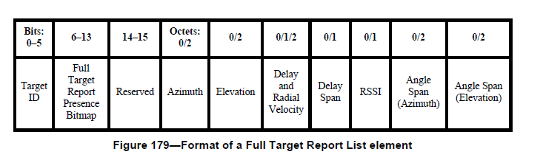

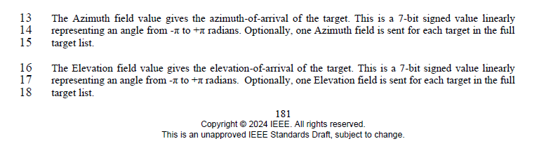

*<page 182>*

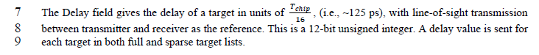

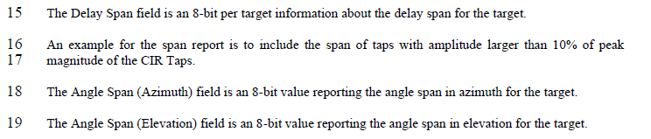

**Discussion:**

Updated units corresponding to the units for delay, and angles as specified in previous sections of the specification. Also aligned text with the figure for bit width.

**Resolution: Revised**

**Notes to Editor:**

Change page 182, lines 15-19 as follows:

The Delay Span field is an 8-bit per target information about the delay span for the target, in units of 𝑇𝑐ℎ𝑖𝑝/16, (i.e., ~125 ps).

An example for the span report is to include the span of taps with amplitude larger than 10% of peak magnitude of the CIR Taps.

The Angle Span (Azimuth) field is gives the angle span in azimuth for the target. This is a 16-bit signed value linearly representing an angle from -π to +π radians.

The Angle Span (Elevation) field gives the angle span in elevation for the target. This is a 16-bit signed value linearly representing an angle from -π to +π radians.