**IEEE P802.15**

**Wireless Personal Area Networks**

|  |  |  |
| --- | --- | --- |
| Project | IEEE P802.15 Working Group for Wireless Personal Area Networks (WPANs) | |
| Title | **Proposed Resolution for Comments #3 and #13** | |
| Date Submitted | September 2, 2025 | |
| Sources | Carlos Aldana (Meta), Guoqing Li (Meta), Kumail Haider (Meta), Davide Magrin (Meta), Pooria Pakrooh (Qualcomm), Bin Tian (Qualcomm), Wenzheng Li (Calterah), Pelin Salem (Cisco), Carlos Cordeiro (Intel), Gaurav Patwardhan (HPE), Ashish Shukla (Amazon) |  |
| Re: |  | |
| Abstract |  | |
| Purpose | To propose resolution to comment with CID #3 and #13 for “P802.15.4ab™/Draft 2.0 Standard for Low-Rate Wireless Networks” | |
| Notice | This document does not represent the agreed views of the IEEE 802.15 Working Group or IEEE 802.15.4ab Task Group. It represents only the views of the participants listed in the “Sources” field above.It is offered as a basis for discussion and is not binding on the contributing individuals. The material in this document is subject to change in form and content after further study. The contributors reserve the right to add, amend or withdraw material contained herein. | |

***Comment Index #3 and 13***

|  |  |  |  |  |  |  |
| --- | --- | --- | --- | --- | --- | --- |
| 3 | Technical | 80 | 10.39.4.2 | 6 | There is no baseline coex mechanism for NB channel access using O-QPSK | Change the "may" to a "shall" to be consistent with ETSI 303687 and adopt changes described in document 15-407-07 |
| 13 | Technical | 83 | 10.39.8.3 | 22 | Change the "may" to a "shall" to enable a baseline NB coex mechanism | Change the "may" to a "shall" to be consistent with ETSI 303687 and adopt changes described in document 15-407-07 |

**Discussion:**

This proposal builds on work presented in the joint 802.11/802.15.4ab Coexistence SC meeting in July 2024 [3], where analysis showed that appropriate LBT thresholds minimize two key risks:

1. **Missed transmission opportunities** when thresholds are set too conservatively, and
2. **Harmful interference** to nearby 802.11 systems when thresholds are set too aggressively.

The proposed energy detect (ED) thresholds reflect practical coexistence scenarios with deployed 802.11 systems operating in both UNII-3 and UNII-5 bands, including bandwidths up to 320 MHz. The thresholds also align with ETSI coexistence approaches [2][5], which have historically influenced global regulatory and standardization practices.

Recent European BRAN work [4] also adopted an LBT-based solution, underscoring its role as a practical, widely accepted coexistence mechanism. Key aspects of that approach—such as minimum CCA duration, proportional ED thresholds, and specific rules for NB CCAs—provide a well-understood technical foundation.

Some highlights of the work in [4] are:

1. LBT is the mandatory channel access mechanism.
2. LBT is optional in the case when the gap to a prior transmission or reception on the same NB channel is less than 18 µs.
3. If an NB CCA indicates an occupied NB channel, NBE-LBT may perform a new NB CCA on another NB channel after at least 50 µs or on the same NB channel after at least 100 µs.
4. The minimum CCA duration is 18 µs.
5. The EDT is proportional to the equipment's transmit power (Ptx):

EDT = min( TBDEDTmax dBm/MHz, TBDEDTmin dBm/MHz + 14 dBm – Ptx )

In order to balance the need for flexibility with the importance of coexistence, we propose that the group adopt a baseline Listen-Before-Talk (LBT) based mechanism.

This baseline does not introduce additional constraints where regulations already prescribe coexistence requirements. Rather, it establishes a foundation that delivers:

* **Interoperability across chipsets** – enabling devices from different vendors to operate together consistently and reliably.
* **Predictable coexistence performance** – ensuring a minimum level of protection so that performance does not fall below acceptable levels.
* **Alignment with existing LBT-based technologies** – supporting consistent operation in markets without explicit coexistence rules, thereby reducing fragmentation and complexity.
* **Flexibility for innovation** – providing a clear baseline while allowing vendors to develop enhanced mechanisms above this minimum (e.g. multiple CCAs, as in [6]), ensuring both fairness and room for advancement.

By defining such a baseline, the group can ensure that a common, interoperable mechanism exists where no regulatory guidance is provided.

The proposed text describes a single-shot LBT measurement using SSBD parameters for both NBA-MMS and UWB data offload to narrowband (Section 10.43):

*Channel access using listen before talk shall be used for improved coexistence performance. When used for narrowband assist, SSBD, as described in Section 10.44, shall be used with the following control attribute values:*

*phyCcaDuration shall be set to the minimum value required by local regulations;  
macSsbdMaxBf may be set to any finite value;*

*macSsbdUnitBackoffPeriod may be set to any finite value;*

*macSsbdMinBf shall be set to 0;   
macSsbdMaxBackoffs shall be set to 0;  
macSsbdTxOnEnd shall be set to FALSE;  
macSsbdPersistence shall be set to FALSE;  
phyCcaMode shall be set to 1 (energy above threshold)*

*phyCcaEdThreshold shall be set to shall be set to the value required by local regulations;  otherwise, it shall be set to min(-69 dBm/MHz, -67 dBm/MHz – Ptx) in channels 0 to 49 and to max(-83 dBm/MHz, min(-63 dBm/MHz,-70 dBm/MHz – Ptx)) in channels 50 to 249, where Ptx is the equipment’s instantaneous transmit power for the upcoming transmission in dBm and Ptx<=Pmax = min(TXMAX_capability, TXMAX_power_Regulatory). TXMAX_power_Regulatory is the max power allowed in the regulatory domain and TXMAX_capability is the max power allowed to be transmitted by the device.*

*The transmitter has three options:*

1. *If Pcca_dBm_MHz <= phyCcaEdThreshold (i.e., channel is idle), then transmit with power Ptx*
2. *If (Pcca_dBm_MHz > phyCcaEdThreshold) AND (Pcca_dBm_MHz <=EDTmax) (i.e., channel is busy and CCA is not too high), then either* 
   1. *do not transmit OR*
   2. *stay in the same channel and transmit according to TX Procedure below.*
3. *If Pcca_dBm_MHz > EDTmax (i.e., channel is busy and CCA is too high), do not transmit*

*where EDTmax = -69 dBm/MHz for channels 0 to 49 and -63 dBm/MHz for channels 50-249.*

***TX Procedure***

*Transmit up to Ptx2_dBm using the formula below:*

*Ptx2_dBm < = Ptx – (Pcca_dBm_MHz – phyCcaEdThreshold)*

Below is the plot showing the more relaxed ED Threshold (than in 15-24-407-07) setting using max NB VLP power of 14 dBm that is set in Europe [2][5]:

In ETSI 303687 Draft 1.1.7, the current PSD limits are as

|  |  |  |  |
| --- | --- | --- | --- |
|  | PSD Limit | Max power | EDT at max power |
| NB VLP | 10 dBm/MHz | 14 dBm |  |
| 160 MHz 802.11 VLP | -8 dBm/MHz | 14 dBm | -75 dBm/MHz |
| 160 MHz 802.11 LPI | +1 dBm/MHz | 23 dBm | -84 dBm/MHz |

As can be seen, NB has an **18 dB** advantage over 160 MHz VLP and **9 dB** advantage over 160 MHz LPI.

**Proposed Resolution :** Revised

**NOTE TO EDITOR:** Replace the following text in Section 10.38.7.3

LBT shall be applied to channel numbers 50 to 249 according to regulatory constraints. LBT may be applied to all channels in the absence of regulatory constraints, for example, to improve coexistence with other spectrum users.

**with the following:**

Channel access using listen before talk shall be used for improved coexistence performance. When used for narrowband assist, SSBD, as described in Section 10.44, shall be used with the following control attribute values so that a single CCA is performed before each transmission attempt:  
phyCcaDuration shall be set to the minimum value required by local regulations;

macSsbdMaxBf may be set to any finite value;

macSsbdUnitBackoffPeriod may be set to any finite value;

macSsbdMinBf shall be set to 0;

macSsbdMaxBackoffs shall be set to 0;  
macSsbdTxOnEnd shall be set to FALSE;

macSsbdPersistence shall be set to FALSE;  
phyCcaMode shall be set to 1 (energy above threshold)  
phyCcaEdThreshold shall be set to shall be set to the value required by local regulations;  otherwise, it shall be set to min(-69 dBm/MHz, -67 dBm/MHz – Ptx) in channels 0 to 49 and to max(-83 dBm/MHz, min(-63 dBm/MHz,-70 dBm/MHz – Ptx)) in channels 50 to 249, where Ptx is the equipment’s instantaneous transmit power for the upcoming transmission in dBm and Ptx<=Pmax = min(TXMAX_capability, TXMAX_power_Regulatory). TXMAX_power_Regulatory is the max power allowed in the regulatory domain and TXMAX_capability is the max power allowed to be transmitted by the device.

Figure 1 shows the simplified SSBD algorithm:

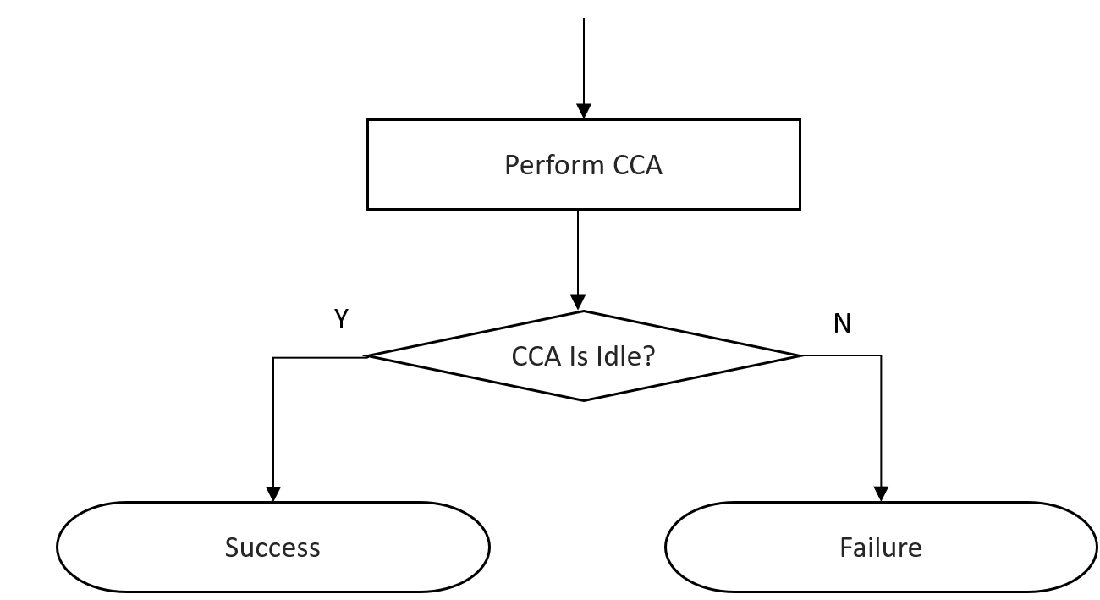

Figure 1

The transmitter has three options:

1. If Pcca_dBm_MHz <= phyCcaEdThreshold, then transmit with power Ptx
2. If (Pcca_dBm_MHz > phyCcaEdThreshold) AND (Pcca_dBm_MHz <= EDTmax), then either
   1. do not transmit OR
   2. stay in the same channel and transmit according to TX Procedure below.
3. If Pcca_dBm_MHz > EDTmax, do not transmit

where EDTmax = -69 dBm/MHz for channels 0 to 49 and -63 dBm/MHz for channels 50-249.

**TX Procedure**

Transmit up to Ptx2_dBm using the formula below:

Ptx2_dBm < = Ptx – (Pcca_dBm_MHz – phyCcaEdThreshold)

**NOTE TO EDITOR**: Please also add the new text at the end of Section 10.43.2.

**References** :

[1]15-24-0226-03-04ab “DraftC comment resolution – NB channel access – CIDs 149, 161”

[2] ETSI EN 303 687 1.1.7 (2025-04-02) draft

[3] IEEE 802.11-24/1182r0, “Transmit Power Control Based EDT for NB”

[4] BRAN(24)124017r3_NB_Channel_Access_Mechanism_Draft.docx, “NBE with LBT normative text”

[5] ETSI EN 300 440 v2.2.1 (2018-07)

[6] 15-25-99-01-04ab ”Multiple CCA for NB”