IEEE P802.15
Wireless Personal Area Networks

Project | IEEE P802.15 Working Group for Wireless Personal Area Networks (WPANs)
Title | Proposed resolution for CID 159
Date Submitted | August 2025
Sources | Mickael Maman (STMicroelectronics)
Re:
Abstract
Purpose | To propose comments resolution for “P802.15.4ab™/D02 C Draft Standard for Low-Rate Wireless Networks”
Notice | This document does not represent the agreed views of the IEEE 802.15 Working Group or IEEE 802.15.4ab Task Group. It represents only the views of the participants listed in the “Sources” field above. It is offered as a basis for discussion and is not binding on the contributing individuals. The material in this document is subject to change in form and content after further study. The contributors reserve the right to add, amend or withdraw material contained herein.

Comment Index #159 in 15-25-0174-09-04ab-consolidated-comments-draft-2-0
Commenter | Index # | page | Sub-Clause | Line | Comment | Proposed Change
MAMAN, MICKAEL | 159 | 64 | 10.39.1 | 17 | The value A in ms is linked to macMmsRcpPollNSlots and macMmsRcpRespNSlots. Missing information about macMmsRangingSlotDuration | add " and macMmsRangingSlotDuration to a value of 600 RSTUs" after both to a value of two.

Discussion of comment ID 159:
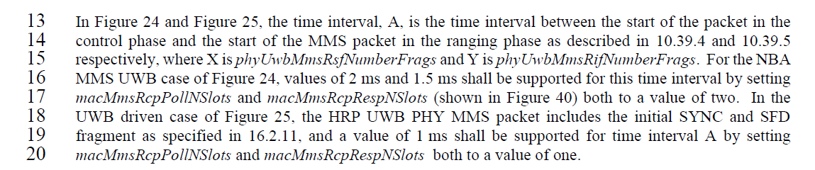
Proposed resolution:
Revised
Proposed text changes on P802.15.4ab™/D02 for comment ID 159:
Change page 64 line 13-20
In Figure 24 and Figure 25, the time interval, A, is the time interval between the start of the packet in the control phase and the start of the MMS packet in the ranging phase as described in 10.39.4 and 10.39.5 respectively, where X is phyUwbMmsRsfNumberFrags and Y is phyUwbMmsRifNumberFrags. This time interval is (macMmsRcpPollNSlots+macMmsRcpRespNSlots)*macMmsRangingSlotDuration and (macMmsRcpRespNSlots +1)*macMmsRangingSlotDuration for the initiator and the responder respectively. For the NBA MMS UWB case of Figure 24, values of 2 ms and 1.5 ms shall be supported for the initiator and responder respectively (macMmsRcpPollNSlots and macMmsRcpRespNSlots both to a value of two and macMmsRangingSlotDuration to a value of 600 RSTUs). In the UWB driven case of Figure 25, the HRP UWB PHY MMS packet includes the initial SYNC and SFD fragment as specified in 16.2.11, and a value of 1 ms shall be supported for time interval A (macMmsRcpPollNSlots and macMmsRcpRespNSlots both to a value of one and macMmsRangingSlotDuration to a value of 600 RSTUs).

