IEEE P802.15
Wireless Personal Area Networks

Project | IEEE P802.15 Working Group for Wireless Personal Area Networks (WPANs)
Title | LB213 comment index 120
Date Submitted | 18 August 2025
Source | Billy Verso (Qorvo), | billy.verso at qorvo.com
Re: | IEEE P802.15.4ab
Abstract | Comment Resolutions for selected comments on the LB213 / P802.15.4ab D02.
Purpose | This document is offered as an alternative resolution for comment index #120 to that proposed in DCN 15-25-0339-01.
Notice | This document does not represent the agreed views of the IEEE 802.15 Working Group or IEEE 802.15.4ab Task Group. It represents only the views of the participants listed in the “Source(s)” field above. It is offered as a basis for discussion and is not binding on the contributing individual(s) or organization(s). The material in this document is subject to change in form and content after further study. The contributor(s) reserve(s) the right to add, amend or withdraw material contained herein.
Release | The contributor acknowledges and accepts that this contribution becomes the property of IEEE and may be made publicly available by P802.15.
Patent Policy | The contributor is familiar with the IEEE-SA Patent Policy and Procedures.  <https://standards.ieee.org/about/sasb/patcom/materials/>

Comments addressed here:

1 Comment Index # 120 2

Comment Index # 120
Ind | pg | clause | line | Comment | Proposed Change
120  (Jaegook) | 220 | 16.2.10 | 18 | According to 15-24-0679, SHR & the first sensing segment are sent at the same channel. However, the mention in 16.2.10 says that " If the channel for the SHR is different to the channel specified by phyFSS1channel, … | Clarify whether SHR & the first sensing segment are sent at the same channel.
Discussion:
This comment, and the resolution to it proposed in DCN 15-25-0339-01, were discussed during the TG4ab call of 12th Aug 2025.
The source of this D02 text was questioned, i.e., what made this (p.191) D01 text…
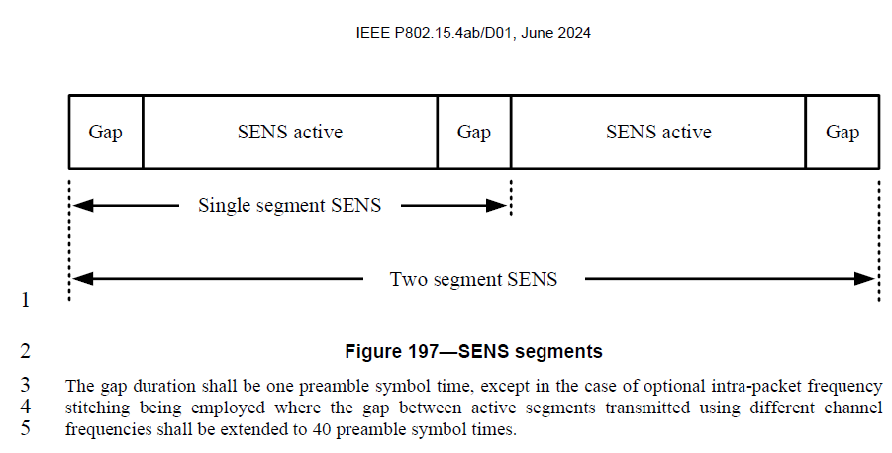
… into this (p.220) D02 text?
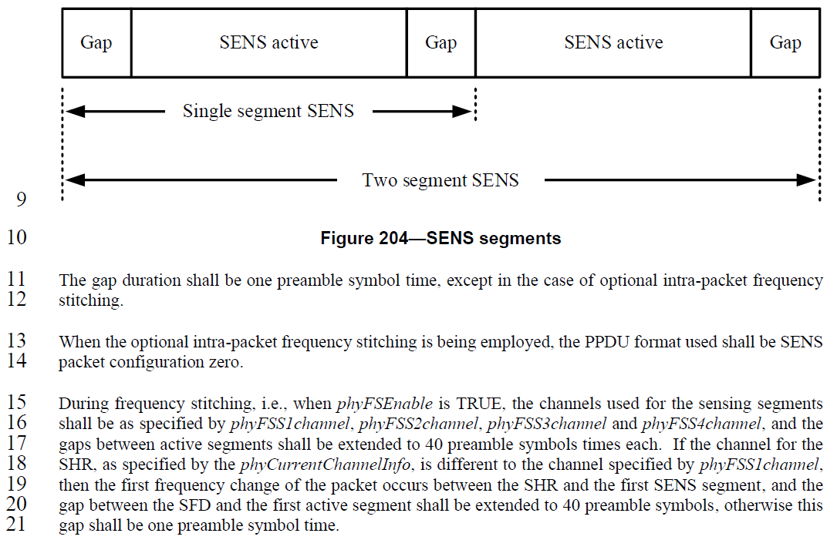

Five comments on D01 are related to this:
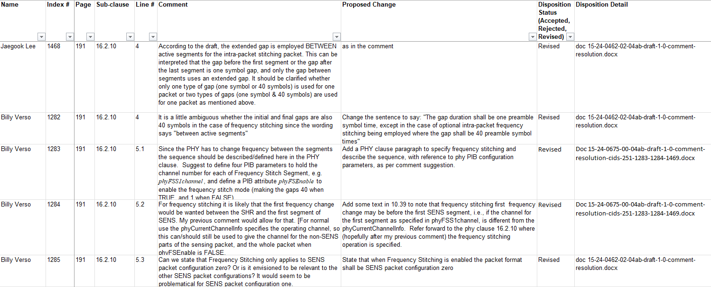
1282, 1468 and 1285 were resolved by 15-24-0462-02 changing Line 3-5 on Page 191 as follows:
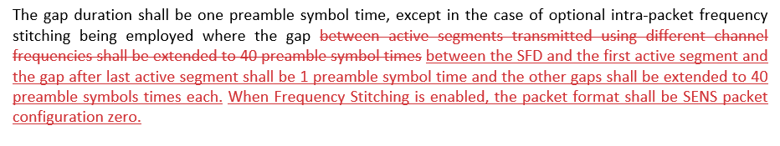
1283 and 1284 were resolved by 15-24-0675-01 adding PHY PIB attributes to configure the channel to use for each sensing segment, and inserting the text below in clause 10.39.3
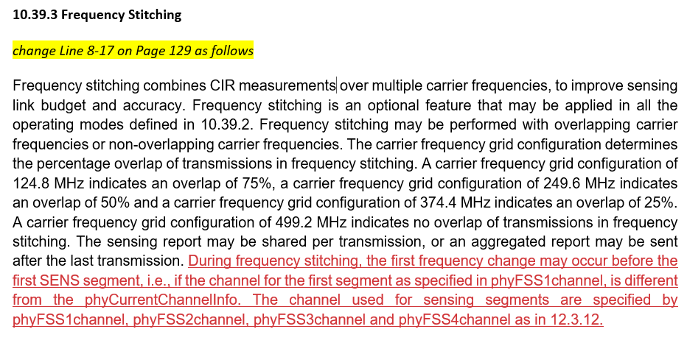

The technical editor made these changes and then during tidy-up determined that changes to 10.39.2 discussing PHY attribute functionality would be more appropriately placed in the PHY clause and moved them. The intermediary text might have looked something like this:
The gap duration shall be one preamble symbol time, except in the case of optional intra-packet frequency stitching being employed where the gap between the SFD and the first active segment and the gap after last active segment shall be 1 preamble symbol time and the other gaps shall be extended to 40 preamble symbols times each.
When Frequency Stitching is enabled, the packet format shall be SENS packet configuration zero.
During frequency stitching, the first frequency change may occur before the first SENS segment, i.e., if the channel for the first segment as specified in phyFSS1channel, is different from the phyCurrentChannelInfo.
The channel used for sensing segments are specified by phyFSS1channel, phyFSS2channel, phyFSS3channel and phyFSS4channel as in 12.3.12.
Knowing that the 40-symbol gap is to allow time for the frequency change, the technical editor could see that the two highlighted pieces were in disagreement, and rather than produce D02 with this inconsistency, amended the text to solve the inconsistency by noting that the functionality of the latter change is a superset of the more restricted functionality of the earlier one, and reorganising the paragraphs to make the text in the D02, (reproduced below with the highlighted text showing the merged functionality in question).
The gap duration shall be one preamble symbol time, except in the case of optional intra-packet frequency stitching.
When the optional intra-packet frequency stitching is being employed, the PPDU format used shall be SENS packet configuration zero.
During frequency stitching, i.e., when phyFSEnable is TRUE, the channels used for the sensing segments shall be as specified by phyFSS1channel, phyFSS2channel, phyFSS3channel and phyFSS4channel, and the gaps between active segments shall be extended to 40 preamble symbols times each. If the channel for the SHR, as specified by the phyCurrentChannelInfo, is different to the channel specified by phyFSS1channel, then the first frequency change of the packet occurs between the SHR and the first SENS segment, and the gap between the SFD and the first active segment shall be extended to 40 preamble symbols, otherwise this gap shall be one preamble symbol time.

As suggested by the LB207 comment, there are some benefits to doing the first frequency change between the SHR and the first SENS fragment, and the D02 text allows for this while not precluding having the SHR and the first SENS fragment on the same channel by setting phyCurrentChannelInfo and phyFSS1channel to the same value.

Conclusions & possible resolutions:

The flexibility offered by the D02 text is arguably a good thing, so we could resolve Comment Index #120 by a Rejected disposition with a reason like: The group prefers to have the flexibility of the current D02 text.

Alternatively, the group might choose to prefer the more restricted functionality that would result by accepting the resolution proposed in 15-25-0339-01 for this comment (#120).

The third possibility is modifying the text to mandate support for using the same channel for the SHR and first SENS fragment with the one symbol gap as a required mode (i.e. ensuring a common mode of interworking is defined), while optionally allowing for the possibility of using different channels. This may best capture the intent of the conflicting comments.
The proposed resolution disposition then is: Revised.
Disposition Detail: Add the following sentence at the end of the paragraph, (line 21, p.220):
For frequency stitching, it is mandatory to support a sensing packet where the phyCurrentChannelInfo and phyFSS1channel specify the same channel, and optional to support a sensing packet where these specify different channels.
<END>

