IEEE P802.15
Wireless Personal Area Networks

Project | IEEE P802.15 Working Group for Wireless Personal Area Networks (WPANs)
Title | LB213/D02 comment resolution -- various CIDs
Date Submitted | August 19, 2025
Sources | Alex Krebs (Apple)  krebs @ apple.com
Re:
Abstract
Purpose | To propose resolution for MMS related comments for “P802.15.4ab™/D02 Draft Standard for Low-Rate Wireless Networks”.
Notice | This document does not represent the agreed views of the IEEE 802.15 Working Group or IEEE 802.15.4ab Task Group. It represents only the views of the participants listed in the “Sources” field above. It is offered as a basis for discussion and is not binding on the contributing individuals. The material in this document is subject to change in form and content after further study. The contributors reserve the right to add, amend or withdraw material contained herein.

Table of contents

CID 229 (Revised) 3
CID 162 (Revised) 4
CID 167 (Revised) 5
CID 239 (Accepted) 6
CID 581 (Reassign) 7

CID 229 (Revised)

Name | Index # | Page | Sub-clause | Line # | Comment | Proposed Change
PAKROOH, POORIA | 229 | 27 | 8.3.4 | 7 | What are the possible values for "CompactMessageVersion"? | Specify the possible values for "CompactMessageVersion".

Discussion: The range of this variable is noted as 0-15 on the same page in Table 1.
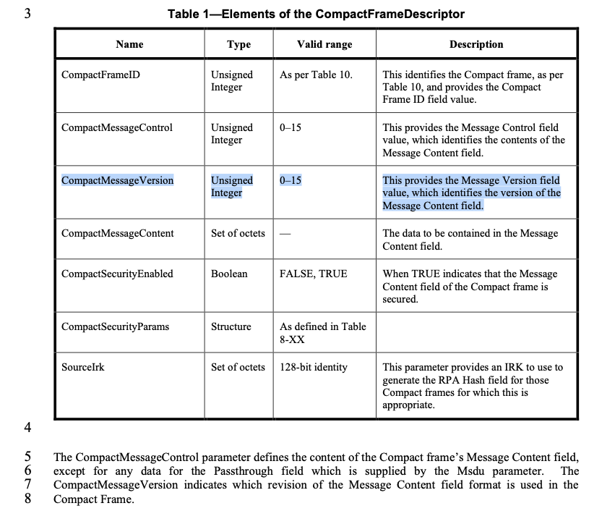

Proposed resolution: Revised.
Disposition detail: Clarification for use of CompactMessageVersion has been accepted for D02 CID 27 in DCN 309.

CID 162 (Revised)

Name | Index # | Page | Sub-clause | Line # | Comment | Proposed Change
MAMAN, MICKAEL | 162 | 66 | 10.39.3.2 | 28 | the field are not always present. Add this condition | line 28 "shall be passed to higher layer if present"

Discussion: Fields may not be present depending on Presence Bitmap indication
Proposed resolution: Revised
Disposition Detail: Instruction to editor: Change paragraphs as follows:

If the initiator intends to proceed to the control phase, the Start of Ranging Compact frame (10.39.11.3.4)
Message Control field (within the Message ID field) shall be set to zero, one or two, with the Startup Status
field set as SUCCESS (as described in Table 25). If a responder receives a Start of Ranging Compact frame
with the Message Control field value (within the Message ID field) of one and the value of the Startup Status
field is set as SUCCESS and if present the values of the NB Channel Map field, Management PHY Configuration field,
Management MAC Configuration field, Ranging PHY Configuration field and MMS Number of Fragments
field shall be passed to the higher layer. If any of the fields is present in both the Advertising Response and
the Start of Ranging packet the latter value shall be passed to the higher layer. Unless further altered by OOB
methods the higher layer is expected to employ the provided ranging configuration values to start the ranging
session.

CID 239 (Accepted)

Name | Index # | Page | Sub-clause | Line # | Comment | Proposed Change
PAKROOH, POORIA | 239 | 100 | 10.39.11.1.3.6 | 19 | This is not an "affine" set, what is the reason for naming this NbChannelAffineSet"? Rename it to NbChannelStepSet or some other name. | Rename all instances of NbChannelAffineSet to NbChannelStepSet or some other name.

Discussion: We had already discussed and agreed on this proposed change a while ago, directly administering it to DCN 174.
Proposed resolution: Accepted
Disposition detail: n/a

CID 581 (Reassign)

Name | Index # | Page | Sub-clause | Line # | Comment | Proposed Change
VERSO, BILLY | 581 | 143 | 10.39.11.3.21 | 10 | All other vendor specific messages within in 802.15.4 are within properly addressed MAC frames. Here there is no addressing so the frames are passed to the upper layer without any notion whether they are for this device or not. If the frames have RPA/HASH they have already passed that part of the MAC where secret keys etc. reside (possibly hidden from the upper layer). Similarly CRC is not part of the definition so if there is one, then the higher layer has to check it separately from any H/W there may have been to do it in the lower MAC. This will make extending the compact messaging scheme less straightforward. Doing this would also facilitate carrying them in the secure compact frame, and it is likely that MAC level security processing will be needed for many vendor specific use cases. | To allow for common MAC processing of the low level parts of the frame, specify RPA HASH and PRAND fields and CRC as fields as part of the Vendor Specific Compact frame format. This would allow the entities using vendor specific format to use same IRK etc in common way.

Discussion: It's a valid point that in case of vendor specific content, unknown to the MAC, the MAC at least should be able to ensure integrity of the content, preferably even be able to drop a frame of which it is not the intended receiver. Note that a solution to this problem had been proposed in DCN 15-25-0027 for D01 comment resolution, but that did not find the appreciation of the commenter. The following options should be considered.
1) 15-25-0027
2) remove vendor specific compact frames (usage would fall back to data frames with VS IE)
3) reassign CID to the commenter and let him make a proposal
On Aug 12 we discussed on revising as suggested by commenter. However, more folks have reached out offline in the meanwhile with concerns on such change would be overly restrictive for vendors, eventually. Since this doesn't appear as a fundamental issue flaw, I'd recommend to table this discussion for the recirc.
Proposed resolution: Withdrawn by commenter.
Disposition detail: n/a

