IEEE P802.15
Wireless Personal Area Networks

Project | IEEE P802.15 Working Group for Wireless Personal Area Networks (WPANs)
Title | Proposed Resolution for CID 121, 227, 628, 629
Date Submitted | July 2025
Sources | Xiliang Luo (Apple)
Re:
Abstract
Purpose | To propose resolutions to comments for “P802.15.4ab™/D02 Draft Standard for Low-Rate Wireless Networks”
Notice | This document does not represent the agreed views of the IEEE 802.15 Working Group or IEEE 802.15.4ab Task Group. It represents only the views of the participants listed in the “Sources” field above. It is offered as a basis for discussion and is not binding on the contributing individuals. The material in this document is subject to change in form and content after further study. The contributors reserve the right to add, amend or withdraw material contained herein.

1 CID #121 (Rejected) 3
2 CID #227 (Revised) 4
3 CID #628 (Revised) 5
4 CID #629 (Accepted) 6

CID #121 (Rejected)
Name | Idx # | Cat. | Pg. | Sub-clause | Line # | Comment | Proposed Change
LEE, JAEGOOK | 121 | Technical | 242 | 16.8.1.2 | 1 | MSR = 256 with #49 MMRS config set (Gap size = 64) , the RSF length is 2051.28 ns * 256 = 525.127 us. The offset of interleaved MMS is 500 us. It means there is a possible setting which a RSF exceeds MMS offset. Even the interval between fragments is 0.33 us for time efficient O2M ranging. | A solution may be necessary for this corner case.
Resolution: Rejected
It is understood that the MMRS configuration sets in Table 85 provide a list of recommended combinations. Different use cases will identify the right configurations to use. In the example provided by the commenter, the Config #49 with the largest gap size does not fit the mentioned use case.

CID #227 (Revised)
Name | Idx # | Cat. | Pg. | Sub-clause | Line # | Comment | Proposed Change
PAKROOH, POORIA | 227 | Technical | 21 | 8.3.2.3 | 9 | What is the reference for the RifMarker startand end time? | In Table 8-28, specify the reference for the RifMarker startand end time
Resolution: Revised
In Table 8-28 in page 21, add the following words in the descriptions of RxRifxMarkerStart and RxRifxMarkerEnd as follows:
“… at the antenna with respect to the reception of the MMS UWB packet.”
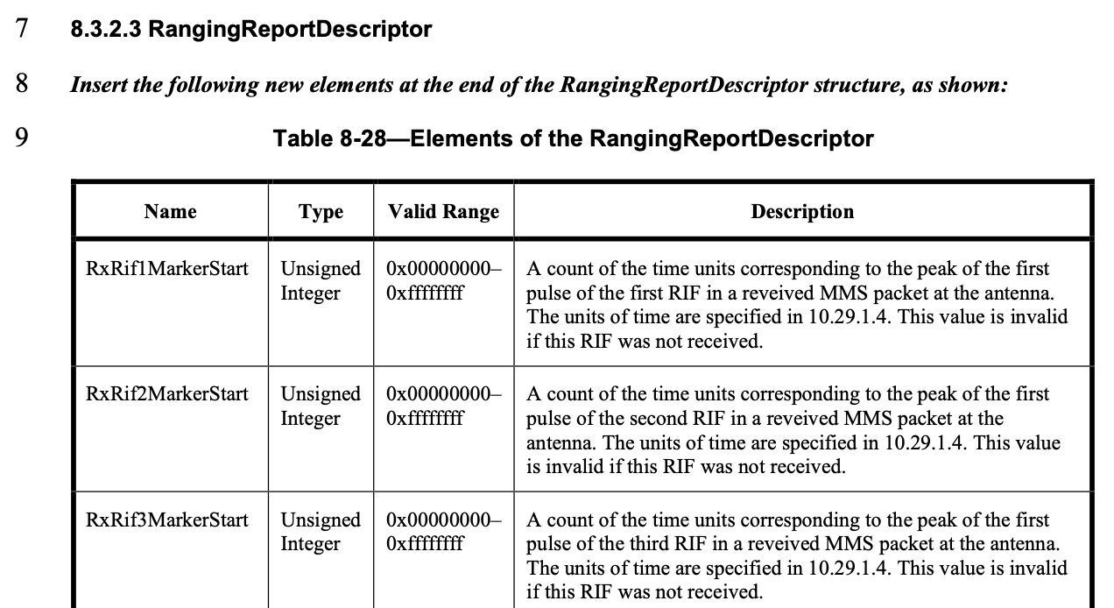

CID #628 (Revised)
Name | Idx # | Cat. | Pg. | Sub-clause | Line # | Comment | Proposed Change
VERSO, BILLY | 628 | Technical | 212 | 13.3.3 | 15 | Clause "13.3.3 Symbol rate" is missing, and needs to be added so that the Base standard Symbol rate clause can be updated to specify the symbol rate(s) for the 5800 MHz and 6200 MHz bands. Also for the NBA use case, the tolerance should be same as UWB (i.e. 20 PPM), rather than the 40PPM specified in the base standard, although this could be stipulated by reference to clause 13.3.14 | Insert Clause 13.3.3 and add text to specify the symbol rate(s) for the 5800 MHz and 6200 MHz bands, and the tolerance needed.
Resolution: Revised
In page 212, before line 15, insert the following paragraphs:
Insert the following at the end of clause 13.3.3:
When operating in the 5800 MHz and 6200 MHz bands, the symbol rates are defined in Table 67 for SHR, PHR, and payload, respectively, and shall have an accuracy of ± 20×10^-6.

CID #629 (Accepted)
Name | Idx # | Cat. | Pg. | Sub-clause | Line # | Comment | Proposed Change
VERSO, BILLY | 629 | Technical | 215 | 16.2.1 | 3 | We have omitted to include a way for the NHL to specify whether the UWB packet has the Dynamic PHR or the basic 4z one. A good way to to do this would be to have a UWB packet configuration specifically selecting the use of the Dynamic PHR in both transmitter and receiver. This only applies to packets without STS and SENS fields, so it is a signle addtional packet type. | Add a line for "DDMP_PACKET" with discription "This selects packet format employing the dynamic data mode PHR described in 16.2.7.4"
Resolution: Accepted

