**IEEE P802.15**

**Wireless Specialty Networks**

|  |  |  |
| --- | --- | --- |
| Project | IEEE P802.15 Working Group for Wireless Specialty Networks (WSNs) | |
| Title | Comment Resolutions – 250, 251, 8 | |
| Date Submitted | July-2025 | |
| Source | Youngwan So (SAMSUNG ELECTRONICS]  [youngwan.so@samsung.com](mailto:youngwan.so@samsung.com) |  |
| Re: | Comments: | |
| Abstract | This document is to suggest changes addressing comments in the title. | |
| Purpose | Resolve comments | |
| Notice | This document has been prepared to assist the IEEE P802.15. It is offered as a basis for discussion and is not binding on the contributing individual(s) or organization(s). The material in this document is subject to change in form and content after further study. The contributor(s) reserve(s) the right to add, amend or withdraw material contained herein. | |
| Release | The contributor acknowledges and accepts that this contribution becomes the property of IEEE and may be made publicly available by P802.15. | |

Revision 0 : Addressing the following CIDs

250, 251, 8

***Comment Indices in 15-25-0174-00-04ab-consolidated-comments-draft-2.0:***

|  |  |  |  |  |  |  |
| --- | --- | --- | --- | --- | --- | --- |
| **Name** | **Index#** | **Pg** | **Sub-Clause** | **line** | **Comment** | **Proposed Change** |
| PAKROOH, POORIA | 250 | 194 | 10.44 | 13 | Not clear why this NB data transmission protocol is needed, given the significantly lower data rate relative to UWB, and also higher fading. If many users start to use this protocol, the congestion can be problematic. This can cause interference to unnecessarily longer range. There is no duty cycle limit specified for this feature and the benefits are not clear.  Remove this functionality, or add a proper mandatory channel access mechanism. | Remove NB data offload by deleting subclause 10.44. Another alternative is to add a proper channel access mechanism for this feature for high duty cycle usage. |
| PAKROOH, POORIA | 251 | 194 | 10.44.1 | 19 | Benefits of NB usage for ranging has been justified. What is the benefit of using two links with significantly different link budget? what is the application? The data communication associated with this application are for close range cases, which does not need NB. | Remove NB data offload by deleting subclause 10.44. |

**Relevant Text :**

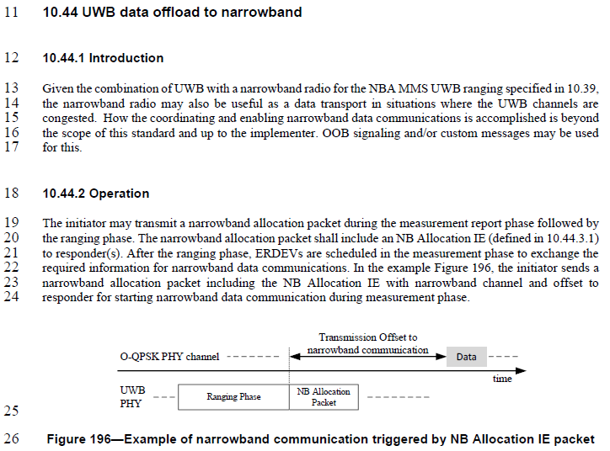

**Disposition Detail :**

It’s true that NB channel provides much lower data rate than that of the UWB channel.

However, what the NB data transmission feature is aiming at is the use case when the multiple devices want to transmit a small data with very low delay through available NB channels, rather than waiting for the scheduled transmission chance having unnecessarily large bandwidth with long delay.

Below is captured from the original author’s contribution:

**[1] 15-23-0243-03-04ab : NB Assisted Data Communications**

<https://mentor.ieee.org/802.15/dcn/23/15-23-0243-03-04ab-nb-assisted-data-communications.pptx>

텍스트, 스크린샷, 폰트, 번호이(가) 표시된 사진

AI 생성 콘텐츠는 정확하지 않을 수 있습니다.

**텍스트, 스크린샷, 폰트, 문서이(가) 표시된 사진

AI 생성 콘텐츠는 정확하지 않을 수 있습니다.**

**[2] 15-23-0243-02-04ab : NB Assisted Data Communications**

<https://mentor.ieee.org/802.15/dcn/23/15-23-0243-02-04ab-nb-assisted-data-communications.pptx>텍스트, 스크린샷, 폰트, 번호이(가) 표시된 사진

AI 생성 콘텐츠는 정확하지 않을 수 있습니다.

텍스트, 스크린샷, 폰트, 도표이(가) 표시된 사진

AI 생성 콘텐츠는 정확하지 않을 수 있습니다.

**Disposition:**

**CID #250 :** Rejected

**CID #251 :** Rejected

**Proposed text changes on P802.15.4ab™/Draft 2.0 :**

No change required

***Comment Indices in 15-25-0174-00-04ab-consolidated-comments-draft-2.0:***

|  |  |  |  |  |  |  |
| --- | --- | --- | --- | --- | --- | --- |
| **Name** | **Index#** | **Pg** | **Sub-Clause** | **line** | **Comment** | **Proposed Change** |
| Aldana, Carlos | 8 | 194 | 10.44.2 | 194 | There is no description on how NB channel access is done. | adopt changes described in document 15-407-07 |

**Relevant Text :**



**Disposition Detail :**

**CID #8**

It is mentioned that “*How the coordinating and enabling narrowband data communications is accomplished is beyond the scope of this standard and is the responsibility of high layer protocols.*”

It means channel access mechanism described in document 15-407-07 can be also adopted and used, but not the only mechanism.

**Disposition:**

**CID #8 :** Rejected

**Proposed text changes on P802.15.4ab™/Draft 2.0 :**

No changes required