IEEE P802.15
Wireless Personal Area Networks

Project | IEEE P802.15 Working Group for Wireless Personal Area Networks (WPANs)
Title | Proposed resolution for MMS ranging procedure with fixed reply time: CIDs 159, 170, 171, 178, 179, 180 and 181
Date Submitted | July 2025
Sources | Mickael Maman (STMicroelectronics)
Re:
Abstract
Purpose | To propose comments resolution for “P802.15.4ab™/D02 C Draft Standard for Low-Rate Wireless Networks”
Notice | This document does not represent the agreed views of the IEEE 802.15 Working Group or IEEE 802.15.4ab Task Group. It represents only the views of the participants listed in the “Sources” field above. It is offered as a basis for discussion and is not binding on the contributing individuals. The material in this document is subject to change in form and content after further study. The contributors reserve the right to add, amend or withdraw material contained herein.

Comment Index #159 in 15-25-0174-09-04ab-consolidated-comments-draft-2-0
Commenter | Index # | page | Sub-Clause | Line | Comment | Proposed Change
MAMAN, MICKAEL | 159 | 64 | 10.39.1 | 17 | The value A in ms is linked to macMmsRcpPollNSlots and macMmsRcpRespNSlots. Missing information about macMmsRangingSlotDuration | add " and macMmsRangingSlotDuration to a value of 600 RSTUs" after both to a value of two.

Discussion of comment ID 159:
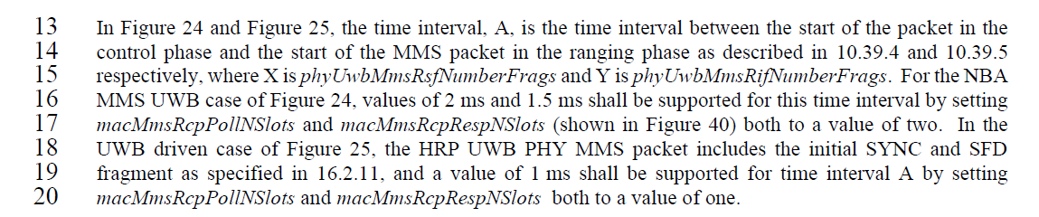
Proposed resolution:
Revised
Proposed text changes on P802.15.4ab™/D02 for comment ID 159:
Change page 64 line 13-20
In Figure 24 and Figure 25, the time interval, A, is the time interval between the start of the packet in the control phase and the start of the MMS packet in the ranging phase as described in 10.39.4 and 10.39.5 respectively, where X is phyUwbMmsRsfNumberFrags and Y is phyUwbMmsRifNumberFrags. This time interval is (macMmsRcpPollNSlots+macMmsRcpRespNSlots)*macMmsRangingSlotDuration and (macMmsRcpRespNSlots +1)*macMmsRangingSlotDuration for the initiator and the responder respectively. For the NBA MMS UWB case of Figure 24, values of 2 ms and 1.5 ms shall be supported for the initiator and responder respectively (macMmsRcpPollNSlots and macMmsRcpRespNSlots both to a value of two and macMmsRangingSlotDuration to a value of 600 RSTUs). In the UWB driven case of Figure 25, the HRP UWB PHY MMS packet includes the initial SYNC and SFD fragment as specified in 16.2.11, and a value of 1 ms shall be supported for time interval A (macMmsRcpPollNSlots and macMmsRcpRespNSlots both to a value of one and macMmsRangingSlotDuration to a value of 600 RSTUs).

Comment Index #170-171-178-179-180-181 in 15-25-0174-09-04ab-consolidated-comments-draft-2-0
Commenter | Index # | page | Sub-Clause | Line | Comment | Proposed Change
MAMAN, MICKAEL | 171 | 80 | 10.39.5 | 19 | Optionally, the responder may start transmitting its HRP UWB PHY MMS packet offset by 600 RSTU from the reception of the first fragment instead of the start into the ranging phase. This new option reduces the energy consumption of the interleaved MMS by avoiding the need to send the report | add text page 81 line 2. "Optionally in the ranging phase, the responder may start transmitting its HRP UWB PHY MMS packet offset by 600 RSTU from the start of the HRP UWB PHY MMS packet received from the initiator.This option is signaled by the MMS_Sync parameter described in 10.38.11.1.3.8". A new bit "MMS_Sync" can be added in Figure 65 to indicate this configuration. A new DCN will be provided and will detail the full changes
MAMAN, MICKAEL | 179 | 94 | 10.39.10.2 | 7 | Optionnally, the MMsRangingRXOnTime can be set 600 RSTU from the Ranging TxTime according to MMS_Sync parameter | Optionnally, the MmsRangingRxOnTime can be set 600 RSTU from the RangingTxTime according to MMS_Sync parameter
MAMAN, MICKAEL | 180 | 94 | 10.39.10.2 | 12 | Optionnally, the RangingTxTime can be set 600 RSTU from the MmsRangingRxOnTime according to MMS_Sync parameter | Optionnally, the RangingTxTime can be set 600 RSTU from the MmsRangingRxOnTime according to MMS_Sync parameter
MAMAN, MICKAEL | 170 | 80 | 10.39.5 | 19 | Optionally the order between the Initiator and the responder can be reversed. Then In the ranging phase, the responder may transmit the HRP UWB PHY MMS packet (described in 16.2.11), and the Initiator may start transmitting its HRP UWB PHY MMS packet offset by 600 RSTU from the start into the ranging phase. | add text page 81 line 2. "Optionally in the ranging phase, the responder may transmit the HRP UWB PHY MMS packet (described in 16.2.11), and the Initiator may start transmitting its HRP UWB PHY MMS packet offset by 600 RSTU from the start into the ranging phase. This option is signaled by the reversed_fragment parameter described in 10.38.11.1.3.8". A new bit "reversed_fragment" can be added in Figure 65 to indicate this configuration. A new DCN will be provided and will detail the full changes
MAMAN, MICKAEL | 178 | 93 | 10.39.10.2 | 23 | The time A can also depend on the MMS order between the initiator and the responder | change to "depending on the slot size, the order and number of slots allocated to the ranging control phase poll and response."
MAMAN, MICKAEL | 181 | 94 | 10.39.10.2 | 15 | The time A can also depend on the MMS order between the initiator and the responder | change to "might be different depending on the slot size, the order and number of slots allocated to this part of the control phase."

Discussion of comment 170-171-178-179-180-181: MMS ranging procedure for SS-TWR with fixed reply time
This CR is an extension of ranging procedure for SS-TWR with fixed reply time to MMS (Section 10.29.6.5 in 802.15.4_2024)
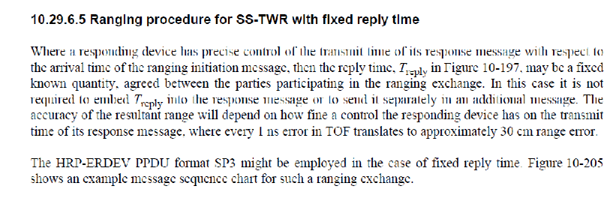
If the responder is able to accurately estimate the arrival time of the MMS UWB packet and to always reply with sufficiently accurate constant or pre-known reply time, it obviates the need for any transfer of the reply time as part of the ranging exchange. The first condition is the responder has precise control of the transmit time of its MMS UWB packet with respect to the arrival time of the MMS UWB packet from the initiator, then the reply time may be a fixed known quantity, agreed between the parties participating in the ranging exchange. The second condition is the accuracy of the arrival time estimation.
This new option reduces the energy consumption of the MMS ranging as it is not required to embed Treply into the report compact frame. The accuracy of the resultant range will depend on how accurate the estimation of the arrival time is and how fine a control the responding device has on the transmit time of its MMS message, where every 1 ns error in TOF translates to approximately 30 cm range error.
To allow a measurement of the ToF by the responder without a report compact frame in the MMS ranging procedure for SS-TWR with fixed reply time, it is interesting to reverse the order of the MMS UWB packet transmission of the initiator and the responder.

Proposed resolution:
revised
Proposed text changes on P802.15.4ab™/D02 for comment ID 170-171-178-179-180-181:
Change in Table 8-29 p24. Add a new element of TxOptions.
Name | Type | Valid Range | Description
MmsFixedReplyTimeEnable | Boolean | TRUE, FALSE | For MMS UWB ranging, this parameter is set TRUE if the transmission of the MMS UWB packet is offset from the reception of the MMS UWB packet, or FALSE otherwise.

Add page 26 line 33
The MmsFixedReplyTimeEnable parameter of TxOptions applies to UWB multi-millisecond (MMS) packet transmissions. When MmsFixedReplyTimeEnable is the transmission of MMS UWB packetis offset by a fixed reply time from the reception of the initiator's MMS UWB packet. By default, MmsFixedReplyTimeEnable is FALSE. The fixed reply time may be a fixed known quantity, agreed between the parties participating in the ranging exchange.

Add page 81 line 2
The MMS ranging procedure may be adapted for SS-TWR with fixed reply time. If the responder is able to accurately estimate the arrival time of the MMS UWB packet and to always reply with sufficiently accurate constant or pre-known reply time, it obviates the need for any transfer of the reply time as part of the ranging exchange. In the ranging phase, the responder may start transmitting its HRP UWB PHY MMS packet offset by a fixed reply time from the start of the HRP UWB PHY MMS packet received from the initiator. This option is signaled by the MMS Fixed Reply Time parameter described in 10.39.11.1.3.8. The accuracy of the resultant range will depend on how accurate the estimation of the arrival time is and how fine a control the responding device has on the transmit time of its MMS message, where every 1 ns error in TOF translates to approximately 30 cm range error.
Optionally in the ranging phase, by combining macMmsFixedReplyTimeEnable and macMmsReversedOrder, the responder may transmit the HRP UWB PHY MMS packet (described in 16.2.11), and the Initiator may start transmitting its HRP UWB PHY MMS packet offset by a fixed reply time from the start of the HRP UWB PHY MMS packet received from the responder. This option is signaled by the reversed MMS Order parameter described in 10.39.11.1.3.8.

Modify page 103 paragraph 10.39.11.1.3.8
10.39.11.1.3.8 The MMS Number of Fragments Configuration field
This is a one-octet field formatted as shown in Figure 65.
Bits: 0–2 | 3–5 | 6–7 | 7
Number of RSF | Number of RIF | MMS Fixed Reply Time | Reversed MMS order

The MMS Fixed Reply Time field specifies if the responder may start transmitting its HRP UWB PHY MMS packet offset by a fixed reply time from the reception of the HRP UWB PHY MMS packet from the initiator instead of the start into the ranging phase. By default, the MMS Fixed Reply Time is FALSE.
The Reversed MMS Order field specifies if the order of the transmissions of the MMS UWB packet of the Initiator and the responder is reversed. When TRUE, in the ranging phase, the responder may transmit the HRP UWB PHY MMS packet (described in 16.2.11), and the Initiator may start transmitting its HRP UWB PHY MMS packet offset by 600 RSTU from the start into the ranging phase.

Add page 123 line 2 paragraph 10.39.11.3.7
When the Message Control field value is two (i.e. Reversed MMS), the Message Content field shall be formatted as shown in Figure XX.
Octets: 5 | 0/variable
Reply Time | Passthrough
Figure XX—Format of the Message Content field in the One-to-one Initiator Report Compact frame when the Message Control field value is two
The Reply Time field value is an unsigned integer that reports the time difference, measured at the initiator, between the RMARKER of the MMS fragments received from the responder and the RMARKER of the MMS fragments transmitted by the initiator in the reversed mode. The units of time are specified in 10.29.1.4.
The Passthrough field content is defined in 10.39.11.1.3.3. Its presence can be inferred from the frame length.
Add page 124 line 23 paragraph 10.39.11.3.8
When the Message Control field value is three (i.e. Reversed MMS), the Message Content field shall be formatted as shown in Figure XX.
Octets: 5 | 0/variable
Round-trip Time | Passthrough
Figure 94—Format of the Message Content field in the One-to-one Responder Report Compact frame when the Message Control field value is three
The Round-trip Time field value is an unsigned integer that reports the time difference, measured at the responder, between the RMARKER of the MMS fragments transmitted by the responder and the RMARKER of the MMS fragments received from the initiator in the reversed mode. The units of time are specified in 10.29.1.4.
The Passthrough field content is defined in 10.39.11.1.3.3. Its presence can be inferred from the frame length.
Add page 146 in Table 31
Attribute | Type | Range | Description | Default
macMmsFixedReplyTimeEnable | Boolean | TRUE-FALSE | Reception of the MMS UWB packet of the initiator and transmission of the MMS fragments of the responder are offset by a fixed reply time. | FALSE
macMmsReversedOrder | Boolean | TRUE-FALSE | The order between the Initiator and the responder. TRUE is reversed. | FALSE

