**IEEE P802.15**

**Wireless Personal Area Networks**

|  |  |
| --- | --- |
| Project | IEEE P802.15 Working Group for Wireless Personal Area Networks (WPANs) |
| Title | **LB213/D02 comment resolution -- CID 545** |
| Date Submitted | July, 2025 |
| Sources | Hong Won Lee (LG Electronics)  [hongwon.lee@lge.com](mailto:hongwon.lee@lge.com) |
| Re: |  |
| Abstract |  |
| Purpose | To propose resolution for MMS related comments for “P802.15.4ab™/D02 Draft Standard for Low-Rate Wireless Networks”. |
| Notice | This document does not represent the agreed views of the IEEE 802.15 Working Group or IEEE 802.15.4ab Task Group. It represents only the views of the participants listed in the “Sources” field above.It is offered as a basis for discussion and is not binding on the contributing individuals. The material in this document is subject to change in form and content after further study. The contributors reserve the right to add, amend or withdraw material contained herein. |

# CID 545

|  |  |  |  |  |  |  |
| --- | --- | --- | --- | --- | --- | --- |
| **Name** | **Index #** | **Page** | **Sub-clause** | **Line #** | **Comment** | **Proposed Change** |
| VERSO, BILLY | 545 | 114 | 10.39.11.3.3 | 13 | I think we could say here that this as an RPA HASH, rather than above on line 2. (And do the same on line 25 too). | On lines 13 and 24, change the phrase "identifies the address of a responder" to "is an RPA Hash field value generated using the RPA Prand field value from the initiator's Advertising Poll Compact frame and the IRK of the responder". And remove the sentence from line 2. |

**Discussion:**

Agree with the commenter in principle, and additional change is needed because if the proposed changes are applied to the draft, the Responder Address in the Public Advertising Confirmation Compact Frame will be affected. Therefore, additional description should be added in the Public Advertising Confirmation Compact Frame subclause

**Disposition: Revised**

**Disposition Detail:**

**Proposed text changes on P802.15.4ab™/D02:**

**- Original Text**

**10.39.11.3.3 Advertising Confirmation Compact frame**

….

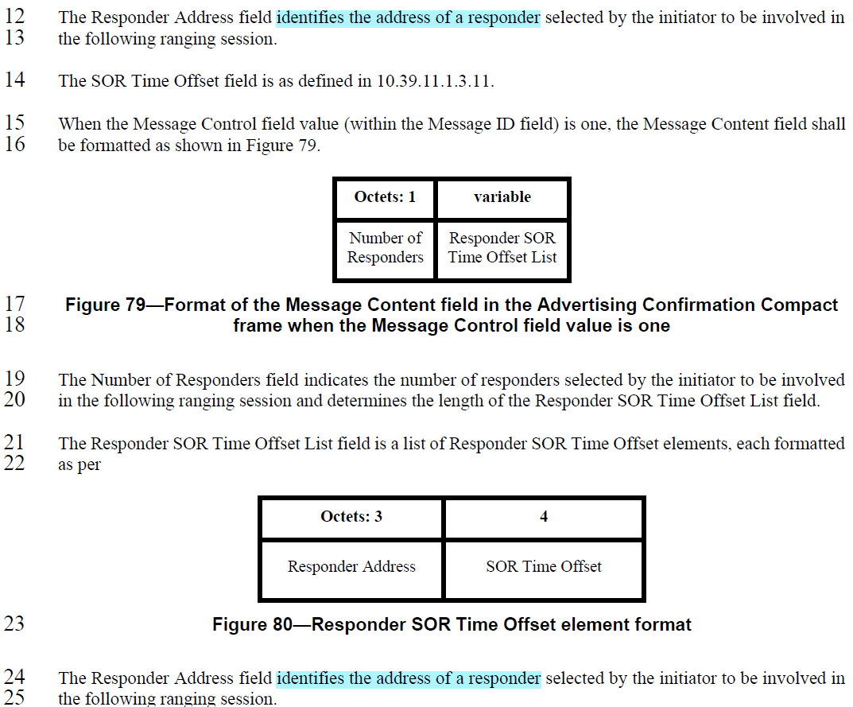

**10.39.11.3.16 Public Advertising Confirmation Compact frame**

….

텍스트, 스크린샷, 폰트, 번호이(가) 표시된 사진

AI 생성 콘텐츠는 정확하지 않을 수 있습니다.

**- Proposed change**

**(*pp. 114 line #12*)**

The Responder Address field is an RPA Hash field value generated using the RPA Prand field value from the initiator's Advertising Poll Compact frame and the IRK of the responder selected by the initiator to be involved in the following ranging session.

**(*pp. 114 line #24*)**

The Responder Address field is an RPA Hash field value generated using the RPA Prand field value from the initiator's Advertising Poll Compact frame and the IRK of the responder selected by the initiator to be involved in the following ranging session.

**(*pp. 138 line #7*)**

When the Message Control field value (within the Message ID field) is zero the Message Content is formatted the same as for the Advertising Confirmation Compact frame Message Content field with Message Control field value of zero, as shown in Figure 78, with the same function and meaning except for the Responder Address field. The Responder Address field identifies the public address of a responder selected by the initiator to be involved in the following ranging session.

**(*pp. 138 line #10*)**

When the Message Control field value (within the Message ID field) is one the Message Content is formatted the same as for the Advertising Response Compact frame Message Content field with Message Control field value of one, as shown in Figure 79, with the same function and meaning for each of the fields except for the Responder Address field. The Responder Address field identifies the public address of a responder selected by the initiator to be involved in the following ranging session.