**IEEE P802.15**

**Wireless Specialty Networks**

|  |  |  |
| --- | --- | --- |
| Project | IEEE P802.15 Working Group for Wireless Specialty Networks (WSNs) | |
| Title | Comment Resolutions –176, 177, 238 | |
| Date Submitted | July-2025 | |
| Source | Youngwan So (SAMSUNG ELECTRONICS]  [youngwan.so@samsung.com](mailto:youngwan.so@samsung.com) |  |
| Re: | Comments: | |
| Abstract | This document is to suggest changes addressing CIDs in the title. | |
| Purpose | Resolve comments | |
| Notice | This document has been prepared to assist the IEEE P802.15. It is offered as a basis for discussion and is not binding on the contributing individual(s) or organization(s). The material in this document is subject to change in form and content after further study. The contributor(s) reserve(s) the right to add, amend or withdraw material contained herein. | |
| Release | The contributor acknowledges and accepts that this contribution becomes the property of IEEE and may be made publicly available by P802.15. | |

Revision 0 : Addressing the following CIDs

176, 177, 238

***Comment Indices in 15-25-0174-00-04ab-consolidated-comments-draft-2.0:***

|  |  |  |  |  |  |  |
| --- | --- | --- | --- | --- | --- | --- |
| **Name** | **Index#** | **Pg** | **Sub-Clause** | **line** | **Comment** | **Proposed Change** |
| PAKROOH, POORIA | 238 | 88 | 10.39.9.4 | 20 | Several drawbacks for this "multiple RSF" mode.  1. If multiple responders are at different ranges, which is a common case in ranging, it becomes almost impossible to retrieve the signal from the farther responder, as it could be burried under the cross-correlation sidelobe of the closer responder. In such scenarios, the time efficient one to many can be employed insted of multi transmission per slot.  2. Also, the initiator needs to do multiple corss correlation to separate signals from different responders, elading to undesired complexity incraese. | Remove the "multiple RSF transmissions per slot" feature/functionality. Specifically remove subclause 10.39.9.4. |

**Relevant Text :**



**Disposition Detail :**

The ‘multiple RSF transmission per slot’ feature is additional on top of other existing features, and optional. As the comment suggested, time efficient one-to-many or multiple transmission with time offset feature can be possible alternative candidate.

However, the ‘multiple RSF transmission per slot’ feature can provide more available option.

It may be difficult to retrieve the signal from the farther responder in cases comment said. However, the scheduling method trying to avoid concurrent transmissions from the responders having far distance gaps to initiator can make them have similar received signal strength level, and then it will get more easy to retrieve. We’re not saying this is always easy to implement, but we’d like to say it will not be always impossible, either, considering environment with appropriate scheduling.

**Disposition :** Rejected

**Proposed text changes on P802.15.4ab™/Draft 2.0 :**

No changes required

***Comment Indices in 15-25-0174-00-04ab-consolidated-comments-draft-2.0:***

|  |  |  |  |  |  |  |
| --- | --- | --- | --- | --- | --- | --- |
| **Name** | **Index#** | **Pg** | **Sub-Clause** | **line** | **Comment** | **Proposed Change** |
| MAMAN, MICKAEL | 176 | 89 | 10.39.8.4.3 | 3 | The procedure for multiple RSF transmissions in a slot is divided into three phases, the control phase, the ranging phase, and the measurement report phase. However in Figure 53 there is several Ranging phases and report phases | please clarify. Two options i) change "divided into three phases" by "composed of three different three phases ii) change Figure 53 |

**Relevant Text :**



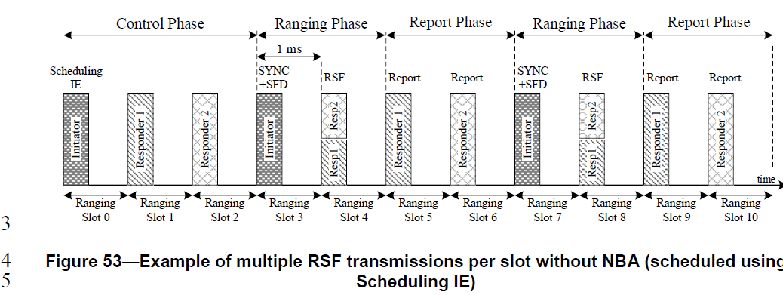

**Disposition Detail :**

The comment makes sense. The Figure 53 has several Ranging phases and Report phases as comment says. The ranging and reporting shown at the end of the timing diagram (from slot #7 to slot #10) are just illustrative and can be omitted to avoid confusion. So the Figure 53 is changed as below.

And irrelevant with the comment, the sentence in P89L5 looks to finish as incomplete, so copied the corresponding text from D1.0.

Based on this, the following changes are suggested.

**Disposition:** Revised

**Proposed text changes on P802.15.4ab™/Draft 2.0 :**

|  |
| --- |
| ***Change 10.39.9.4.2 P89L3 as below ;***  3 The procedure for multiple RSF transmissions in a slot is composed of three different three phases, the control phase, the  4 ranging phase, and the measurement report phase. In the ranging phase, RSF transmissions are scheduled to  5 have the RSF transmission timing of each responder. In the control phase, the initiator sends a poll  Compact frame to trigger RSF transmission in the ranging phase. After that, in the ranging phase multiple  RSF transmissions occur from the responders to the initiator in the slot. The measurement report phase delivers ranging results from the responders to the initiator. Responders may send Ranging report Compact  frames to the initiator, or the initiator can send reports to the responders to conduct this phase.  ***Change 10.39.9.4.3 Figure53 as below ;*** |

***Comment Indices in 15-25-0174-00-04ab-consolidated-comments-draft-2.0:***

|  |  |  |  |  |  |  |
| --- | --- | --- | --- | --- | --- | --- |
| **Name** | **Index#** | **Pg** | **Sub-Clause** | **line** | **Comment** | **Proposed Change** |
| MAMAN, MICKAEL | 177 | 89 | 10.39.8.4.3 | 24 | In this case the SYNC+SFD is sent only by the initiator. The responder does not follow figure 205. | two options: add SYNC SFD for responder or delete this sentence. |

**Relevant Text :**



**Disposition Detail :**

Agree with the comment. Deleted a relevant sentence.

**Disposition:** Revised

**Proposed text changes on P802.15.4ab™/Draft 2.0 :**

|  |
| --- |
| ***Change 10.39.9.4.3 P89L24 as below ;***  24 In the ranging slot 3, the initiator transmits the  26 SYNC+SFD fragment to trigger multiple RSF transmissions as in 10.39.9.4.4. If the responder receives the  27 SYNC+SFD fragment of the initiator, the responders reply with RSF as allocated by the One-to-many Poll  28 Compact frame (10.39.11.3.9) or the Scheduling IE (10.32.9.10) in the control phase, with the constraint that  29 the time interval between the start of the packet in the control phase and the start of the MMS UWB packet  30 in the ranging phase is one millisecond. |