**IEEE P802.15**

**Wireless Personal Area Networks**

|  |  |  |
| --- | --- | --- |
| Project | IEEE P802.15 Working Group for Wireless Personal Area Networks (WPANs) | |
| Title | **Proposed Resolution for Pulse shape of the NB** | |
| Date Submitted | July 2025 | |
| Sources | Wenzheng Li; Qinying Zhou;(Calterah Semiconductor)  [wenzheng.li@calterah.com](mailto:wenzheng.li@calterah.com); [qinying.zhou@calterah.com](mailto:qinying.zhou@calterah.com) |  |
| Re: |  | |
| Abstract |  | |
| Purpose | To propose resolution for “P802.15.4ab™/D02 Draft Standard for Low-Rate Wireless Networks” . | |
| Notice | This document does not represent the agreed views of the IEEE 802.15 Working Group or IEEE 802.15.4ab Task Group. It represents only the views of the participants listed in the “Sources” field above.It is offered as a basis for discussion and is not binding on the contributing individuals. The material in this document is subject to change in form and content after further study. The contributors reserve the right to add, amend or withdraw material contained herein. | |

Rev 0: Initial version.

**Discussion**：

In the current 802.1.5.4 specification, clause 12.2.7, there is the pulse shape definition for the O-QPSK PHY, however it is not defined for narrow band, which runs on the 5.8GHz and 6.2GHz.

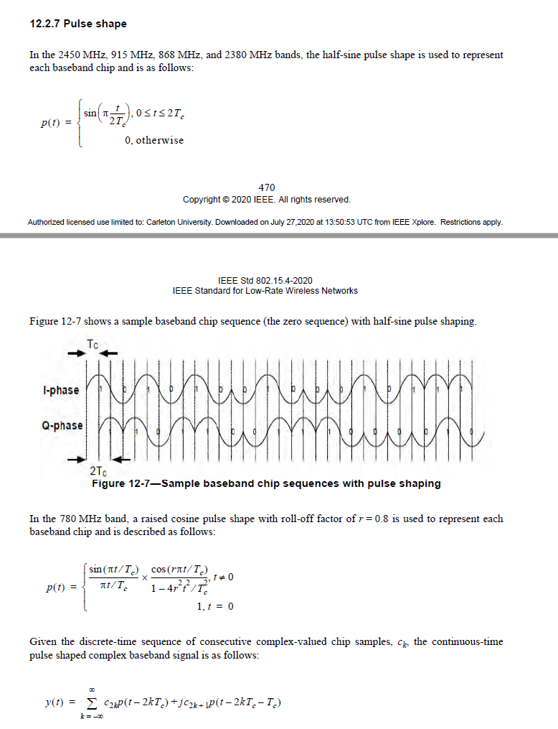

For the two pulse shapes defined for O-QPSK PHY

|  |  |  |
| --- | --- | --- |
| **Items** | **Half‑sine pulse** | **Raised‑cosine pulse** |
| Complexity | Low(simple LUT or 1‑pole IIR) | High(≥ 8‑tap FIR or RRC pair) |
| Power Consumption | High | Low |
| Spectral roll-off | Side-lobes= ‑13dB | Side‑lobes < ‑35dB, |

UWB is expected as an economical and low power consumption technology, which is also applicable for the narrow band. And since narrow band runs in the UNII-3/UNII-5, which does not impose strict ACLR requirement. So, half-sine pulse is recommended to be used for narrow band.

**Disposition: Revised**

**Disposition Detail:**

**Proposed text changes on P802.15.4ab™/D02**

**13.2.7 Pulse shape**

In the 2450 MHz, 915 MHz, 868 MHz, 2380 MHz, 5800MHz, and 6200MHz bands, the half-sine pulse shape is used to represent

each baseband chip and is as follows:

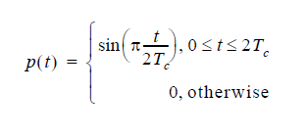

Figure 12-7 shows a sample baseband chip sequence (the zero sequence) with half-sine pulse shaping.

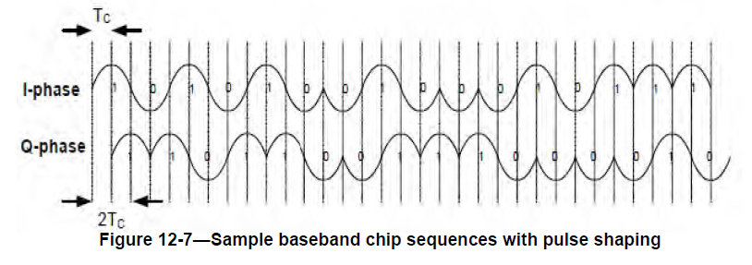

In the 780 MHz band, a raised cosine pulse shape with roll-off factor of *r* = 0.8 is used to represent each

baseband chip and is described as follows:

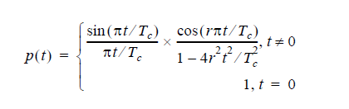

Given the discrete-time sequence of consecutive complex-valued chip samples, *ck*, the continuous-time

pulse shaped complex baseband signal is as follows:

