**IEEE P802.15**

**Wireless Personal Area Networks**

|  |  |  |
| --- | --- | --- |
| Project | IEEE P802.15 Working Group for Wireless Personal Area Networks (WPANs) | |
| Title | **Proposed Resolution for Multiple advertising NB channels for MMS initialization** | |
| Date Submitted | July 2025 | |
| Sources | Wenzheng Li (Calterah Semiconductor)  [wenzheng.li@calterah.com](mailto:wenzheng.li@calterah.com); |  |
| Re: |  | |
| Abstract |  | |
| Purpose | To propose resolution for “P802.15.4ab™/D02 Draft Standard for Low-Rate Wireless Networks” . | |
| Notice | This document does not represent the agreed views of the IEEE 802.15 Working Group or IEEE 802.15.4ab Task Group. It represents only the views of the participants listed in the “Sources” field above.It is offered as a basis for discussion and is not binding on the contributing individuals. The material in this document is subject to change in form and content after further study. The contributors reserve the right to add, amend or withdraw material contained herein. | |

Rev 0: Initial version.

**Discussion**：

**Back ground:**

According to the current IEEE 802.15.4ab D02, in prior to MMS initialization and setup phase, the NB initialization channel and the modulation configuration are selected by macMmsNbInitChannel and macMmsNbInitMode attributes.

However, only one value can be configured for the macMmsNbInitChannel and macMmsNbInitMode, which may lead to the NB channel congestion/conflictions in the case that multiple UWB devices attempt to employ the same NB channel for MMS initialization simultaneously.

In case of complicated MMS ranging environment, based on the analysis of contribution: xxxxxxxxxxxxx, simply configure multiple NB initialization channels for each initiator and responder(s) can benefit the randomness of NB initialization channel occupation, thus relieve the possible congestion and conflictions of the NB initialization channel

This contribution aims to configure multiple NB initialization channels for both initiator and responder(s) engaged in the MMS.

**Proposed solution:**

Amendment 1:

Multiple NB Initialization Channels can be configured for each MMS initialization:

* macMmsNbInitChannelList: extend to an array of NB channels
* macMmsNbInitMode: retain one modulation mode for all NB channels in the macMmsNbInitChannelList

Amendment 2:

Initiator randomly selects one of the NB channels in the macMmsNbInitChannelList and corresponding modulation mode in macMmsNbInitMode to start MMS initialization

Amendment 3:

Responder scan all NB channels in the macMmsNbInitChannelList to capture the ADV POLL and response ADV RESP POLL in the same NB channel;

Amendment 4:

All the following MMS Initialization procedure is carried on this NB channel until responder need to capture the ADV POLL again

**Disposition: Revised**

**Disposition Detail:**

**Proposed text changes on P802.15.4ab™/D02**

**10.39.3.1 Overview**

An MMS UWB ranging session is configured by a set of parameters for PHY and MAC. The set of PHY parameters include as appropriate PHY configuration of channels, modulation, and data rate to be used for control, ranging, and report phases. The MAC parameters include the slot, round, and block configuration for control, ranging, and report phases.

To start an MMS UWB ranging session, initiator and responder devices may engage in an initialization and setup phase to negotiate a ranging configuration different from the default set of parameters. Configuration attributes as given in Table 31, including initialization channel list selected by the macMmsNbInitChannelList attribute and the modulation selected by the macMmsNbInitMode attribute, are set by the higher layer prior to the initialization and setup phase.

**10.39.3.2 Session initialization**

Before entering the control phase, devices may engage in an initialization and setup stage. The initialization and setup stage provides time synchronization of the first poll packet transmitted by the initiator during an upcoming control phase, e.g., as shown in Figure 27. Furthermore, the ranging session configuration may be altered by a two-way handshake packet exchange between devices. Unless renegotiated during initialization and setup or via OOB methods, the default ranging configuration parameters are used for the ranging session.

To begin narrowband O-QPSK initialization, devices should transmit and receive on the dedicated initialization channel using the PHY modulation, as specified in the default ranging session configuration (as described in Table 31) or as configured prior to initialization via higher layer protocols. If more than one NB channels are included in the macMmsNbInitChannelList attribute, the initiator shall randomly select one dedicated NB channel as the initialization channel which is included in the macMmsNbInitChannelList attribute. The initiator may send Advertising Poll Compact frames at times and intervals at its discretion as deemed suitable for the higher layer functionality to be supported. Similarly, the responder should listen for incoming Advertising Poll Compact frames.

The initiator’s transmission of an advertising message, (e.g., an Advertising Poll Compact frame), on the initialization channel defines a grid of initialization slots, each starting at integer multiples of macMmsNbInitSlotDuration after the start of the advertising message. Once the initiator has sent an advertising message, the initiator shall listen for an incoming advertising response in the initialization slot directly following the Advertising Poll Compact frame.

If more than one NB channels are included in the macMmsNbInitChannelList attribute, in order to capture the Advertising Poll Compact frame on the initialization channel, the responder shall scan all NB channels which are included in the macMmsNbInitChannelList attribute. Once a responder has received an Advertising Poll Compact frame on the initialization channel, it may transmit the Advertising Response Compact frame in the subsequent initialization slot on the initialization channel. The responder shall deem this channel as the initialization channel until it tries to capture the new Advertising Poll Compact frame on the different NB channels.

If the initiator intends to proceed to the control phase, the Start of Ranging Compact frame (10.39.11.3.4) Message Control field (within the Message ID field) shall be set to zero, one or two, with the Startup Status field set as SUCCESS (as described in Table 25). If a responder receives a Start of Ranging Compact frame with the Message Control field value (within the Message ID field) of one and the value of the Startup Status field is set as SUCCESS and the values of the NB Channel Map field, Management PHY Configuration field, Management MAC Configuration field, Ranging PHY Configuration field and MMS Number of Fragments field shall be passed to the higher layer. If any of the fields is present in both the Advertising Response and the Start of Ranging packet the latter value shall be passed to the higher layer. Unless further altered by OOB methods the higher layer is expected to employ the provided ranging configuration values to start the ranging session.

Otherwise, if the initiator does not intend to proceed to the control phase, the Message Control field (within the Message ID field) of the Start of Ranging Compact frame shall be set to one, and the value of the Startup Status field set as one of the non-reserved entries in Table 25 other than SUCCESS. If a responder receives a Start of Ranging Compact frame with the Message Control field equal to one and the value of the Startup Status field is one of the non-reserved entries in Table 25 other than SUCCESS, the responder’s action is as follows:

* If the value of the Startup Status field is INVALID_PARAMETERS, the responder may reattempt the session initialization with a different set of parameters by listening for another Advertising Poll Compact frame.
* If the value of the Startup Status field is CAPABILITY_NOT_SUPPORTED, the responder shall discontinue session initialization.
* If the value of the Startup Status field is CONFIG_REJECTED, the responder may reattempt the session initialization with the initiator suggested configuration, however if the suggested configuration is not supported by the responder then the responder shall discontinue session initialization.
* If the value of the Startup Status field is FAILURE, the responder may reattempt the session initialization by listening for another Advertising Poll Compact frame. .

When the responder has transmitted the Advertising Response Compact frame, it shall listen for a Start of Ranging Compact frame in the subsequent slot. If the initiator receives an Advertising Response Compact frame, it may transmit a Start of Ranging Compact frame in the subsequent slot. Otherwise, the initiator may reattempt initialization and setup by continuing to send Advertising Poll Compact frames.

After transmitting the Start of Ranging Compact frame with the Message Control field (within the Message ID field) equal to zero or one with the Startup Status field set as SUCCESS as described in Table 25, or a Public Start of Ranging Compact frame with the Message Control field equal to zero, the initiator shall enter the control phase at the time it has indicated in the Start of Ranging Compact frame. After the initiator has confirmed receipt of the expected response from the responder during control phase, and unless initialization of further devices is required, the initiator shall discontinue ranging initialization and cease transmission of Advertising Poll Compact frames.

A successful initialization process when coordination is not active is illustrated in Figure 27.

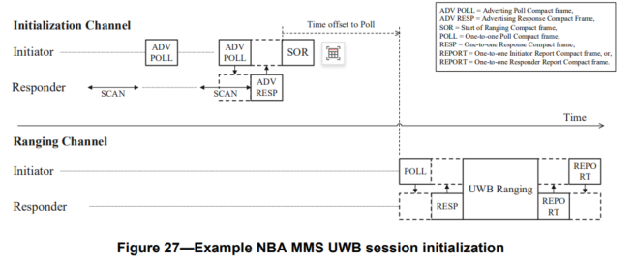

If coordination is active, the initiator determines the configuration for the ranging session based on knowledge of UWB channel usage learned from Acquisition Compact frames received from other initiators as described in 10.39.3.3 transmitting the Start of Ranging Compact frame.

The advertising poll, advertising response, advertising confirmation and start of ranging frames are part of the initialization phase. To perform scanning for coordination and defer the transmission of the Start of Ranging Compact frame, the initiator sends an Advertising Confirmation Compact frame in the slot subsequent to receiving the Advertising Response Compact frame. The Advertising Confirmation Compact frame includes the time offset between the first symbol of the Advertising Confirmation Compact frame and the first symbol of the Start of Ranging Compact frame.

The process of the initiator after receiving Advertising Confirmation Compact frame is the same irrespective of whether coordination is active or inactive.

A successful initialization process when coordination is active is illustrated in Figure 28.

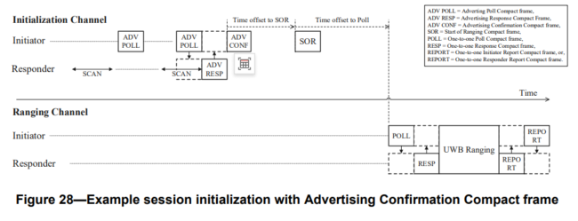

Figure 29 shows the message sequence chart for the initialization handshake for one-to-one ranging with coordination, and with Advertising Confirmation Compact frame, as illustrated in Figure 28. The responder periodically enables the receiver to scan for Advertising Poll Compact frame from the initiator. The initiator periodically sends the Advertising Poll Compact frame and then enables its receiver to look for the Advertising Response Compact frame from the responder. When this is received the initiator proceeds to send the Advertising Confirm Compact frame and later the Start of Ranging Compact frame, and then both sides update their long-term operating parameters and proceed to the ranging phase.

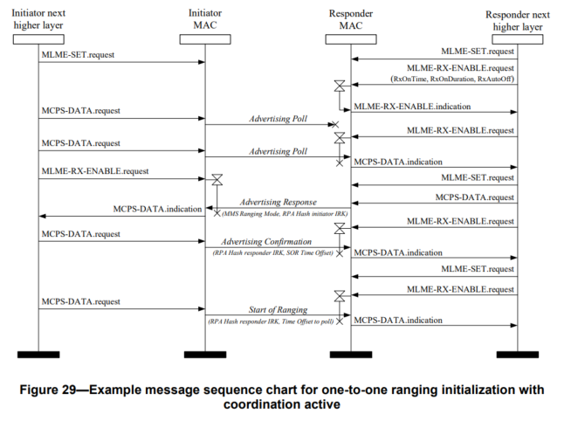

**10.39.3.4 Initialization configuration**

The channel list used for transmissions during the initialization phase is macMmsNbInitChannelList.

The macMmsNbInitSlotDuration attribute specifies the initialization slot duration. The value might be changed by the next higher layer prior to use or via the messages exchanged on the initialization channel, i.e., Advertising Poll Compact frame or Public Advertising Poll Compact frame.

**10.39.11.3.13 Public Advertising Poll Compact frame**

The Public Advertising Poll Compact frame is transmitted by the initiator during the initialization phase. The Compact Frame Content field of the Public Advertising Poll Compact frame shall be formatted as shown in Figure 123.

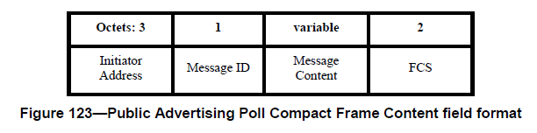

The Initiator Address field shall be set as specified in 10.39.11.1.2.2.

The Message Control field value (within the Message ID field) shall be either: zero or one. This value determines the formatting of the Message Content field.

When the Message Control field value (within the Message ID field) is zero, the Message Content field is empty, i.e., has zero length.

When the Message Control field value (within the Message ID field) is one, the Message Content field shall be formatted as shown in Figure 124.

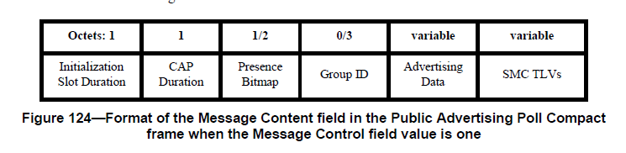

The Initialization Slot Duration field is an unsigned integer that specifies the duration of an initialization slot. The duration in RSTU is given by the expression: 600 + 300 × N, where N is the Initialization Slot Duration field value.

The CAP Duration field is an unsigned integer that specifies the duration of the contention access period in units of initialization slots.

The Presence Bitmap is set as specified in specified in 10.39.11.1.3.14, except that the fields other than the SMC TLVs Present field, the Group ID Present field and the Extended Presence Bitmap Present field shall be set to zero.

The Group ID field is the ID of a group of multiple responders in a one-to-many ranging session, as described in 10.39.3.7.

The Advertising Data field is a variable length field of data used by the higher application layer. It is formatted as shown in Figure 125.

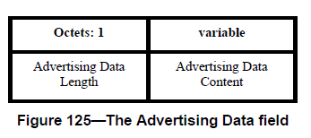

The Advertising Data Length field value indicates the number of octets contained in the Advertising Data Content field.

The Advertising Data Content field contains a variable length string of data determined by the initiator’s higher application layer. For example, this field may contain advertisement information which an initiator announces, such as service representation, friendly name, vendor-specific information and so on. The default values of macMmsNbInitChannelList and macMmsNbInitSlotDuration should be used if the Public Advertising Poll Compact frame includes the Advertising Data field.

The SMC TLVs field is a sequence of structures which shall have Type, Length and Value (TLV). It is the list of supported messages control commands.

The SMC TLVs field is the list of supported message control commands as defined in 10.39.11.1.3.2. This is used by the initiator to signal to responders which compact frames and which message control values it supports. The length of the SMC TLVs field can be inferred from the frame length.

**10.39.12 MAC constants and PIB attributes for MMS operation**

MMS operation specific MAC constants are defined in Table 30, and MMS operation specific MAC PIB attributes are defined in Table 31**.**

**Table 30—MMS related MAC constants**

|  |  |  |
| --- | --- | --- |
| **Attribute** | **Description** | **Value** |
| *aOqpsk5g8AquisitionChan* | The O-QPSK PHY 5800 MHz band channel number to use for NB Acquisition Compact frames. | 2 |
| *aHrpUwbAquisitionChan* | The HRP UWB PHY channel number to use for UWB Acquisition Compact frames | 9 |

**Table 31—MMS related MAC PIB attributes**

|  |  |  |  |  |
| --- | --- | --- | --- | --- |
| **Attribute** | **Type** | **Range** | **Description** | **Default** |
| *macIrkDescriptor* | Structure as defined by Table 32 | - | This structure holds IRK values for Compact frames. | empty |

|  |  |  |  |  |
| --- | --- | --- | --- | --- |
| **Attribute** | **Type** | **Range** | **Description** | **Default** |
| *macMmsNbChannelAllowList* | Array of integers | - | List of channels enabled for channel switching. The value of this attribute can be constructed from the NB Full Channel Map field value, the NB Lower Channel Map field value, or NB Higher Channel Map field value. | Channels 0 to 249 allowed. |
| *macMmsPrngSeed* | Integer | 0–255 | Seed value for the channel switching function | 0 |
| *macMmsControlPhaseMode* | Integer | 1–8, 14, 15 | Modulation for the MMS control phase. The values are defined in Table 20. | 1 |
| *macMmsReportPhaseMode* | Integer | 1–8, 14, 15 | Modulation for the MMS report phase. The values are defined in Table 20. | 1 |
| *macMmsRcpPollNSlots* | Integer | 1–15 | Number of ranging slots allocated to the Control Phase Poll message | 2 |
| *macMmsRcpRespNSlots* | Integer | 1–15 | Number of ranging slots allocated to the Control Phase Response message | 2 |
| *macMmsRpDuration* | Integer | 1–4095 | Number of ranging slots in the ranging phase. | 20 |
| *macMms1stReportNSlots* | Integer | 0–15 | Number of slots for 1st report period | 2 |
| *macMms2ndReportNSlots* | Integer | 0–15 | Number of slots for 2nd report period | 2 |
| *macMms3rdReportNSlots* | Integer | 0–15 | Number of slots for 3rd report period | 2 |
| *macMmsNonInterleavedMode* | Integer | 0–5 | The interleaving mode, with value meanings as defined by Table 19. | 0 |
| *macMmsNbInitChannelList* |  | Array of integers | Initialization channel List for NBA MMS, | 2 |
| *macMmsNbInitMode* | Integer | 1–9 | Modulation mode for initialization phase, values relate to Table 67. | 1 |
| *macMmsNbInitSlotDuration* | Integer | 600+300×N  , ≤ N ≤ 5 | Initialization slot duration in RSTU | 1800 |
| *macMmsRangingSlotDuration* | Integer | 300+300×N  ,  ≤ N ≤ | Ranging slot duration in RSTU | 600 |
| *macMmsRangingRoundDuration* | Integer | 300–612000 | Ranging round duration in RSTU | 16800 a |

|  |  |  |  |  |
| --- | --- | --- | --- | --- |
| **Attribute** | **Type** | **Range** | **Description** | **Default** |
| *macMmsRangingBlockDuration* | Integer | 300–  156060000 | Ranging block duration in RSTU | 1209600 b |
| *macMmsUwbChannel* | Integer | 0–113 | UWB channel for MMS ranging, as defined in 16.4.1.2 | 9 |