IEEE P802.15
Wireless Personal Area Networks

Project | IEEE P802.15 Working Group for Wireless Personal Area Networks (WPANs)
Title | LB213/D02 comment resolution -- CID 545
Date Submitted | July 28, 2025
Sources | Alex Krebs (Apple)  krebs @ apple.com
Re:
Abstract
Purpose | To propose resolution for MMS related comments for “P802.15.4ab™/D02 Draft Standard for Low-Rate Wireless Networks”.
Notice | This document does not represent the agreed views of the IEEE 802.15 Working Group or IEEE 802.15.4ab Task Group. It represents only the views of the participants listed in the “Sources” field above. It is offered as a basis for discussion and is not binding on the contributing individuals. The material in this document is subject to change in form and content after further study. The contributors reserve the right to add, amend or withdraw material contained herein.

CID 545

Name | Index # | Page | Sub-clause | Line # | Comment | Proposed Change
VERSO, BILLY | 545 | 114 | 10.39.11.3.3 | 13 | I think we could say here that this as an RPA HASH, rather than above on line 2. (And do the same on line 25 too). | On lines 13 and 24, change the phrase "identifies the address of a responder" to "is an RPA Hash field value generated using the RPA Prand field value from the initiator's Advertising Poll Compact frame and the IRK of the responder". And remove the sentence from line 2.

Discussion: Accepted to be confirmed with Youngwan et al.
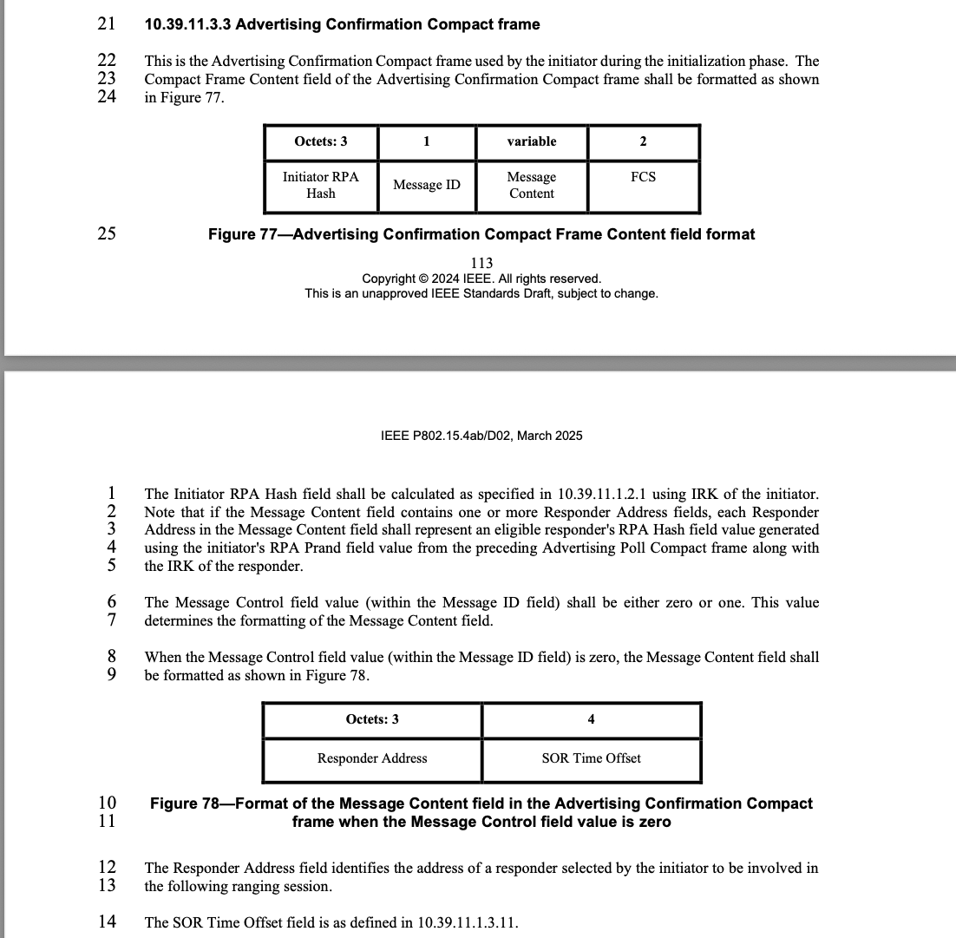
Proposed resolution: Accepted.
Disposition detail: n/a.

