**IEEE P802.15**

**Wireless Personal Area Networks**

|  |  |  |
| --- | --- | --- |
| Project | IEEE P802.15 Working Group for Wireless Personal Area Networks (WPANs) | |
| Title | **D02 Proposed Resolution for MAC data service for the Compact Frame** | |
| Date Submitted | July 2025 | |
| Sources | Hong Won Lee (LG Electronics), Alex Krebs (Apple)  [hongwon.lee@lge.com](mailto:hongwon.lee@lge.com) |  |
| Re: |  | |
| Abstract |  | |
| Purpose | To propose resolution for “P802.15.4ab™/D02 Draft Standard for Low-Rate Wireless Networks”. | |
| Notice | This document does not represent the agreed views of the IEEE 802.15 Working Group or IEEE 802.15.4ab Task Group. It represents only the views of the participants listed in the “Sources” field above.It is offered as a basis for discussion and is not binding on the contributing individuals. The material in this document is subject to change in form and content after further study. The contributors reserve the right to add, amend or withdraw material contained herein. | |

This submission contains the proposed comment resolutions for the CIDs 60, 67, 68, 323 and 331

Rev 0: Initial version.

***Comment index #60, 67, 68, 323 and 331 in 15-25-0174-016-04ab-consolidated-comments-draft-2-0.xlsx***

|  |  |  |  |  |  |  |  |
| --- | --- | --- | --- | --- | --- | --- | --- |
| **Name** | **Index#** | **Pg** | **Sub-Clause** | **Ln** | **Comment** | **Proposed Change** | **Disposition** |
| Kivinen, Tero | 60 | 26 | 8.3.4 | 11 | Does both SrcAddrMode and DstAddrMode need to be NONE, or COMPACT? | Add text explaining whether it is valid to have SrcAddrMode of NONE, and DstAddrMode of COMPACT. Specify whether it is needed that both SrcAddrMode and DstAddrMode to be COMPACT for SourceIrk and DstAddr contain the IRK. | Revised  Add text to clarify how a private address can be included, depending on the address mode.  **Tagged by CID #60** |
| VERSO, BILLY | 323 | 26 | 8.3.4 | 11 | This is covering the RPA prand/hash/IRK compact frame addressing, but has omitted a mechansim/discussion of specifying addrees for those compact frames using public addresses | Add method for specifying compact frame public addressing. | Revised  The sentence specifying the method for constructing a compact frame with public addressing is added. This should also be applied to MCPS-DATA.indication  There is one more discussion point. The format of the Message Content field in the Public Advertising Poll Compact frame (where Message Control field value = 1) should be consistent with that in the Advertising Poll Compact frame. However, there is a difference: the Supported O-QPSK Modulation Modes are included in the Advertising Poll Compact frame but are absent in the Public Advertising Poll Compact frame. Because we do not have any comment on addressing this issue so far, I suggest including additional changes in the below to the resolution proposal for this CID  **Tagged by CID #323** |
| Kivinen, Tero | 67 | 30 | 8.3.6 | 11 | How does one know whether the SrcAddr or DstAdddr parameter is used? | Add reference to the table or location that enumerates which CompactFrameIDs use SrcAddr and whch use DstAddr. | Revised as per below and before in DCN 337r1 where clarifying text has been added to the compact frame definitions in subclauses of 10.39.11.1.3. |
| VERSO, BILLY | 331 | 30 | 8.3.6 | 12 | "either the SrcAddr or DstAddr parameters contain the IRK" is a little vague. I expect witch is used will be based on which of SrcAddrMode or DstAddrMode parameter values is COMPACT. If that is the case then for clarity we should state that. | Change to say "… then depending on the CompactFrameID conveyed in the CompactFrameDescriptor, and which of SrcAddrMode or DstAddrMode values is COMPACT, either the SrcAddr or DstAddr parameters contain the IRK ..." | Revised as per below |
| Kivinen, Tero | 68 | 30 | 8.3.6 | 13 | SrcAddr and DstAddr cannot contain 128-bit IRK, so how is that stored there. | I think the IRK would be contained in the SourceIrk of the CompcatFrameDescriptor. If so specify so. | Revised as per below. |

**Discussion**:

Public addressing cases should be explained. The figure below can explain the procedure for MCPS-DATA.request and MCPS-DATA.indication between MAC and next higher layer of an initiator and a responder

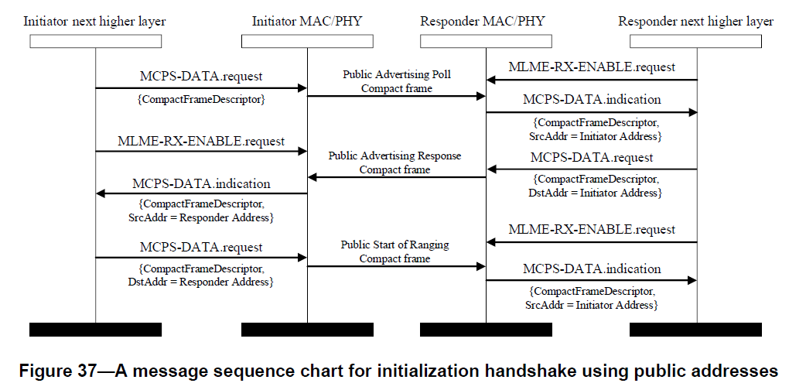

SourceIrk already defined in the Element of the CompactFrameDescriptor (see Table 1) can be reused for the initialization phase using public addresses. The IRK using public addresses is formatted as in Figure 39. The Address1 field is the initiator’s public address and the Address2 field is the responder’s public address. If public addresses are used, only SourceIrk of the CompactFrameDescriptor in the MCPS-DATA.request and SrcAddr in the MCPS-DATA.indication is used because the IRK using public addresses contains both the initiator’s address and the responder’s address

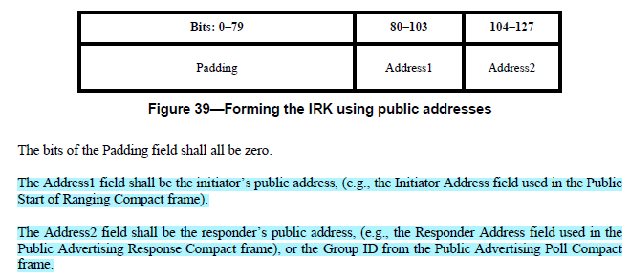

There is one more discussion point. The format of the Message Content field in the Public Advertising Poll Compact frame (where Message Control field value = 1) should be consistent with that in the Advertising Poll Compact frame. However, there is a difference: the Supported O-QPSK Modulation Modes are included in the Advertising Poll Compact frame but are absent in the Public Advertising Poll Compact frame. Because we do not have any comment on addressing this issue so far, I suggest including additional changes related to the Supported O-QPSK Modulation Modes field to the resolution proposal under CID 323

**Disposition: Revised**

**Disposition Detail:**

**Proposed text changes on P802.15.4ab™/D02:**

**- Original Text**

**8.3.4 MCPS-DATA.request**

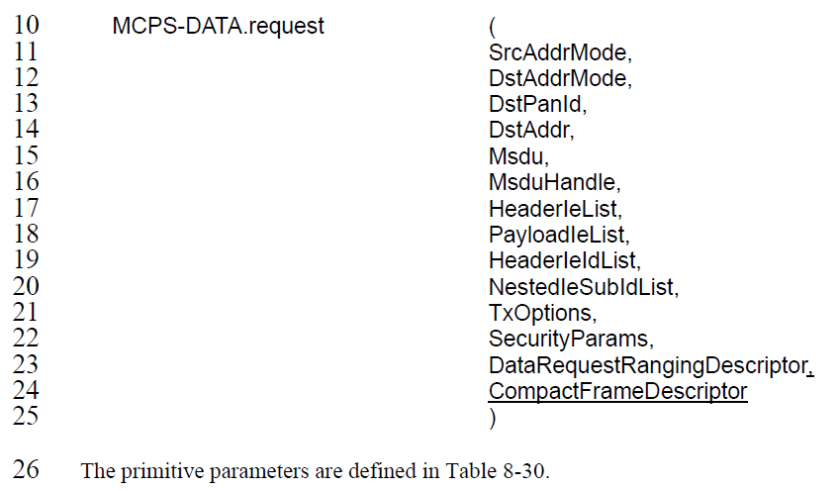

……

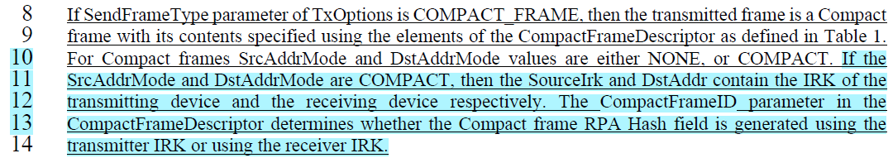

**8.3.4 MCPS-DATA.indication**

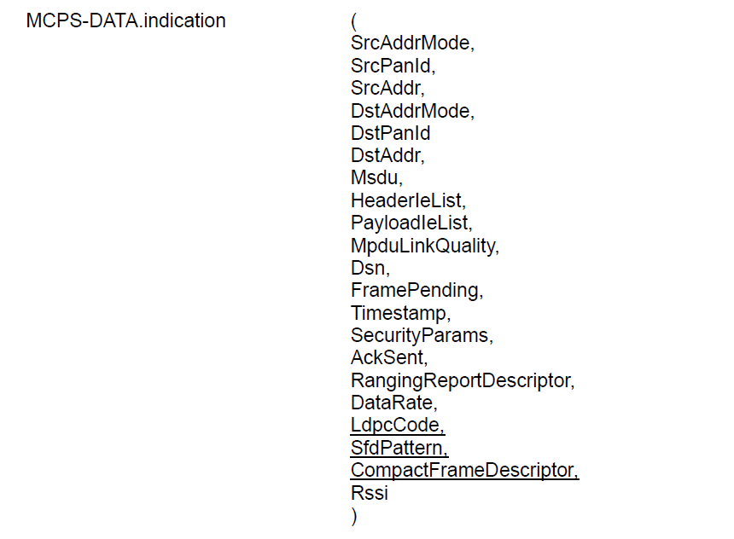

……

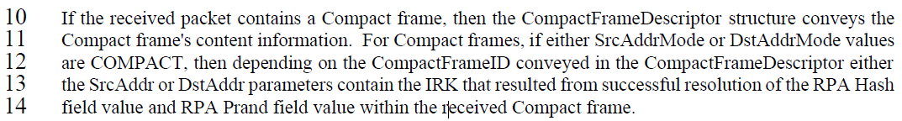

**- Proposed change**

**(*pp. 26 line #8*)**

***Instruction to the editor:*** *Please update paragraphs below:*

If SendFrameType parameter of TxOptions is COMPACT_FRAME, then the transmitted frame is a Compact frame with its contents specified using the elements of the CompactFrameDescriptor as defined in Table 1. For Compact frames SrcAddrMode and DstAddrMode values are either NONE, or COMPACT.

(#60) If the private address defined in 10.39.11.1.2.1 is used:

* when SrcAddrMode is COMPACT, the SourceIrk contains the IRK of the transmitting device.
* when DstAddrMode is COMPACT, the DstAddr contains the IRK of the receiving device.

The CompactFrameID parameter in the CompactFrameDescriptor determines whether the Compact frame RPA Hash field is generated using the transmitter IRK or using the receiver IRK. (#323) If the public address defined in 10.39.11.1.2.2 is used, then SourceIrk contains the IRK as shown in Figure 39.

(#323) NOTE – If the value of the CompactFrameID parameter in the CompactFrameDescriptor is set to 12 (Public Advertising Poll), the Address2 field in SourceIrk is not used.

**(*pp. 30 line #10*)**

If the received packet contains a Compact frame, then the CompactFrameDescriptor structure conveys the Compact frame's content information. For Compact frames, if either SrcAddrMode or DstAddrMode values are COMPACT, then depending on the CompactFrameID conveyed in the CompactFrameDescriptor either the SrcAddr or DstAddr parameters contain the IRK that resulted from successful resolution of the RPA Hash field value and RPA Prand field value within the received Compact frame.

(#323) If the public address defined in 10.39.11.1.2.2 is used, then SrcAddr contains the IRK as shown in Figure 39.

(#323) NOTE – If the value of the CompactFrameID parameter in the CompactFrameDescriptor is set to 12 (Public Advertising Poll), the Address2 field in SrcAddr is not used.

**(*pp. 76 line #1*)**

***Instruction to the editor:*** *Please remove SrcAddr and DstAddr in the parenthesis below MCPS-DATA.request and MPCS-DATA.indication in Figure 37:*

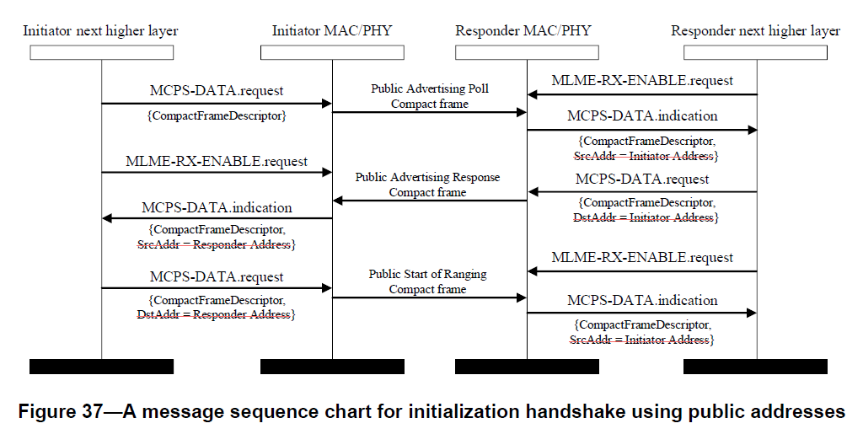

**(*pp. 135 line #16*)**

***Instruction to the editor: Please******change the Figure 126 (only relevant rows shown) as follows:***

|  |  |  |  |  |  |  |
| --- | --- | --- | --- | --- | --- | --- |
| Octets: 1 | 1 | 1/2 | (#323) 0/1 | 0/3 | variable | variable |
| Initialization Slot Duration | CAP Duration | Presence Bitmap | (#323) Supported O-QPSK Modulation Modes | Group ID | Advertising Data | SMC TLVs |

**Figure 124—Format of the Message Content field in the Public Advertising Poll Compact 16 frame when the Message Control field value is one**

**(*pp. 135 line #25*)**

***Instruction to the editor: Please add the following sentence after line 25:***

(#323) The Supported O-QPSK Modulation Modes field shall be set as per 10.39.11.1.3.16. 1