**IEEE P802.15**

**Wireless Personal Area Networks**

|  |  |  |
| --- | --- | --- |
| Project | IEEE P802.15 Working Group for Wireless Personal Area Networks (WPANs) | |
| Title | Proposed Resolutions for D02 CID 139 | |
| Date Submitted | July 28, 2025 | |
| Source | Huan-Bang Li and Takeshi Matsumura (NICT, Japan) | {lee, Matsumura}@nict.go.jp |
| Re: | IEEE P802.15.4ab | |
| Abstract | Comment Resolutions for selected comments on the LB213 / P802.15.4ab D02. | |
| Purpose | This document provides text changes intended to be part of the final IEEE Std 802.15.4ab (amendment to IEEE Std 802.15.4), as part of resolving selected comments from the consolidated spreadsheet (DCN 15-25-0174) that have been assigned to the author to resolve. | |
| Notice | This document does not represent the agreed views of the IEEE 802.15 Working Group or IEEE 802.15.4ab Task Group. It represents only the views of the participants listed in the “Source(s)” field above. It is offered as a basis for discussion and is not binding on the contributing individual(s) or organization(s). The material in this document is subject to change in form and content after further study. The contributor(s) reserve(s) the right to add, amend or withdraw material contained herein. | |
| Release | The contributor acknowledges and accepts that this contribution becomes the property of IEEE and may be made publicly available by P802.15. | |
| Patent Policy | The contributor is familiar with the IEEE-SA Patent Policy and Procedures.  <https://standards.ieee.org/about/sasb/patcom/materials/> | |

# Comment Index # 139

|  |  |  |  |  |  |
| --- | --- | --- | --- | --- | --- |
| **Index #** | **Page** | **Sub-clause** | **Line #** | **Comment** | **Proposed Change** |
| 139 | 145 | 10.39.12 | 1 | In Table 31, macMmsNbInitMode is given a range of 1-9, which is not agree to that given in Table 67. | set to the same range as that in Table 67. |

This comment is related to the following texts:

**10.39.12 MAC constants and PIB attributes for MMS operation**

……

**Table 31—MMS related MAC PIB attributes**

|  |  |  |  |  |
| --- | --- | --- | --- | --- |
| **Attribute** | **Type** | **Range** | **Description** | **Default** |
| *macIrkDescriptor* | Structured as defined by Table 32 | - | This structure holds IRK values for Compact frames. | empty |
| … |  |  |  |  |
| … |  |  |  |  |
| *macMmsNbInitMode* | Integer | 1-9 | Modulation mode for initialization phase, values relate to Table 67. | 1 |
| … |  |  |  |  |
| … |  |  |  |  |

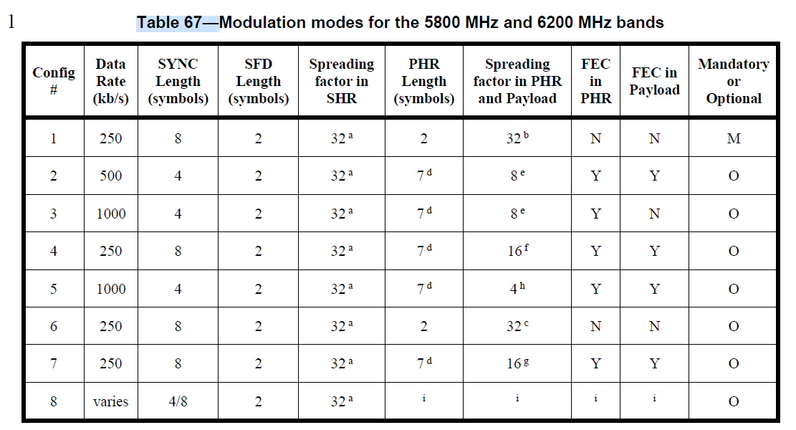

**Discussion:**

In Table 31, the attribute ‘*macMmsNbInitMode*’ with a type of integer is used to select a modulation mode for initialization phase, while the modulation mode needs to be selected from Table 67. The range of integer ‘*macMmsNbInitMode*’ is given as 1 – 9. However, only 8 modulation modes are defined in Table 67. Therefore, the range 1-9 is beyond the capacity of Table 67.

**Proposed Disposition:** Revised.

**Disposition Detail:** The range of integer ‘*macMmsNbInitMode*’ in Table 31 should be within capacity provided by Table 67. The proposed modification is as in the follows:

**Table 31—MMS related MAC PIB attributes**

|  |  |  |  |  |
| --- | --- | --- | --- | --- |
| **Attribute** | **Type** | **Range** | **Description** | **Default** |
| … |  |  |  |  |
| *macMmsNbInitMode* | Integer | 1-8 | Modulation mode for initialization phase, values relate to Table 67. | 1 |
| … |  |  |  |  |
| … |  |  |  |  |