**IEEE P802.15**

**Wireless Personal Area Networks**

|  |  |
| --- | --- |
| Project | IEEE P802.15 Working Group for Wireless Personal Area Networks (WPANs) |
| Title | **Resolutions to CIDs 19, 234, 311** |
| Date Submitted | July 30th, 2025 |
| Sources | Riku Pirhonen (NXP) |
| Abstract | Comment resolution proposals for 4ab D02 comments 19, 234 and 311. Resolutions for these CIDs were first presented in Doc 25/258r0, but were removed after 4ab Warsaw for further discussion. |
| Purpose | Propose resolutions to comments received on IEEE P802.15.4ab/D02, March 2025. |
| Notice | This document does not represent the agreed views of the IEEE 802.15 Working Group or IEEE 802.15.4ab Task Group. It represents only the views of the participants listed in the “Sources” field above.It is offered as a basis for discussion and is not binding on the contributing individuals. The material in this document is subject to change in form and content after further study. The contributors reserve the right to add, amend or withdraw material contained herein. |

## Resolution proposal

### Summary of comments

|  |  |  |  |  |  |  |
| --- | --- | --- | --- | --- | --- | --- |
| **Name** | **Index #** | **Page** | **Sub-clause** | **Line #** | **Comment** | **Proposed Change** |
| CHITRAKAR, ROJAN | 19 | 79 | 10.39.4 | 7 | Is this subclause also applicable for non-interleaved mode? | Add clarification that this subclause is not applicable for non-interleaved mode |
| PAKROOH, POORIA | 234 | 82 | 10.39.7 | 3 | The benefits of Noninterleaved MMS mode are not justified properly. On the other hand, there are several disadvantages relative to the interleaved mode, such as longer duration for the ranging, limitations due to channel coherence time, and market fragmentation. | Remove Non-interleaved MMS mode, specifically subclause 10.39.7 and other ralted subclauses. |
| TIAN, BIN | 311 | 82 | 10.39.7 | 7 | In the non-interleaved modes, why not moving the responder NB transmission immediately after the Initiator transmission so that Initiator knows that responder is ready for followijng UWB excahnge. In the ranging subround 2 or later, no NB transmission is needed. Mutliple NB transmission may lead to different frequency and time reference | as in the comment |

**Comment #19**

|  |  |  |  |  |  |  |
| --- | --- | --- | --- | --- | --- | --- |
| **Name** | **Index #** | **Page** | **Sub-clause** | **Line #** | **Comment** | **Proposed Change** |
| CHITRAKAR, ROJAN | 19 | 79 | 10.39.4 | 7 | Is this subclause also applicable for non-interleaved mode? | Add clarification that this subclause is not applicable for non-interleaved mode |

**Resolution:** (Accepted/Rejected/**Revised**)

**Discussion:**

Draft 02 subclause 10.39.4.1, page 79, has general control phase description, poll and response behavior is described in the paragraph starting on line 15. A control phase as such is applicable also to the non-interleaved sub-rounds. Each sub-round has its own control phase, length given by *macMmsRcpPollNSlots* and *macMmsRcpRespNSlots*.

The difference in non-interleaved sub-round is that the initiator doesn’t wait for responder to acknowledge reception of the NB poll compact frame before it sends the MMS UWB packet in a non-interleaved sub-round. Resolution to CID #22 in Doc 25/292r1 introduces additional text and pictures to subclause 10.39.7 to explain the sub-round details and that provides clarification, see the picture below. Short clarification to highlight the different behavior compared to the interleaved mode can be added to 10.39.4.1, see the proposed change below.

*An example showing SS-TWR with two non-intereleaved sub-rounds in subclause 10.39.7.*

**Change:**

On page 79, MMS UWB control phase General subclause 10.39.4.1, after line 20, add the following text. Text is updated from the original proposal in Doc 25/258r0 taking into account the changes introduced in resolution to CID #22 in Doc 25/292r1. The blue text is added in this document (25/331r1):

In case of non-interleaved sub-rounds, described in subclause 10.39.7, each non-interleaved sub-round has a control phase with duration defined by *macMmsRcpPollNSlots* or *macMmsRcpRespNSlots* parameter followed by a ranging phase of *macMmsRpDuration*. When a non-interleaved sub-round is used, the Initiator proceeds to transmit the MMS UWB Packet without waiting for a response compact frame from the Responder as it would in the interleaved case. The responder sends the response after the reception of the MMS UWB Packet from the Initiator. Any further non-interleaved NBA MMS UWB exchanges in subsequently sub-rounds would similarly each have the narrowband compact frame followed by the MMS UWB packet.

**Comment #234**

|  |  |  |  |  |  |  |
| --- | --- | --- | --- | --- | --- | --- |
| **Name** | **Index #** | **Page** | **Sub-clause** | **Line #** | **Comment** | **Proposed Change** |
| PAKROOH, POORIA | 234 | 82 | 10.39.7 | 3 | The benefits of Noninterleaved MMS mode are not justified properly. On the other hand, there are several disadvantages relative to the interleaved mode, such as longer duration for the ranging, limitations due to channel coherence time, and market fragmentation. | Remove Non-interleaved MMS mode, specifically subclause 10.39.7 and other ralted subclauses. |

**Resolution** (Accepted/Rejected/Revised) **Withdrawn**

**Discussion:**

The commenter has withdrawn this comment.

**Comment #311**

|  |  |  |  |  |  |  |
| --- | --- | --- | --- | --- | --- | --- |
| **Name** | **Index #** | **Page** | **Sub-clause** | **Line #** | **Comment** | **Proposed Change** |
| TIAN, BIN | 311 | 82 | 10.39.7 | 7 | In the non-interleaved modes, why not moving the responder NB transmission immediately after the Initiator transmission so that Initiator knows that responder is ready for followijng UWB excahnge. In the ranging subround 2 or later, no NB transmission is needed. Mutliple NB transmission may lead to different frequency and time reference | as in the comment |

**Resolution:** (Accepted/**Rejected**/Revised)

The answer to the question why not moving the response is that the change would introduce new tighter PHY performance requirements for the non-interleaved mode compared to the interleaved mode.

**Discussion:**

The comment asks why not to move NB response to be done immediately after poll, before the non-interleaved MMS UWB packets are sent. The pictures below show why not.

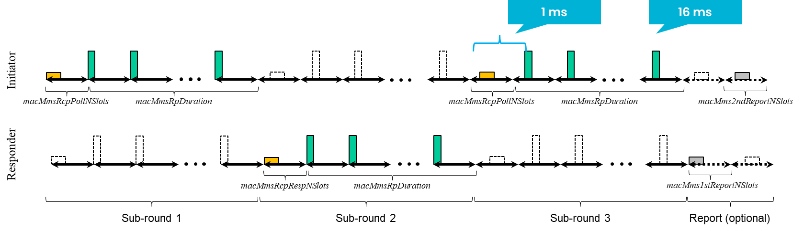

*NB poll and response as in draft 02.*

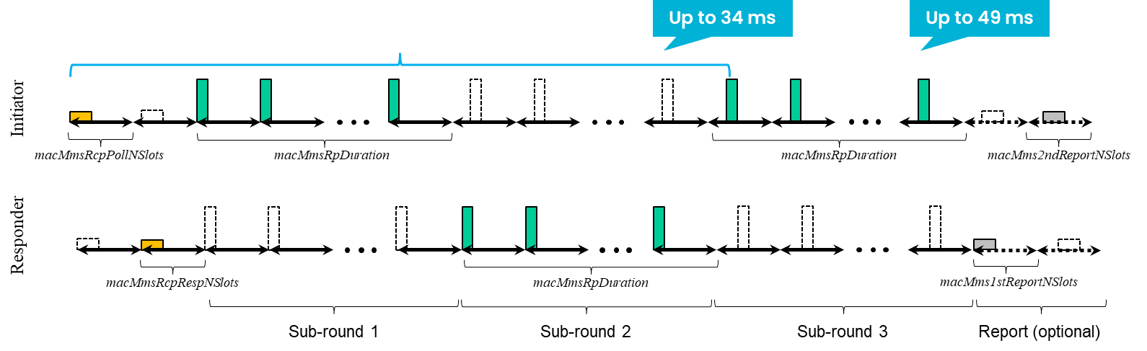

*NB poll and response as per the proposed change.*

In order to keep the CFO estimate as accurate as possible, to avoid adverse effects of frequence or timing drift, the NB reference should be as close to the UWB MMS packet as possible. Therefore each subround sends its own NB reference. If the compact poll and response frames were exchanged only before the subrounds start, the gap between the NB reference and UWB fragments could be several tens of milliseconds. Tolerating such delay would be a new requirement for UWB MMS.

In the case of non-interleaved sub-round the initiator sends the UWB MMS packet without without the acknowledging response message from the responder. This may cause an non-productive sending of a MMS UWB packet. A similar event can happen also in the interleaved mode, if the Initiator misses the Responder NB response compact frame. In that case the responder sends the UWB MMS packet and the Initiator cannot receive it. There is always some risk for unnecessary transmissions. Note that the parties have already exchanged NB messages during the ADV-POLL, ADV-RESP and SOR exchange, so they are assumed to be with a reasonable probability within the NB range.

Purpose of the non-interleaved sub-round is to support DS-TWR, so in case of multiple NB packets from the Initiator the impact of drift is negligible as explained in 15.4 base standard subclause 10.29.1.2.3 and its reference IEEE 802.15.8-2017 Annex D.