**IEEE P802.15**

**Wireless Specialty Networks**

|  |  |  |
| --- | --- | --- |
| Project | IEEE P802.15 Working Group for Wireless Specialty Networks (WSNs) | |
| Title | Comment Resolutions – 8, 250, 251, 252, 623, 636, 637, 638 | |
| Date Submitted | July-2025 | |
| Source | Youngwan So (SAMSUNG ELECTRONICS]  [youngwan.so@samsung.com](mailto:youngwan.so@samsung.com) |  |
| Re: | Comments: | |
| Abstract | This document is to suggest changes addressing comments in the title. | |
| Purpose | Resolve comments | |
| Notice | This document has been prepared to assist the IEEE P802.15. It is offered as a basis for discussion and is not binding on the contributing individual(s) or organization(s). The material in this document is subject to change in form and content after further study. The contributor(s) reserve(s) the right to add, amend or withdraw material contained herein. | |
| Release | The contributor acknowledges and accepts that this contribution becomes the property of IEEE and may be made publicly available by P802.15. | |

Revision 0 : Addressing the following CIDs

8, 250, 251, 252, 623, 636, 637, 638

Revision 1 : No changes from rev1, just except DCN numbering added in header of document.

8, 250, 251, 252, 623, 636, 637, 638

Revision 2: Removed three CIDs by request of Pooria as his absence while discussion.

**Proposed CRs ( CID#8, CID#250, CID#251 ) in this document are void and**

**will be re-discussed. Only CID#252, #623, #636, #637, #638 are approved.**

~~8, 250, 251~~, 252, 623, 636, 637, 638

***~~Comment Indices in 15-25-0174-00-04ab-consolidated-comments-draft-2.0:~~***

|  |  |  |  |  |  |  |
| --- | --- | --- | --- | --- | --- | --- |
| **~~Name~~** | **~~Index#~~** | **~~Pg~~** | **~~Sub-Clause~~** | **~~line~~** | **~~Comment~~** | **~~Proposed Change~~** |
| ~~PAKROOH, POORIA~~ | ~~250~~ | ~~194~~ | ~~10.44~~ | ~~13~~ | ~~Not clear why this NB data transmission protocol is needed, given the significantly lower data rate relative to UWB, and also higher fading. If many users start to use this protocol, the congestion can be problematic. This can cause interference to unnecessarily longer range. There is no duty cycle limit specified for this feature and the benefits are not clear.  Remove this functionality, or add a proper mandatory channel access mechanism.~~ | ~~Remove NB data offload by deleting subclause 10.44. Another alternative is to add a proper channel access mechanism for this feature for high duty cycle usage.~~ |
| ~~PAKROOH, POORIA~~ | ~~251~~ | ~~194~~ | ~~10.44.1~~ | ~~19~~ | ~~Benefits of NB usage for ranging has been justified. What is the benefit of using two links with significantly different link budget? what is the application? The data communication associated with this application are for close range cases, which does not need NB.~~ | ~~Remove NB data offload by deleting subclause 10.44.~~ |

**~~Relevant Text :~~**

~~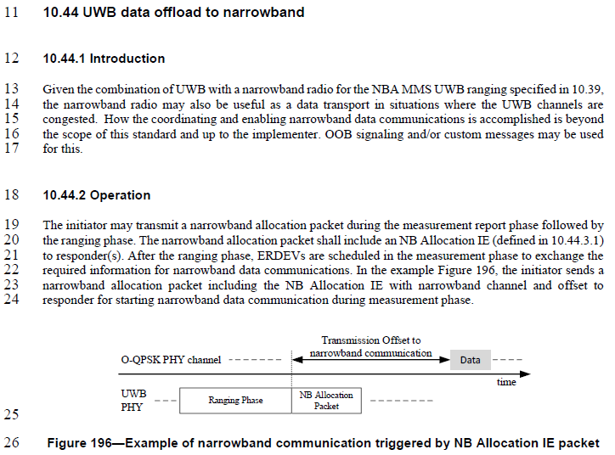~~

**~~Disposition Detail :~~**

~~It’s true that NB channel provides much lower data rate than that of the UWB channel.~~

~~However, what the NB data transmission feature is aiming at is the use case when the multiple devices want to transmit a small data with very low delay through available NB channels, rather than waiting for the scheduled transmission chance having unnecessarily large bandwidth with long delay.~~

**~~Disposition:~~**

**~~CID #250 :~~** ~~Rejected~~

**~~CID #251 :~~** ~~Rejected~~

**~~Proposed text changes on P802.15.4ab™/Draft 2.0 :~~**

~~No change required~~

***Comment Indices in 15-25-0174-00-04ab-consolidated-comments-draft-2.0:***

|  |  |  |  |  |  |  |
| --- | --- | --- | --- | --- | --- | --- |
| **Name** | **Index#** | **Pg** | **Sub-Clause** | **line** | **Comment** | **Proposed Change** |
| VERSO, BILLY | 623 | 194 | 10.44.1 | 16 | Saying "up to the implementer" is a bit vague, and no need to talk about OOB or custome messages if it is out of scope already. | change: "and up to the implementer" to ", i.e., is the responsibility of high layer protocols", and delete the sentence following about OOB custome messages. |
| VERSO, BILLY | 636 | 194 | 10.44.2 | 19 | "narrowband allocation packet" is not properly defined. I think it is any frame containin the NB Allocation IE, that definition should be clearly made. I think we should call it The narrowband allocation message folling the example of RCM for ranging control message. | On line 20 instead of saying "The narrowband allocation packet shall include an NB Allocation IE …" make it a definition: "The narrowband allocation message is a Data frame that includes an NB Allocation IE ...". And change the other two uses of "narrowband allocation packet" to ""narrowband allocation message". |
| ~~Aldana, Carlos~~ | ~~8~~ | ~~194~~ | ~~10.44.2~~ | ~~194~~ | ~~There is no description on how NB channel access is done.~~ | ~~adopt changes described in document 15-407-07~~ |

**Relevant Text :**



**Disposition Detail :**

**CID #623**

The comment is correct. Accepted proposed changes and made a revision based on it.

**CID #636**

The comment is correct. Accepted proposed changes and made a revision based on it.

**~~CID #8~~**

~~It is mentioned that “~~*~~How the coordinating and enabling narrowband data communications is accomplished is beyond the scope of this standard and is the responsibility of high layer protocols.~~*~~”~~

~~It means channel access mechanism described in document 15-407-07 can be adopted and used, but not the only mechanism.~~

**Disposition:**

**CID #623 :** Accepted

**CID #636 :** Accepted

**~~CID #8 :~~** ~~Rejected~~

**Proposed text changes on P802.15.4ab™/Draft 2.0 :**

|  |
| --- |
| ***Change 10.44.1 P194 as below ;***  11 **10.44 UWB data offload to narrowband**  12 **10.44.1 Introduction**  13 Given the combination of UWB with a narrowband radio for the NBA MMS UWB ranging specified in 10.39,  14 the narrowband radio may also be useful as a data transport in situations where the UWB channels are  15 congested. How the coordinating and enabling narrowband data communications is accomplished is beyond  16 the scope of this standard" and is the responsibility of high layer protocols.  18 **10.44.2 Operation**  19 The initiator may transmit a narrowband allocation message during the measurement report phase followed by  20 the ranging phase. The narrowband allocation message is a Data frame that includes an NB Allocation IE. (defined in 10.44.3.1)  21 to responder(s). After the ranging phase, ERDEVs are scheduled in the measurement phase to exchange the  22 required information for narrowband data communications. In the example Figure 196, the initiator sends a  23 narrowband allocation message including the NB Allocation IE with narrowband channel and offset to  24 responder for starting narrowband data communication during measurement report phase. |

***Comment Indices in 15-25-0174-00-04ab-consolidated-comments-draft-2.0:***

|  |  |  |  |  |  |  |
| --- | --- | --- | --- | --- | --- | --- |
| **Name** | **Index#** | **Pg** | **Sub-Clause** | **line** | **Comment** | **Proposed Change** |
| POORIA | 252 | 195 | 10.44.3.1 | 6 | If this is a unicast message, why does it inclue address in the IE? | Remove "Address size" and "Address" from Figure 197. |
| BILLY | 637 | 195 | 10.44.3.1 | 11 | The address of the participating device doesn't make any sense… it says on line three that the NB Allocation IE is used by an initiator to send … to a responder (in a unicast frame)" so the address of the responder is already in the frame carrying the IE. | Delete the field. |
| BILLY | 638 | 195 | 10.44.3.1 | 17 | Transmission Offset is good, but is it the (initiator) device sending the IE or the (responder) device receiving the IE that is expected to be tranmsitting first or how is this determined? One posibility is to use a one of the free reserved bits to say whether which is sending and whihc is receiving this (first) transmittion. | Make it clear that it is the responer always sending, or add a bit to say Responder TX which when one means that the receiver of the IE is to send after the specified offset, or when it's zero is to turn on its receiver to receive a packet from the initiator. |

**Relevant Text :**

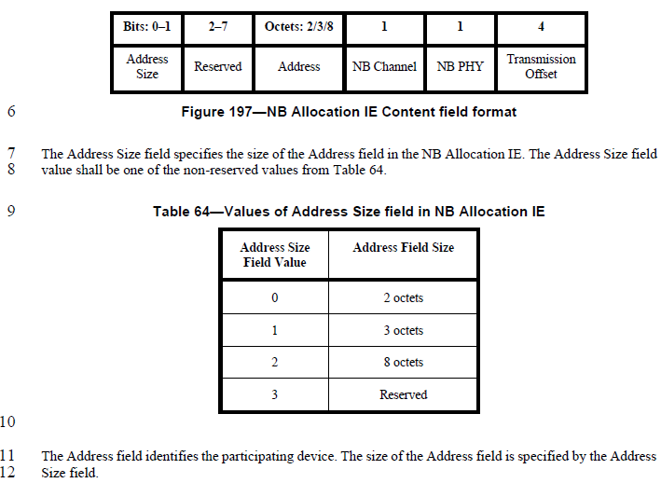

**Disposition Detail :**

**CID #252 & CID #637**

Both comments make sense. If NB Allocation IE is carried by a unicast message, the Address field can be omitted. But as the text says the details are beyond of this standard, I think it would be better to give an option/flexibility rather than to delete the fields. Revision was made so that the address size can also be zero, which means Address field itself can be omitted.

**CID #638**

The comment is correct. There’s no way for now to indicate who’s transmitting first at ‘NB channel assigned’

**Disposition:**

**CID #252 :** Revised

**CID #637 :** Revised

**CID #638 :** Revised

**Proposed text changes on P802.15.4ab™/Draft 2.0 :**

|  |  |  |  |  |  |  |  |  |  |  |  |  |  |  |  |  |  |  |  |  |  |  |  |  |
| --- | --- | --- | --- | --- | --- | --- | --- | --- | --- | --- | --- | --- | --- | --- | --- | --- | --- | --- | --- | --- | --- | --- | --- | --- |
| ***Change 10.39.9.4.3 P89L24 as below ;***  1 **10.44.3 Nested IEs for UWB data offload to narrowband**  2 **10.44.3.1 NB Allocation IE**  3 The NB Allocation IE is used by an initiator to send the narrowband resource allocation information to a  4 responder. The content field of the NB Allocation IE shall be formatted as shown in  5 Figure 197.   |  |  |  |  |  |  |  | | --- | --- | --- | --- | --- | --- | --- | | Bits: 0-1 | 2 | 3-7 | Octets: 0/2/3/8 | 1 | 1 | 4 | | Address Size | TX direction | Reserved | Address | NB Channel | NB PHY | Transmission Offset |   6  **Figure 197—NB Allocation IE Content field format**  7 The Address Size field specifies the size of the Address field in the NB Allocation IE. The Address Size field  8 value shall be one of values from Table 64. If the IE is delivered in unicast frame Address field size is 0 octet otherwise the size should be one of 2/3/8 octets.  9 **Table 64—Values of Address Size field in NB Allocation IE**   |  |  | | --- | --- | | Address Size  Field Value | Address Field Size | | 0 | 0 octets | | 1 | 2 octets | | 2 | 3 octets | | 3 | 8 octets |   10 The TX direction field when zero indicates initiator will transmit first, and when one indicates responder transmit first.  11 The Address field identifies the participating device. The size of the Address field is specified by the Address  12 Size field.  13 The NB Channel field is used to assign a narrowband channel to the device identified by the address field.  14 The NB Channel field value shall be an O-QPSK PHY channel number as defined in 11.1.3.15.  15 The NB PHY field specifies the O-QPSK modulation mode configuration index. The NB PHY field value  16 shall be one of the configuration number values given in Table 67.  17 The Transmission Offset field specifies the time in RSTU until the start of the narrowband packet  18 transmission in the channel specified by the NB Channel field. This transmission offset is relative to the start  19 of the packet conveying the NB Allocation IE. |