**IEEE P802.15**

**Wireless Specialty Networks**

|  |  |  |
| --- | --- | --- |
| Project | IEEE P802.15 Working Group for Wireless Specialty Networks (WSNs) | |
| Title | Comment Resolutions – 165, 213, 214, 215, 242, 243, 576, 579 | |
| Date Submitted | July-2025 | |
| Source | Youngwan So (SAMSUNG ELECTRONICS]  [youngwan.so@samsung.com](mailto:youngwan.so@samsung.com) |  |
| Re: | Comments: | |
| Abstract | This document is to suggest changes addressing comments in the title. | |
| Purpose | Resolve comments | |
| Notice | This document has been prepared to assist the IEEE P802.15. It is offered as a basis for discussion and is not binding on the contributing individual(s) or organization(s). The material in this document is subject to change in form and content after further study. The contributor(s) reserve(s) the right to add, amend or withdraw material contained herein. | |
| Release | The contributor acknowledges and accepts that this contribution becomes the property of IEEE and may be made publicly available by P802.15. | |

Revision 0 : Addressing the following CIDs (Totally 8 CIDs)

165, 213, 214, 215, 242, 243, 576, 579

***Comment Indices in 15-25-0174-00-04ab-consolidated-comments-draft-2.0:***

|  |  |  |  |  |  |  |
| --- | --- | --- | --- | --- | --- | --- |
| **Name** | **Index#** | **Pg** | **Sub-Clause** | **line** | **Comment** | **Proposed Change** |
| MAMAN, MICKAEL | 165 | 69 | 10.39.3.3 | 8 | the NB Acquisition compact frame is only sent in the aOqpsk5g8AquisitionChan. If the channel is jammed , the initiator is blocked. This initialization channel for acquisition compact frame should have a backup channel. | open discussion to add a backup channel for acquisition compact frame. The higher layer may change aOqpsk5g8AquisitionChan to a backup channel. |
| MICKAEL | 213 | 140 | 10.39.11.3.19 | 12 | the UWB Channel in the UWB AP Info Field is in contradiction with the fixed UWB channel aHrpUwbAquisitionChan defined in 10.39.3.3 (p.69 Coordination) | A consensus is need for the UWB and NB acquisition channel |

**Relevant Text :**



**Disposition Detail :**

**CID #165**

Now, in current Draft 2.0 specification, the NB Acquisition compact frame is defined to be sent in the following fixed channel only. In short, now the D2.0 specification text is mandating NB channel number two as Acquisition Compact Frame transmission.

**Table 30—MMS related MAC constants (pg.144, Draft 2.0)**

|  |  |  |
| --- | --- | --- |
| Attribute | Description | Value |
| *aOqpsk5g8AquisitionChan* | The O-QPSK PHY 5800 MHz band channel number to use for NB Acquisition Compact frames. | 2 |
| *aHrpUwbAquisitionChan* | The HRP UWB PHY channel number to use for UWB Acquisition Compact frames | 9 |

The comment is proposing to have a backup channel for Acquisition compact frame, because if the channel is jammed for some reason, the initiator may be blocked.

The comment makes sense and we can solve the problem by allowing NB channel number to be varied.

Therefore, this CR suggests the change as below

1. Change the relevant text to make it say NB channel number for Acquisition frame transmission can be ‘varied’ rather than ‘fixed’ one.
2. Change the text to say that the NB Channel number two is just recommended not mandated.

**CID #213**

From the current D2.0 specification text, the ‘UWB Channel’ field in the ‘UWB AP Info’ is defined to be variable. However, the UWB channel number where UWB Acquisition frame will be sent, a.k.a. *aHrpUwbAquisitionChan*, is defined as fixed constant in subclause 10.39.3.3, so the comment is talking about it.

If previous comment CID#165 is accepted, there will be no contradiction anymore, as the change makes both of O-QPSK PHY channel number and HRP UWB PHY channel number for Acquisition compact frame not fixed anymore. Then, the comment is automatically resolved.

**Disposition :**

**CID #165 :** Revised

**CID #213 :** Rejected

**Proposed text changes on P802.15.4ab™/Draft 2.0 :**

**For CID #165**

|  |  |  |  |  |  |  |  |  |  |  |  |  |  |  |  |  |  |  |  |  |
| --- | --- | --- | --- | --- | --- | --- | --- | --- | --- | --- | --- | --- | --- | --- | --- | --- | --- | --- | --- | --- |
| ***Change 10.39.3.3 P69L1 as below ;***  **10.39.3.3 Coordination**  2 The coordination mechanism may be used by the initiator to discover UWB sessions nearby and to avoid  3 collisions resulting from the overlap of blocks. Support for this coordination is optional for all devices. The  4 higher layer determines whether coordination is active or not. If coordination is active, the initiator  5 opportunistically or periodically transmits an Acquisition Compact frame (10.39.11.3.17) with information  6 about its UWB channel usage after a session is configured. The transmission of these Acquisition Compact  7 frames may start before the start of the first block. The initiator transmits these Acquisition Compact frames  8 using either the O-QPSK PHY, for NB Acquisition Compact frames, in the *macNbAquisitionChan*  9 channel or the HRP UWB PHY, for UWB Acquisition Compact frames, in the *macHrpUwbAquisitionChan*  10 channel, or using both. It is recommended that O-QPSK PHY channel number two is used in default for NB Acquisition Compact frame transmissions, and that HRP UWB PHY channel number nine is used in default for UWB Acquisition Compact frame transmissions, upon regional or regulatory channel availability. The NB Acquisition Compact frame and UWB Acquisition Compact frame are  11 described in 10.39.11.3.17. To provide information about UWB channel usage, both the NB Acquisition  12 Compact frame and the UWB Acquisition Compact frame include the UWB Per-Session Info Fields. The  13 next higher layer determines the interval between Acquisition Compact frame transmissions.  14 If coordination is active, before starting a new session, the initiator scans for Acquisition Compact frame on  15 the *macNbAquisitionChan* channel and/or the *macHrpUwbAquisitionChan* channel. The length of the  16 scanning period is implementation dependent. The initiator thus obtains information about the UWB channel  17 usage from other initiators, and with this knowledge, the initiator may select values for configuring its new  18 session to minimize the overlap with active periods of other sessions nearby. The details of this are  19 implementation specific.  20 Otherwise, the initiator starts the control phase without scanning for Acquisition Compact frame.  ***Remove Table 30 in 10.39.12, P144L20 as below ;***      ***Add the following row at the end of Table 31 in 10.39.12, P144L22 as below ;***  **Table 31—MMS related MAC PIB attributes (*Note: pg.144, Draft 2.0)**   |  |  |  |  |  | | --- | --- | --- | --- | --- | | Attribute | Type | Range | Description | Default | | …. | …. | … | … | … | | *macNbAquisitionChan* | Integer | 0-249 | The O-QPSK PHY 5800 MHz band channel number to use for NB Acquisition Compact frames. | 2 | | *macHrpUwbAquisitionChan* | Integer | 0-113 | The HRP UWB PHY channel number to use for UWB Acquisition Compact frames | 9 | |

**For CID #213**

No change required

***Comment Indices in 15-25-0174-00-04ab-consolidated-comments-draft-2.0:***

|  |  |  |  |  |  |  |
| --- | --- | --- | --- | --- | --- | --- |
| **Name** | **Index#** | **Pg** | **Sub-Clause** | **line** | **Comment** | **Proposed Change** |
| BILLY | 576 | 140 | 10.39.11.3.18 | 7 | If the AP transmissions are aperiodic, will the Next NB AP time always be known, or might they be done opertunistically? Maybe we need something to say whether this field is valid, or allow it to be omitted if it is not known. | Add support for case when next time is not known, (if this is a seenario that needs to be supported). And similarily for UWB AP. |

**Relevant Text :**

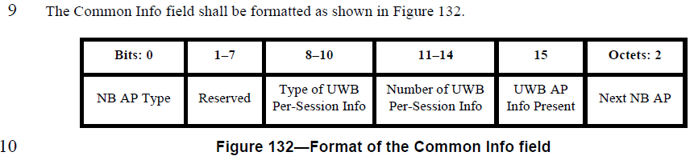

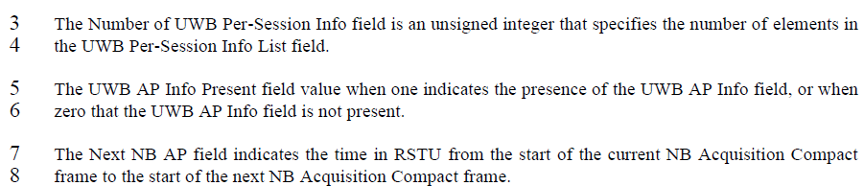

**Disposition Detail :**

Regarding cases when the device (i.e. initiators) sending the Acquisition frame does not know when it will send a next Acquisition frame (at Next NB AP), the comment suggests to make a way to say ‘the Next NB AP value is not valid’ or to omit the ‘Next NB AP’ field itself as it cannot provide valid value.

However, once ‘the Next NB AP value is told as invalid’ or ‘the Next NB AP field itself is omitted’, the receiving device will lose track of next Acquisition frame reception chain, as the receiving device will fail to extract valid ‘Next NB AP’ field value from Acquisition frame.

Therefore, it is thought to be better way to always keep the ‘Next NB AP’ field in Acquisition frame, and say whether the ‘Next NB AP’ value is valid or not, considering comment’s suggestions.

This CR suggests the change as below

1. Newly define ‘Next NB AP Validity’ field to indicate whether the ‘Next NB AP’ field in current AP is valid or not.
2. Add the text explaining how to use the field:

If the receiving device (initiator) successfully receives Acquisition frame and the ‘Next NB AP Validity’ field value in that received Acquisition frame is ‘one’, the receiving device uses information that will be sent in the Acquisition frame specified by ‘Next NB AP’.

In this case, the ‘UWB Per-Session Info’ field scheduled to be sent in the Acquisition frame specified by ‘Next NB AP’ field is used for the receiving device to allocate resources for its own ranging.

If the receiving device (initiator) successfully receives Acquisition frame and the ‘Next NB AP Validity’ field value in that received Acquisition frame is ‘zero’, the receiving device ignores information that will be sent in the Acquisition frame specified by ‘Next NB AP’. But, the ‘Next NB AP’ field is not ignored.

In this case, the ‘UWB Per-Session Info’ field scheduled to be sent in the Acquisition frame specified by ‘Next NB AP’ field is not usable for the receiving device to allocate resources for its own ranging. Then, the receiving device tries to receive next Acquisition frames until the valid Acquisition frame having the ‘Next NB AP Validity’ field value one is received.

Based on above, we can revise the text as follows

**Disposition:** Revised

**Proposed text changes on P802.15.4ab™/Draft 2.0 :**

|  |  |  |  |  |  |  |  |  |  |  |  |  |  |  |
| --- | --- | --- | --- | --- | --- | --- | --- | --- | --- | --- | --- | --- | --- | --- |
| ***Change 10.39.3.17.2 P139L9 Figure 132 and P139L12 as below ;***   |  |  |  |  |  |  |  | | --- | --- | --- | --- | --- | --- | --- | | Bits: 0 | 1 | 2-7 | 8-10 | 11-14 | 15 | Octets: 2 | | NB AP Type | Next NB AP Validity | Reserved | Type of UWB Per-session Info | Number of UWB Per-Session Info | UWB AP Info Present | Next NB AP |   **Figure 132—Format of the Common Info field**  11 The NB AP Type field when zero specifies periodic coordination, and when one specifies aperiodic  12 coordination.  13 The Next NB AP Validity field value when one indicates all the field values in the Acquisition frame specified by ‘Next NB AP’ field is valid and usable. The Next NB AP Validity field value when zero indicates all the field values except ‘Next NB AP’ in the Acquisition frame specified by ‘Next NB AP’ field is not valid and not usable.  …………….  ***Change 10.39.3.3 P69L14 as below ;***  **10.39.3.3 Coordination**  2 The coordination mechanism may be used by the initiator to discover UWB sessions nearby and to avoid  3 collisions resulting from the overlap of blocks. Support for this coordination is optional for all devices. The  4 higher layer determines whether coordination is active or not. If coordination is active, the initiator  5 opportunistically or periodically transmits an Acquisition Compact frame (10.39.11.3.17) with information  6 about its UWB channel usage after a session is configured. The transmission of these Acquisition Compact  7 frames may start before the start of the first block. The initiator transmits these Acquisition Compact frames  8 using either the O-QPSK PHY, for NB Acquisition Compact frames, in the *aOqpsk5g8AquisitionChan*  9 channel or the HRP UWB PHY, for UWB Acquisition Compact frames, in the *aHrpUwbAquisitionChan*  10 channel, or using both. The NB Acquisition Compact frame and UWB Acquisition Compact frame are  11 described in 10.39.11.3.17. To provide information about UWB channel usage, both the NB Acquisition  12 Compact frame and the UWB Acquisition Compact frame include the UWB Per-Session Info Fields. The  13 higher layer determines the interval between Acquisition Compact frame transmissions.  If the receiving device (initiator) successfully receives Acquisition frame and the ‘Next NB AP Validity’ field value in that received Acquisition frame is ‘one’, the receiving device uses information that will be sent in the Acquisition frame specified by ‘Next NB AP’.  In this case, the ‘UWB Per-Session Info’ field scheduled to be sent in the Acquisition frame specified by ‘Next NB AP’ field is used for the receiving device to allocate resources for its own ranging.  If the receiving device (initiator) successfully receives Acquisition frame and the ‘Next NB AP Validity’ field value in that received Acquisition frame is ‘zero’, the receiving device ignores information that will be sent in the Acquisition frame specified by ‘Next NB AP’. But, the ‘Next NB AP’ field is not ignored.  In this case, the ‘UWB Per-Session Info’ field scheduled to be sent in the Acquisition frame specified by ‘Next NB AP’ field is not usable for the receiving device to allocate resources for its own ranging. Then, the receiving device tries to receive next Acquisition frame until the valid Acquisition frame having the ‘Next NB AP Validity’ field value one is received. |

***Comment Indices in 15-25-0174-00-04ab-consolidated-comments-draft-2.0:***

|  |  |  |  |  |  |  |
| --- | --- | --- | --- | --- | --- | --- |
| **Name** | **Index#** | **Pg** | **Sub-Clause** | **line** | **Comment** | **Proposed Change** |
| MICKAEL | 214 | 140 | 10.39.11.3.19 | 12 | in UWB AP Info Field, if the UWB channel is a legacy channel, the size should be changed to bits 0-4. If it includes extended UWB Channel as in 16.4.1.2 instead of legacy channel, then the text should be changed | Option legacy: change figure 133 with 0-4 for UWB Channel and 5-7 for reserved. Option extended line 19: The UWB Channel field specifies the extended UWB channel number, defined in section 16.4.1.2, on which the UWB Acquisition Compact frame is to be transmitted. |
| MICKAEL | 215 | 140 | 10.39.11.3.19 | 13 | change Delta T name to avoid confusion with Delta_T in UWB Per session info elements | change to Delta NB to UWB |

**Relevant Text :**

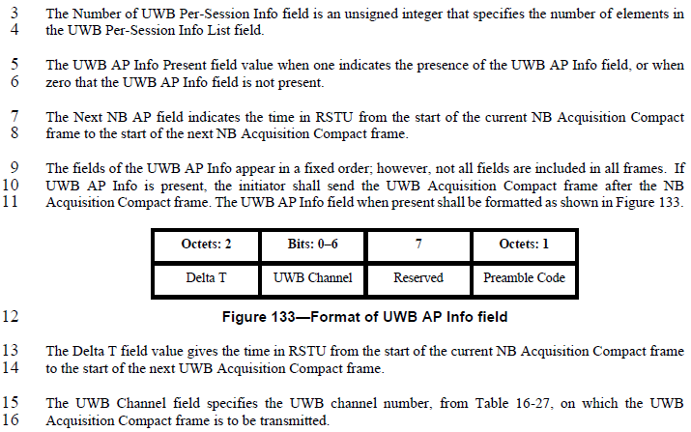

**Disposition Detail :**

**CID #214**

The comment makes sense. The “UWB Channel” field specifies the UWB channel number to use. The “UWB Channel” values in the range from 0 to 15 refer to legacy channel numbering defined in Table 16-27, while the values from 16 to 113 refer to the extended channel numbering as specified in 16.4.1.2.

To represent legacy channels (totally 16 channels), it looks just only 4 bits are needed to represent those, i.e. “Bit 0~3” not “Bit 0~4”. And, to represent extended channels (totally 114 channels), it seems totally 7 bits are needed to represent those, i.e. “Bit 0~6” as in original text.

I think there’s no reason to exclude extended channels here, so second option from commenter looks the right answer.

However, while “UWB Channel” field in Figure 133 is assigned as “Bits: 0-6”, “UWB Channel” field in Figure 134/135/136 are assigned as “Bits: 0-4”, which has no consistency, so Figure 134/135/136 also should be updated to keep consistency.

**CID #215**

The comment makes sense. As pointed out, “*Delta T*” is used two times inside an Acquisition Compact Frame. Therefore, either of these should have different name to distinguish.

The current “*Delta T*” in UWB AP Info field means the remaining time in RSTU from the start of the current NB Acquisition Compact frame to the start of the next UWB Acquisition Compact frame. So, we change this in Figure 133 into “Delta NB to UWB” as proposed from commenter.

**Disposition:**

CID #214 : Revised

CID #215 : Accepted

**Proposed text changes on P802.15.4ab™/Draft 2.0 :**

|  |  |  |  |  |  |  |  |  |  |  |  |  |  |  |  |  |  |  |  |  |  |  |  |  |  |  |  |  |  |  |  |  |  |  |  |  |  |  |  |  |  |  |  |  |
| --- | --- | --- | --- | --- | --- | --- | --- | --- | --- | --- | --- | --- | --- | --- | --- | --- | --- | --- | --- | --- | --- | --- | --- | --- | --- | --- | --- | --- | --- | --- | --- | --- | --- | --- | --- | --- | --- | --- | --- | --- | --- | --- | --- | --- |
| ***Change 10.39.11.3.17.2 P140L15 as below ;***  3 The Number of UWB Per-Session Info field is an unsigned integer that specifies the number of elements in  4 the UWB Per-Session Info List field.  5 The UWB AP Info Present field value when one indicates the presence of the UWB AP Info field, or when  6 zero that the UWB AP Info field is not present.  7 The Next NB AP field indicates the time in RSTU from the start of the current NB Acquisition Compact  8 frame to the start of the next NB Acquisition Compact frame.  9 The fields of the UWB AP Info appear in a fixed order; however, not all fields are included in all frames. If  10 UWB AP Info is present, the initiator shall send the UWB Acquisition Compact frame after the NB  11 Acquisition Compact frame. The UWB AP Info field when present shall be formatted as shown in Figure 133.   |  |  |  |  | | --- | --- | --- | --- | | Octets: 2 | Bits: 0-6 | 7 | Octets: 1 | | Delta NB to UWB | UWB Channel | Reserved | Preamble Code |   **Figure 133— Format of UWB AP Info field**  12  13 The Delta NB to UWB field value gives the time in RSTU from the start of the current NB Acquisition Compact frame  14 to the start of the next UWB Acquisition Compact frame.  15 The UWB Channel field specifies the extended UWB channel number, defined in section 16.4.1.2, on which the UWB  16 Acquisition Compact frame is to be transmitted.  17 The Preamble Code field specifies the preamble code index to be used for the UWB Acquisition Compact  18 frame transmission. This shall be a code index selected from either the length 91 ternary codes given in  19 Table 16-9 or the length 127 ternary codes given in Table 16-8.  ***Change Figure 134 / 135 / 136 in sub-clause 10.39.3.17.2 as below ;***   |  |  |  |  |  | | --- | --- | --- | --- | --- | | Octets: 3 | Bits: 0-6 | 7 |  | Octets: 1 | | Block Duration | UWB Channel | Hop mode |  | Preamble Code Index |   **Figure 134— Format of UWB Per-Session Info elements, type 1**   |  |  |  |  |  | | --- | --- | --- | --- | --- | | Octets: 3 | Bits: 0-6 | 7 | Octets: 1 | 3 | | Delta T | UWB Channel | Reserved | Preamble Code Index | Active Period Duration |   **Figure 135— Format of UWB Per-Session Info elements, type 2**   |  |  |  |  |  |  |  |  | | --- | --- | --- | --- | --- | --- | --- | --- | | Octets: 3 | Bits: 0-6 | 7 |  | Octets: 1 | 3 | 1 | 3 | | Delta T | UWB Channel | Hop mode |  | Preamble Code Index | Round Duration | Number of Rounds | Active Rounds |   **Figure 136— Format of UWB Per-Session Info elements, type 3** |

***Comment Indices in 15-25-0174-00-04ab-consolidated-comments-draft-2.0:***

|  |  |  |  |  |  |  |
| --- | --- | --- | --- | --- | --- | --- |
| **Name** | **Index#** | **Pg** | **Sub-Clause** | **line** | **Comment** | **Proposed Change** |
| PAKROOH, POORIA | 242 | 141 | 10.39.11.3.18 | 4 | Does this refer to round hopping? If it is enabled, what is the hopping pattern? | Clarify what "Hop Mode" refers to and what the hopping pattern is. |
| VERSO, BILLY | 579 | 141 | 10.39.11.3.19 | 4 | "for a block of UWB session" reads badly and is not clear in meaning, is it just one block or all blocks. I assumne all blocks, since round hopping acts acctoss multiple blocks. Also since this is essentially advertising | Make it clear by stating this bit "when one is indicating that round hopping is being used" (and not being used when = zero). MAKE SAME CHANGE ON p142 line 1. |

**Relevant Text :**

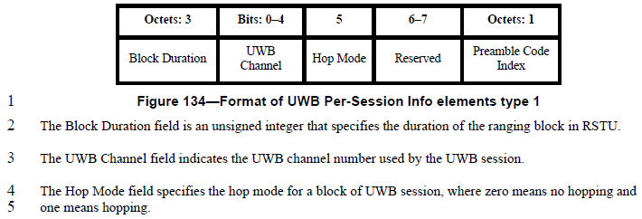

**Disposition Detail :**

**CID #242**

The “Hop Mode” refers to round hopping, which is in 10.32.3.3

In IEEE802.15.4z-2020 specification (pg.48), it says “… *However, it is assumed that as part of such function/protocol, the devices participating in the ranging exchange have either (a) pre-negotiated a hopping sequence that is known to all devices, or (b) have exchanged all the information necessary such that each device can generate the hopping sequence so that they know which ranging round in each ranging block is to be used if hopping. ….*

Therefore, the same rule also should apply to.

**CID #579**

Agree with the comment. The changes are made as suggested.

**Disposition:**

CID #242 : Revised

CID #579 : Revised

**Proposed text changes on P802.15.4ab™/Draft 2.0 :**

|  |
| --- |
| ***Change 10.39.11.3.19 P141L4 as below ;***    2 The Block Duration field is an unsigned integer that specifies the duration of the ranging block in RSTU.  3 The UWB Channel field indicates the UWB channel number used by the UWB session.  4 The Hop Mode field when one is indicating that round hopping specified in 10.32.3.3 is being used and not being used when zero.  ***Change 10.39.11.3.19 P142L1 as below ;***  1 The Hop Mode field when one is indicating that round hopping specified in 10.32.3.3 is being used and not being used when zero. |

***Comment Indices in 15-25-0174-00-04ab-consolidated-comments-draft-2.0:***

|  |  |  |  |  |  |  |
| --- | --- | --- | --- | --- | --- | --- |
| **Name** | **Index#** | **Pg** | **Sub-Clause** | **line** | **Comment** | **Proposed Change** |
| PAKROOH, POORIA | 243 | 144 | 10.39.12 | 21 | Channels 5 and 9 are popular UWB channel. It is good that we do not cause interference there by sending periodic Acquisition packets. | Change "9" to a value other than 5 or 9. |

**Relevant Text :**

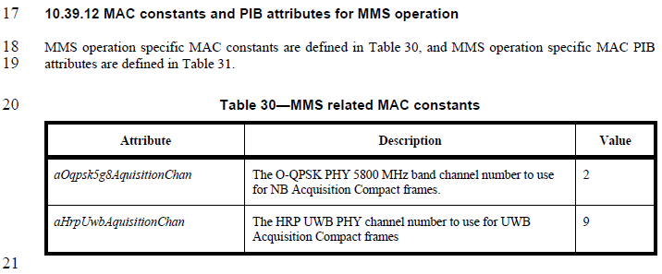

**Disposition Detail :**

Keep with 9 as is, as the default channel value is configurable.

**Disposition:**

Rejected

**Proposed text changes on P802.15.4ab™/Draft 2.0 :**

|  |  |  |  |  |  |  |  |  |  |
| --- | --- | --- | --- | --- | --- | --- | --- | --- | --- |
| ***Change 10.39.12 P144L21 as below ;***    **Table 30—MMS related MAC constants**   |  |  |  | | --- | --- | --- | | Attribute | Description | Value | | *aOqpsk5g8AquisitionChan* | The O-QPSK PHY 5800 MHz band channel number to use for NB Acquisition Compact frames. | 2 | | *aHrpUwbAquisitionChan* | The HRP UWB PHY channel number to use for UWB Acquisition Compact frames | 9 | |