IEEE P802.15
Wireless Personal Area Networks

Project | IEEE P802.15 Working Group for Wireless Personal Area Networks (WPANs)
Title | LB213/D02 comment resolution -- CIDs 509 and 186
Date Submitted | July 1, 2025
Sources | Alex Krebs (Apple)  krebs @ apple.com
Re:
Abstract
Purpose | To propose resolution for MMS related comments for “P802.15.4ab™/D02 Draft Standard for Low-Rate Wireless Networks”.
Notice | This document does not represent the agreed views of the IEEE 802.15 Working Group or IEEE 802.15.4ab Task Group. It represents only the views of the participants listed in the “Sources” field above. It is offered as a basis for discussion and is not binding on the contributing individuals. The material in this document is subject to change in form and content after further study. The contributors reserve the right to add, amend or withdraw material contained herein.

Table of contents

CID 509 3
CID 186 4

CID 509

Name | Index # | Page | Sub-clause | Line # | Comment | Proposed Change
VERSO, BILLY | 509 | 104 | 10.39.11.1.3.9 | 5 | is it worth rearanging to place 8-bit fields first so that they are byte octet alinged and pairs of 4-bit fields next, etc. to make software handling that little bit more efficient. | Consider. Then rearrange if worth it.

Discussion:

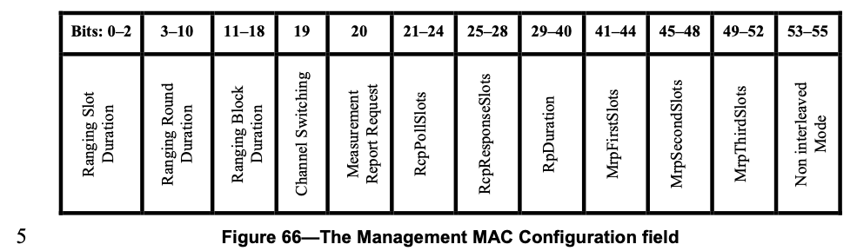

has currently bit lengths of [3, 8, 8, 1, 1, 4, 4, 12, 4, 4, 4, 3]

If we moved the red marked fields to the end, it would create more octet-ish alignment. If we additionally move the 1-bit fields first to the end, followed by the 3+8+8 bit fields, we also keep related fields adjacent.

Proposed resolution: Revised.
Disposition detail: Instruction to editor: Change p.104, Figure 66 to the following:

Bits: 0-3 | 4-7 | 8-19 | 20-23 | 24-27 | 28-31 | 32-34 | 35 | 36 | 37-39 | 40-47 | 48-55
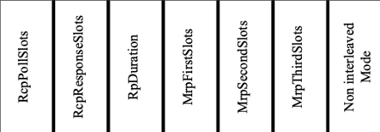 |  |  |  |  |  |  | 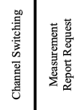 |  | 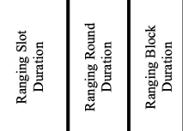

CID 186

Name | Index # | Page | Sub-clause | Line # | Comment | Proposed Change
MAMAN, MICKAEL | 186 | 105 | 10.39.11.1.3.9 | 9 | one to many Response compact frame instead of Poll | change Poll by Response

Discussion: Likely an oversight/typo.
Proposed resolution: Accepted.
Disposition detail: n/a

