**IEEE P802.15**

**Wireless Personal Area Networks**

|  |  |
| --- | --- |
| Project | IEEE P802.15 Working Group for Wireless Personal Area Networks (WPANs) |
| Title | **Resolution to 17 CIDs** |
| Date Submitted | July 1st, 2025 |
| Sources | Riku Pirhonen (NXP) |
| Abstract | Comment resolution to comments 21, 26, 22, 23, 297, 24, 172, 296, 467, 25, 468, 295, 529, 196, 302, 35, 197 |
| Purpose | Propose resolutions to comments received on IEEE P802.15.4ab/D02, March 2025. |
| Notice | This document does not represent the agreed views of the IEEE 802.15 Working Group or IEEE 802.15.4ab Task Group. It represents only the views of the participants listed in the “Sources” field above.It is offered as a basis for discussion and is not binding on the contributing individuals. The material in this document is subject to change in form and content after further study. The contributors reserve the right to add, amend or withdraw material contained herein. |
|  |

### Summary of comments

|  |  |  |  |  |  |  |
| --- | --- | --- | --- | --- | --- | --- |
| **Name** | **Index #** | **Page** | **Sub-clause** | **Line #** | **Comment** | **Proposed Change** |
| CHITRAKAR, ROJAN | 21 | 82 | 10.39.7 | 9 | "A non-interleaved ranging round may consist of one, two, three or four sub-rounds or a hybrid sub-round." What does "Hybrid sub-round" mean here? This is the only occurance of the term. | Either clarify the meaning of hybrind sub-round or replace with the actual number of sub-rounds required for the hybrid mode. |
| CHITRAKAR, ROJAN | 26 | 82 | 10.39.7 | 9 | What about the Report phase? Is it in a separate sub-round or included in the last sub-round. | Clarify the location of the Report phase for the various non-interleaved modes. |
| CHITRAKAR, ROJAN | 22 | 82 | 10.39.7 | 10 | Each of the ranging methods OWR, SS-TWR, DS-TWR with 3 or 4 MMS packets deserves to be described in separate sub-clauses, or at least separate paragraphs. | Describe each of the ranging methods: OWR, SS-TWR, DS-TWR with 3 or 4 MMS packets in separate sub-clauses, or at least separate paragraphs. |
| CHITRAKAR, ROJAN | 23 | 82 | 10.39.7 | 11 | What's the use case for hybrid mode? It is not clear if the SS-TWR and OWR is performed between the same initiator and responder? | Add a figure and related description for hybrid mode. |
| SUN, LIHSIANG | 297 | 82 | 10.39.7 | 11 | DS-TWR with four packets. Suggest to clarify in this case subround 3 is from responder and subround 4 is initiator | as in comment |
| CHITRAKAR, ROJAN | 24 | 82 | 10.39.7 | 12 | "The mode is signaled by the Non-Interleaved Mode parameter described in 10.39.11.1.3.9." Which frame? SOR, POLL or both? | Describe the Compact frame that may be used to signal non-interleaved mode. |
| MAMAN, MICKAEL | 172 | 82 | 10.39.7 | 14 | In the hybrid or OWR mode, How the OWR sub-round transmission can de defined by macMmsRcpPollNSlots and macMmsRcpRespNSlots? | Please Clarify |
| SUN, LIHSIANG | 296 | 82 | 10.39.7 | 14 | "In the hybrid mode, the OWR sub-round transmission can be either from the initiator to the responder or from the responder to the initiator, which is defined by macMmsRcpPollNSlots and macMmsRcpRespNSlots."   But macMmsRcpPollNSlots and macMmsRcpRespNSlots is used for interleaved SS-TWR, how it is reused to configure direction for OWR subround? | as in comment |
| VERSO, BILLY | 467 | 82 | 10.39.7 | 14 | It is wrong to refer to part of the hybrid mode as a "OWR sub-round transmission" it is part of the Hybrid DS-TWR. | Change "OWR sub-round transmission" to "non-interleaved sub-round transmission" |
| CHITRAKAR, ROJAN | 25 | 82 | 10.39.7 | 15 | It is not clear how the OWR sub-round transmitter is determined based on macMmsRcpPollNSlots and macMmsRcpRespNSlots | Describe how the OWR sub-round transmitter is determined based on macMmsRcpPollNSlots and macMmsRcpRespNSlots |
| VERSO, BILLY | 468 | 82 | 10.39.7 | 16 | It is not clear to me how vairables mmsRcpPollNSlots and mmsRcpRespNSlots, can define this. Both will need to have agreed values for the preceding interleaved exchange so how can they define the direction for the final sub-round? It would be more sensible to have the direction defined simply by which side is the initiator, which then would also send this final message. Failing that have a separate parameter specify it. | Delete clause 10.39.7 |
| SUN, LIHSIANG | 295 | 82 | 10.39.7 |  | How OWR direction is configured? RcpPollSlots and RcpResponseSlots does not seem to have value 0? | please clarify |
| VERSO, BILLY | 529 | 109 | 10.39.11.1.3.15 | 16 | This field looks like a better home for the signalling the interleaving ranging mode currently placed in MAC Configuration and also talking about ranging modes OWR, SS-TWR, DS-TWR etc. It is really NHL that is really implementing the ranging protocol and sending the packets involved at the appropriate time. | Move it to here, if that makes sense. And possibly merge them if there is cross over. |
| MAMAN, MICKAEL | 196 | 122 | 10.39.11.3.7 | 20 | This text is specific to non interleaved MMS. It could be extended to any DS-TWR | Add "In non-interleaved mode", before the definition of Round-trip Time and Reply Time field. Extention with "RMARKER selected" |
| SUN, LIHSIANG | 302 | 122 | 10.39.11.3.7 | 24 | The Reply Time field description does not seem to work for non interleaved mode 4 | as in comment |
| CHITRAKAR, ROJAN | 35 | 124 | 10.39.11.3.8 | 11 | A report variant of Figure 98 that includes "Round-trip time" field is also required. | Add the report variant (Message control three) of Figure 98 that includes "Round-trip time" field is also required. |
| MAMAN, MICKAEL | 197 | 124 | 10.39.11.3.8 | 20 | This text is specific to non interleaved MMS. It could be extended to any DS-TWR | Add "In non-interleaved mode", before the definition of Round-trip Time and Reply Time field. Extention with "RMARKER selected" |

**Comment #21**

|  |  |  |  |  |  |  |
| --- | --- | --- | --- | --- | --- | --- |
| **Name** | **Index #** | **Page** | **Sub-clause** | **Line #** | **Comment** | **Proposed Change** |
| CHITRAKAR, ROJAN | 21 | 82 | 10.39.7 | 9 | "A non-interleaved ranging round may consist of one, two, three or four sub-rounds or a hybrid sub-round." What does "Hybrid sub-round" mean here? This is the only occurance of the term. | Either clarify the meaning of hybrind sub-round or replace with the actual number of sub-rounds required for the hybrid mode. |

**Resolution** (Accepted/Rejected/**Revised**)

**Discussion:**

The description continues beyond the first sentence, but I agree the term “hybrid sub-round” is misleading. A hybrid ranging round would consist of two sub-rounds having interleaved and non-interleaved ranging packets, which are in D02 referred as consecutive SS-TWR and OWR.

**Change:**

Page 82: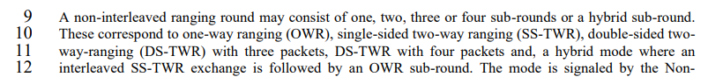

To clarify the terminology the text on page 82 can be modifed to say:

A non-interleaved ranging round may consist of one, two, three or four sub-rounds ~~or a hybrid sub-round~~. These correspond to one-way ranging (OWR), single-sided two-way ranging (SS-TWR), double-sided two way-ranging (DS-TWR) with three packets~~,~~ and a DS-TWR with four packets. ~~and, a~~ A hybrid ~~mode~~ ranging round consists of  ~~where~~ an interleaved SS-TWR sub-round ~~is~~ followed by an OWR sub-round.

Editor is kindly asked to align the terminology in Table 19 to match this terminology.

**Table 19 – Values of Interlaving Mode field**

|  |  |
| --- | --- |
| **Interleaving Mode field value** | **Heading** |
| 0 | Interleaved mode (SS-TWR) |
| 1 | One non-interleaved sub-round (OWR) |
| 2 | Two non-interleaved sub-rounds (SS-TWR) |
| 3 | Three non-interleaved sub-rounds (DS-TWR) |
| 4 | Four non-interleaved sub-rounds (DS-TWR) |
| 5 | Hybrid ranging ~~sub-~~round~~s~~ with one interleaved and one non-interleaved sub-round (DS-TWR) |
| 6 | Two interleaved sub-rounds (DS-TWR) |
| 7 | Reserved |

**Comment #26**

|  |  |  |  |  |  |  |
| --- | --- | --- | --- | --- | --- | --- |
| **Name** | **Index #** | **Page** | **Sub-clause** | **Line #** | **Comment** | **Proposed Change** |
| CHITRAKAR, ROJAN | 26 | 82 | 10.39.7 | 9 | What about the Report phase? Is it in a separate sub-round or included in the last sub-round. | Clarify the location of the Report phase for the various non-interleaved modes. |

**Resolution** (Accepted/Rejected/**Revised**)

**Discussion:**

Report phase follows the ranging phase after completiton of the sub-rounds. There are no changes to the optional report phase location, it follows the ranging phase as described in Figure 26.

**Change:**



To clarify the text on page 82 line 13 can be changed into:

In the non-interleaved mode, the sub-rounds ~~control and ranging phases,~~ may be followed by ~~an~~ the optional report phase after all the sub-rounds are completed.

**Comment #22**

|  |  |  |  |  |  |  |
| --- | --- | --- | --- | --- | --- | --- |
| **Name** | **Index #** | **Page** | **Sub-clause** | **Line #** | **Comment** | **Proposed Change** |
| CHITRAKAR, ROJAN | 22 | 82 | 10.39.7 | 10 | Each of the ranging methods OWR, SS-TWR, DS-TWR with 3 or 4 MMS packets deserves to be described in separate sub-clauses, or at least separate paragraphs. | Describe each of the ranging methods: OWR, SS-TWR, DS-TWR with 3 or 4 MMS packets in separate sub-clauses, or at least separate paragraphs. |

**Resolution** (Accepted/Rejected/**Revised**)

**Discussion**:

The concepts for SS-TWR, DS-TWR with 3 or 4 packets and OWR are described in chapter 10.29.1.2. To clarify the use of these modes in context of MMS more clarifying text as suggested and pictures can be added.

**Change:**

Replace the text on page 82 line 14 – 24 with the text below.

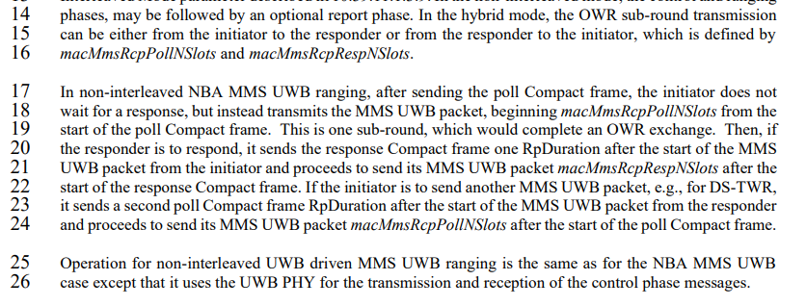

~~In the hybrid mode, the OWR sub-round transmission can be either from the initiator to the responder or from the responder to the initiator, which is defined by macMmsRcpPollNSlots and macMmsRcpRespNSlots.~~

~~In non-interleaved NBA MMS UWB ranging, after sending the poll Compact frame, the initiator does not wait for a response, but instead transmits the MMS UWB packet, beginning macMmsRcpPollNSlots from the start of the poll Compact frame. This is one sub-round, which would complete an OWR exchange. Then, if the responder is to respond, it sends the response Compact frame one RpDuration after the start of the MMS UWB packet from the initiator and proceeds to send its MMS UWB packet macMmsRcpRespNSlots after the start of the response Compact frame. If the initiator is to send another MMS UWB packet, e.g., for DS-TWR, it sends a second poll Compact frame RpDuration after the start of the MMS UWB packet from the responder and proceeds to send its MMS UWB packet macMmsRcpPollNSlots after the start of the poll Compact frame.~~

~~Operation for non-interleaved UWB driven MMS UWB ranging is the same as for the NBA MMS UWB case except that it uses the UWB PHY for the transmission and reception of the control phase messages.~~

**Single-sided two-way ranging**

In NBA-MMS non-interleaved SS-TWR consists of two sub-rounds. The Initiator sends poll compact frame followed by a MMS packet *macMmsRcpPollNSlot* after start of the poll compact frame without waiting for the response compact frame from the responder. This forms the first sub-round, which has length *macMmsRcpPollNSlot* + *macMmsRpDuration*. The responder starts sub-round 2 with response compact frame one *macMmsRpDurtion* after reception of the start of the MMS packet sent by the initiator and continues with a MMS packet *macMmsRcpRespNSlots* after start of sub-round 2. These form the second sub-round, which has length *macMmsRcpRespNSlot* + *macMmsRpDuration*.

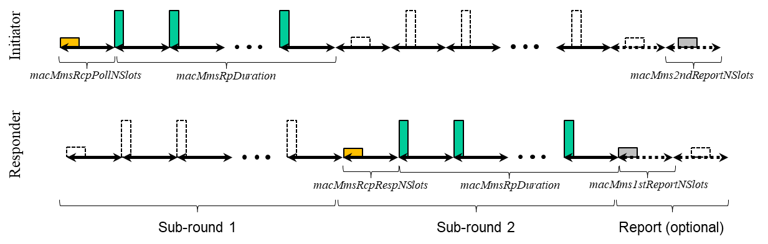

Figure XX NBA-MMS non-interleaved SS-TWR

**Double-sided two-way ranging with three packets**

In DS-TWR with 3 packets starts with similar exchange as SS-TWR. After the sub-round 2, sub-round 3 starts by repetition of the compact poll frame by the initiator at *macMmsRpDuration* after start of the MMS packet sent by the responder in sub-round 2. Initiator transmits a MMS ranging packet *macMmsRcpPollNSlots* after the start of sub-round 3.

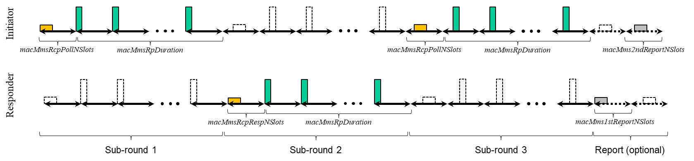

Figure XX NBA-MMS non-interleaved DS-TWR with 3 packets

**Double-sided two-way ranging with four packets**

In DS-TWR with 4 packets starts with similar exchange as SS-TWR. After the sub-round 2, sub-round 3 starts by repetition of the response compact frame by the responder at *macMmsRpDuration* after start of the MMS packet sent by the responder in sub-round 2. Responder transmits a MMS ranging packet *macMmsRcpRespNSlots* after the start of sub-round 3. Initiator responds to responder in sub-round 4 by sending poll compact frame *macMmsRpDuration* after start of the MMS ranging packet sent by responder in sub-round 3. Initiator transmits ranging MMS packet *macMmsRcpPollNSlots* after start of the sub-round 4.

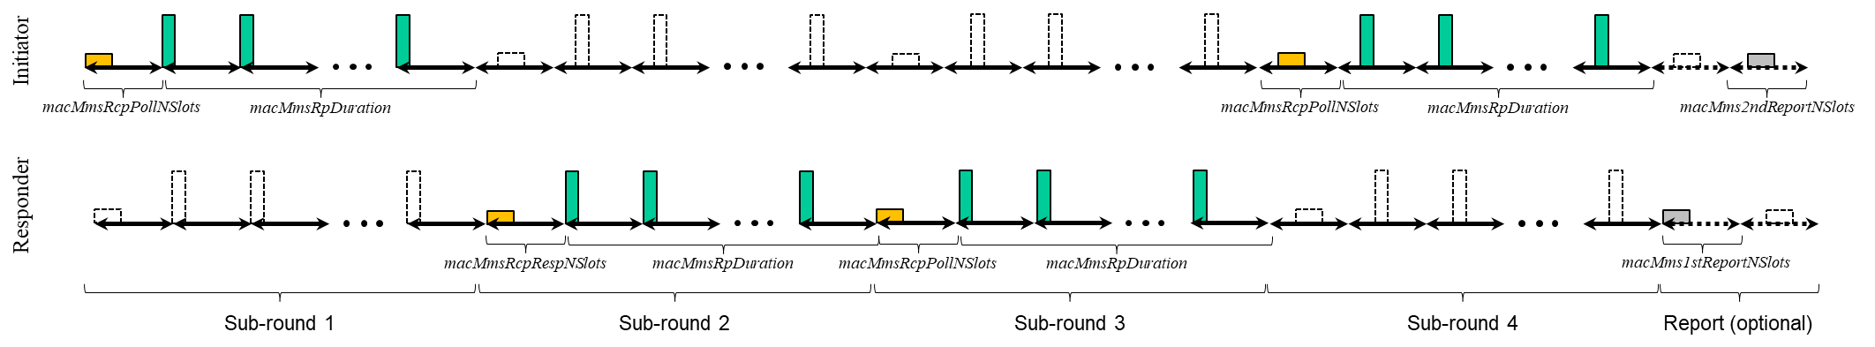

Figure XX NBA-MMS non-interleaved SS-TWR with 4 packets

**Hybrid ranging**

An hybrid ranging round consists of an interleaved sub-round 1 and non-interleaved sub-round 2. An interleaved SS-TWR style exchange is done in sub-round 1. After the interleaved sub-round 1 exchange the Initiator repeats the packets it used during the sub-round 1 in a non-interleaved sub-round 2. The Initiator starts transmission MacMmsRpDuration after reception of the start of the MMS Ranging packet from the Responder. Initiator doesn’t wait for response from the responder after the poll, but transmits the UWB ranging packet macMmsRcpPollNSlots after the start of the sub-round 2. The responder doesn’t transmit during the sub-round 2.

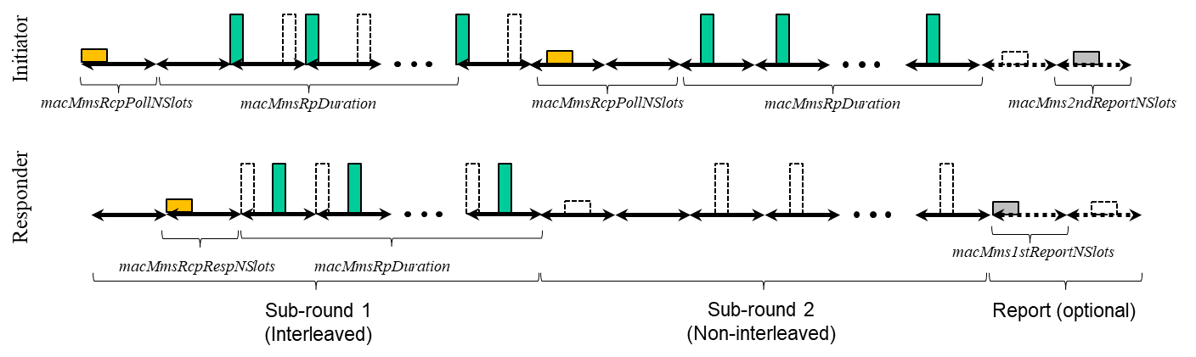

Figure XX NBA-MMS hybrid ranging

**One-way ranging**

One-way ranging is procedure where transmission happens only in one direction. Initiator transmits poll compact frame and the MMS packet, responder doesn’t respond.

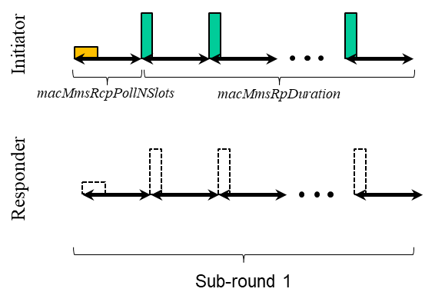

Figure XX NBA-MMS one-way ranging

**Non-interleaved UWB Driven MMS**

Operation for non-interleaved UWB driven MMS UWB ranging is similar to NBA MMS UWB case except that control phase uses UWB and ranging phase MMS UWB packet configuration two as defined by management MAC configuration field.

**Comment #23**

|  |  |  |  |  |  |  |
| --- | --- | --- | --- | --- | --- | --- |
| **Name** | **Index #** | **Page** | **Sub-clause** | **Line #** | **Comment** | **Proposed Change** |
| CHITRAKAR, ROJAN | 23 | 82 | 10.39.7 | 11 | What's the use case for hybrid mode? It is not clear if the SS-TWR and OWR is performed between the same initiator and responder? | Add a figure and related description for hybrid mode. |

**Resolution** (Accepted/Rejected/**Revised**)

See resolution to Comment #21 and #22. Text added to describe hybrid ranging round.

**Comment #297**

|  |  |  |  |  |  |  |
| --- | --- | --- | --- | --- | --- | --- |
| **Name** | **Index #** | **Page** | **Sub-clause** | **Line #** | **Comment** | **Proposed Change** |
| SUN, LIHSIANG | 297 | 82 | 10.39.7 | 11 | DS-TWR with four packets. Suggest to clarify in this case subround 3 is from responder and subround 4 is initiator | as in comment |

**Resolution** (Accepted/Rejected/**Revised**)

Clarification added, see Comment #22.

**Comment #24**

|  |  |  |  |  |  |  |
| --- | --- | --- | --- | --- | --- | --- |
| **Name** | **Index #** | **Page** | **Sub-clause** | **Line #** | **Comment** | **Proposed Change** |
| CHITRAKAR, ROJAN | 24 | 82 | 10.39.7 | 12 | "The mode is signaled by the Non-Interleaved Mode parameter described in 10.39.11.1.3.9." Which frame? SOR, POLL or both? | Describe the Compact frame that may be used to signal non-interleaved mode. |

**Resolution** (Accepted/**Rejected**/Revised)

**Discussion:**

The non-interleaved mode is indicated by the Control MAC Configuration parameter Non-interleaved mode shown in D02 Figure 66. The name of the parameter was later changed into Interleaving mode in Doc 25/258r1. It can be indicated in SOR or POLL if so wished, so there is no need to separately specify the compact frames.

**Comment #172**

|  |  |  |  |  |  |  |
| --- | --- | --- | --- | --- | --- | --- |
| **Name** | **Index #** | **Page** | **Sub-clause** | **Line #** | **Comment** | **Proposed Change** |
| MAMAN, MICKAEL | 172 | 82 | 10.39.7 | 14 | In the hybrid or OWR mode, How the OWR sub-round transmission can de defined by macMmsRcpPollNSlots and macMmsRcpRespNSlots? | Please Clarify |

**Resolution:** (Accepted/Rejected/**Revised**)

**Discussion:** Use of these parameters to indicate presence of transmission in one or another direction is not very clean solution and could lead to confusion. The proposed resolution is to remove the reference to *macMmsRcpPollNSlots* and *macMmsRcpRespNSlots* in this context. The roles, initator and responder, are defined by the use case and controlled by higher layers. If swiching of the roles is needed, it can be introduced as a separate control parameter (see contribution 25/224r1).

**Change:**



Remove the reference to OWR on page 82, lines 14 – 16.

~~In the hybrid mode, the OWR sub-round transmission can be either from the initiator to the responder or from the responder to the initiator, which is defined by~~ *~~macMmsRcpPollNSlots~~* ~~and~~ *~~macMmsRcpRespNSlots~~*~~.~~

**Comment #296**

|  |  |  |  |  |  |  |
| --- | --- | --- | --- | --- | --- | --- |
| **Name** | **Index #** | **Page** | **Sub-clause** | **Line #** | **Comment** | **Proposed Change** |
| SUN, LIHSIANG | 296 | 82 | 10.39.7 | 14 | "In the hybrid mode, the OWR sub-round transmission can be either from the initiator to the responder or from the responder to the initiator, which is defined by macMmsRcpPollNSlots and macMmsRcpRespNSlots."   But macMmsRcpPollNSlots and macMmsRcpRespNSlots is used for interleaved SS-TWR, how it is reused to configure direction for OWR subround? | as in comment |

**Resolution:** (Accepted/Rejected/**Revised**)

**Discussion:** Use of these parameters to indicate presence of transmission in one or another direction is not very clean solution and could lead to confusion. The proposed resolution is to remove the reference to *macMmsRcpPollNSlots* and *macMmsRcpRespNSlots* in this context.

**Change:** See resolution #172

**Comment #467**

|  |  |  |  |  |  |  |
| --- | --- | --- | --- | --- | --- | --- |
| **Name** | **Index #** | **Page** | **Sub-clause** | **Line #** | **Comment** | **Proposed Change** |
| VERSO, BILLY | 467 | 82 | 10.39.7 | 14 | It is wrong to refer to part of the hybrid mode as a "OWR sub-round transmission" it is part of the Hybrid DS-TWR. | Change "OWR sub-round transmission" to "non-interleaved sub-round transmission" |

**Resolution:** (Accepted/Rejected/**Revised**)

**Discussion:** Agreed. The comment is taken into account in resolution #22.

**Change:** See resolution #22.

**Comment #25**

|  |  |  |  |  |  |  |
| --- | --- | --- | --- | --- | --- | --- |
| **Name** | **Index #** | **Page** | **Sub-clause** | **Line #** | **Comment** | **Proposed Change** |
| CHITRAKAR, ROJAN | 25 | 82 | 10.39.7 | 15 | It is not clear how the OWR sub-round transmitter is determined based on macMmsRcpPollNSlots and macMmsRcpRespNSlots | Describe how the OWR sub-round transmitter is determined based on macMmsRcpPollNSlots and macMmsRcpRespNSlots |

**Resolution:** (Accepted/Rejected/**Revised**)

**Discussion:** Use of these parameters to indicate presence of transmission in one or another direction is not very clean solution and could lead to confusion. The proposed resolution is to remove the reference to *macMmsRcpPollNSlots* and *macMmsRcpRespNSlots* in this context.

**Change:** See resolution #172

**Comment #468**

|  |  |  |  |  |  |  |
| --- | --- | --- | --- | --- | --- | --- |
| **Name** | **Index #** | **Page** | **Sub-clause** | **Line #** | **Comment** | **Proposed Change** |
| VERSO, BILLY | 468 | 82 | 10.39.7 | 16 | It is not clear to me how vairables mmsRcpPollNSlots and mmsRcpRespNSlots, can define this. Both will need to have agreed values for the preceding interleaved exchange so how can they define the direction for the final sub-round? It would be more sensible to have the direction defined simply by which side is the initiator, which then would also send this final message. Failing that have a separate parameter specify it. | Delete clause 10.39.7 |

**Resolution:** (Accepted/Rejected/**Revised**)

**Discussion:** Use of these parameters to indicate presence of transmission in one or another direction is not very clean solution and could lead to confusion. The proposed resolution is to remove the reference to *macMmsRcpPollNSlots* and *macMmsRcpRespNSlots* in this context.

**Change:** See resolution #172

**Comment #295**

|  |  |  |  |  |  |  |
| --- | --- | --- | --- | --- | --- | --- |
| **Name** | **Index #** | **Page** | **Sub-clause** | **Line #** | **Comment** | **Proposed Change** |
| SUN, LIHSIANG | 295 | 82 | 10.39.7 |  | How OWR direction is configured? RcpPollSlots and RcpResponseSlots does not seem to have value 0? | please clarify |

**Resolution:** (Accepted/Rejected/**Revised**)

**Discussion:** Use of these parameters to indicate presence of transmission in one or another direction is not very clean solution and could lead to confusion. The proposed resolution is to remove the reference to *macMmsRcpPollNSlots* and *macMmsRcpRespNSlots* in this context.

**Change:** See resolution #172

**Comment #529**

|  |  |  |  |  |  |  |
| --- | --- | --- | --- | --- | --- | --- |
| **Name** | **Index #** | **Page** | **Sub-clause** | **Line #** | **Comment** | **Proposed Change** |
| VERSO, BILLY | 529 | 109 | 10.39.11.1.3.15 | 16 | This field looks like a better home for the signalling the interleaving ranging mode currently placed in MAC Configuration and also talking about ranging modes OWR, SS-TWR, DS-TWR etc. It is really NHL that is really implementing the ranging protocol and sending the packets involved at the appropriate time. | Move it to here, if that makes sense. And possibly merge them if there is cross over. |

**Resolution:** (Accepted/**Rejected**/Revised)

**Discussion:** Management MAC Configuration field (Figure 66) has other related MAC parameters such as duration of different parts of the ranging round and is included in SOR when the Message Control Field value is zero. The MMS Ranging Mode configuration on the other hand deals with the number of participants in the ranging process and requires different SOR message content field value 2. Non-interleaved mode and one-to-many ranging modes are not exclusive. Basic one-to-many ranging could be done done also in non-interleaved mode. Therefore use of Management MAC Configuration field is preferred.

**Comment #196**

|  |  |  |  |  |  |  |
| --- | --- | --- | --- | --- | --- | --- |
| **Name** | **Index #** | **Page** | **Sub-clause** | **Line #** | **Comment** | **Proposed Change** |
| MAMAN, MICKAEL | 196 | 122 | 10.39.11.3.7 | 20 | This text is specific to non interleaved MMS. It could be extended to any DS-TWR | Add "In non-interleaved mode", before the definition of Round-trip Time and Reply Time field. Extention with "RMARKER selected" |

**Resolution**: (Accepted/Rejected/**Revised**)

**Discussion:** The Initiator report description can be generalized to reflect any DS-TWR initiator report.

**Change:**

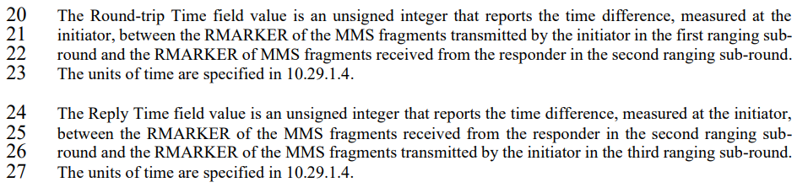

The Round-trip Time field value (*Tround1*) is an unsigned integer that reports the time difference, measured at the initiator, between the RMARKER selected of the MMS fragments of the first MMS packet transmitted by the initiator ~~in the first ranging sub-round~~ and the RMARKER selected of MMS fragments received from the responder in the second MMS packet ~~ranging sub-round~~. ~~The units of time are specified in 10.29.1.4.~~

In case of DS-TWR with three packets ~~T~~the Reply Time (*Treply2*) field value is an unsigned integer that reports the time difference, measured at the initiator, between the RMARKER selected of the MMS fragments received from the responder in the second MMS packet ~~ranging sub-round~~ and the RMARKER selected of the MMS fragments transmitted by the initiator in the third MMS packet ~~ranging sub-round~~. ~~The units of time are specified in 10.29.1.4.~~

In case of DS-TWR with four packets the Reply Time (*Treply2*) field value is an unsigned integer that reports the time difference, measured at the initiator, between the RMARKER selected of the MMS fragments received from the responder in the third MMS packet and the RMARKER selected of the MMS fragments transmitted by the initiator in the fourth MMS packet.

The units of time are specified in 10.29.1.4. and for DS-TWR reference, see Figures 10-198 and 10-199.

**Comment #302**

|  |  |  |  |  |  |  |
| --- | --- | --- | --- | --- | --- | --- |
| **Name** | **Index #** | **Page** | **Sub-clause** | **Line #** | **Comment** | **Proposed Change** |
| SUN, LIHSIANG | 302 | 122 | 10.39.11.3.7 | 24 | The Reply Time field description does not seem to work for non interleaved mode 4 | as in comment |

**Resolution:** (Accepted/Rejected/**Revised**)

Agreed. The comment is taken into account in resolutions for #196 and #197.

**Comment #35**

|  |  |  |  |  |  |  |
| --- | --- | --- | --- | --- | --- | --- |
| **Name** | **Index #** | **Page** | **Sub-clause** | **Line #** | **Comment** | **Proposed Change** |
| CHITRAKAR, ROJAN | 35 | 124 | 10.39.11.3.8 | 11 | A report variant of Figure 98 that includes "Round-trip time" field is also required. | Add the report variant (Message control three) of Figure 98 that includes "Round-trip time" field is also required. |

**Resolution:** (Accepted/Rejected/**Revised**)

**Discussion:** Introduce Message Content field for Message Control field value 3 as proposed.

**Change:**

Enter following text at the end of subclause 10.39.11.3.8 on page 124 after line 23

When the Message Control field value (within the Message ID field) is three, the Message Content field shall be formatted as shown in Figure XX.

|  |  |  |  |  |  |  |  |  |
| --- | --- | --- | --- | --- | --- | --- | --- | --- |
| **Octets: 5** | **5** | **1** | **0/2/5/6** | **0/1** | **0/8** | **0/4** | **0/1** | **0/variable** |
| Reply Time | Roundtrip Time | Presence Bitmap | NB Channel Map | Management PHY Configuration | Management MAC Configuration | Ranging PHY Configuration | MMS Number of Fragments | Passthrough |

Figure XX - Format of the Message Content field in the One-to-one Responder Report Compact frame when the Message Control field value is three

The Reply Time field value (*Treply1*) is an unsigned integer that reports the time difference, measured at the responder, between the RMARKER selected of the MMS fragments received from the initiator in the first ranging packet and the RMARKER of MMS fragments transmitted by the responder in the second ranging packet.

In case of DS-TWR with three packets ~~T~~the Round-trip Time (*Tround2*) field value is an unsigned integer that reports the time difference, measured at the responder, between the RMARKER selected of the MMS fragments transmitted by the responder in the second ranging packet and the RMARKER selected of the MMS fragments received from the initiator in the third ranging packet.

In case of DS-TWR with four packets the Round-trip Time (*Tround2*) field value is an unsigned integer that reports the time difference, measured at the responder, between the RMARKER selected of the MMS fragments transmitted by the responder in the third ranging packetand the RMARKER selected of the MMS fragments received from the initiator in the fourth ranging packet.

The units of time are specified in 10.29.1.4. and for DS-TWR reference, see Figures 10-198 and 10-199.

The Presence Bitmap field is set as specified in 10.39.11.1.3.14, except that the Block and Round Index Present field and the Extended Presence Bitmap Present field shall both be set to zero.

The encodings and meanings of the subsequent fields in the frame content is identical to that of the Advertising Response Compact frame with Message Control field value (within the Message ID field) of one.

For the One-to-one Responder Report Compact frame with Message Control field value (within the MessageID field) of one, at least one of the NB Channel Map, Management PHY Configuration, Management MAC Configuration, Ranging PHY Configuration, or MMS Number of Fragments fields shall be present in the Message Content field.

The Passthrough field is defined in 10.39.11.1.3.3. In the receiver the presence of the Passthrough field can be inferred from the received frame length.

**Comment #197**

|  |  |  |  |  |  |  |
| --- | --- | --- | --- | --- | --- | --- |
| **Name** | **Index #** | **Page** | **Sub-clause** | **Line #** | **Comment** | **Proposed Change** |
| MAMAN, MICKAEL | 197 | 124 | 10.39.11.3.8 | 20 | This text is specific to non interleaved MMS. It could be extended to any DS-TWR | Add "In non-interleaved mode", before the definition of Round-trip Time and Reply Time field. Extention with "RMARKER selected" |

**Resolution**: (Accepted/Rejected/**Revised**)

**Discussion:** The Responder report description can be generalized to reflect any DS-TWR responder report and also DS-TWR with four packets can be added.

**Change:**

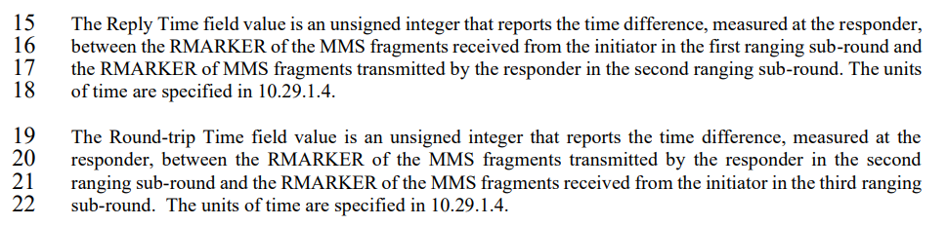

The Reply Time field value (*Treply1*) is an unsigned integer that reports the time difference, measured at the responder, between the RMARKER selected of the MMS fragments received from the initiator in the first ranging packet ~~sub-round~~ and the RMARKER of MMS fragments transmitted by the responder in the second ranging packet ~~sub-round~~. ~~The units of time are specified in 10.29.1.4.~~

In case of DS-TWR with three packets ~~T~~the Round-trip Time (*Tround2*) field value is an unsigned integer that reports the time difference, measured at the responder, between the RMARKER selected of the MMS fragments transmitted by the responder in the second ranging packet ~~sub-round~~ and the RMARKER selected of the MMS fragments received from the initiator in the third ranging packet ~~sub-round~~. ~~The units of time are specified in 10.29.1.4.~~

In case of DS-TWR with four packets the Round-trip Time (*Tround2*) field value is an unsigned integer that reports the time difference, measured at the responder, between the RMARKER selected of the MMS fragments transmitted by the responder in the third ranging packetand the RMARKER selected of the MMS fragments received from the initiator in the fourth ranging packet.

The units of time are specified in 10.29.1.4. and for DS-TWR reference, see Figures 10-198 and 10-199.