IEEE P802.15
Wireless Personal Area Networks

Project | IEEE P802.15 Working Group for Wireless Personal Area Networks (WPANs)
Title | D02 Miscellaneous Comment Resolutions VI
Date Submitted | 10 September 2025
Source | Billy Verso (Qorvo), | billy.verso at qorvo.com
Re: | IEEE P802.15.4ab
Abstract | Comment Resolutions for selected comments on the LB213 / P802.15.4ab D02.
Purpose | This document provides text changes intended to be part of the final IEEE Std 802.15.4ab (amendment to IEEE Std 802.15.4), as part of resolving selected comments from the consolidated spreadsheet (DCN 15-25-0174) that have been assigned to the author to resolve.
Notice | This document does not represent the agreed views of the IEEE 802.15 Working Group or IEEE 802.15.4ab Task Group. It represents only the views of the participants listed in the “Source(s)” field above. It is offered as a basis for discussion and is not binding on the contributing individual(s) or organization(s). The material in this document is subject to change in form and content after further study. The contributor(s) reserve(s) the right to add, amend or withdraw material contained herein.
Release | The contributor acknowledges and accepts that this contribution becomes the property of IEEE and may be made publicly available by P802.15.
Patent Policy | The contributor is familiar with the IEEE-SA Patent Policy and Procedures.  <https://standards.ieee.org/about/sasb/patcom/materials/>

Comments addressed here:
See list on page 2.

Introduction
This submission addresses some more comments relating to the distinction between MAC functionality and Next Higher Layer functionality.
1 Comment Index #s 391 and 582 3
2 Comment Index #s 392, 383 and 394 4
3 Comment Index # 396 4
4 Comment Index # 413 5
5 Comment Index # 450 5
6 Comment Index # 455 6
7 Comment Index # 460 7
8 Comment Index # 462 7
9 Comment Index # 486 8
10 Comment Index # 528 8
11 Comment Index # 583 9
12 Comment Index #s 510 and 511 10
13 Comment Index #s 512 and 513 11
14 Comment Index #s 515 and 516 11

- Comment Index #s 391 and 582
Ind | Pg | clause | line | Comment | Proposed Change
391  (Billy) | 65 | 10.39.3.1 | 36 | I think some of the parameters in the referenced table 31 are not really MAC level parameters but are rather "mms protocol parameters" that the MMS Higher Layers in each device needs to know to drive the MAC appropriately. These NHL configurations are agreed via in band or OOB mechanisms. The macMmsNbInitChannel and macMmsNbInitMode fall into this category. e.g., the MMS NHL knowing the mmsNbInitChannel, should set the phyCurrentChannelInfo appropriately before sending/receiving the init channel messages. etc. | "Separate mac PIB attributes, and mms NHL protocol control variables, and update this clause accordingly.
582  (Billy) | 144 | 10.39.12 | 22 | In hindsight it was wrong for many of the parameters in Table 31 to be made into MAC PIB attributes. Some may be controlling MAC activity, but many are specifying protocol timings for activities at NHL, i.e., the MAC is not really implementing the protocol, it is the NHL that is deciding what flavour of message to send when. It is the NHL that initiates that sending invoking the MCPS-DATA.request to provide the frame and specify the TX time. For those parameters not actually used by the MAC it would be clearer to recast these as MMS protocol control parameters, as they were originally provided. | Revert appropriate parameters to protocol specification variables so that they are not confused with PIB parameters that actually control specific MAC activity.
Discussion:
In the original documents describing the MMS ranging protocol, (15-22-0381, 15-23-0371, 15-23-0412, etc.), the variables defining the protocol were just called parameters. Making all of these into MAC PIB attributes (which the editor did) in hindsight was the wrong thing to do. Arguably most of these are solely parameters of the ranging protocol in the realms of the next higher layer (NHL) and not really used directly by the MAC.
The commenter is asking for these to be separated out to ease the task of MAC implementors, allowing them to clearly see what is at MAC level and what is at ranging protocol level.
The goal of this is to keep the MAC definition simple knowing that the protocol is complex (potentially with a device participating in multiple sessions) and properly identify what are protocol variables in the realms of the next higher layer rather than MAC controls. To embed this functionality at the MAC layer, we would need to do a lot more work, but let’s not consider that since really this protocol should not be at MAC level. Ranging to many devices in multiple complex schemes is arguably a higher layer protocol networking function.
The proposed changes to address this are actually pretty straightforward, simply redesignate sub-clause 10.39.12 as “MMS UWB ranging parameters, MAC constants and PIB attributes”, and separate/redesignate the appropriate parameters as “mms” parameters rather than “mac” attributes.
Proposed Disposition: Revised. Disposition Detail: see below
Instructions to the editor:
- Change the title of sub-clause 10.39.12 from “MAC constants and PIB attributes for MMS operation” to “MMS UWB ranging parameters, MAC constants and PIB attributes”.

- Change title of Table 31 from “MMS related MAC PIB attributes” to “MMS UWB ranging parameters.”

- Create a new table for “MMS related MAC PIB attributes” and move the following parameters from table 31 into the new table: macIrkDescriptor, macMmsPrngSeed

- Rename all remaining table 31 parameters changing “macMmsParameterName” to “mmsParameterName”, and wherever they appear elsewhere in the draft.

- Comment Index #s 392, 383 and 394
Ind | Pg | clause | line | Comment | Proposed Change
392  (Billy) | 65 | 10.39.3.1 | 36 | macMmsNbInitChannel should be NHL protocol control variable, PHY channel is selected by phyCurrentChannelInfo | Change macMmsNbInitChannel to mmsNbInitChan parameter to be known by NHL, and update text accordingly.
393  (Billy) | 66 | 10.39.3.1 | 1 | macMmsNbInitMode should be NHL protocol control variable, O-PQSK PHY config (for TX) is select modes is selected by MCPS-DATA.request TxOptions parameter DataRate (see p25 L#3) | Change macMmsNbInitChannel to mmsNbInitChan parameter to be known by NHL, and update text accordingly.
394  (Billy) | 66 | 10.39.3.1 | 1 | Instead of "set by the higher layer" | change to "pre-agreed by higher layers"
Discussion:
These relate to the same point as Comment Index #s 391, 582 above, and based on its resolution proposal, the resolution for these three CIDs (392, 383 and 394) is as below:
Proposed Disposition: Revised. Disposition Detail: see below
Change the sentence from:
Configuration attributes as given in Table 31, including initialization channel selected by the macMmsNbInitChannel attribute and the modulation selected by the macMmsNbInitMode attribute, are set by the higher layer prior to the initialization and setup phase.
To:
The operating parameters given in Table 31, including mmsNbInitChannel and mmsNbInitMode, are selected by the higher layers prior to the initialization and setup phase.

Comment Index # 396
Ind | Pg | clause | line | Comment | Proposed Change
396  (Billy) | 66 | 10.39.3.2 | 17 | macMmsNbInitSlotDuration should be NHL protocol control variable, transmission times (slot boundaries) are determined by when the NHL submits the MCPS-DATA.request with the frame to transmit, (and TxTimeSpecified = RSTU_TIME) | Change macMmsNbInitSlotDuration to mmsNbInitSlotDuration parameter to be known by NHL, and update text accordingly.
Discussion:
This relates to the same point as Comment Index #s 391, 582 above, and is resolved by the changes proposed for it. With those changes made, no further changes are needed and the resolution for this comment is as below.
Proposed Disposition: Revised.
Disposition Detail: Resolved by changes nominated for Comment Index #s 391, 582 above.

- Comment Index # 413
Ind | Pg | clause | line | Comment | Proposed Change
413  (Billy) | 70 | 10.39.3.4 | 20 | Another comment said macMmsNbInitSlotDuration should be NHL protocol control variable, assuming that is the case then this paragraph should change accordingly. | Change to "Updates to the mmsNbInitSlotDuration agreed by the next higher layers may be signalled on the initialization channel using the Advertising Poll Compact frame or Public Advertising Poll Compact frame."
Discussion:
This relates to the paragraph screen shot below, and Comment Index #s 391, 582 above.
Based on the resolution proposal for comment indexes 391 and 582, the resolution for this comment is as below.
Proposed Disposition: Revised. Disposition Detail: Change the paragraph to:
The mmsNbInitSlotDuration value defines the initialization slot duration. The default value is given in Table 31. This value might be changed by the next higher layers prior to use. The value can be signalled on the initialization channel in the Advertising Poll Compact frame or Public Advertising Poll Compact frame.

- Comment Index # 450
Ind | Pg | clause | line | Comment | Proposed Change
450  (Billy) | 78 | 10.39.3.8 | 32 | I think some of the parameters in the referenced table 31 are not really MAC level parameters but are rather mmsParameters that the MMS Higher Layers in each device needs to know to drive the MAC appropriately. | If we have a separate class of mms parameters that are really variables used by the NHL then this line will have to change to refer to them also.
Discussion:
This relates to the paragraph screen shot below, and Comment Index #s 391, 582 above.
Based on the resolution proposal for comment indexes 391 and 582, the resolution for this comment requires some rewording of this paragraph as per the resolution proposal below.
Proposed Disposition: Revised. Disposition Detail: Change the paragraph to:
The parameters in Table 31 define the operation of the MMS UWB ranging, along with the MAC attributes in Table X and the HRP UWB PHY attributes in Table 12-8.
[Editor to insert correct table number reference instead of the X in the above paragraph.]

- Comment Index # 455
Ind | Pg | clause | line | Comment | Proposed Change
455  (Billy) | 79 | 10.39.4.1 | 10 | I think macMmsRcpPollNSlots and macMmsRcpRespNSlots are more in the class of mms control parameters that the NHL in each device needs to know to drive the MAC appropriately. In this case the SHALL on line 11 is problematic. | Separate these into mms NHL protocol control variables and update this clause accordingly.  Change the "shall set" here to "should use"
Discussion:
This relates to the paragraph screen shot below, and Comment Index #s 391, 582 above.
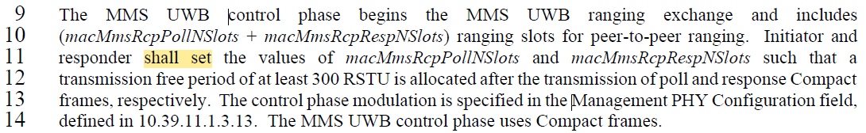
Based on the resolution proposal for comment indexes 391 and 582, (addressing the first part of the commenter’s proposed change), then “shall set” is not appropriate. The resolution proposal below amends this wording appropriately.
Proposed Disposition: Revised. Disposition Detail:
Change “…shall set the values of…”
to “…should use values of…”

- Comment Index # 460
Ind | Pg | clause | line | Comment | Proposed Change
460  (Billy) | 80 | 10.39.5 | 24 | macMmsRpDuration should be an NHL protocol control variable, since it is the NHL that is providing the report frames and dictating the time of sending, it should be the one specifying the TX time of the report so it should be basing this on the agreed mmsRpDuration, and its role, and the phases. | Change macMmsRpDuration to mmsRpDuration parameter to be known by NHL, and update text accordingly.
Discussion:
This relates to the sentence below and Comment Index #s 391, 582 above.
macMmsRpDuration shall be set at minimum to the required duration for all RSF and RIF fragments to be transmitted and received but may be larger to provide flexibility in scheduling the report phase and/or to allow extra time after the final fragment.
Based on the resolution proposal for comment indexes 391 and 582, the resolution for this comment requires this sentence to be reworded as per the resolution proposal below.
Proposed Disposition: Revised. Disposition Detail: Change the sentence to:
The mmsRpDuration value needs to be sufficient to encompass the duration of all RSF and RIF fragments to be transmitted and received in the ranging phase. However, a larger value can be used to provide flexibility in scheduling the report phase and/or to allow extra time after the final fragment.

- Comment Index # 462
Ind | Pg | clause | line | Comment | Proposed Change
462  (Billy) | 81 | 10.39.6 | 10 | macMms1stReportNSlots and macMms2ndReportNSlots should be NHL protocol control variables, since it is the NHL that is providing the report frames dictating the time of sending, the NHL rather than the MAC needs to manage all these phase durations rather than trying to have the MAC aware of the NHL protocol phases. | Change macMms1stReportNSlots and macMms2ndReportNSlots to mms1stReportNSlots and mms2ndReportNSlots parameters to be agreed/known by NHLs and update the text accordingly.
Discussion:
This relates to the sentence below and Comment Index #s 391, 582 above.
The durations of the two reporting periods are specified by the macMms1stReportNSlots and macMms2ndReportNSlots attributes.
Based on the resolution proposal for comment indexes 391 and 582, this sentence needs minor rewording as per the resolution proposal below.
Proposed Disposition: Revised. Disposition Detail: Change the sentence to:
The durations of the two reporting periods are defined by the values of the mms1stReportNSlots and mms2ndReportNSlots parameters.

- Comment Index # 486
Ind | Pg | clause | line | Comment | Proposed Change
486  (Billy) | 87 | 10.39.9.3 | 18 | These three MAC PIB "...NSlots" attributes should be NHL protocol control variables, since it is the NHL that is providing the report frames dictating the time of sending, the NHL rather than the MAC needs to manage all these phase durations rather than trying to have the MAC aware of the NHL protocol phases. | Change to parameters to be agreed/known by NHLs, and update the text accordingly.
Discussion:
This relates to the sentence below and Comment Index #s 391, 582 above.
The durations of the three reporting periods are specified by the macMms1stReportNSlots, macMms2ndReportNSlots, and macMms3rdReportNSlots attributes.
Based on the resolution proposal for comment indexes 391 and 582, this sentence needs minor rewording as per the resolution proposal below.
Proposed Disposition: Revised. Disposition Detail: Change the sentence to:
The durations of the three reporting periods are defined by the values of the mms1stReportNSlots, mms2ndReportNSlots and mms3rdReportNSlots parameters.

- Comment Index # 528
Ind | Pg | clause | line | Comment | Proposed Change
528  (Billy) | 106 | 10.39.11.1.3.13 | 17 | I think macMmsControlPhaseMode and value of macMmsReportPhaseMode should be NHL protocol control variables and not MAC variables. | on line 17 change "defines the value of macMmsControlPhaseMode which corresponds to" to "signals" and on line 20, similarly, replace "defines the value of macMmsReportPhaseMode which corresponds to" with "signals"
Discussion:
This relates to the two paragraphs screen shot below, and Comment Index #s 391, 582 above.
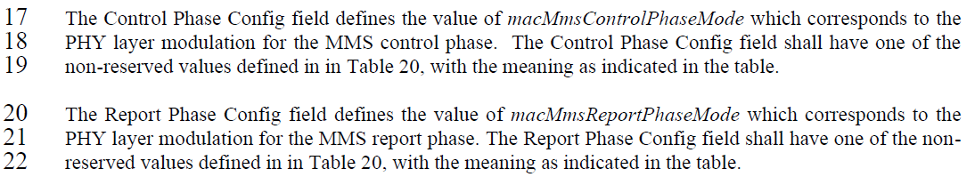
Although this relates to comment indexes 391 and 582 and the NHL vs MAC question, the commenter is proposing a simple change of removing the parameter reference. The resolution proposal (below) adopts this approach with some minor re-wording in line with wording used in other common field definitions.
Proposed Disposition: Revised. Disposition Detail: see below
Change the sentence on line 17 to:
The Control Phase Config field specifies the PHY layer modulation for the MMS control phase.
And change the sentence on line 20 to:
The Report Phase Config field specifies the PHY layer modulation for the MMS report phase.

- Comment Index # 583
Ind | Pg | clause | line | Comment | Proposed Change
396  (Billy) | 145 | 10.39.12 | 14 | macMmsNbInitMode should be mms application parameter instead of mac PIB, but also range is wrong, table 67 has no config #9 | Make into an MMS protocol layer variable, and correct range to be 1 to 8 only.
Discussion:
This comment covers two separate issues. Firstly. the NHL vs MAC question which is the same point as per Comment Index #s 391, 582 above, and resolved by the changes proposed for those comments.
The second issue is an error in the range for this parameter. This error was also spotted/reported by comment index #139, which has already been resolved by DCN 15-25-0332-00, so additional changes are necessary.
Proposed Disposition: Revised.
Disposition Detail: Resolved by changes nominated for Comment Index #s 391, 582 above, along with the resolution for comment index #139 given in DCN 15-25-0332-00.

- Comment Index #s 510 and 511
Ind | Pg | clause | line | Comment | Proposed Change
510  (Billy) | 104 | 10.39.11.1.3.9 | 5 | "encodes the value of" appears a number of times in the description of the fields of this figure. I believe compact frames with this field are passed through MCPS-DATA.request primitive, so I assume it is the NHL that sets the value to put in this field, i.e. MAC does not automatically populate it. If macMmsRangingSlotDuration, was a NHL variable (as I have proposed in another comment then it makes sense for NLH to signal the value wishes to use for a forthcoming ranging round. In reception then the receiving NHL can choose to accept or not, and update its own slot duration variable. | I think in general there is some confusion in the spec regarding these over the air message fields and how they are described. Key to solving this is to bottom out what is passed via MCPS-DATA primitives and the respective roles of MAC and NHL in forming the content of the transmitted frames. Here we should change "encodes ... "
511  (Billy) | 104 | 10.39.11.1.3.9 | 6 | "encodes the value of macMmsRangingSlotDuration" is little confusing in meaning since it is unclear about NHL and MAC involvement. I think it is NHL and we make the clear. | Change "encodes the value of macMmsRangingSlotDuration" to "signals the slot duration the sender wishes to use."
Discussion:
Both these comments relate to the same line and the phrase highlighted in the screenshot below from D02 p104.
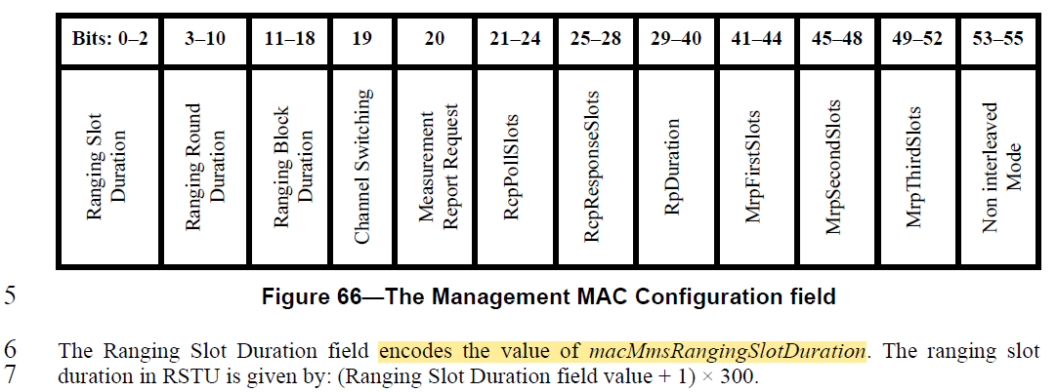
The phrasing “encodes the value” appears three times, and “encodes the duration” twice, with separate comments on each. Rather than address the complicated point (in comment index #510) relating to the negotiation of the parameter, the simple resolution proposed here to change the wording (resolving both #510 and #511) to not mention the configuration parameter names.
Proposed Disposition: Revised. Disposition Detail: see below
Change the sentence on p104 line 6 to:
The Ranging Slot Duration field value specifies the ranging slot duration. This is given in RSTU by: (Ranging Slot Duration field value + 1) × 300.

- Comment Index #s 512 and 513
Ind | Pg | clause | line | Comment | Proposed Change
512  (Billy) | 104 | 10.39.11.1.3.9 | 8 | "encodes the value of macMmsRangingRoundDuration" is little confusing in meaning since it is unclear about NHL and MAC involvement. I think it is NHL and we make the clear. | Change "encodes the value of macMmsRangingRoundDuration" to "signals the ranging round duration the sender wishes to use."
513  (Billy) | 104 | 10.39.11.1.3.9 | 10 | "encodes the value of macMmsRangingBlockDuration" is little confusing in meaning since it is unclear about NHL and MAC involvement. I think it is NHL and we make the clear. | Change "encodes the value of macMmsRangingBlockDuration" to "signals the ranging block duration the sender wishes to use"
Discussion:
Thes relate to the lines and the phrases highlighted in the screenshot below from D02 p104.
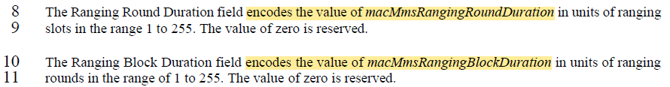
The issue here is the same as for comment #511 addressed above, and a similar simple resolution is proposed here to change wording as shown below.
Proposed Disposition: Revised. Disposition Detail: see below
Change the two paragraphs on p104 lines 8 and 10 to:
The Ranging Round Duration field specifies the ranging round duration in units of ranging slots, with valid values being in the range 1 to 255. The value of zero is reserved.
The Ranging Block Duration field specifies the ranging block duration in units of ranging rounds, with valid values being in the range 1 to 255. The value of zero is reserved.

- Comment Index #s 515 and 516
Ind | Pg | clause | line | Comment | Proposed Change
515  (Billy) | 105 | 10.39.11.1.3.9 | 5 | "encodes the duration of macMmsRcpPollNSlots" is little confusing in meaning since it is unclear about NHL and MAC involvement. I think it is NHL and we make the clear. | Change "encodes the duration of macMmsRcpPollNSlots used by" to "signals the number of slots the sender wishes to be used by ..."
516  (Billy) | 105 | 10.39.11.1.3.9 | 8 | "encodes the duration of macMmsRcpRespNSlots" is little confusing in meaning since it is unclear about NHL and MAC involvement. I think it is NHL and we make the clear. | Change "encodes the duration of macMmsRcpRespNSlots used by" to "signals the number of slots the sender wishes to be used by ..."
Discussion:
Thes relate to the lines and the phrases highlighted in the screenshot below from D02 p105.
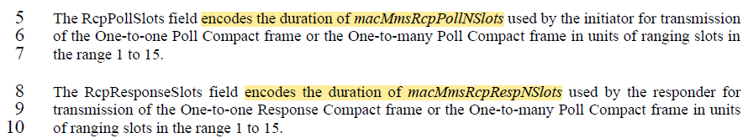
The issue here is the same as that of comments #511, 512, 513 addressed above, and a similar simple resolution is proposed here to change wording as shown below.
Proposed Disposition: Revised. Disposition Detail: see below
Change the two paragraphs on p105 lines 5 and 8 as shown:
The RcpPollSlots field encodes the duration of macMmsRcpPollNSlots used by the initiator specifies the number of slots used for transmission of the One-to-one Poll Compact frame or the One-to-many Poll Compact frame in units of ranging slots in the range 1 to 15.
The RcpResponseSlots field encodes the duration of macMmsRcpRespNSlots used by the responder specifies the number of slots used for transmission of the One-to-one Response Compact frame or the One-to-many Poll Compact frame in units of ranging slots in the range 1 to 15.

<END>

