**IEEE P802.15**

**Wireless Personal Area Networks**

|  |  |
| --- | --- |
| Project | IEEE P802.15 Working Group for Wireless Personal Area Networks (WPANs) |
| Title | **Proposed resolutions to comments 267, 268, 269 and 270** |
| Date Submitted | June 10th, 2025 |
| Sources | Riku Pirhonen (NXP) |
| Abstract | Proposed resolutions to comments 267, 268, 269 and 270 related to the control phase length set by attributes *macMmsRcpPollNSlots* and *macMmsRcpRespNSlots*. |
| Purpose | Propose resolutions to comments received on IEEE P802.15.4ab/D02, March 2025. |
| Notice | This document does not represent the agreed views of the IEEE 802.15 Working Group or IEEE 802.15.4ab Task Group. It represents only the views of the participants listed in the “Sources” field above.It is offered as a basis for discussion and is not binding on the contributing individuals. The material in this document is subject to change in form and content after further study. The contributors reserve the right to add, amend or withdraw material contained herein. |

### Resolution to Comments 267, 268, 269 and 270

|  |  |  |  |  |  |  |
| --- | --- | --- | --- | --- | --- | --- |
| **Name** | **Index #** | **Page** | **Sub-clause** | **Line #** | **Comment** | **Proposed Change** |
| Pirhonen, Riku | 267 | 105 | 10.39.11.1.3.9 | 7 | The minimum value for macMmsRcpPollNSlots can be 0 | change the range from 1 - 15 to 0 – 15 |
| Pirhonen, Riku | 268 | 105 | 10.39.11.1.3.9 | 10 | The minimum value for macMmsRcpRespNSlots can be 0 | change the range from 1 - 15 to 0 - 15 |
| Pirhonen, Riku | 269 | 145 | 10.39.12 | 1 | The minimum value for macMmsRcpPollNSlots can be 0 | Change the value range for macMmsRcpPollNSlots to 0 - 15 |
| Pirhonen, Riku | 270 | 145 | 10.39.12 | 1 | The minimum value for macMmsRcpRespNSlots can be 0 | Change the value range for macMmsRcpRespNSlots to 0 - 15 |

Resolution (**Accepted**/Rejected/Revised)

**Discussion**

**NB Assisted and UWB Driven modes**

Ranging session initialization is done by exchanging advertising messages and finalized by sending a Start of Ranging (SOR) message. The SOR message defines parameters for the ranging round, for example if control and report are done on NB (*NB Assisted mode*), or if all the packets are on UWB (*UWB Driven mode*). SOR defines also how long the control, ranging and report phases are.

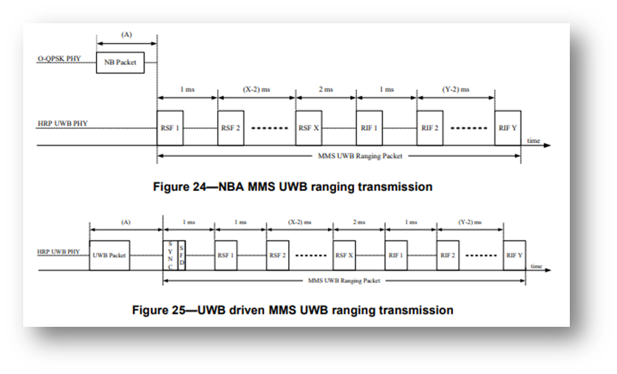

*NBA and UWB driven MMS compared showing the SYNC+SFD included in the UWB driven packet.*

In *NB assisted mode*, in order to be able to receive the MMS UWB ranging packet, the synchronization and CFO estimation are done using a NB packet sent during the control phase. This is mandatory because the NBA UWB ranging packet doesn’t have separate synchronization support, only the ranging fragments. (Figure 24.)

In *UWB Driven mode* the ranging packet itself has the SYNC + SFD fragment used for synchronization and CFO estimation. (Figure 25.) Ranging is driven by this UWB SYNC + SFD fragment, and unlike in the NBA mode, a separate control packet is not necessary to receive the UWB ranging packet. A SP0 packet is used for control, and when used, it is the weakest link for ranging. For best performance it is desirable not to use the SP0 packet, and this can be achived by setting the *macMmsRcpPollNSlots* and *macMmsRcpRespNSlots* values to zero. The logical control phase exists, but the length of the phase is zero.

*Summary* – NBA MMS requires a control packet for CFO estimation and sync, UWB Driven MMS doesn’t. Therefore it is possible to use value 0 for *macMmsRcpPollNSlots* and *macMmsRcpRespNSlots.*

**Paylaod**

Control phase carries one-to-one or one-to-many poll and response packets (see subclauses 10.39.11.3.5, 10.39.11.3.6, 10.39.11.3.9, 10.39.11.3.10). The payload is defined by the Message ID field. The Compact Poll and Response frame content field formats are as below.

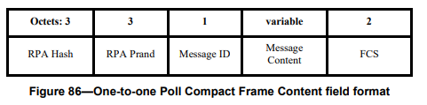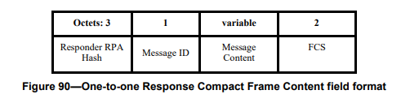

*Poll and Response Frame Content field formats*

The compact poll and response frames can be split into two categories - frames with no meaningful payload and and frames with meaningful payload. When frames with payload are used, the control phase length has to be set accordingly, taking into account possibly long frame length especially in the NBA case. In case of UWB Driven mode a SP0 control packet is used.

When the Message Control Field value is zero, the Poll and Response Message Content fields are set all zeroes as shown in Figures 87, 91, 101 and 113.

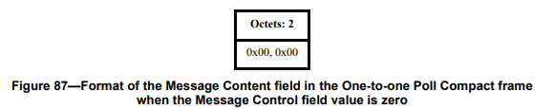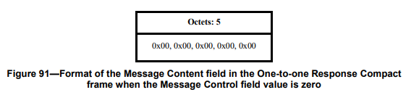

*Message Content field with Message Control field value 0*

In case of NB packet, this content field can be used to provide extra reference symbols for CFO estimation. In UWB Driven case the payload of zeroes has no use, and because the packet is not needed for CFO or timing, it is advantageous not to send the packet at all.

**RPA – Resolvable Private Address**

RPA Hash and RPA Prand provide tracking for the packet, and FCS is used to check integrity of the control packet. These are used when the Message Content has information and impact to the ranging process. Integrity of ranging itself, the Time of Flight measurement, is based on use of RIF fragments. If there is no payload, use RPA and FCS during the ranging round is not necessary. If the use case requires RPA, then control phase length is not set to zero and a SP0 packet is used.

**Poll and Response**

When control phase length is set to zero, the poll and response function are done by the SYNC + SFD fragment of the MMS UWB packet. It provides better performance than the SP0 packet, and less ranging rounds will get terminated due to unsuccessful poll/response.

**Report**

While the control phase length doesn’t directly impact the optional report, makes it sense to also consider how reporting is done. If SP0 is not used for control, using a data packet on UWB for report would become the performance bottleneck. To keep the performance improvements, report is either sent out of band or fixed response time as described in subclause 10.29.6.5 is used.

**Performance improvement to UWB Driven mode**

To illustrate the benefits to using control phase length zero, and skipping the SP0 packet, it is practical to look at the simplest ranging case, in which the MMS UWB packet consists of the SYNC + SFD fragment and one RIF.

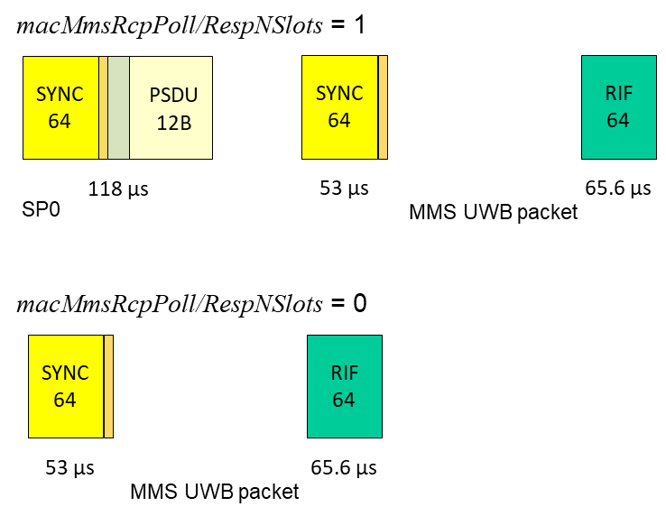

*Control phase length 1 ms vs 0 ms*

*Link budget*

SP0 has over double the length of the SYNC + SFD fragment and almost double that of the RIF. If limited by the power level set by RIF, the link budget would be 2.3 dB better with zero control length, but the regulatory limits and typical conformance test requirements allow 3.8 dB link budget improvement. That corresponds to 55% more range and 140% more area with free space loss formula.

*Power consumption*

SP0 requires double the time for transmitter and receiver, so the power consumption with SP0 would be roughly double.

*Interference*

SP0 packet is longer, to it is more likely to cause collisions, and 50% more packets increase also collision probability.

*Poll / Response*

Shorter SYNC + SFD based poll without need to reciver and decode the SP0 packet improves the poll and response performance in terms of link budget and avoiding collisions.

*Ranging speed*

Skipping one packet improves the ranging speed by 50%.

**Resolution**

