**IEEE P802.15**

**Wireless Personal Area Networks**

|  |  |  |
| --- | --- | --- |
| Project | IEEE P802.15 Working Group for Wireless Personal Area Networks (WPANs) | |
| Title | **Proposed Resolutions for LB213 CID 218, 276, 277, 606, 479, 480, 482, 484, 600** | |
| Date Submitted | June 2025 | |
| Sources | Panpan Li, Bin Qian, Lei Huang, Rojan Chitrakar (Huawei)  Lipanpan25@huawei.com |  |
| Re: |  | |
| Abstract |  | |
| Purpose | To propose comments resolution for “P802.15.4ab™/D1.0 Draft Standard for Low-Rate Wireless Networks” | |
| Notice | This document does not represent the agreed views of the IEEE 802.15 Working Group or IEEE 802.15.4ab Task Group. It represents only the views of the participants listed in the “Sources” field above.It is offered as a basis for discussion and is not binding on the contributing individuals. The material in this document is subject to change in form and content after further study. The contributors reserve the right to add, amend or withdraw material contained herein. | |

# CID 218

|  |  |  |  |  |  |
| --- | --- | --- | --- | --- | --- |
| **Commenter** | **Sub-Clause** | **Page** | **Line** | **Comment** | **Proposed Change** |
| MAMAN, MICKAEL | 10.40.6.3 | 177 | 2 | Address Size field indicates the size of the addresses used in both the SBP Request IE and the Sensing Control Address List field. Then merge the 2 paragraphes | merge the two paragraphes |

**Resolution: Revised**

*change Line 2-7 on Page 170 as follows*

The Address Size field specifies the size of the address used in the SBP Request IE and the Sensing Controlee Address List field. The Address Size field shall be set to zero when short addresses are used, and shall be set to 1 when extended addresses are used.

# CID 276

|  |  |  |  |  |  |
| --- | --- | --- | --- | --- | --- |
| **Commenter** | **Sub-Clause** | **Page** | **Line** | **Comment** | **Proposed Change** |
| Bin Qian | 10.39.6.2 | 170 | 11 | The range of "i" is not clearly clarified | The range of i is from 0 to N-1 |

**Resolution: Revised**

*change Line 10-12 on Page 170 as follows*

The center frequency $f_{i}$ in MHz of CH(i) shall be computed according to

$$f_{i}=f_{BASE}+124.8×i×\left(4−OF\right)×\left(2×D−1\right), i=0,1,2,…, N−1$$

where $f_{BASE}$ is the center frequency of the base channel in MHz, and D is the Frequency Stitching Direction field value.

# CID 606

|  |  |  |  |  |  |
| --- | --- | --- | --- | --- | --- |
| **Commenter** | **Sub-Clause** | **Page** | **Line** | **Comment** | **Proposed Change** |
| Billy Verso | 10.40.6.1 | 170 | 22 | Intra-packet frequency stitching is something that the PHY does (if it supports configuration of mulkti packet. The channel to use for SHR can be separatelty configured using the normal channel selection method.. | State that support of intra-packet frequency stitching is dependant on how many sensing segments the PHY supports and on it supporting the configuration of the channel for each frequency stitching segment via the phyFSS1channel, phyFSS2channel, phyFSS3channel and phyFSS4channel attributes. And state, that phyCurrentChannelInfo specifies the channel for the SHR. |

**Discussion:**

SBP support both CIR reports and Processed Target Feature reports.

**Resolution: Revised**

*change Line 22-25 on Page 170 as follows*

Intra-packet frequency stitching means that the channel frequency is changed during the packet, and if supported, this is enabled by setting *phyFSEnable* to TRUE. The channel for the SHR is selected by *phyCurrentChannelInfo* and the channels for the sensing segments are specified by *phyFSS1channel*, *phyFSS2channel*, *phyFSS3channel* and *phyFSS4channel* respectively. When *phyFSEnable* is FALSE, intra-packet frequency stitching is disabled, and all parts of the sensing packet are sent on the channel specified by *phyCurrentChannelInfo*. The intra-packet frequency stitching capability depends on the individual *phyFSS1channel*, *phyFSS2channel*, *phyFSS3channel* and *phyFSS4channel* configurations being supported appropriately for the number of supported segments as specified in 16.2.10. Inter-packet frequency stitching means different packets are transmitted on different channels, with the SHR and all segments within the packet transmitted on the same channel.

# CID 277

|  |  |  |  |  |  |
| --- | --- | --- | --- | --- | --- |
| **Commenter** | **Sub-Clause** | **Page** | **Line** | **Comment** | **Proposed Change** |
| Bin Qian | 10.41.4.1 | 185 | 18 | The current Capability Information field does not clearly indicate the device type | First, change "Dynamic PHR" to "LLDDEV", since dynamic PHR is a mandatory feature of LLDDEV. Second, add one bit to indicate ARDEV. Third, add one bit to indicate SDEV. |

**Discussion:**

Agree with commentor but capability typically indicates supported features, not device types/mode. It seems a bit odd to signal SDEV, ARDEV etc. Suggest use sensing, advance ranging, which may be more appropriate as capaiblities

**Resolution: Revised**

*change Line 18-19 on Page 185 as follows*

The HRP UWB Capability Information field shall be formatted as per Figure 187.

|  |  |  |  |  |  |  |  |  |  |
| --- | --- | --- | --- | --- | --- | --- | --- | --- | --- |
| Bits: 0 | 1 | 2-3 | 4 | 5 | 6 | 7 | 8 | 9 | 10-15 |
| LDPC | High Throughput | Supported AIFS | Low-latency Data | Frequency Stitching | Aggregrated Channel Report | DEFLATE Compression | Advanced Ranging | Sensing | Reserved |

Figure 187—HRP UWB Capability Information field format

*change Line 3-10 on Page 86 as follows*

The Low-latency Data field shall be set to one if Low-latency Data is supported. Otherwise, it shall be set to zero.

The Frequency Stitching field shall be set to one if the controlee supports frequency stitching. Otherwise, it shall be set to zero.

The Aggregated Channel Report field shall be set to one if the controlee supports report for the aggregated channel after the last transmission of frequency stitching. Otherwise, it shall be set to zero.

The DEFLATE Compression field shall be set to one if the controlee supports the compression and decompression, using the compression format defined in 10.40.4.5.2. Otherwise, it shall be set to zero.

The Advanced Ranging field shall be set to one if Advanced Ranging is supported. Otherwise, it shall be set to zero.

The Sensing field shall be set to one if Sensing is supported. Otherwise, it shall be set to zero.

# CID 479

|  |  |  |  |  |  |
| --- | --- | --- | --- | --- | --- |
| **Commenter** | **Sub-Clause** | **Page** | **Line** | **Comment** | **Proposed Change** |
| VERSO, BILLY | 10.39.9.3 | 86 | 21 | It is not really within one ranging slot. The current default value of macMmsRangingSlotDuration is 600 RSTU == 500 μs, and MMS fragment TX spacing is not based on slots in any case, it is fixed at 1ms irrespective of slot size used by the application for scheduling purposes. | change "one ranging slot" to "one milisecond". |

**Discussion:**

Agree with the commentor.

**Resolution: Accepted**

# CID 480

|  |  |  |  |  |  |
| --- | --- | --- | --- | --- | --- |
| **Commenter** | **Sub-Clause** | **Page** | **Line** | **Comment** | **Proposed Change** |
| VERSO, BILLY | 10.39.9.3 | 86 | 22 | This line is not clear. Is limited to "two fragments", given that there are clearly six fragments shown in Figures 48 and 49. I assume it means two transmitted per device this should be clarified. However it seems a very artificial limit and I am not sure why it is here, why not allow it for all MMS packet configurations, the benifit of this Time-efficiency is more pronounced for longer packets. Also for the UWB driven case this limit does not even allow for 1xRSF + 1xRIF to be included in addtion to the mandatory SYNC+SFD fragment. The limititation is not needed. Since the mode is already optional (by line 24) it can be optional how many fragments to support too. | Delete this sentence. |

**Discussion:**

The six fragments are actually sent by initiator and two responders, so every responder’s fragements are limitted to two. But agree this sentence is not clear, so accept the proposed change.

**Resolution: Accepted**

# CID 482

|  |  |  |  |  |  |
| --- | --- | --- | --- | --- | --- |
| **Commenter** | **Sub-Clause** | **Page** | **Line** | **Comment** | **Proposed Change** |
| VERSO, BILLY | 10.39.9.3 | 86 | 33 | This line is unclear. The previous line is talking about the case of only one responder, which must be the final sub-round. So there should not be a subsequent sub-round. I am not sure what fix is, but it needs a better description. Perhaps a figure with 3 or 5 responders, covering one or two ranging rounds, each with required numbe of sub-rounds each, could be used to appropriately clarify where the one-to-many poll with message control 9 or 10, and the one-to-many poll with message control zero are to be used. | Improve text and consider a figure, to clarify where the different poll messages are to be used. |

**Discussion:**

The inappropriate order of sentences causes confusion to commentor. The first sentence of this paragraph describes the Message Control field of the One-to-many Poll Compact frame in the first ranging sub-round, while the last sentence of this paragraph describes the Message Control field of the One-to-many Poll Compact frame in subsequent ranging sub-round. The other sentences talk about the field values of two responders. So I think rearranging the sentences may help avoid the confusion.

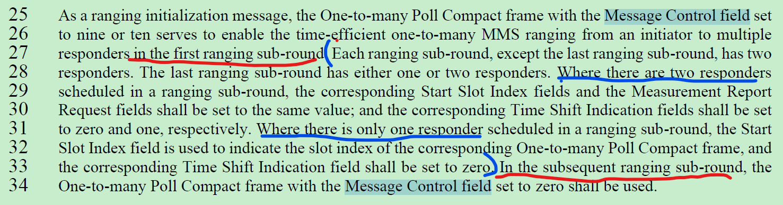

**Resolution: Revised**

*change Line 25-34 on Page 86 as follows*

As a ranging initialization message, the One-to-many Poll Compact frame with the Message Control field set to nine or ten serves to enable the time-efficient one-to-many MMS ranging from an initiator to multiple responders in the first ranging sub-round. In the subsequent ranging sub-round, the One-to-many Poll Compact frame with the Message Control field set to zero shall be used. Each ranging sub-round, except the last ranging sub-round, has two responders. The last ranging sub-round has either one or two responders. Where there are two responders scheduled in a ranging sub-round, the corresponding Start Slot Index fields and the Measurement Report Request fields shall be set to the same value; and the corresponding Time Shift Indication fields shall be set to zero and one, respectively. Where there is only one responder scheduled in a ranging sub-round, the Start Slot Index field is used to indicate the slot index of the corresponding One-to-many Poll Compact frame, and the corresponding Time Shift Indication field shall be set to zero.

# CID 484

|  |  |  |  |  |  |
| --- | --- | --- | --- | --- | --- |
| **Commenter** | **Sub-Clause** | **Page** | **Line** | **Comment** | **Proposed Change** |
| VERSO, BILLY | 10.39.9.3 | 87 | 8 | There will obviously be some small variability in this response scheduling since they will be timed from the poll RX time (which has some error) using in the local clock of each responder. To reflect this, the part of the sentence beginning "with the fragments.." could be made into a separate sentence, as per proposed change. | Make the sentence end into a separate sentence as follows: "The response packets from responders one and two are nominally offset from the initiator's packet by 400 and 800 RSTU, respectively. |

**Discussion:**

SBP support both CIR reports and Processed Target Feature reports.

**Resolution: Revised**

*change Line 7-8 on Page 87 as follows*

The MMS UWB packet format shall be as specified in 16.2.11. The response packets from responders one and two are nominally offset from the initiator’s packet by 400 and 800 RSTU, respectively.

# CID 600

|  |  |  |  |  |  |
| --- | --- | --- | --- | --- | --- |
| **Commenter** | **Sub-Clause** | **Page** | **Line** | **Comment** | **Proposed Change** |
| VERSO, BILLY | 10.40.5 | 155 | 21 | SBP is essentially a protocol for controlling sensing remotely and getting reports. While defining IEs to support this is informative and possibly useful, it is essentially a networking layer and as such logically lives above 802.15.4 so architecturally should not be in this amendment, and the "shalls" should be removed. | We sholuld preferably delete it, and at least move it to an annex, and definitely should remove the "shall" statements. |

**Discussion:**

Deleting this section 10.40.5 may result in deleting all other SBP related stuff (IEs). Moving it into Annex will make SBP informative.

Regarding “shall”, there’s no statement mandadating SBP. The only “shall” word in 10.40.5 is as follows, is clearly a conditional mandatory since it only applies to SDEV that supports SBP. So I believe this “shall” should not be deleted.

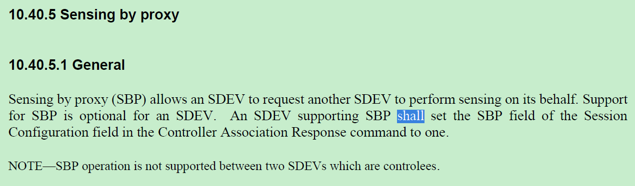

**Resolution: Rejected**