IEEE P802.15
Wireless Personal Area Networks

Project | IEEE P802.15 Working Group for Wireless Personal Area Networks (WPANs)
Title | Proposed resolution for RSS related comments: CIDs 317 and 319
Date Submitted | May 2025
Sources | Mickael Maman (STMicroelectronics)
Re:
Abstract
Purpose | To propose comments resolution for “P802.15.4ab™/D02 C Draft Standard for Low-Rate Wireless Networks”
Notice | This document does not represent the agreed views of the IEEE 802.15 Working Group or IEEE 802.15.4ab Task Group. It represents only the views of the participants listed in the “Sources” field above. It is offered as a basis for discussion and is not binding on the contributing individuals. The material in this document is subject to change in form and content after further study. The contributors reserve the right to add, amend or withdraw material contained herein.

Commenter | Index # | page | Sub-Clause | Line | Comment | Proposed Change
VERSO, BILLY | 317 | 15 | 5.2.5 | 9 | Is RSS a special application space on its own? I think not, it is more a subset of ranging/RTLS. If we had someone to draft it, I can think of some broader special application spaces that might be worth adding here, (e.g., real time location, access control, sensing). In the absence of that I propose to delete all of 5.2.5. | Delete all of 5.2.5
VERSO, BILLY | 319 | 15 | 5.2.5 | 13 | "Time structures for communication are defined by the upper layer using the UWB ranging service." is not clear in meaning anything. | Delete the sentence.

Comment Index #317 in 15-25-0174-09-04ab-consolidated-comments-draft-2-0
Commenter | Index # | page | Sub-Clause | Line | Comment | Proposed Change
VERSO, BILLY | 317 | 15 | 5.2.5 | 9 | Is RSS a special application space on its own? I think not, it is more a subset of ranging/RTLS. If we had someone to draft it, I can think of some broader special application spaces that might be worth adding here, (e.g., real time location, access control, sensing). In the absence of that I propose to delete all of 5.2.5. | Delete all of 5.2.5

Discussion of comment ID 317:
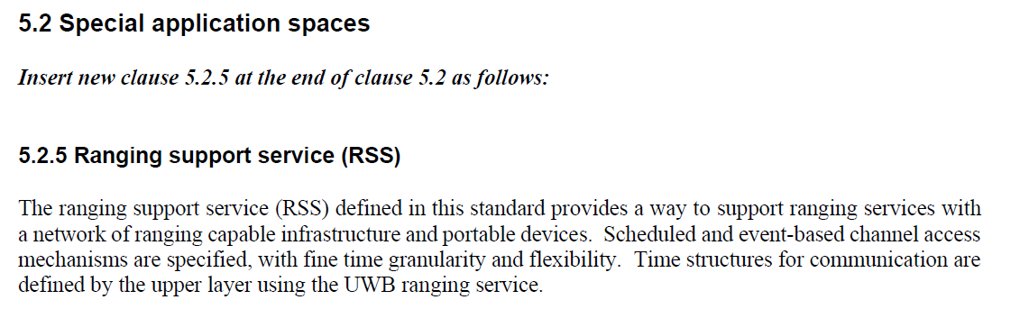
Section 5.2.5 is an informative section about special application spaces. It is important to introduce ranging support service (RSS) and indicate that RSS is based on time structures with fine time granularity and flexibility.
The application is network of ranging capable infrastructure and portable devices. We can add “ for flexible real-time locating solutions”
Proposed resolution:
Revised
Proposed text changes on P802.15.4ab™/D02 for comment ID 317:
Change page 15 line 10-11
The ranging support service (RSS) defined in this standard provides a way to support ranging services with a network of ranging capable infrastructure and portable devices (e.g., for flexible real-time locating solutions)

Comment Index #319 in 15-25-0174-09-04ab-consolidated-comments-draft-2-0
Commenter | Index # | page | Sub-Clause | Line | Comment | Proposed Change
VERSO, BILLY | 319 | 15 | 5.2.5 | 13 | "Time structures for communication are defined by the upper layer using the UWB ranging service." is not clear in meaning anything. | Delete the sentence.

Discussion of comment 319:
Time structures can be managed by the higher layer is using RSS slotframe structures as defined in section 10.46.3.
Proposed resolution:
Revised
Proposed text changes on P802.15.4ab™/D02 for comment ID 317:
Change page 15 line 12-13
RSS slotframe Time structures for communication are defined as in 10.46.3, by the upper layer using the UWB ranging service.

