**IEEE P802.15**

**Wireless Personal Area Networks**

|  |  |
| --- | --- |
| Project | IEEE P802.15 Working Group for Wireless Personal Area Networks (WPANs) |
| Title | **Resolutions-to-14-CIDs** |
| Date Submitted | May 14th, 2025 |
| Sources | Riku Pirhonen (NXP) |
| Abstract | Comment resolution proposals for 4ab D02 comments 351, 19, 20, 234, 235, 311, 173, 524, 525, 136, 30, 31, 34, 36 |
| Purpose | Propose resolutions to comments received on IEEE P802.15.4ab/D02, March 2025. |
| Notice | This document does not represent the agreed views of the IEEE 802.15 Working Group or IEEE 802.15.4ab Task Group. It represents only the views of the participants listed in the “Sources” field above.It is offered as a basis for discussion and is not binding on the contributing individuals. The material in this document is subject to change in form and content after further study. The contributors reserve the right to add, amend or withdraw material contained herein. |

## Resolution proposal

### Summary of comments

|  |  |  |  |  |  |  |
| --- | --- | --- | --- | --- | --- | --- |
| **Name** | **Index #** | **Page** | **Sub-clause** | **Line #** | **Comment** | **Proposed Change** |
| VERSO, BILLY | 351 | 42 | 10.29.6.6 | 14 | Figure 3 MSC is very sparse, it is missing the Control phase messages that should precede each of the MMS UWB packets, (e.g.as shown in Figure 43), would be good to include the RX enables, and any other setup stages either in the figure but at least covered in some text describing the figure. The current text and description is so minimal that it is hardly worth having the figure. | Delete the figure and text, or make it more useful by adding the missing steps for control phase packets etc and describing them in the text. |
| CHITRAKAR, ROJAN | 19 | 79 | 10.39.4 | 7 | Is this subclause also applicable for non-interleaved mode? | Add clarification that this subclause is not applicable for non-interleaved mode |
| CHITRAKAR, ROJAN | 20 | 80 | 10.39.5 | 17 | Is this subclause also applicable for non-interleaved mode? | Add clarification that this subclause is not applicable for non-interleaved mode |
| PAKROOH, POORIA | 234 | 82 | 10.39.7 | 3 | The benefits of Noninterleaved MMS mode are not justified properly. On the other hand, there are several disadvantages relative to the interleaved mode, such as longer duration for the ranging, limitations due to channel coherence time, and market fragmentation. | Remove Non-interleaved MMS mode, specifically subclause 10.39.7 and other ralted subclauses. |
| PAKROOH, POORIA | 235 | 82 | 10.39.7 | 4 | Clarify that this mode is optional for ARDEVs. | Add a sentence in line 4 "Support of Non-interleaved mode is optional for ARDEV devices." |
| TIAN, BIN | 311 | 82 | 10.39.7 | 7 | In the non-interleaved modes, why not moving the responder NB transmission immediately after the Initiator transmission so that Initiator knows that responder is ready for followijng UWB excahnge. In the ranging subround 2 or later, no NB transmission is needed. Mutliple NB transmission may lead to different frequency and time reference | as in the comment |
| MAMAN, MICKAEL | 173 | 82 | 10.39.7 | 24 | Missing figure for UWB-Driven MMS UWB | Please add a new figure |
| VERSO, BILLY | 524 | 105 | 10.39.11.1.3.9 | 28 | For interleaving modes, I think rather then talking about interleaved/non-interleaved sub-rounds, it would be mor logical to talking about interleaved and non-interleaved SS-TWR and DS-TWR, Hybrid DS-TWR, and OWR which by definition is not interleaved. | Redefining values in Table 19 based on ranging algorithm: 0 is SS-TWR (A single interleaved sub-round). 1 is OWR ranging (a single non-interleaved sub-round) 2 is SS-TWR (2x non-interleaved sub-rounds) 3 is DS-TWR (3x non-interleaved sub-rounds) 4 is DS-TWR (4x non-interleaved sub-rounds) 5 is DS-TWR (1x interleaved sub-round and 1 non-interleaved) |
| VERSO, BILLY | 525 | 105 | 10.39.11.1.3.9 | 29 | Looking at the list we are missing DS-TWR using interleaved packets, This is like #4 using 4 packets, but taking half the time. | Add 6: DS-TWR using 2 interleaved sub-rounds. |
| LI, HuanBang | 136 | 107 | 10.39.11.1.3.13 | 5 | According to the description that when the Control Phase Config field is set to 14, the Report Phase Config field can be set to either 14 or 15. This should be modified to a description like the Report Phase Config field shall be set to the same value as Control Phase Config field is set. | modify the sentence. |
| CHITRAKAR, ROJAN | 30 | 118 | 10.39.11.3.5 | 25 | Can all the existing O2O Poll message variants also be used for non-interleaved mode? To avoid confusion (for the responder) with interleaved mode, it may be better to define new variants for non-interleaved mode even if the content of the frames are the same. | Define new variants of O2O Poll compact frames to be used for non-interleaved mode and describe their usage in subclause 10.39.7. |
| CHITRAKAR, ROJAN | 31 | 120 | 10.39.11.3.6 | 30 | Can all the existing O2O Response message variants also be used for non-interleaved mode? To avoid confusion with interleaved mode, it may be better to define new variants for non-interleaved mode even if the content of the frames are the same. | Define new variants of O2O Response compact frames to be used for non-interleaved mode and describe their usage in subclause 10.39.7. |
| CHITRAKAR, ROJAN | 34 | 122 | 10.39.11.3.7 | 16 | The usage of Message control one should be explained. | Add description to explain that Message control one is used for DS-TWR. |
| CHITRAKAR, ROJAN | 36 | 124 | 10.39.11.3.8 | 11 | The usage of Message control two should be explained. | Add description to explain that Message control two is used for DS-TWR. |

**Comment #351**

|  |  |  |  |  |  |  |
| --- | --- | --- | --- | --- | --- | --- |
| **Name** | **Index #** | **Page** | **Sub-clause** | **Line #** | **Comment** | **Proposed Change** |
| VERSO, BILLY | 351 | 42 | 10.29.6.6 | 14 | Figure 3 MSC is very sparse, it is missing the Control phase messages that should precede each of the MMS UWB packets, (e.g.as shown in Figure 43), would be good to include the RX enables, and any other setup stages either in the figure but at least covered in some text describing the figure. The current text and description is so minimal that it is hardly worth having the figure. | Delete the figure and text, or make it more useful by adding the missing steps for control phase packets etc and describing them in the text. |

**Resolution** (**Accepted**/Rejected/Revised)

**Discussion:**

There are no other MMS message sequence charts added in subclause 10.29 describing the various control procedures, so the trivial presentation of one MMS DS-TWR can be be deleted.

**Change:**

Delete lines 11 – 15, including figure 3, on page 42.

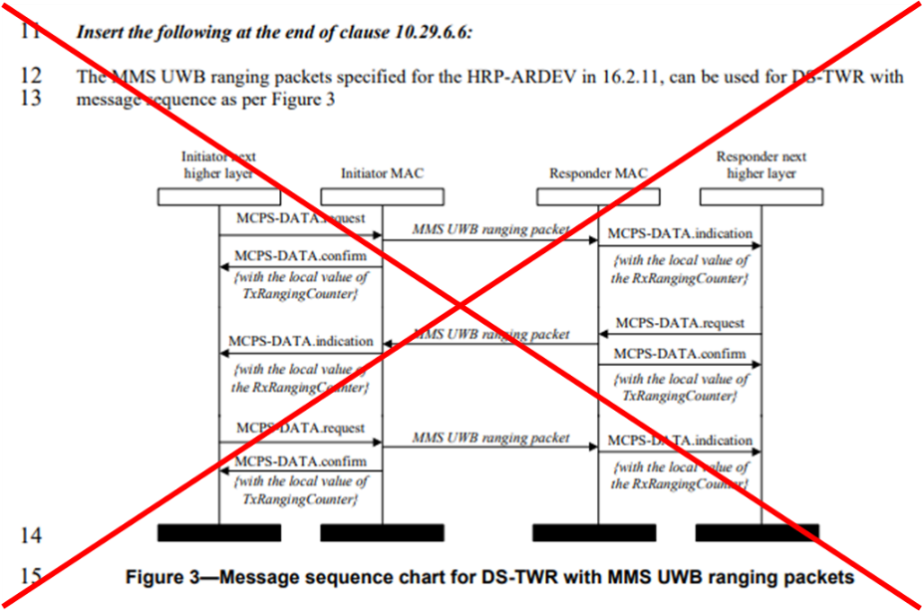

**Comment #19**

|  |  |  |  |  |  |  |
| --- | --- | --- | --- | --- | --- | --- |
| **Name** | **Index #** | **Page** | **Sub-clause** | **Line #** | **Comment** | **Proposed Change** |
| CHITRAKAR, ROJAN | 19 | 79 | 10.39.4 | 7 | Is this subclause also applicable for non-interleaved mode? | Add clarification that this subclause is not applicable for non-interleaved mode |

**Resolution:** (Accepted/Rejected/**Revised**)

**Discussion:**

The control phase is applicable also to the non-interleaved mode. Each subround has its own control phase, length given by *macMmsRcpPollNSlots* and *macMmsRcpRespNSlots*. See for example slides 13 and 14 in Doc 15-25-0194-00-04ab.

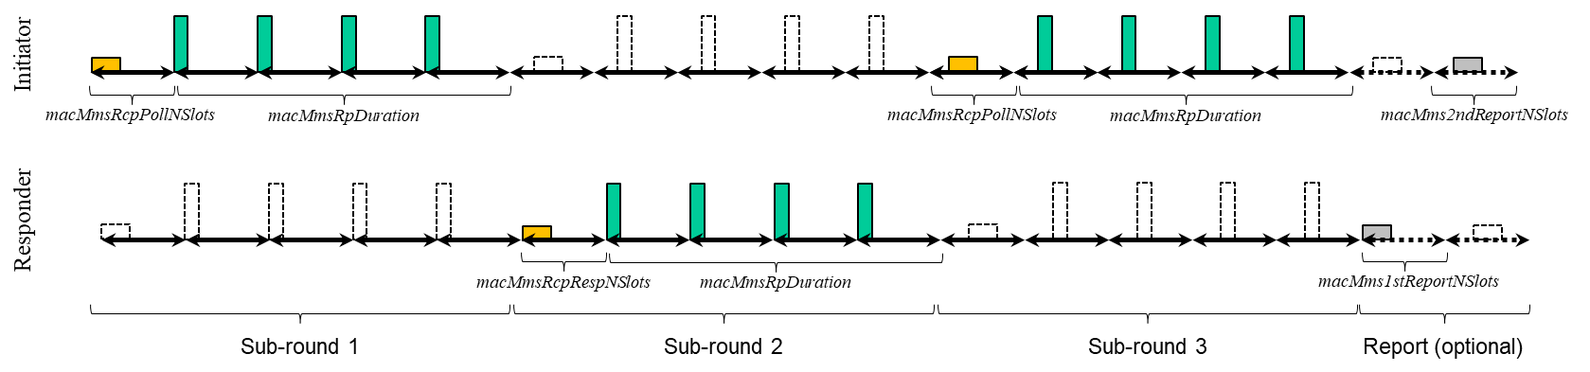

Draft 02 subclause 10.39.4.1, page 79, has control phase general description. Poll and response behavior is described in the paragraph starting on line 15. An exception to this behavior is described on page 82 in the the Non-interleaved mode subclause 10.39.7, line 17. The exception can be clarified in subclause 10.39.4.1, see the proposed change below.

**Change:**

On page 79, after line 20, following text:

In non-interleaved mode, described in subclause 10.39.7, MMS UWB Packets are sent in separate sub-rounds. Each non-interleaved subround has a control phase defined by *macMmsRcpPollNSlots* or *macMmsRcpRespNSlots* parameter. This control phase is followed by a ranging phase of *macMmsRpDuration*, consisting of one MMS UWB packet, as illustrated in figure 43. When the non-interleaved subrounds are used, the Initiator does not wait for the Responder response after it has sent the Poll. After the Control Phase it proceeds to the Ranging Phase and completes the MMS UWB Packet transmission. The Responder waits until the Initiator Ranging Phase passes and it has received the full MMS UWB Packet, then sends the response and MMS UWB packets. These alternating transmissions continue number of times depending on the interleaving mode as defined by *macInterleavingMode* and described in table 19.

**Comment #20**

|  |  |  |  |  |  |  |
| --- | --- | --- | --- | --- | --- | --- |
| **Name** | **Index #** | **Page** | **Sub-clause** | **Line #** | **Comment** | **Proposed Change** |
| CHITRAKAR, ROJAN | 20 | 80 | 10.39.5 | 17 | Is this subclause also applicable for non-interleaved mode? | Add clarification that this subclause is not applicable for non-interleaved mode |

**Resolution** (Accepted/Rejected/**Revised**)

**Discussion:**

The ranging phase is applicable also to the non-interleaved mode, and each non-interleaved sub-round has a ranging phase, with length defined by *macMmsRpDuration*.

The definition of offset described on page 80 line 15 differs, see page 82, line 19. This can be clarified also in chapter 10.39.5.

**Change:**

Change line 19 on page 80 as follows:

In the ranging phase, the initiator shall transmit the HPR UWB PHY MMS packet (described in 16.2.11), and in the interleaved mode responder may start transmitting its HRP UWB PHY MMS packet offset by 600 RSTU from the start into the ranging phase. In non-interleaved mode the MMS UWB packets are sent in separate sub-rounds as described in 10.39.7. and the 600 RSTU offset doesn’t apply.

**Comment #234**

|  |  |  |  |  |  |  |
| --- | --- | --- | --- | --- | --- | --- |
| **Name** | **Index #** | **Page** | **Sub-clause** | **Line #** | **Comment** | **Proposed Change** |
| PAKROOH, POORIA | 234 | 82 | 10.39.7 | 3 | The benefits of Noninterleaved MMS mode are not justified properly. On the other hand, there are several disadvantages relative to the interleaved mode, such as longer duration for the ranging, limitations due to channel coherence time, and market fragmentation. | Remove Non-interleaved MMS mode, specifically subclause 10.39.7 and other ralted subclauses. |

**Resolution** (Accepted/**Rejected**/Revised)

**Discussion:**

The non-interleaved mode:

* Reduces number of transitions between the TX and RX mode, while keeping 1 ms distance and coherence between fragements
* Has longer gaps between transmission of fragments, and results in lower TRX duty cycle, which is beneficial for low current / low power consumption applications.
* Supports 4z style ranging modes with one, two, three or four messages, including DS-TWR.

**Comment #235**

|  |  |  |  |  |  |  |
| --- | --- | --- | --- | --- | --- | --- |
| **Name** | **Index #** | **Page** | **Sub-clause** | **Line #** | **Comment** | **Proposed Change** |
| PAKROOH, POORIA | 235 | 82 | 10.39.7 | 4 | Clarify that this mode is optional for ARDEVs. | Add a sentence in line 4 "Support of Non-interleaved mode is optional for ARDEV devices." |

Resolution (**Accepted**/Rejected/Revised)

**Discussion:**

Subclause 10.39.7 starts with words “An optional non-interleaved mode …”, but if further clarification is needed, the proposed change is ok. In that case the text could be modified as below.

**Change:**

~~An optional n~~Non-interleaved mode can be used to reduce the amount of transitions between transmission and reception at the cost of total ranging time. Support of Non-interleaved mode is optional for ARDEV devices. An example of non-interleaved mode ranging round is shown in Figure 43.

**Comment #311**

|  |  |  |  |  |  |  |
| --- | --- | --- | --- | --- | --- | --- |
| **Name** | **Index #** | **Page** | **Sub-clause** | **Line #** | **Comment** | **Proposed Change** |
| TIAN, BIN | 311 | 82 | 10.39.7 | 7 | In the non-interleaved modes, why not moving the responder NB transmission immediately after the Initiator transmission so that Initiator knows that responder is ready for followijng UWB excahnge. In the ranging subround 2 or later, no NB transmission is needed. Mutliple NB transmission may lead to different frequency and time reference | as in the comment |

Resolution (Accepted/**Rejected**/Revised)

In order to keep the CFO estimate as accurate as possible, to avoid any adverse effects of frequence or timing drift, the NB reference should be as close to the UWB MMS packet as possible. Therefore each subround sends its own NB reference. The Compact Frame Message tells the type message used.

**Comment #173**

|  |  |  |  |  |  |  |
| --- | --- | --- | --- | --- | --- | --- |
| **Name** | **Index #** | **Page** | **Sub-clause** | **Line #** | **Comment** | **Proposed Change** |
| MAMAN, MICKAEL | 173 | 82 | 10.39.7 | 24 | Missing figure for UWB-Driven MMS UWB | Please add a new figure |

Resolution (**Accepted**/Rejected/Revised)

**Discussion:**

The picture for UWBD MMS can be added after the NBA MMS picture and the text reference to the pictures upadated.

**Change:**

*Page 82, line 5 add the text in red:*

An example of NBA MMS non-interleaved mode ranging round is shown in Figure 43 and a UWBD MMS non-interleaved ranging round in Figure XX .

*Page 82, line 9 add figure as below*

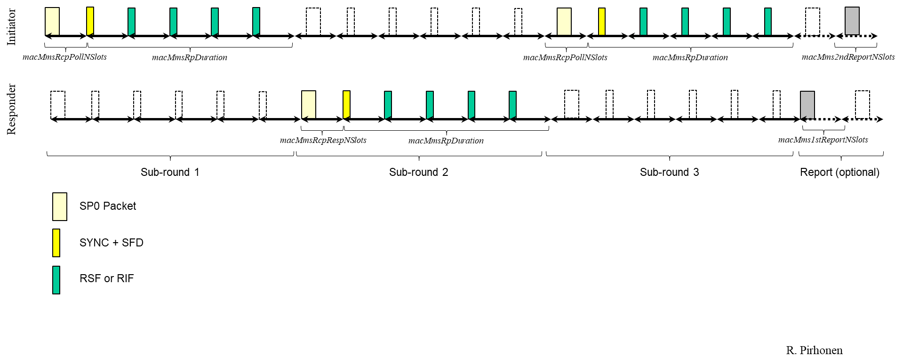

**Figure XX - UWBD MMS non-interleaved DS-TWR with three sub-rounds**

**Comment #524**

|  |  |  |  |  |  |  |
| --- | --- | --- | --- | --- | --- | --- |
| **Name** | **Index #** | **Page** | **Sub-clause** | **Line #** | **Comment** | **Proposed Change** |
| VERSO, BILLY | 524 | 105 | 10.39.11.1.3.9 | 28 | For interleaving modes, I think rather then talking about interleaved/non-interleaved sub-rounds, it would be mor logical to talking about interleaved and non-interleaved SS-TWR and DS-TWR, Hybrid DS-TWR, and OWR which by definition is not interleaved. | Redefining values in Table 19 based on ranging algorithm: 0 is SS-TWR (A single interleaved sub-round). 1 is OWR ranging (a single non-interleaved sub-round) 2 is SS-TWR (2x non-interleaved sub-rounds) 3 is DS-TWR (3x non-interleaved sub-rounds) 4 is DS-TWR (4x non-interleaved sub-rounds) 5 is DS-TWR (1x interleaved sub-round and 1 non-interleaved) |

Resolution (Accepted/Rejected/**Revised**)

**Discussion:**

Attribute name *macMmsNonInterleavedMode* is not good. It is better to call it *macMmsInterleavingMode*, which has default value of 0 that corresponds to the interleaved operation, and the corresponding Management MAC Configuration field “Interleaving Mode” instead of “Non interleaved Mode”. Elsewhere the name non-interleaved mode can be used, because in those cases it refers to the MMS UWB Packets that are sent individually without interleaving them with packets in the opposite direction.

The ranging modes supported by each value, e.g. SS-TWR or DS-TWR, can be added to clarify the use, but it is better still to name the parameter with the number of sub-rounds and then add description of the ranging mode.

**Changes:**

*Change the attribute name macMmsNonInterleavedMode to macMmsInterleavingMode.*

* *Page 105, line 15*
* *Page 105, line 28 Table 19 caption and in the first column title*
* *Page 145, Table 31 attribute name on the 11th row*

*Change the MAC Configuration field name from Non interleaved Mode to Interleaved Mode*

* *Page 104, line 4, Figure 66, last field*
* *Page 105, line 25*

*Table 19 can be reformatted as below*

**Table 19 – Values of Interlaving Mode field**

|  |  |
| --- | --- |
| **Interleaving Mode field value** | **Heading** |
| 0 | Interleaved mode (SS-TWR) |
| 1 | One non-interleaved sub-round (OWR) |
| 2 | Two non-interleaved sub-rounds (SS-TWR) |
| 3 | Three non-interleaved sub-rounds (DS-TWR) |
| 4 | Four non-interleaved sub-rounds (DS-TWR) |
| 5 | Hybrid sub-rounds with one interleaved and one non-interleaved sub=round (DS-TWR) |
| 6 | Two interleaved sub-rounds (DS-TWR) |
| 7 | Reserved |

**Comment #525**

|  |  |  |  |  |  |  |
| --- | --- | --- | --- | --- | --- | --- |
| **Name** | **Index #** | **Page** | **Sub-clause** | **Line #** | **Comment** | **Proposed Change** |
| VERSO, BILLY | 525 | 105 | 10.39.11.1.3.9 | 29 | Looking at the list we are missing DS-TWR using interleaved packets, This is like #4 using 4 packets, but taking half the time. | Add 6: DS-TWR using 2 interleaved sub-rounds. |

**Resolution:** (**Accepted**/Rejected/Revised)

**Discussion:**

Accepted as proposed. Change already included on the previous page on comment 524 resolution but repeated below.

**Change:**

*Table 19 can be reformatted as below*

**Table 19 – Values of Interlaving Mode field**

|  |  |
| --- | --- |
| **Interleaving Mode field value** | **Heading** |
| 0 | Interleaved mode (SS-TWR) |
| 1 | One non-interleaved sub-round (OWR) |
| 2 | Two non-interleaved sub-rounds (SS-TWR) |
| 3 | Three non-interleaved sub-rounds (DS-TWR) |
| 4 | Four non-interleaved sub-rounds (DS-TWR) |
| 5 | Hybrid sub-rounds with one interleaved and one non-interleaved sub=round (DS-TWR) |
| 6 | Two interleaved sub-rounds (DS-TWR) |
| 7 | Reserved |

**Comment #136**

|  |  |  |  |  |  |  |
| --- | --- | --- | --- | --- | --- | --- |
| **Name** | **Index #** | **Page** | **Sub-clause** | **Line #** | **Comment** | **Proposed Change** |
| LI, HuanBang | 136 | 107 | 10.39.11.1.3.13 | 5 | According to the description that when the Control Phase Config field is set to 14, the Report Phase Config field can be set to either 14 or 15. This should be modified to a description like the Report Phase Config field shall be set to the same value as Control Phase Config field is set. | modify the sentence. |

**Resolution:** (**Accepted**/Rejected/Revised)

**Discussion:**

Based on discussion during the ad hoc meeting group view was to agree with the proposal.

**Change:**

*Page 107, line 6.*

If the Control Phase Config field is set to either 14 or 15, then the Report Phase Config shall also be set to same value, either 14 or 15.

**Comment #30**

|  |  |  |  |  |  |  |
| --- | --- | --- | --- | --- | --- | --- |
| **Name** | **Index #** | **Page** | **Sub-clause** | **Line #** | **Comment** | **Proposed Change** |
| CHITRAKAR, ROJAN | 30 | 118 | 10.39.11.3.5 | 25 | Can all the existing O2O Poll message variants also be used for non-interleaved mode? To avoid confusion (for the responder) with interleaved mode, it may be better to define new variants for non-interleaved mode even if the content of the frames are the same. | Define new variants of O2O Poll compact frames to be used for non-interleaved mode and describe their usage in subclause 10.39.7. |

**Resolution:** (Accepted/**Rejected**/Revised)

**Discussion:**

Based on the discussion in the ad hoc meeting separate messages for non-interleaved mode are not needed.

**Comment #31**

|  |  |  |  |  |  |  |
| --- | --- | --- | --- | --- | --- | --- |
| **Name** | **Index #** | **Page** | **Sub-clause** | **Line #** | **Comment** | **Proposed Change** |
| CHITRAKAR, ROJAN | 31 | 120 | 10.39.11.3.6 | 30 | Can all the existing O2O Response message variants also be used for non-interleaved mode? To avoid confusion with interleaved mode, it may be better to define new variants for non-interleaved mode even if the content of the frames are the same. | Define new variants of O2O Response compact frames to be used for non-interleaved mode and describe their usage in subclause 10.39.7. |

**Resolution:** (Accepted/**Rejected**/Revised)

**Discussion:**

Based on the discussion in the ad hoc meeting separate messages for non-interleaved mode are not needed.

**Comment #34**

|  |  |  |  |  |  |  |
| --- | --- | --- | --- | --- | --- | --- |
| **Name** | **Index #** | **Page** | **Sub-clause** | **Line #** | **Comment** | **Proposed Change** |
| CHITRAKAR, ROJAN | 34 | 122 | 10.39.11.3.7 | 16 | The usage of Message control one should be explained. | Add description to explain that Message control one is used for DS-TWR. |

**Resolution**: (**Accepted**/Rejected/Revised)

**Change:**

*On page 122, line 17 add the text shown in red.*

When the Message Control field value is one the Message Content field shall be formatted as shown in Figure 95. Note that this frame is used for DS-TWR.

**Comment #36**

|  |  |  |  |  |  |  |
| --- | --- | --- | --- | --- | --- | --- |
| **Name** | **Index #** | **Page** | **Sub-clause** | **Line #** | **Comment** | **Proposed Change** |
| CHITRAKAR, ROJAN | 36 | 124 | 10.39.11.3.8 | 11 | The usage of Message control two should be explained. | Add description to explain that Message control two is used for DS-TWR. |

**Resolution**: (**Accepted**/Rejected/Revised)

**Change:**

*On page 124, line 12 add the text shown in red.*

When the Message Control field value is two, the Message Content field shall be formatted as shown in Figure 99. Note that this frame is used for DS-TWR.