IEEE P802.15
Wireless Personal Area Networks

Project | IEEE P802.15 Working Group for Wireless Personal Area Networks (WPANs)
Title | Proposed resolution for RCM related comments: CIDs 353 and 354
Date Submitted | May 2025
Sources | Mickael Maman (STMicroelectronics)
Re:
Abstract
Purpose | To propose comments resolution for “P802.15.4ab™/D02 C Draft Standard for Low-Rate Wireless Networks”
Notice | This document does not represent the agreed views of the IEEE 802.15 Working Group or IEEE 802.15.4ab Task Group. It represents only the views of the participants listed in the “Sources” field above. It is offered as a basis for discussion and is not binding on the contributing individuals. The material in this document is subject to change in form and content after further study. The contributors reserve the right to add, amend or withdraw material contained herein.

Commenter | Index # | page | Sub-Clause | Line | Comment | Proposed Change
VERSO, BILLY | 353 | 45 | 10.32.1 | 25 | The statement here that is a little vague and really is not needed, since this handling is all the domain of the higher layer. | Change the end of the paragraph starting from the sentence: "If a device receives RCMs with different contents, …" to: "The higher layer is responsible for processing, and acting on, the RCM content."
VERSO, BILLY | 354 | 46 | 10.32.2 | 28 | Is there something in the RCM to indicate which slot it is being sent in, so that for example if a devices receives and RCM not sent in slot zero, after missing the initial RCM, that it knows where slot zero is to correctly synchronise to the ranging block/round etc. I don't see this in the ARC IE or AC IE, so I think that maybe this is broken as an idea. The ARC IE is part of the base standard so we probably cannot add a slot # field in it, but we can do so in the AC IE, in which case this text can say "RCM using AC IE" and state that the slot# field is present for this purpose. | Add slot number field to the AC IE, and modify this text to say "RCM using AC IE", which "shall have the slot number field included if RCM are being sent in slots other than slot zero".

Comment Index #353 in 15-25-0174-09-04ab-consolidated-comments-draft-2-0
Commenter | Index # | page | Sub-Clause | Line | Comment | Proposed Change
VERSO, BILLY | 353 | 45 | 10.32.1 | 25 | The statement here that is a little vague and really is not needed, since this handling is all the domain of the higher layer. | Change the end of the paragraph starting from the sentence: "If a device receives RCMs with different contents, …" to: "The higher layer is responsible for processing, and acting on, the RCM content."

Discussion of comment ID 353:
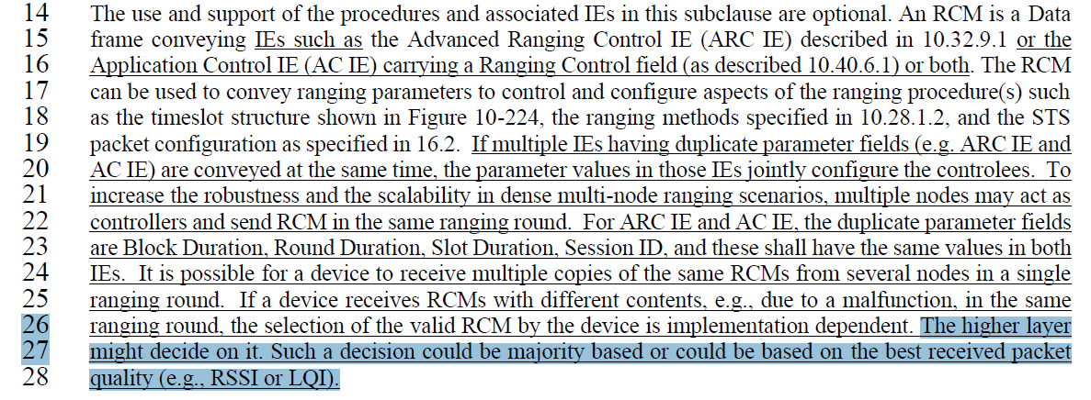
Proposed resolution:
Accepted
Proposed text changes on P802.15.4ab™/D02 for comment ID 353:
Change page 45 line 25-27
If a device receives RCMs with different contents, e.g., due to a malfunction, in the same ranging round, the selection of the valid RCM by the device is implementation dependent. The higher layer might decide on it. Such a decision could be majority based or could be based on the best received packet quality (e.g., RSSI or LQI). The higher layer is responsible for processing and acting on, the RCM content.

Comment Index #354 in 15-25-0174-09-04ab-consolidated-comments-draft-2-0
Commenter | Index # | page | Sub-Clause | Line | Comment | Proposed Change
VERSO, BILLY | 354 | 46 | 10.32.2 | 28 | Is there something in the RCM to indicate which slot it is being sent in, so that for example if a devices receives and RCM not sent in slot zero, after missing the initial RCM, that it knows where slot zero is to correctly synchronise to the ranging block/round etc. I don't see this in the ARC IE or AC IE, so I think that maybe this is broken as an idea. The ARC IE is part of the base standard so we probably cannot add a slot # field in it, but we can do so in the AC IE, in which case this text can say "RCM using AC IE" and state that the slot# field is present for this purpose. | Add slot number field to the AC IE, and modify this text to say "RCM using AC IE", which "shall have the slot number field included if RCM are being sent in slots other than slot zero".

Discussion of comment 354:
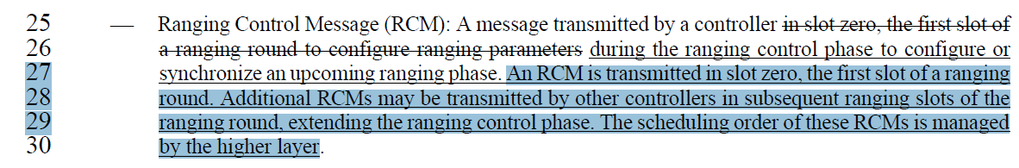
In the RSS slotframe, slots of the ranging control phase are assigned to controllers for transmitting Ranging Control messages. The RDM IE (described in 10.32.9.8) in the RCM is used to convey the assignment of time slots and device roles in a ranging round. If a device receives an RCM not sent in slot zero, after missing the initial RCM, it knows where slot zero is to correctly synchronize to the ranging block/round according to the controller address. The RDM IE can be omitted from the RCM in the case where the roles and transmission schedule is pre-determined or conveyed via some out-of-band mechanism.

Proposed resolution:
Rejected

