**IEEE P802.15**

**Wireless Personal Area Networks**

|  |  |  |
| --- | --- | --- |
| Project | IEEE P802.15 Working Group for Wireless Personal Area Networks (WPANs) | |
| Title | **LB213 - CRs for MMS SMC TLVs** | |
| Date Submitted | May 2025 | |
| Sources | Rojan Chitrakar, Lei Huang (Huawei)  [rojan.chitrakar@huawei.com](mailto:rojan.chitrakar@huawei.com) |  |
| Re: |  | |
| Abstract |  | |
| Purpose | To propose resolution for “P802.15.4ab™/D02 Draft Standard for Low-Rate Wireless Networks” | |
| Notice | This document does not represent the agreed views of the IEEE 802.15 Working Group or IEEE 802.15.4ab Task Group. It represents only the views of the participants listed in the “Sources” field above.It is offered as a basis for discussion and is not binding on the contributing individuals. The material in this document is subject to change in form and content after further study. The contributors reserve the right to add, amend or withdraw material contained herein. | |

Rev 0: Initial version: 4 CIDs

|  |  |  |  |  |  |  |  |
| --- | --- | --- | --- | --- | --- | --- | --- |
| **Name** | **Index#** | **Pg** | **Sub-Clause** | **Ln** | **Comment** | **Proposed Change** | **Disposition** |
| VERSO, BILLY | 537 | 111 | 10.39.11.3.1 | 24 | in the interest of saving space there seems little point in having a presence bitmap if all it is doing is saying whether the SMC TLVs field is present. The length of the SMC TLVs field already has to be inferred from the length of the frame, (which is not stated but perhaps should be), so its presence can be similarly inferred. And probably handiest to put the SMC TLVs field at the end of the frame too. | Remove the presence bitmap (saving 2 octets) and move SMC TLVs field to the end, and add a statemet to say that the SMC TLVs field length can be determined from the frame length. | Revise |
| VERSO, BILLY | 541 | 113 | 10.39.11.3.2 | 1 | Would be good to put the SMC TLVs field at the end, and look to do the same in any other frames containing it, since remaining Message Content would then all be SMC TLV structures. | Move SMC TLVs field to the end of the message. | Revise |
| VERSO, BILLY | 542 | 113 | 10.39.11.3.2 | 17 | Would be good to say that the SMC TLVs field length can be determined from the frame length. | add a statemet to say that the SMC TLVs field length can be determined from the frame length. | Revise |
| MAMAN, MICKAEL | 194 | 119 | 10.39.11.3.5 | 7 | the last reserved bit of the poll control field can be used to indicate the presence of the presence bitmap | change "reserved" in bit 7 by "presence bitmap presence". Add the size 0 for the presence bitmap in Figure 88. Add page 102 line 4 the presence bittap presence field when set to one indicates thet the presence bitmap field is present. | Reject  It is desirable to carry the Presence Bitmap field even when no optional fields are present to make the Message Control field 2 octets long. |

**Proposed text changes on P802.15.4ab™/D02:**

**10.39.11.3.1 Advertising Poll Compact frame**

***Modify the subclause as follows (Track changes ON)***

…

***Delete the Presence Bitmap field from Figure 73 and move the SMC TLVs field to the end of the Message Content field.***

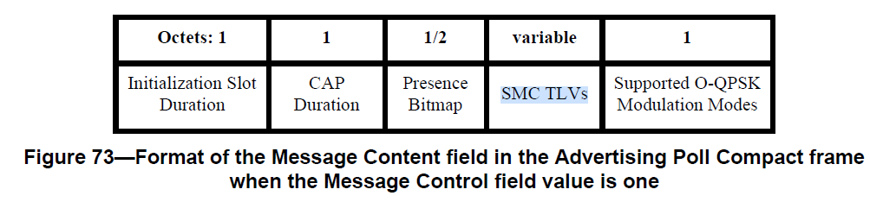

…

The SMC TLVs field is the list of supported message control commands as defined in 10.39.11.1.3.2. This is used by the initiator to signal to responders which compact frames and which message control values it supports. Its presence and length can be inferred from the frame length.

**10.39.11.3.2 Advertising Response Compact frame**

…

***Move the SMC TLVs field to the end of the Message Content field in Figure 76.***

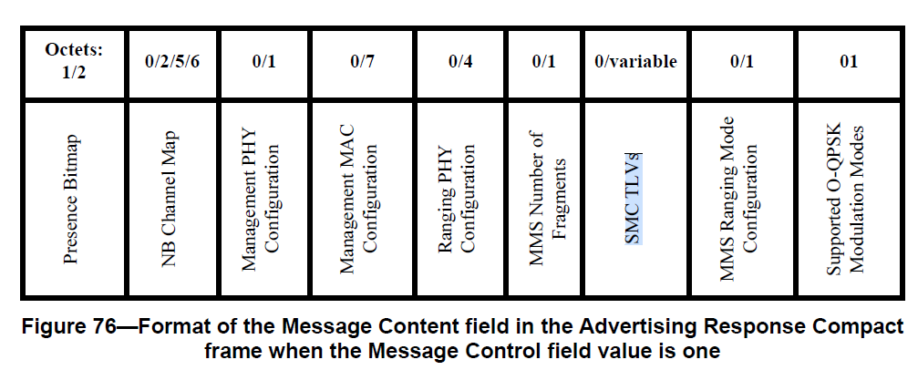

The Presence Bitmap field is set as specified in 10.39.11.1.3.14, where the following fields may be used, and all other Presence Bitmap fields shall be set to zero: the NB Channel Map Present field, the Management PHY Configuration Present field, the Management MAC Configuration Present field, the Ranging PHY Configuration Present field, the MMS Number of Fragments Present field, the MMS Ranging Mode Configuration Present field and the Extended Presence Bitmap Present field.

…

The MMS Number of Fragments field if present shall be set as per 10.39.11.1.3.8. 14

The SMC TLVs field is the list of supported messages and if present shall be set as per 10.39.11.1.3.2. This is used by the initiator to signal to responders which compact frames and which message control values it supports. Its presence and length can be inferred from the frame length.

**10.39.11.3.13 Public Advertising Poll Compact frame**

…

The CAP Duration field is an unsigned integer that specifies the duration of the contention access period in units of initialization slots.

The Presence Bitmap is set as specified in specified in 10.39.11.1.3.14, except that the fields other than the Group ID Present field and the Extended Presence Bitmap Present field shall be set to zero.

…

The SMC TLVs field is the list of supported message control commands as defined in 10.39.11.1.3.2. This is used by the initiator to signal to responders which compact frames and which message control values it supports. The length of the SMC TLVs field can be inferred from the frame length.

**10.39.11.1.3.14 The Presence Bitmap field**

…

***Delete the SMC TLVs Present field from the Extended Presence Bitmap field in Figure 69.***

***Note to editor: 15-25\209r0 adds a new field “Response Status present” to the end of the Extended Presence Bitmap so bit 7 is still the only Reserved bit.***

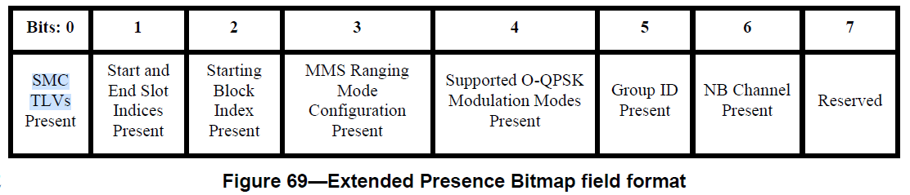

The Start and End Slot Indices Present field when one indicates that both the Start Slot Index field and the End Slot Index field are present in the Message Content field, or are not included when the Start and End Slot Indices Present field value is zero.