IEEE P802.15
Wireless Personal Area Networks

Project | IEEE P802.15 Working Group for Wireless Personal Area Networks (WPANs)
Title | Proposed resolution for MMS without report related comments: CIDs 159, 170, 171, 178, 179, 180 and 181
Date Submitted | May 2025
Sources | Mickael Maman (STMicroelectronics)
Re:
Abstract
Purpose | To propose comments resolution for “P802.15.4ab™/D02 C Draft Standard for Low-Rate Wireless Networks”
Notice | This document does not represent the agreed views of the IEEE 802.15 Working Group or IEEE 802.15.4ab Task Group. It represents only the views of the participants listed in the “Sources” field above. It is offered as a basis for discussion and is not binding on the contributing individuals. The material in this document is subject to change in form and content after further study. The contributors reserve the right to add, amend or withdraw material contained herein.

R1: add explanation and extension to UWB-Driven MMS + split between synchronized and reversed MMS.

Commenter | Index # | page | Sub-Clause | Line | Comment | Proposed Change
MAMAN, MICKAEL | 159 | 64 | 10.39.1 | 17 | The value A in ms is linked to macMmsRcpPollNSlots and macMmsRcpRespNSlots. Missing information about macMmsRangingSlotDuration | add " and macMmsRangingSlotDuration to a value of 600 RSTUs" after both to a value of two.
MAMAN, MICKAEL | 170 | 80 | 10.39.5 | 19 | Optionnally the order between the Initiator and the responder can be reversed. Then In the ranging phase, the responder may transmit the HRP UWB PHY MMS packet (described in 16.2.11), and the Initiator may start transmitting its HRP UWB PHY MMS packet offset by 600 RSTU from the start into the ranging phase. | add text page 81 line 2. "Optionnally in the ranging phase, the responder may transmit the HRP UWB PHY MMS packet (described in 16.2.11), and the Initiator may start transmitting its HRP UWB PHY MMS packet offset by 600 RSTU from the start into the ranging phase. This option is signaled by the reversed_fragment parameter described in 10.38.11.1.3.8". A new bit "reversed_fragment" can be added in Figure 65 to indicate this configuration. A new DCN will be provided and will detail the full changes
MAMAN, MICKAEL | 171 | 80 | 10.39.5 | 19 | Optionnally, the responder may start transmitting its HRP UWB PHY MMS packet offset by 600 RSTU from the reception of the first fragment instead of the start into the ranging phase. This new option reduces the energy consumption of the interleaved MMS by avoiding the need to send the report | add text page 81 line 2. "Optionnally in the ranging phase, the responder may start transmitting its HRP UWB PHY MMS packet offset by 600 RSTU from the start of the HRP UWB PHY MMS packet received from the initiator.This option is signaled by the MMS_Sync parameter described in 10.38.11.1.3.8". A new bit "MMS_Sync" can be added in Figure 65 to indicate this configuration. A new DCN will be provided and will detail the full changes
MAMAN, MICKAEL | 178 | 93 | 10.39.10.2 | 23 | The time A can also depend on the MMS order between the initiator and the responder | change to "depending on the slot size, the order and number of slots allocated to the ranging control phase poll and response."
MAMAN, MICKAEL | 179 | 94 | 10.39.10.2 | 7 | Optionnally, the MMsRangingRXOnTime can be set 600 RSTU from the Ranging TxTime according to MMS_Sync parameter | Optionnally, the MmsRangingRxOnTime can be set 600 RSTU from the RangingTxTime according to MMS_Sync parameter
MAMAN, MICKAEL | 180 | 94 | 10.39.10.2 | 12 | Optionnally, the RangingTxTime can be set 600 RSTU from the MmsRangingRxOnTime according to MMS_Sync parameter | Optionnally, the RangingTxTime can be set 600 RSTU from the MmsRangingRxOnTime according to MMS_Sync parameter
MAMAN, MICKAEL | 181 | 94 | 10.39.10.2 | 15 | The time A can also depend on the MMS order between the initiator and the responder | change to "might be different depending on the slot size, the order and number of slots allocated to this part of the control phase."

Comment Index #159 in 15-25-0174-09-04ab-consolidated-comments-draft-2-0
Commenter | Index # | page | Sub-Clause | Line | Comment | Proposed Change
MAMAN, MICKAEL | 159 | 64 | 10.39.1 | 17 | The value A in ms is linked to macMmsRcpPollNSlots and macMmsRcpRespNSlots. Missing information about macMmsRangingSlotDuration | add " and macMmsRangingSlotDuration to a value of 600 RSTUs" after both to a value of two.

Discussion of comment ID 159:
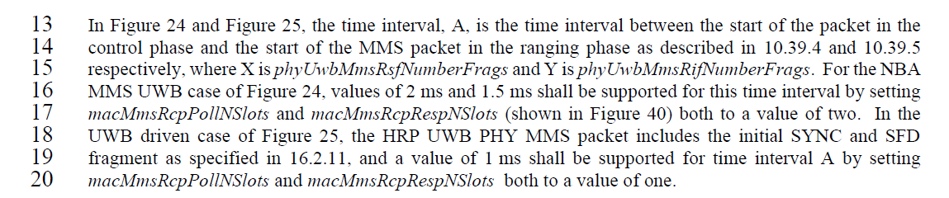
Proposed resolution:
Accepted
Proposed text changes on P802.15.4ab™/D02 for comment ID 159:
Change page 64 line 13-20
In Figure 24 and Figure 25, the time interval, A, is the time interval between the start of the packet in the control phase and the start of the MMS packet in the ranging phase as described in 10.39.4 and 10.39.5 respectively, where X is phyUwbMmsRsfNumberFrags and Y is phyUwbMmsRifNumberFrags. For the NBA MMS UWB case of Figure 24, values of 2 ms and 1.5 ms shall be supported for this time interval by setting macMmsRcpPollNSlots and macMmsRcpRespNSlots (shown in Figure 40) both to a value of two and macMmsRangingSlotDuration to a value of 600 RSTUs. In the UWB driven case of Figure 25, the HRP UWB PHY MMS packet includes the initial SYNC and SFD fragment as specified in 16.2.11, and a value of 1 ms shall be supported for time interval A by setting macMmsRcpPollNSlots and macMmsRcpRespNSlots both to a value of one.

Comment Index #171-179-180 in 15-25-0174-09-04ab-consolidated-comments-draft-2-0
Commenter | Index # | page | Sub-Clause | Line | Comment | Proposed Change
MAMAN, MICKAEL | 171 | 80 | 10.39.5 | 19 | Optionally, the responder may start transmitting its HRP UWB PHY MMS packet offset by 600 RSTU from the reception of the first fragment instead of the start into the ranging phase. This new option reduces the energy consumption of the interleaved MMS by avoiding the need to send the report | add text page 81 line 2. "Optionally in the ranging phase, the responder may start transmitting its HRP UWB PHY MMS packet offset by 600 RSTU from the start of the HRP UWB PHY MMS packet received from the initiator.This option is signaled by the MMS_Sync parameter described in 10.38.11.1.3.8". A new bit "MMS_Sync" can be added in Figure 65 to indicate this configuration. A new DCN will be provided and will detail the full changes
MAMAN, MICKAEL | 179 | 94 | 10.39.10.2 | 7 | Optionnally, the MMsRangingRXOnTime can be set 600 RSTU from the Ranging TxTime according to MMS_Sync parameter | Optionnally, the MmsRangingRxOnTime can be set 600 RSTU from the RangingTxTime according to MMS_Sync parameter
MAMAN, MICKAEL | 180 | 94 | 10.39.10.2 | 12 | Optionnally, the RangingTxTime can be set 600 RSTU from the MmsRangingRxOnTime according to MMS_Sync parameter | Optionnally, the RangingTxTime can be set 600 RSTU from the MmsRangingRxOnTime according to MMS_Sync parameter

Discussion of comment 171-179-180:
The timing of the MMS ranging transmission (Figure 24) is managed by the MAC Layer. To evaluate the Time of Flight (ToF), the initiator needs to receive a report compact frame including a reply time from the responder.
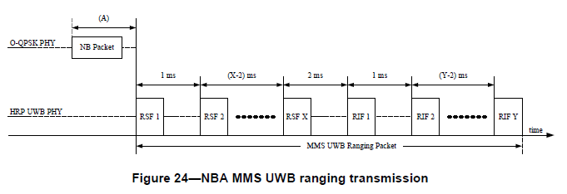
In this CR, we propose to synchronize the NBA MMS UWB ranging transmission of the Responder to the one of the initiator by setting a fixed and accurate reply time. The synchronization can be done on the SYNC and SFD fragment for the UWB driven MMS mode or on the first RSF fragment for the NBA-UWB MMS mode.
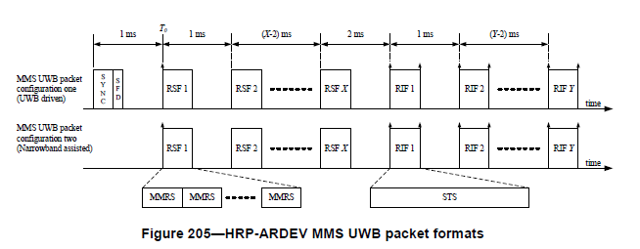
In this case, the fixed reply time is the time between the reception of the first RSF fragment received from the initiator and the transmission of the first RSF fragment by the responder for the NBA-UWB MMS mode or between the reception of the first SYNC and SFD fragment received from the initiator and the transmission of the first SYNC and SFD fragment by the responder for the UWB-driven MMS mode.
This new option reduces the energy consumption of the interleaved MMS by avoiding the need to send the report. This optimization is interesting for use cases in which the CIR estimation on the first fragment is good enough
In NBA-UWB MMS, the initiator sends a POLL compact frame in the POLL slot and sends the first RSF fragments 2400 RSTUs later and then each fragment 1200 RSTUs after. The Responder sends a RESP compact frame in the RESP slot and sends the first RSF fragments 1800 RSTUs later and then each fragment 1200 RSTUs after.
Both Initiator and Responder manage their NBA MMS UWB ranging transmission according to the beginning of the POLL and RESP slot respectively. The timing is managed by the MAC layer. To evaluate the ToF the initiator needs a report compact frame with the treply.
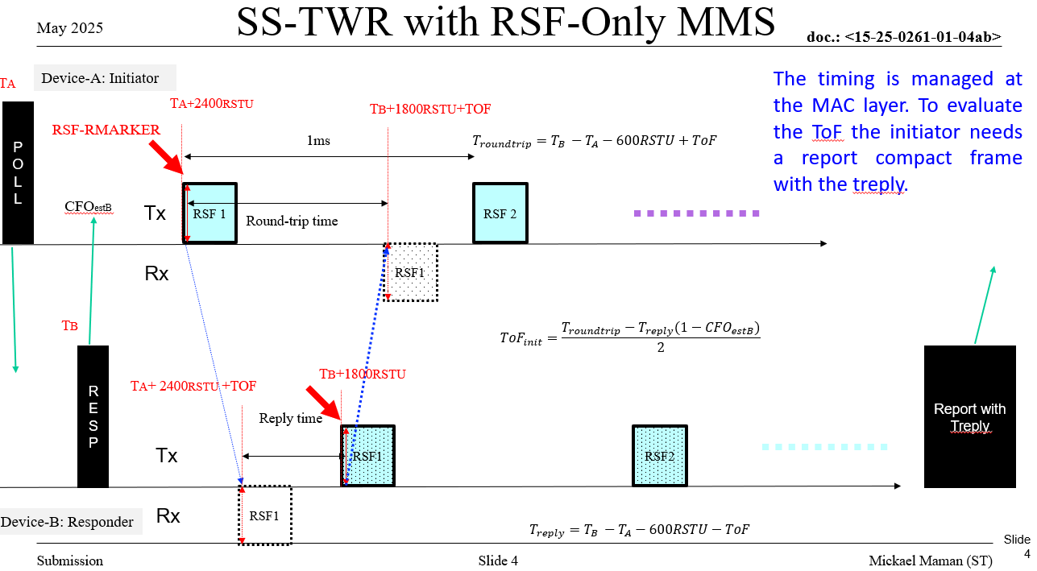
In this CR, we propose to synchronize the NBA MMS UWB ranging transmission of the Responder to the one of the initiator by setting a fixed and accurate reply time between the reception of the first RSF fragment received from the initiator and the transmission of the first RSF fragment by the responder. The initiator sends the POLL compact frame at the beginning of the POLL slot. The responder sends the RESP compact frame at the beginning of the RESP slot. The Initiation sends the first RSF fragment exactly 2400RSTU after the beginning of the POLL compact frame. Until now, there is no change from the legacy procedure. However the Responder does not send the first RSF fragment 1800RSTU after the beginning of the RESP compact frame but 600 RTSU after the reception of the first RSF fragment from the initiator. At the end, the initiator does not need the report compact frame from the responder to compute the ToF.
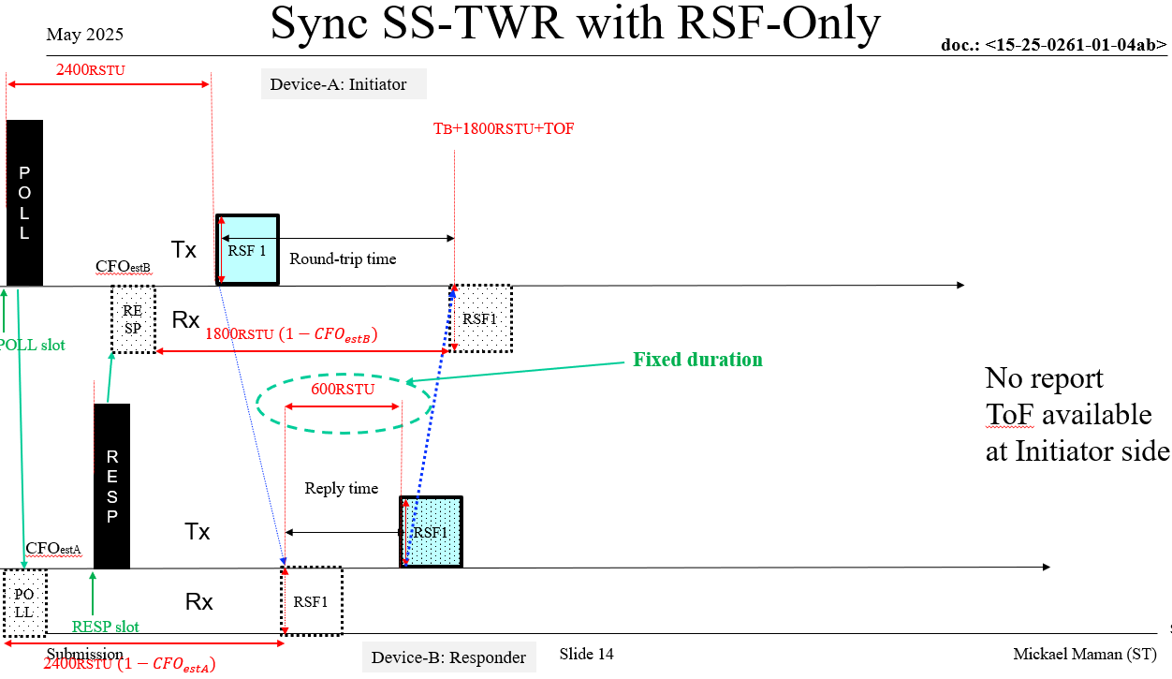
In UWB-driven MMS, we propose to synchronize the NBA MMS UWB ranging transmission of the Responder to the one of the initiator by setting a fixed and accurate reply time between the reception of the first SYNC and SFD fragment received from the initiator and the transmission of the first SYNC and SFD fragment by the responder. The initiator sends the POLL compact frame at the beginning of the POLL slot. The responder sends the RESP compact frame at the beginning of the RESP slot. The Initiation sends the first SYNC and SFD fragment exactly 1200RSTU after the beginning of the POLL compact frame. Until now, there is no change from the legacy procedure. However, the Responder does not send the first SYNC and SFD fragment 1200RSTU after the beginning of the RESP compact frame but 600 RTSU after the reception of the first SYNC and SFD fragment from the initiator.
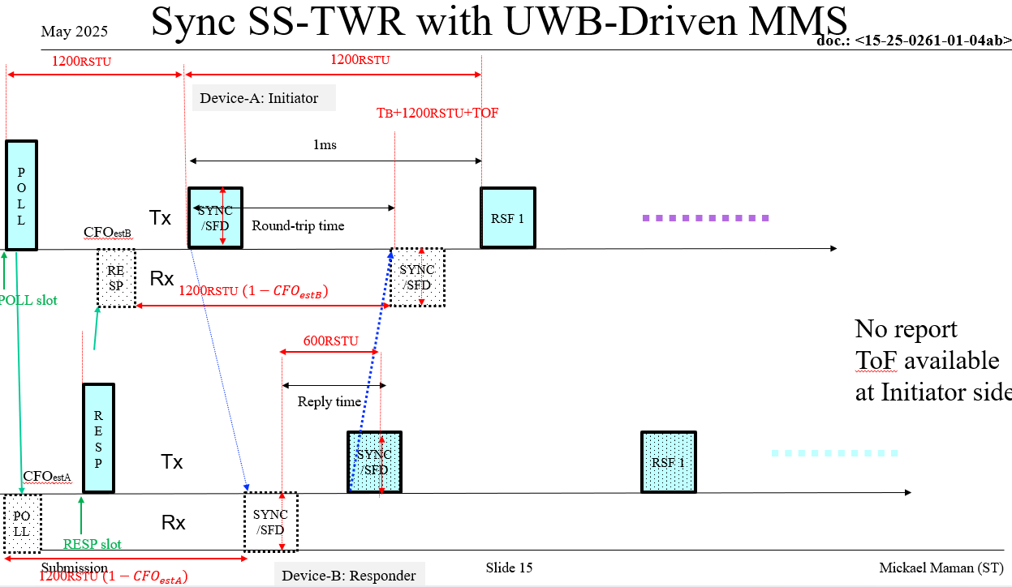

Proposed resolution:
revised
Proposed text changes on P802.15.4ab™/D02 for comment ID 171-179-180:

Change in Table 8-29 p24. Add a new element of TxOptions.
Name | Type | Valid Range | Description
MmsSync | Boolean | TRUE, FALSE | For MMS UWB ranging, this parameter is set TRUE if the transmission of the interleaved fragment is synchronized on the reception of the first fragment, or FALSE otherwise.

Add page 26 line 33
The MmsSync parameter of TxOptions applies to UWB multi-millisecond (MMS) packet transmissions. When MmsSync is TRUE it enables the synchronization of the transmission of MMS UWB fragments interleaved to the transmitted MMS UWB fragments.
Add page 81 line 2
Optionally in the ranging phase, the responder may start transmitting its HRP UWB PHY MMS packet offset by 600 RSTU from the start of the HRP UWB PHY MMS packet received from the initiator. This option is signaled by the MMS_Sync parameter described in 10.38.11.1.3.8.

add page 94 line 9
While this reception, (for the simple single responder case), nominally starts 600 RSTU offset from start of the ranging phase, the MmsRangingRxOnTime might be based on the arrival time reported by the MCPS-DATA.indication for the NBA response Compact frame, which also reports the clock offset measurement for that frame. Optionnally, the MmsRangingRxOnTime can be set 600 RSTU from the RangingTxTime according to MMS_Sync parameter.

add page 94 line 12-16
-TxTimeSpecified and RangingTxTime to specify when to send the first fragment, which for the responder (in the single responder case) nominally starts 600 RSTU offset from start of the ranging phase. This time, denoted (A) in Figure 24, which for the responder would be relative to the transmission of the NBA response, is 1.5 ms by default, but might be different depending on the slot size, the order and number of slots allocated to this part of the control phase. Optionnally, the RangingTxTime can be set 600 RSTU from the MmsRangingRxOnTime according to MMS_Sync parameter i.e. the time of the responder starts to receive the first fragment.

Modify page 103 paragraph 10.39.11.1.3.8
10.39.11.1.3.8 The MMS Number of Fragments Configuration field
This is a one-octet field formatted as shown in Figure 65.
Bits: 0–2 | 3–5 | 6–7 | 7
Number of RSF | Number of RIF | Reserved MMS_Sync | reserved

The MMS_Sync field specifies if the responder may start transmitting its HRP UWB PHY MMS packet offset by 600 RSTU from the reception of the first fragment instead of the start into the ranging phase. By default, the MMS_Sync is FALSE.

Add page 146 in Table 31
Attribute | Type | Range | Description | Default
macMmsSync | Boolean | TRUE-FALSE | Synchronization of the MMS fragments of the initiator and the responder. | FALSE

Comment Index #170-178-181 in 15-25-0174-09-04ab-consolidated-comments-draft-2-0
Commenter | Index # | page | Sub-Clause | Line | Comment | Proposed Change
MAMAN, MICKAEL | 170 | 80 | 10.39.5 | 19 | Optionally the order between the Initiator and the responder can be reversed. Then In the ranging phase, the responder may transmit the HRP UWB PHY MMS packet (described in 16.2.11), and the Initiator may start transmitting its HRP UWB PHY MMS packet offset by 600 RSTU from the start into the ranging phase. | add text page 81 line 2. "Optionally in the ranging phase, the responder may transmit the HRP UWB PHY MMS packet (described in 16.2.11), and the Initiator may start transmitting its HRP UWB PHY MMS packet offset by 600 RSTU from the start into the ranging phase. This option is signaled by the reversed_fragment parameter described in 10.38.11.1.3.8". A new bit "reversed_fragment" can be added in Figure 65 to indicate this configuration. A new DCN will be provided and will detail the full changes
MAMAN, MICKAEL | 178 | 93 | 10.39.10.2 | 23 | The time A can also depend on the MMS order between the initiator and the responder | change to "depending on the slot size, the order and number of slots allocated to the ranging control phase poll and response."
MAMAN, MICKAEL | 181 | 94 | 10.39.10.2 | 15 | The time A can also depend on the MMS order between the initiator and the responder | change to "might be different depending on the slot size, the order and number of slots allocated to this part of the control phase."

Discussion of comment 170-178-181:
In this CR, we propose to change the order of the fragment (i.e. the responder sends the first fragment and the initiator sends its first fragment 600 RSTU after the first fragment from the responder. This means in NBA-UWB MMS, the initiator sends a POLL compact frame in the POLL slot and sends the first RSF fragments 3000 RSTUs later and then each fragment 1200 RSTUs after. The Responder sends a RESP compact frame in the RESP slot and sends the first RSF fragments 1200 RSTUs later and then each fragment 1200 RSTUs after.
Note: This option is interesting with Sync MMS. When the MMS_field is set to TRUE, it is possible to compute the ToF at the responder side without the reception of the report.
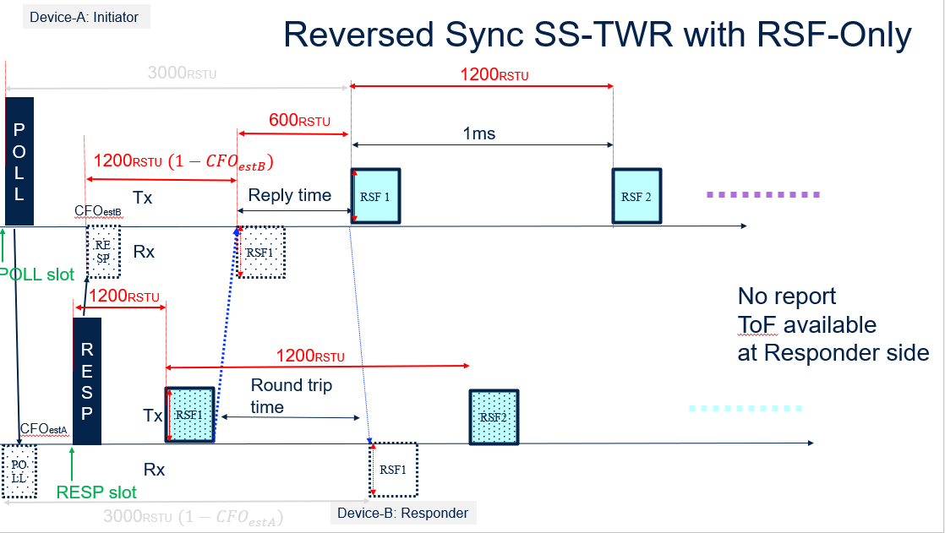
To allow a measurement of the ToF by the responder without a report compact frame with a sync SS-TWR procedure, we propose to reverse the order of the fragment of the initiator and the responder. The control phase is the same. The initiator sends the POLL compact frame in the POLL slot and the responder sends the RESP compact frame in the RESP slot. In this new mode, the responder sends the first RSF fragment i.e. 1200 RSTU after the beginning of the transmission of the RESP compact frame. The initiator does not send the first RSF fragment 3000RSTU after the beginning of the POLL compact frame (POLL slot + RESP slot + Ranging slot = 1200+1200+600 RSTU) but 600 RTSU after the reception of the first RSF fragment from the responder. In that case, we propose to synchronize the NBA MMS UWB ranging transmission of the Initiator to the one of the responder by setting a fixed and accurate reply time. The Responder does not need the report compact frame from the initiator to compute the ToF.
Proposed resolution:
revised
Proposed text changes on P802.15.4ab™/D02 for comment ID 170-178-181:
Add page 81 line 2
Optionally in the ranging phase, the responder may transmit the HRP UWB PHY MMS packet (described in 16.2.11), and the Initiator may start transmitting its HRP UWB PHY MMS packet offset by 600 RSTU from the start into the ranging phase. This option is signaled by the reversed_fragment parameter described in 10.38.11.1.3.8.

Modify page 93 line 21-23 and page 94 line1-2
- - TxTimeSpecified and RangingTxTime to specify when to send the first fragment, which for the initiator will be relative to the transmission of its poll. This TxTimeSpecified is time (A) in Figure 24, which for the initiator is 2 ms by default but possibly a different value depending on the slot size, the order and number of slots allocated to the ranging control phase poll and response. This RangingTxTime time, i.e., the time that the initiator starts to transmit the first fragment, marks the start of the ranging phase.

10.39.11.1.3.8 The MMS Number of Fragments Configuration field
This is a one-octet field formatted as shown in Figure 65.
Bits: 0–2 | 3–5 | 6–7 | 7
Number of RSF | Number of RIF | Reserved MMS_Sync | Reversed Fragment

The MMS_Sync field specifies if the responder may start transmitting its HRP UWB PHY MMS packet offset by 600 RSTU from the reception of the first fragment instead of the start into the ranging phase. By default, the MMS_Sync is FALSE.
The Reversed Fragment field specifies if the order between the Initiator and the responder is reversed. When TRUE, in the ranging phase, the responder may transmit the HRP UWB PHY MMS packet (described in 16.2.11), and the Initiator may start transmitting its HRP UWB PHY MMS packet offset by 600 RSTU from the start into the ranging phase.

Add page 123 line 2 paragraph 10.39.11.3.7
When the Message Control field value is two (i.e. Reversed MMS), the Message Content field shall be formatted as shown in Figure XX.
Octets: 5 | 0/variable
Reply Time | Passthrough
Figure XX—Format of the Message Content field in the One-to-one Initiator Report Compact frame when the Message Control field value is two
The Reply Time field value is an unsigned integer that reports the time difference, measured at the initiator, between the RMARKER of the MMS fragments received from the responder and the RMARKER of the MMS fragments transmitted by the initiator in the reversed mode. The units of time are specified in 10.29.1.4.
The Passthrough field content is defined in 10.39.11.1.3.3. Its presence can be inferred from the frame length.

Add page 124 line 23 paragraph 10.39.11.3.8
When the Message Control field value is three (i.e. Reversed MMS), the Message Content field shall be formatted as shown in Figure XX.
Octets: 5 | 0/variable
Round-trip Time | Passthrough
Figure 94—Format of the Message Content field in the One-to-one Responder Report Compact frame when the Message Control field value is three
The Round-trip Time field value is an unsigned integer that reports the time difference, measured at the responder, between the RMARKER of the MMS fragments transmitted by the responder and the RMARKER of the MMS fragments received from the initiator in the reversed mode. The units of time are specified in 10.29.1.4.
The Passthrough field content is defined in 10.39.11.1.3.3. Its presence can be inferred from the frame length.

Add page 146 in Table 31
Attribute | Type | Range | Description | Default
macMmsReversed | Boolean | TRUE-FALSE | The order between the Initiator and the responder. TRUE is reversed. | FALSE

