**IEEE P802.15**

**Wireless Personal Area Networks**

|  |  |  |
| --- | --- | --- |
| Project | IEEE P802.15 Working Group for Wireless Personal Area Networks (WPANs) | |
| Title | **LB213 - CRs for CIR Report** | |
| Date Submitted | May 2025 | |
| Sources | Rojan Chitrakar, Lei Huang (Huawei)  [rojan.chitrakar@huawei.com](mailto:rojan.chitrakar@huawei.com) |  |
| Re: |  | |
| Abstract |  | |
| Purpose | To propose resolution for “P802.15.4ab™/D02 Draft Standard for Low-Rate Wireless Networks” | |
| Notice | This document does not represent the agreed views of the IEEE 802.15 Working Group or IEEE 802.15.4ab Task Group. It represents only the views of the participants listed in the “Sources” field above.It is offered as a basis for discussion and is not binding on the contributing individuals. The material in this document is subject to change in form and content after further study. The contributors reserve the right to add, amend or withdraw material contained herein. | |

Rev 0: Initial version: 1 CIDs

|  |  |  |  |  |  |  |  |
| --- | --- | --- | --- | --- | --- | --- | --- |
| **Name** | **Index#** | **Pg** | **Sub-Clause** | **Ln** | **Comment** | **Proposed Change** | **Disposition** |
| MAMAN, MICKAEL | 217 | 174 | 10.40.6.2 | 12 | When the Compression field value is one, how to diffferentiate when the Receive Report Lists field is compressed or the CIR Taps field of each receive report in the Receive Report Lists field is compressed individually? | clarify the two cases or merge the two paragraphes | Revise |

**Related Text:**

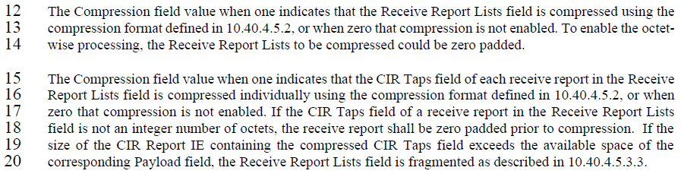

**Proposed text changes on P802.15.4ab™/D02:**

**10.39.6.2 CIR Report IE**

***Modify the subclause as follows (Track changes ON)***

…

The Compression field value when one indicates that the CIR Taps field of each receive report in the Receive Report Lists field is compressed individually using the compression format defined in 10.40.4.5.2, …