**IEEE P802.15**

**Wireless Personal Area Networks**

|  |  |  |
| --- | --- | --- |
| Project | IEEE P802.15 Working Group for Wireless Personal Area Networks (WPANs) | |
| Title | **D02 Proposed Resolution for Bitmap-based block scheduling** | |
| Date Submitted | May 2025 | |
| Sources | Hong Won Lee (LG Electronics)  [hongwon.lee@lge.com](mailto:hongwon.lee@lge.com) |  |
| Re: |  | |
| Abstract |  | |
| Purpose | To propose resolution for “P802.15.4ab™/D02 Draft Standard for Low-Rate Wireless Networks”. | |
| Notice | This document does not represent the agreed views of the IEEE 802.15 Working Group or IEEE 802.15.4ab Task Group. It represents only the views of the participants listed in the “Sources” field above.It is offered as a basis for discussion and is not binding on the contributing individuals. The material in this document is subject to change in form and content after further study. The contributors reserve the right to add, amend or withdraw material contained herein. | |

This submission contains the proposed comment resolutions for the CID 118

Rev 0: Initial version.

***Comment index #118 in 15-25-0174-07-04ab-consolidated-comments-draft-2-0.xlsx***

|  |  |  |  |  |  |  |  |
| --- | --- | --- | --- | --- | --- | --- | --- |
| **Name** | **Index#** | **Pg** | **Sub-Clause** | **Ln** | **Comment** | **Proposed Change** | **Disposition** |
| LEE, HONGWON | 118 | 58 | 10.32.9.10 | 12 | The Meaning in Table 8 includes detailed values, increasing in multiples of 8 from the Block Scheduling Bitmap Length field value minus 1. However, when the Block Scheduling Bitmap Length field value is 6, the corresponding value is 196, which does not align with the expected multiple-of-8 progression. Therefore, it would be more appropriate for the value to be 192 when the Block Scheduling Bitmap Length field value is 6 | Change "Block Scheduling Bitmap field is 196 bits long" in the Meaning column to "Block Scheduling Bitmap field is 192 bits long" | Accept |

**Discussion:**

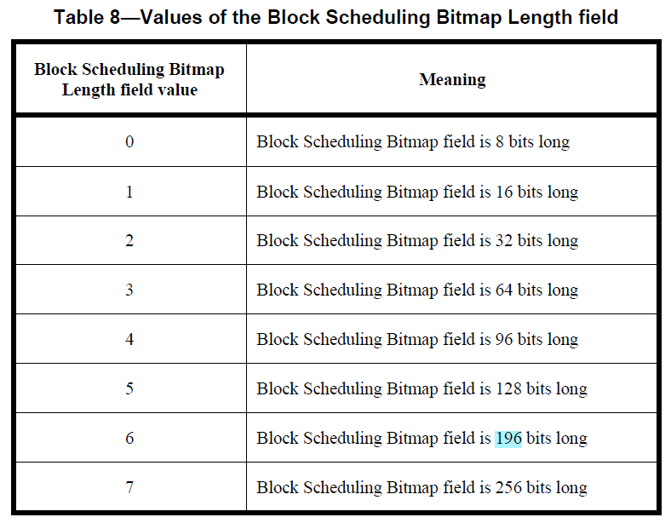

In Table 8, when the Meaning of the Block Scheduling Bitmap Length field is set to 6, it indicates that the Block Scheduling Bitmap field is 196 bits long. This value is awkward. There is a rule for the granularity corresponding to each value. The meaning, "Block Scheduling Bitmap field is 192 bits long," is more appropriate, as noted in the comment

**Disposition: Accept**