**IEEE P802.15**

**Wireless Personal Area Networks**

|  |  |  |
| --- | --- | --- |
| Project | IEEE P802.15 Working Group for Wireless Personal Area Networks (WPANs) | |
| Title | **D02 Proposed Resolution for MMS Public part1** | |
| Date Submitted | May 2025 | |
| Sources | Hong Won Lee (LG Electronics)  [hongwon.lee@lge.com](mailto:hongwon.lee@lge.com) |  |
| Re: |  | |
| Abstract |  | |
| Purpose | To propose resolution for “P802.15.4ab™/D02 Draft Standard for Low-Rate Wireless Networks”. | |
| Notice | This document does not represent the agreed views of the IEEE 802.15 Working Group or IEEE 802.15.4ab Task Group. It represents only the views of the participants listed in the “Sources” field above.It is offered as a basis for discussion and is not binding on the contributing individuals. The material in this document is subject to change in form and content after further study. The contributors reserve the right to add, amend or withdraw material contained herein. | |

This submission contains the proposed comment resolutions for the CIDs 439, 440, 441, 442, 447, 448 and 550

Rev 0: Initial version.

***Comment index #439, 441 in 15-25-0174-07-04ab-consolidated-comments-draft-2-0.xlsx***

|  |  |  |  |  |  |  |  |
| --- | --- | --- | --- | --- | --- | --- | --- |
| **Name** | **Index#** | **Pg** | **Sub-Clause** | **Ln** | **Comment** | **Proposed Change** | **Disposition** |
| VERSO, BILLY | 439 | 75 | 10.39.3.7.1 | 29 | I reckon it is the NHL that doing this, so propose to rewrite to say the same thing without the "shall". | change "shall listen" to "listens" | Revised |
| VERSO, BILLY | 441 | 75 | 10.39.3.7.1 | 35 | I reckon it is the NHL that doing this, so propose to rewrite to say the same thing without the "shall". | change "shall listen" to "listens" | Revised |

**Discussion:**

Agree with the commenter. It is reasonable that “shall” statement may be changed because procedures related to these CIDs are performed by the NHL. Based on other CIDs which are relevant to these CIDs, we could consider to change from “shall” to “should”.

|  |  |  |  |  |  |  |
| --- | --- | --- | --- | --- | --- | --- |
| **Name** | **Index #** | **Pg** | **Sub-clause** | **Ln** | **Comment** | **Proposed Change** |
| VERSO, BILLY | 397 | 66 | 10.39.3.2 | 18 | I reckon it is the NHL that decides to turn on the RX to receive the response. | change "shall" to "should" |
| VERSO, BILLY | 401 | 67 | 10.39.3.2 | 5 | I reckon it is the NHL that decides to turn on the RX to receive the Start of Ranging. | change "shall" to "should" |

**For CID 397**

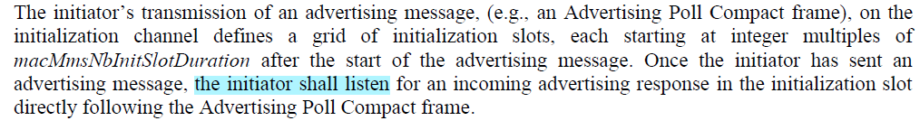

**For CID 401**

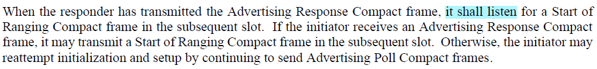

We could simply accept the proposed change for these CIDs(CID 397 and 401)

**Disposition:**

**Disposition Detail:**

**Proposed text changes on P802.15.4ab™/D01:**

**10.38.3.6 UWB MMS ranging session initialization using public addresses**

**- Original Text**

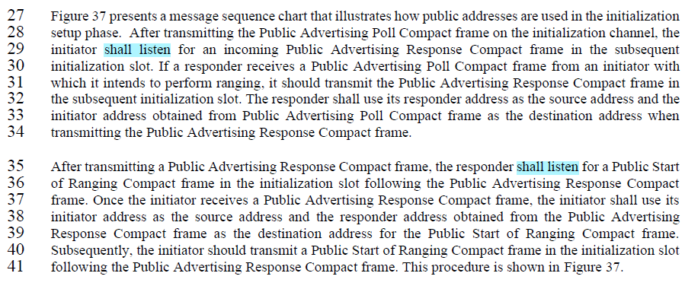

**- Proposed change**

***Change the sub-clause as follows (Track changes ON)***

**(*pp. 75 line #29*)**

After transmitting the Public Advertising Poll Compact frame on the initialization channel, the initiator should listen for an incoming Public Advertising Response Compact frame in the subsequent initialization slot.

**(*pp. 75 line #35*)**

After transmitting a Public Advertising Response Compact frame, the responder should listen for a Public Start of Ranging Compact frame in the initialization slot following the Public Advertising Response Compact frame.

***Comment index #440, 442, 447 and 448 in 15-25-0174-07-04ab-consolidated-comments-draft-2-0.xlsx***

|  |  |  |  |  |  |  |  |
| --- | --- | --- | --- | --- | --- | --- | --- |
| **Name** | **Index#** | **Pg** | **Sub-Clause** | **Ln** | **Comment** | **Proposed Change** | **Disposition** |
| VERSO, BILLY | 440 | 75 | 10.39.3.7.1 | 32 | Is this NHL or MAC, let's avoid the distinction. | change "shall use" to "uses" | Revised |
| VERSO, BILLY | 442 | 75 | 10.39.3.7.1 | 37 | Is this NHL or MAC, let's avoid the distinction. | change "shall use" to "uses" | Revised |
| VERSO, BILLY | 447 | 77 | 10.39.3.7.1 | 9 | Is this NHL or MAC, let's avoid the distinction. | change "shall be used" to "are used" | Revised |
| VERSO, BILLY | 448 | 77 | 10.39.3.7.2 | 25 | I reckon it is the NHL that doing this, so propose to rewrite to say the same thing without the "shall". | change "shall be" to "is" here and on lines 30 and 33. | Revised |

**Discussion**：

Agree with the commenter. It is reasonable that the “shall” statement may be changed because the procedures related to these CIDs are performed by the NHL. Considering that this behaviour is related to setting the source and destination addresses, it is proposed that “should” be changed to provide a recommendation for the NHL to prevent misuse

**Disposition: Revised**

**Disposition Detail:**

**Proposed text changes on P802.15.4ab™/D01:**

**10.38.3.6 UWB MMS ranging session initialization using public addresses**

**- Original Text**

**For CIDs 440 and 442**

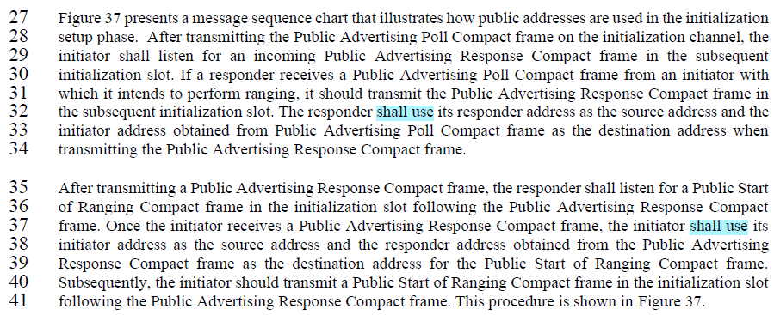

**For CID 447**

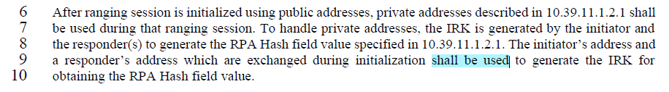

**For CID 448**

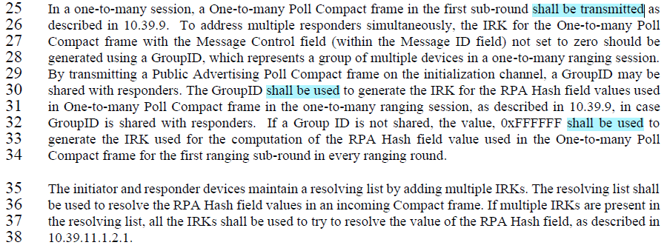

**- Proposed change**

***Change the sub-clause as follows (Track changes ON)***

**(*pp. 75 line #32*)**

The responder should use its responder address as the source address and the initiator address obtained from Public Advertising Poll Compact frame as the destination address when transmitting the Public Advertising Response Compact frame.

**(*pp. 75 line #37*)**

Once the initiator receives a Public Advertising Response Compact frame, the initiator should use its initiator address as the source address and the responder address obtained from the Public Advertising Response Compact frame as the destination address for the Public Start of Ranging Compact frame.

**(*pp. 77 line #8*)**

The initiator’s address and a responder’s address which are exchanged during initialization should be used to generate the IRK for obtaining the RPA Hash field value.

**(*pp. 77 line #25*)**

In a one-to-many session, a One-to-many Poll Compact frame in the first sub-round is transmitted as described in 10.39.9.

**(*pp. 77 line #30*)**

The GroupID should be used to generate the IRK for the RPA Hash field values used in One-to-many Poll Compact frame in the one-to-many ranging session, as described in 10.39.9, in case GroupID is shared with responders. If a Group ID is not shared, the value, 0xFFFFFF should be used to generate the IRK used for the computation of the RPA Hash field value used in the One-to-many Poll Compact frame for the first ranging sub-round in every ranging round.

***Comment index #550 in 15-25-0174-07-04ab-consolidated-comments-draft-2-0.xlsx***

|  |  |  |  |  |  |  |  |
| --- | --- | --- | --- | --- | --- | --- | --- |
| **Name** | **Index#** | **Pg** | **Sub-Clause** | **Ln** | **Comment** | **Proposed Change** | **Disposition** |
| VERSO, BILLY | 550 | 9 | 10.39.11.3.3 | 32 | Values REJECT_WITH_ADDR_DUP, and ACCEPT_WITH_NEW_ADDR are not discussed in referenced clause 10.39.3.2, seems they are only used in public SOR. | We should have a separate status parameter / table defintiion for "Public Start Status" for that usage and have them here. There is no reason to have a common table,which forces one to keep talking about the values that don't apply. |  |

**Discussion**

Agree with the comment. Those values should be removed in the subclause 10.39.11.3.4 Start of Ranging Compact frame and the table for Status should be added to the subclause 10.39.11.3.15 Public Start of Ranging Compact frame

**Disposition: Revised**

**Disposition Detail:**

**Proposed text changes on P802.15.4ab™/D01:**

**10.39.11.3.4 Start of Ranging Compact frame**

**- Original Text**

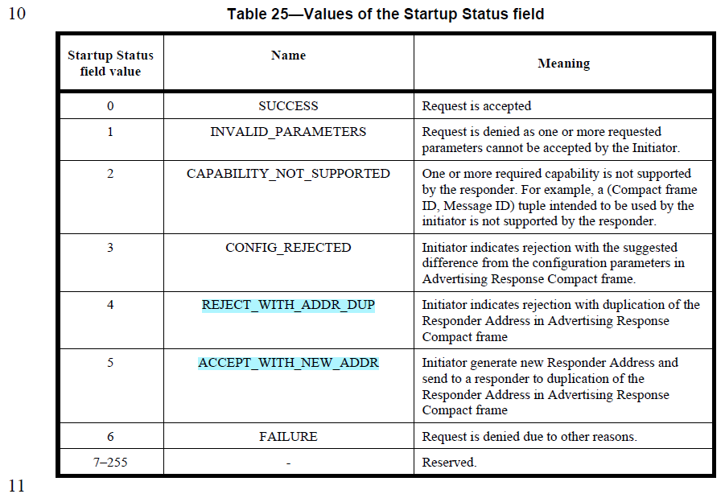

**- Proposed change**

***Change the sub-clause as follows (Track changes ON)***

**10.39.11.3.4 Start of Ranging Compact frame**

**(*pp. 116 line #10*)**

**Table 25—Values of the Startup Status field 10**

|  |  |  |
| --- | --- | --- |
| **Startup Status field value** | **Name** | **Meaning** |
| 0 | SUCCESS | Request is accepted |
| 1 | INVALID_PARAMETERS | Request is denied as one or more requested parameters cannot be accepted by the Initiator. |
| 2 | CAPABILITY_NOT_SUPPORTED | One or more required capability is not supported by the responder. For example, a (Compact frame ID, Message ID) tuple intended to be used by the initiator is not supported by the responder. |
| 3 | CONFIG_REJECTED | Initiator indicates rejection with the suggested difference from the configuration parameters in Advertising Response Compact frame. |
|  |  |  |
|  |  |  |
| 4 | FAILURE | Request is denied due to other reasons. |
| 5–255 | - | Reserved. |

**10.39.11.3.15 Public Start of Ranging Compact frame**

**(*pp. 116 line #17*)**

The fields of Figure 128 are the same as described in 10.39.11.3.4, except for the Status field and the New Responder Address field. The Status field indicates the status of the initialization and setup phase, with the valid values defined by Table XX. The Status field value is set to SUCCESS or ACCEPT_WITH_NEW_ADDR if the initiator intends to proceed into the control phase. Otherwise, if the initiator does not intend to proceed to the control phase, the value of the Status field is set to one of the non-reserved values other than SUCCESS or ACCEPT_WITH_NEW_ADDR as described in 10.39.3.7.

**Table XX —Values of the Startup Status field 10**

|  |  |  |
| --- | --- | --- |
| **Startup Status field value** | **Name** | **Meaning** |
| 0 | SUCCESS | Request is accepted |
| 1 | INVALID_PARAMETERS | Request is denied as one or more requested parameters cannot be accepted by the Initiator. |
| 2 | CAPABILITY_NOT_SUPPORTED | One or more required capability is not supported by the responder. For example, a (Compact frame ID, Message ID) tuple intended to be used by the initiator is not supported by the responder. |
| 3 | CONFIG_REJECTED | Initiator indicates rejection with the suggested difference from the configuration parameters in Advertising Response Compact frame. |
| 4 | REJECT_WITH_ADDR_DUP | Initiator indicates rejection with duplication of the Responder Address in Advertising Response Compact frame |
| 5 | ACCEPT_WITH_NEW_ADDR | Initiator generate new Responder Address and send to a responder to duplication of the Responder Address in Advertising Response Compact frame |
| 6 | FAILURE | Request is denied due to other reasons. |
| 7–255 | - | Reserved. |

The value of the New Responder Address field is set to the value generating randomly by an initiator when the Startup Status field value is ACCEPT_WITH_NEW_ADDR. This subfield is omitted unless the Startup Status field value is ACCEPT_WITH_NEW_ADDR.