**IEEE P802.15**

**Wireless Specialty Networks**

|  |  |  |
| --- | --- | --- |
| Project | IEEE P802.15 Working Group for Wireless Specialty Networks (WSNs) – 802.15.6ma | |
| Title | **Proposed resolution draft for BAN communication - LB212 CID129, 130, 133, 134, 135, 150, 152** | |
| Date Submitted | 6 May, 2025 | |
| Source | Seong-Soon Joo (Nano HiTech) | E-mail: [ssjoo@etri.sci.kr] |
| Re: | Contribution to IEEE 802.15.6ma | |
| Abstract | This document provides a proposed text draft for resolving LB212 comment, CID 129, 130, 133, 134, 135, 150, 152 on BAN and group BAN communication. | |
| Purpose | Support development of technical content for the draft | |
| Notice | This document has been prepared to assist the IEEE P802.15. It is offered as a basis for discussion and is not binding on the contributing individual(s) or organization(s). The material in this document is subject to change in form and content after further study. The contributor(s) reserve(s) the right to add, amend or withdraw material contained herein. | |
| Release | The contributor acknowledges and accepts that this contribution becomes the property of IEEE and may be made publicly available by P802.15. | |

Draft for

1. **Overview** 
   1. MAC Services
      1. Communication in a dependable BAN

The dependable BAN shall operate in beacon mode with superframes over IR-UWB PHY. A coordinator of a BAN forms a multi-superframe that consists of one active superframe, which contains a beacon period, contention free period (CFP), and contention access period (CAP), and inactive superframe, which contains multiple idle superframes of 1 BTU long, as shown in Figure 21. The active superframe duration (ASD) is a multiple of BTU and the beacon interval (BI) is a multiple of BTU. The maximum BI is 224 BTU.

A coordinator broadcasts a beacon frame on the beacon period. A coordinator and nodes of a BAN communicate on CAP with contention access mode for transmitting frames. A coordinator may assign guaranteed time slots (GTS) of CFP for reserving up or down preemptive communication with requesting from a node. The GTS may be one of aperiodic, periodic uniform, and periodic configured type. Aperiodic GTS reserves preemptive time slots for a duration, which is within one active superframe or over multiple active superframes. Periodic uniform GTS reserves consecutive time slots for fixed inter-arrival time. Periodic configured GTS reserves a sequence of GTS that is specified with the start time and number of consecutive slots for a GTS. A node in a BAN requests GTS allocation by using sending an Association Request management frame.

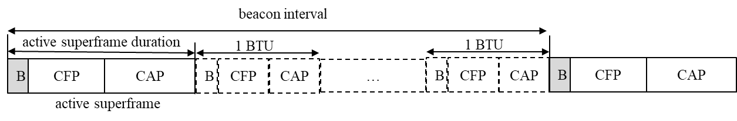

1. —Multi-superframe structure for a dependable BAN
   * 1. Communication in a dependable group BAN

A dependable BAN may coexist with other dependable BANs within interfering range. For coexisting multiple dependable BANs, a dependable BAN coordinates other dependable BANs to avoid interference or to mitigate interference by forming a dependable group BAN.

A node of a dependable BAN may become a coordinator that maintains a dependable BAN. A coordinator of a dependable BAN may become a group coordinator who maintains a dependable group BAN. The capability of a node may be set as coordinator disabled, coordinator enabled, or group coordinator enabled prior to start a node.

When an out-of-band channel for a group BAN control is not available, a group coordinator of a dependable group BAN forms a group superframe structure, which contains group coordination period (GCP) and group allocation period (GAP), as shown in Figure 22. GCP contains a group beacon slot, group coordination slots, and a group notification slot. GAP contains active superframe duration of BANs in a group BAN that contains beacon period, CFP, and CAP of each BANs.

GCP is a control channel for coordinators of a dependable group BAN. A group coordinator broadcasts a group beacon frame on the group bacon slot and a group allocation map frame on the group notification slot of GCP for maintaining a dependable group BAN. A group coordinator and coordinators of a dependable group BAN may use group coordination slots with contention access mode for transmitting management frames such as group association request, group response frame, group disassociation frame, group migration frame, group disband frame, and group merged frame which come to and from a group coordinator and coordinators of a group BAN.

The length of a group superframe is specified with the number of BTU. A BTU is a fixed length of time, 1,024 us long. A group superframe duration, group beacon interval (GBI), is varied according to the number of BANs in a group BAN. The group coordination period consists of one time slot for a group beacon, one time slot for a group notification, and multiple time slots for group coordination, which are the two times the number of BANs in a BAN group. The length of the group allocation period is varied according to the length of active superframe duration of each BAN in a group BAN. For a BAN joined in a group BAN, the length of the beacon interval and the inactive superframe duration are varied whenever the group superframe of a group BAN is changed. A group BAN coordinator may assign multiple active superframe of a BAN in a group beacon interval.

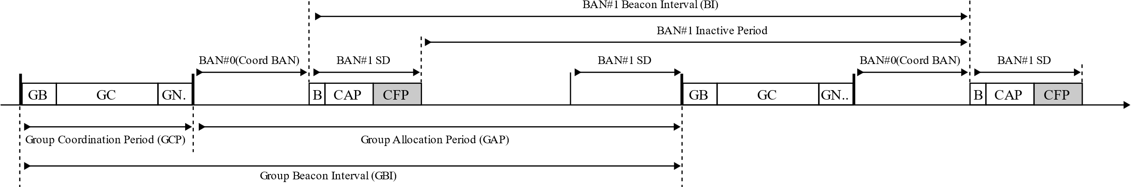

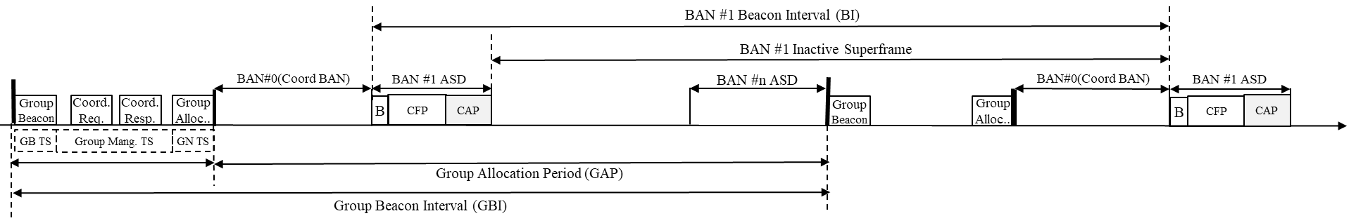

1. —Group superframe structure for a dependable group BAN