IEEE P802.15
Wireless Personal Area Networks

Project | IEEE P802.15 Working Group for Wireless Personal Area Networks (WPANs)
Title | Proposed Resolution for Comments #1060
Date Submitted | February 19, 2025
Sources | Carlos Aldana (Meta)
Re:
Abstract
Purpose | To propose resolution to comment with CID #1060 for “P802.15.4ab™/Draft 1.0 Standard for Low-Rate Wireless Networks”
Notice | This document does not represent the agreed views of the IEEE 802.15 Working Group or IEEE 802.15.4ab Task Group. It represents only the views of the participants listed in the “Sources” field above. It is offered as a basis for discussion and is not binding on the contributing individuals. The material in this document is subject to change in form and content after further study. The contributors reserve the right to add, amend or withdraw material contained herein.

Comment Index #1060

1060 | Technical | 37 | 10.21.8 | 1 | The controller has a slotted protocol, is a particular slot defined for the Association Response command frame to be sent in. The would be good so that the joining controlee does not have to listen in lots of slots for a possible response. | Consider including in the protocol a specification of the slot for the association response command frame to be sent and expected

Discussion:
The control message in the subsequent Ranging Block should have information containing when the Assoc Response will be sent.

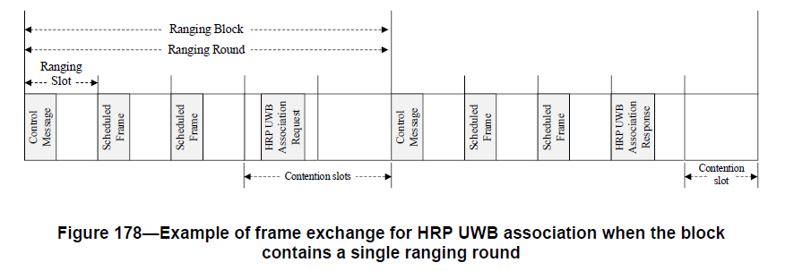
Proposed Resolution: Revise

NOTE TO EDITOR: Please make the changes as shown below
Current text in 10.40.3
Upon successful receipt of the HRP UWB Association Request command, the controller shall schedule a slot in the next block for the transmission of an HRP UWB Association Response command to the sender of the HRP UWB Association Request command, unless the controller has no available slots in the next block. If the controller has available slots in the next block, the scheduling IE (10.32.9.10) in the RCM indicates the slot in which the HRP UWB Association Response will be sent, as shown in Figure 178.

