IEEE P802.15
Wireless Personal Area Networks

Project | IEEE P802.15 Working Group for Wireless Personal Area Networks (WPANs)
Title | Multiple CCA for NB
Date Submitted | February 2025
Sources | Menzo Wentink (Qualcomm)  Carlos Aldana (Meta)  Bin Tian (Qualcomm)  Pooria Pakrooh (Qualcomm)  Carlos Cordeiro (Intel)  Pontus Arvidson (Ericsson)  Stuart Strickland (HPE)  Pelin Mohammed (Cisco)  David Boldy (Broadcom)
Abstract | This submission proposes text for IEEE 802.15.4ab to enable multiple CCAs for NB

Start of proposed changes

The baseline for these changes is 802.15.4ab-D0.2

Modify as shown

10.39.8.3 Listen-before-talk (LBT)

A device shall perform CCA before each O-QPSK PHY transmission. If the CCA is idle, the device shall start transmission no later than 16 μs after completing the CCA. If the CCA is busy and the number of consecutive CCAs is not equal to macMmsNbMaxConsecutiveCCAs, the device shall go the next channel (which might be the same channel) and perform a new CCA after at least 50 μs when on another channel or after at least 100 μs when on the same channel. Otherwise, the device shall skip transmission for the current ranging round.

A receiving device shall check for the presence of an expected O-QPSK PHY transmission. If the expected transmission is not present and the number of consecutive absences is not equal to macMmsNbMaxConsecutive-CCAs, the device shall go to the next channel (which might be the same channel) and check for the presence of the expected transmission there. Otherwise, the device shall skip the expected reception.

[Maybe add optional padding to create a gap of at most 16 μs, in which case the CCA for the responder can be waived when on the same channel.]

[Need to define a negotiated time between transmitter and receiver for being at the next channel.]

[Need to define a handshake for transmitter and the receiver to agree on macMmsNbMaxConsecutiveCCAs, hopping for the subsequent CCAs and other related parameters such as the time to be on the next channel.]

[Clarify that a transmission follows 16 us also after subsequent CCA idle. -- maybe this is already implied by the first sentence. Otherwise it would need to be repeated for the subsequent CCAs]

Figure 45 illustrates the use of CCA for the two-sided packet exchange across two consecutive slots between the initiator and responder, as needed during the MMS UWB control phase. The timings shown in Figure 45 are based on information in [B1].

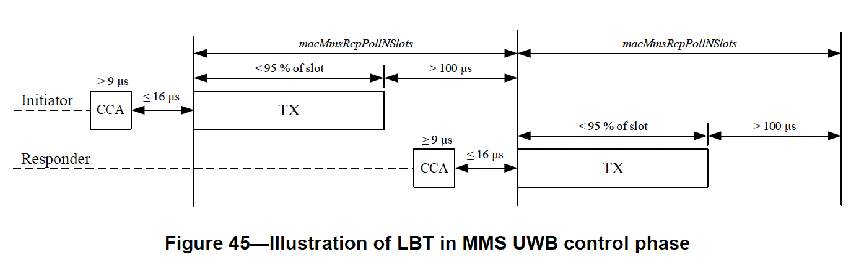

For O-QPSK PHY transmissions, either CCA mode 1 or CCA mode 3a shall be used for the CCA (see 11.2.8 (Clear channel assessment (CCA)). Other CCA modes shall not be used.

[Need to add a maximum energy detect threshold.]

End of proposed changes

Reference material

From 802.15.4-2024:

11.2.8 Clear channel assessment (CCA)

With the exception of the HRP UWB PHY, a compliant PHY shall provide the capability to perform CCA according to at least one of the following methods:

- CCA Mode 1: Energy above threshold. CCA shall report a busy medium upon detecting any energy above the ED threshold.

- CCA Mode 2: Carrier sense only. CCA shall report a busy medium only upon the detection of a signal compliant with this standard with the same modulation and spreading characteristics of the PHY that is currently used by the device.

- CCA Mode 3: one of following:

  - CCA Mode 3a: Carrier sense with energy detect above threshold when either is required. CCA shall report a busy medium if either CCA Mode 1 or CCA Mode 2 would return busy.

  - CCA Mode 3b: Carrier sense with energy detect above threshold when both are required. CCA shall report a busy medium only if CCA Mode 1 and CCA Mode 2 would return busy.

- CCA Mode 4: ALOHA. CCA shall always report an idle medium

Note on CBP
The proposed protocol is "A protocol that allows multiple users to share the same spectrum by defining the events that must occur when two or more transmitters attempt to simultaneously access the same channel and establishing rules by which a transmitter provides reasonable opportunities for other transmitters to operate."

Note on NBA-LBT
The proposed protocol meets the definition for NBA-LBT in ETSI EN 303 687 V1.1.6 (2024-12), where it is still referred to as NBE-LBT.

