IEEE P802.15
Wireless Personal Area Networks

Project | IEEE P802.15 Working Group for Wireless Personal Area Networks (WPANs)
Title | Multiple CCA for NB
Date Submitted | February 2025
Sources | Menzo Wentink (Qualcomm)  Carlos Aldana (Meta)  Bin Tian (Qualcomm)  Pooria Pakrooh (Qualcomm)  Carlos Cordeiro (Intel)  Pontus Arvidson (Ericsson)  Stuart Strickland (HPE)  Pelin Mohammed (Cisco)  David Boldy (Broadcom)
Abstract | This submission proposes text for IEEE 802.15.4ab to enable multiple CCAs for NB

Start of proposed changes

Modify as shown

10.38.7.3 Listen-before-talk (LBT)

A device shall perform CCA before each O-QPSK PHY transmission. If the channel is assessed as clear, the radio shall start transmission no later than 16 μs after completing the CCA. If the channel is assessed as occupied and the number of consecutive CCAs is not equal to macMmsNbMaxConsecutiveCCAs, the radio shall switch to the next NB channel according to 10.38.7.4.3 (Channel switching protocol) and perform a new CCA after at least 50 μs. Otherwise, the radio shall skip transmission for the current ranging round.

Figure 39 illustrates the use of CCA for the two-sided packet exchange across two consecutive slots between the initiator and responder, as needed during the UWB MMS control phase. The timings shown in Figure 39 are based on information in [B1].
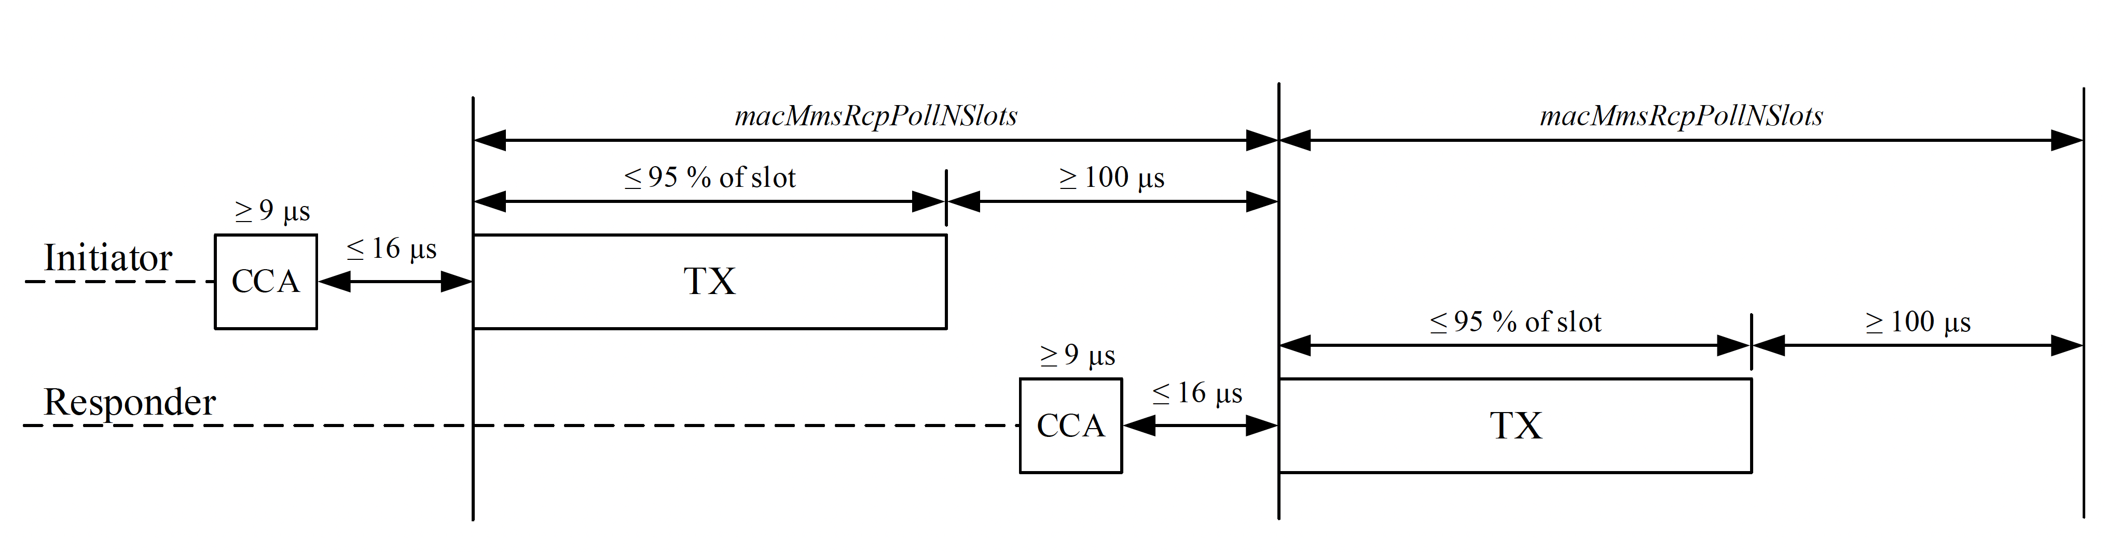

Figure 39—Illustration of LBT in UWB MMS control phase

CCA mode 1 shall be used for the CCA (see 11.2.8 (Clear channel assessment (CCA))). Other CCA modes may be used in addition to CCA mode 1 for the purpose of assessing the medium as occupied. Other CCA modes shall not be used in addition to CCA mode 1 for the purpose of assessing the medium as clear.

End of proposed changes

