**IEEE 802.15**

**Wireless Personal Area Networks**

|  |  |  |
| --- | --- | --- |
| Project | IEEE P802.15 Working Group for Wireless Personal Area Networks (WPANs) | |
| Title | **Proposed Text for Draft 1.0 Comment Resolution – Part 4** | |
| Date Submitted | February 18, 2025 | |
| Sources | Youngwan So and Taeyoung Ha (SAMSUNG Electronics)  [youngwan.so@samsung.com](mailto:youngwan.so@samsung.com) |  |
| Re: |  | |
| Abstract |  | |
| Purpose | To propose resolution for miscellaneous hyper block related comments for “P802.15.4ab™/D1.0 Draft Standard for Low-Rate Wireless Networks” . | |
| Notice | This document does not represent the agreed views of the IEEE 802.15 Working Group or IEEE 802.15.4ab Task Group. It represents only the views of the participants listed in the “Sources” field above.It is offered as a basis for discussion and is not binding on the contributing individuals. The material in this document is subject to change in form and content after further study. The contributors reserve the right to add, amend or withdraw material contained herein. | |

Rev 0: Initial version. Solutions are suggested for the following CIDs. (Totally 19)

48, 49, 50, 51, 155, 156, 157, 193, 194, 195,

946, 876, 947, 948, 949, 950, 951, 1193, 1194,

***Comment Indices in 15-24-0371-01-04ab-consolidated-comments-draft-1.0:***

|  |  |  |  |  |  |  |  |
| --- | --- | --- | --- | --- | --- | --- | --- |
| **Name** | **Index#** | **Pg** | **Sub-Clause** | **line** | **Comment** | **Proposed Change** | **Disposition** |
| Mickael Maman | 48 | 76 | 10.38.8.4.2 | 9 | One-to-many ranging with multiple RSF transmissions per slot looks limited to only one RSF fragment per responder. Clarification is needed | as in comment | Revised |

**Disposition Detail:**

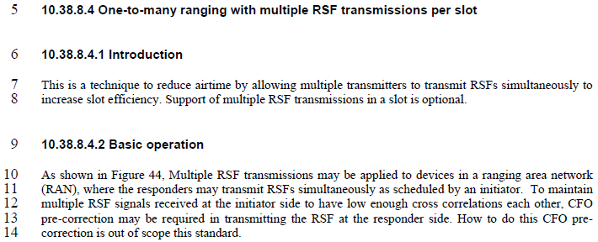

**CID#48**

Revised. ‘One-to-many ranging with multiple RSF transmissions per slot’ is limited to only one RSF fragment per responder PER SLOT.

**Proposed text changes on P802.15.4ab™/Draft 1.0 :**

***Change sub-clause 10.38.8.4.1 P76L9 as below;***

6 **10.38.8.4.1 Introduction**

7 This is a technique to reduce airtime by allowing multiple transmitters to transmit RSFs simultaneously to

8 increase slot efficiency. In this case, multiple RSF transmissions per slot’ is limited to only one RSF fragment per responder per slot. Support of multiple RSF transmissions in a slot is optional.

***Comment Indices in 15-24-0371-01-04ab-consolidated-comments-draft-1.0:***

|  |  |  |  |  |  |  |  |
| --- | --- | --- | --- | --- | --- | --- | --- |
| **Name** | **Index#** | **Pg** | **Sub-Clause** | **line** | **Comment** | **Proposed Change** | **Disposition** |
| Wenzheng Li | 193 | 77 | 10.38.8.4.3 | 3 | For the Multiple RSF transmissions in a slot without NB assist, according to Figure 45 and description, only one One-to-many Poll Compact frame or a frame that carries the Scheduling IE from initiatorand one respective One-to-many Response Compact frame or a frame that carries the MMRC IE from each responder are exchanged in the control phase. Can multiple One-to-many Poll Compact frame or a frame that carries the Scheduling IE and One-to-many Response Compact frame or a frame that carries the MMRC IE be exchanged as configured by Management MAC Configuration field in control phase? | It is better to follow the same mechanism as which in control phase. The number of One-to-many Poll Compact frame or frame that carries the Scheduling IE from initiator and the number of One-to-many Response Compact frame or a frame that carries the MMRC IE from each responder can be configured in the Management MAC Configuration field. | Rejected |
| Youngwan So | 948 | 77 | 10.38.8.4.3 | 4 | Only Initiator operation is described. There's no responder operation description. Need to specify responder operation. | Change   From "The control phase uses the UWB channel and starts with the transmission by the initiator of either a One-to many Poll Compact Frame or a frame that carries the Scheduling IE (10.32.9.10)."  To  "The control phase uses the UWB channel and starts with the transmission by the initiator of either a One-to many Poll Compact Frame or a frame that carries the Scheduling IE (10.32.9.10) to the responders. Based on the control phase, the transmissions of responders may be scheduled." | Accepted |

**Disposition Detail:**

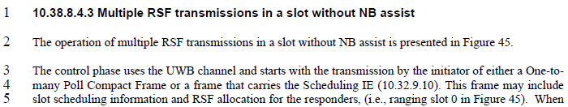

**CID#193**

Rejected. Sorry but hard to understand question. Many parameters can be configured with Management MAC Configuration field if we define some new fields to do so, but the number of Poll / RESPONSE messages, etc. seem not needed to configure with it as those are dependent on the number of responders which are rather dynamic.

**CID#948**

Accepted.

**Proposed text changes on P802.15.4ab™/Draft 1.0 :**

***Change 10.38.8.4.3 P77L4 as below ;***

3 The control phase uses the UWB channel and starts with the transmission by the initiator of either a One-to

4 many Poll Compact Frame or a frame that carries the Scheduling IE (10.32.9.10) to the responders. Based on the control phase, the transmissions of responders may be scheduled. This frame may include

5 slot scheduling information and RSF allocation for the responders, (i.e., ranging slot 0 in Figure 45). When

6 the Scheduling IE is used, the Scheduling List Type field value is set to four. After receiving the frame

7 from the initiator, each responder replies with either a One-to-many Response Compact Frame or a frame

8 that carries the MMRC IE, (i.e., ranging slots 1 and 2 in Figure 45)

***Comment Indices in 15-24-0371-01-04ab-consolidated-comments-draft-1.0:***

|  |  |  |  |  |  |  |  |
| --- | --- | --- | --- | --- | --- | --- | --- |
| **Name** | **Index#** | **Pg** | **Sub-Clause** | **line** | **Comment** | **Proposed Change** | **Disposition** |
| Mickael | 49 | 77 | 10.38.8.4.3 | 12 | the initiator sends a SYNC+SFD in slot 3. Where are the SYNC+SFD of responders according to UWB driven MMS? | need clarification | Revised |
| Bin Qian | 155 | 77 | 10.38.8.4.3 | 12 | In UWB driven case, SYNC+SFD is the first fragment. It is not consist with the UWB driven MMS packet format if the responders reply with RSF aftering receiving SYNC+SFD | The responders could reply SYNC + SFD after receiving SYNC + SFD from the initiator | Revised |
| Billy Verso | 1194 | 77 | 10.38.8.4.3 | 12 | Figure 45 does not match the text and the text is not aligned with the PHY specified format of UWB driven MMS packet. Each device needs to send the SYNC-SFD fragment in first millisecond, and RSF fragments in the next millisecond. Really the default mode here should match the mandatory mode as per Table 24, so it should be RIF in the next millisecond. | Since this text is broken, the easiest fix is to delete the clause. Failing that in needs to support the default UWB driven format, and include SYNC+SFD from each responder, for the receivers to synchronise on. | Revised |
| Wenzheng Li | 194 | 77 | 10.38.8.4.3 | 12 | "If responder receives the SYNC+SFD fragment of the initiator, after AIFS the responders reply with RSF as allocated by the scheduling IE in the control phase. " Since the initial SYNC+SFD fragment shall be exchanged in UWB driven UWB MMS, the type of SYNC+SFD should be introduced in the MMS fragment exchange in the time efficient one to many ranging | If responder receives the SYNC+SFD fragment of the initiator, after AIFS the responders reply with MMS fragments (i.e., RSF and/or RIF or SYNC+SFD) as allocated by the scheduling IE in the control phase. | Revised |
| Billy Verso | 1193 | 77 | 10.38.8.4.3 | 12 | It is not good to use AIFS here since this is not an ACK. Such reuse makes the standard maintenance harder. Suggest to define a special constant for this or insert the constant number value into the text as is done elsewhere for MMS responder timing, indeed better to specify the timing in the same way as for the other cases. | Align with other MMS text and use appropriate offset for this case, (Do not use AIFS for this time). | Revised |
| Bin Qian | 156 | 77 | 10.38.8.4.3 | 12 | The time interval between the reception and transmission of the responder is set to be AIFS, which is too limited | Delete the AIFS constrain | Revised |
| Youngwan So | 946 | 77 | 10.38.8.4.3 | 13 | Generally, the procedure comprise of three phases ; control, ranging and report phase. However, explanation corresponding to the Measurement Report Phase is missing here. So the report phase briefly is described. | Add below texts at the end of the paragraph ;  "In the measurement report phase, the initiator and/or the responders send measurement report by One-to-Many initiator report and/or One-to-Many responder report compact frame or Ranging Measurement Information IE (RMI IE) in the UWB channel." | Revised |
| Youngwan So | 949 | 77 | 10.38.8.4.3 | 13 | Not enough responder operation description.. | Change  From "If responder receives the SYNC+SFD fragment of the initiator, after AIFS the responders reply with RSF as allocated by the scheduling IE in the control phase."  To  "If responder receives the SYNC+SFD fragment of the initiator, after AIFS the responders reply with RSF as allocated by the scheduling IE in the control phase, when SYNC+SFD fragment is sent at the allocated slot which was scheduled in Control Phase." | Revised |

**Disposition Detail:**





**CID#49 and #155 and #1194**

Revised. Figure 198 (P192), Figure 23/24 (P55) illustrate SYNC+SFD as the first fragment in UWB-driven MMS packet format. And the figure is updated as initiator sends the SYNC-SFD fragment in first millisecond, and the RSF fragments are in the next millisecond NOT within the same slot.

Regarding the SYNC+SFD of responders according to UWB driven MMS, As far as I know, it is NOT needed as what the responder transmit is NOT one whole MMS packet but just a part of it (i.e. RSF fragment). For example, in Figure 41, responder doesn’t send SYNC+SFD before when it transmits RSF fragments.



**CID#194, #1193, #156, #946 and #949**

Revised. In the UWB driven case, the HRP UWB PHY MMS packet includes the initial SYNC and SFD fragment as specified in 16.2.11, and a value of 1 ms shall be supported for time interval between the start of SYNC+SFD and the first SFD. So AIFS is deleted.

**Proposed text changes on P802.15.4ab™/Draft 1.0 :**

***Change 10.38.8.4.3 P77L12 as below ;***

9 In the ranging phase, the UWB MMS packet including the initial SYNC+SFD fragment, as per Figure 198,

10 is transmitted to trigger multiple RSF transmissions. In the ranging slot 3, the initiator transmits the

11 SYNC+SFD fragment to trigger multiple RSF transmissions as in 10.38.8.4.4. If responder receives the

12 SYNC+SFD fragment of the initiator, the responders reply with RSF as allocated by the O2M POLL or scheduling IE in the control phase with the constraint the time interval between the start of the packet in the control phase and the start of the MMS packet in the ranging phase is 1ms.

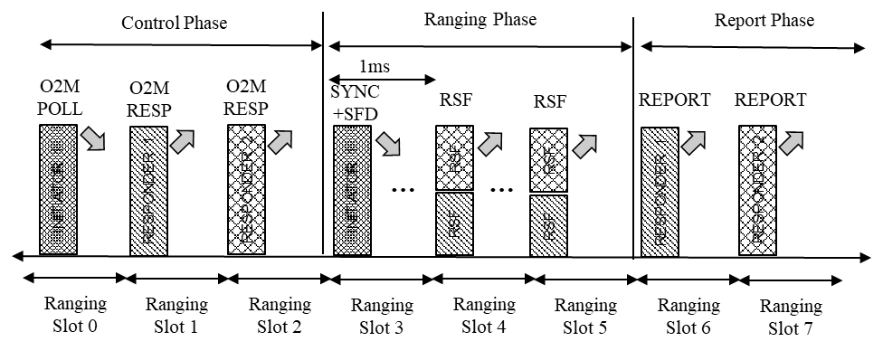

***Comment Indices in 15-24-0371-01-04ab-consolidated-comments-draft-1.0:***

|  |  |  |  |  |  |  |  |
| --- | --- | --- | --- | --- | --- | --- | --- |
| **Name** | **Index#** | **Pg** | **Sub-Clause** | **line** | **Comment** | **Proposed Change** | **Disposition** |
| Wenzheng Li | 195 | 77 | 10.38.8.4.3 | 18 | For the Multiple RSF transmissions in a slot with NB assist, according to Figure 46 and description, only one One-to-many Poll Compact frame and one respective One-to-many Response Compact frame from each responder are exchanged in the control phase. Can multiple One-to-many Poll Compact frame and One-to-many Response Compact frame be exchanged as configured by Management MAC Configuration field in control phase? | It is better to follow the same mechanism as which in control phase. The number of One-to-many Poll Compact frame from initiator and the number of One-to-many Response Compact frame from each responder can be configured in the Management MAC Configuration field. | Rejected |
| Youngwan So | 950 | 77 | 10.38.8.4.4 | 18 | Lack of responder operation.  Clarify the operation of responders | Change   From "The control phase is conducted by sending a One-to-many Poll Compact frame in the NB channel."  To  "The control phase is conducted by sending a One-to-many Poll Compact frame in the NB channelto responders. Based on the control phase, the transmissions of responders may be scheduled." | Accepted |
| Mickael Maman | 50 | 77 | 10.38.8.4.4 | 19 | why in multiple RSF transmissions in a slot with NB assist, the initiator sends a SYNC+SFD? The initiator can directly send its RSF | remove reference to SYNC+SFD in lines 19 to 23 | Accepted |
| Bin Qian | 157 | 77 | 10.38.8.4.4 | 19 | If there exists NB, the MMS packet format does not include SYNC + SFD | The RSF is transmitted directly instead of transmitting SYNC + SFD fragment | Accepted |
| Carl Murray | 876 | 77 | 10.38.8.4.4 | 21 | Starting on this line the description for NB assist includes transmitting a fragment with SYNC+SFD. NB assist does not support fragments with SYNC+SFD. | Update text to remove references to SYNC+SFD fragments | Accepted |
| Youngwan So | 951 | 77 | 10.38.8.4.4 | 21 | Clarify the control phase in example operation | Change ; From "Example operation of the multiple RSF transmissions per slot with NB assist is shown in Figure 46." To "Example operation of the multiple RSF transmissions per slot with NB assist is shown in Figure 46. The control phase uses the NB channel and starts with the transmission by the initiator of a One-to many Poll Compact Frame. This frame may include slot scheduling information and RSF allocation for the responders, (i.e., ranging slot 0 in Figure 46)." | Accepted |
| Youngwan So | 947 | 77 | 10.83.8.4.4 | 19 | To trigger the multiple RSF transmissions, SYNC+SFD fragment is used rather than MMS packet. So it should be corrected. | Change   From "After control phase, the UWB ~~MMS~~ packet including the initial SYNC+SFD fragment, as per Figure 198, is transmitted to trigger multiple RSF transmissions."  To "After control phase, the UWB packet including the initial SYNC+SFD fragment, as per Figure 198, is transmitted to trigger multiple RSF transmissions." | Agreed |

**Disposition Detail:**

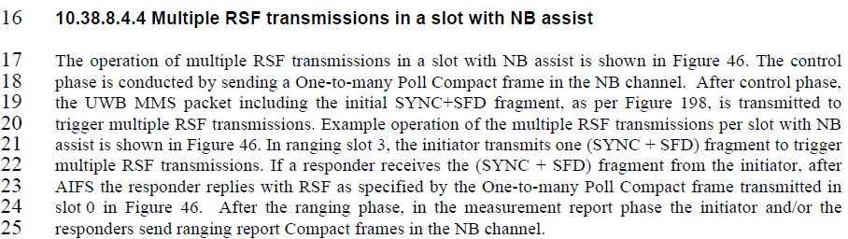

**CID #195**

Rejected. I went through Management MAC Configuration field (P85). But it seems there’s no relevant field to control the number of One-to-many Poll Compact frame from initiator and the number of One-to-many Response Compact frame from each responder.

**CID #950**

Accepted.

**CID #50, 157, 876, 947**

Accepted. There’s no need to send SYNC+SFD in NB assisted case.

**CID#951**

Accepted

**Proposed text changes on P802.15.4ab™/Draft 1.0 :**

***Change 10.38.8.4.4 P77L17-25 as below ;***

16 **10.38.8.4.4 Multiple RSF transmissions in a slot with NB assist**

17 The operation of multiple RSF transmissions in a slot with NB assist is shown in Figure 46. The control

18 phase is conducted by sending a One-to-many Poll Compact frame in the NB channel to responders. Based on the control phase, the transmissions of responders may be scheduled. After control phase,

19 Example operation of the multiple RSF transmissions per slot with NB

21 assist is shown in Figure 46. The control phase uses the NB channel and starts with the transmission by the initiator of a One-to many Poll Compact Frame. This frame may include slot scheduling information and RSF allocation for the responders, (i.e., ranging slot 0 in Figure 46). In ranging slot 3, the initiator transmits one RSF fragment to trigger

22 multiple RSF transmissions. If a responder receives the RSF fragment from the initiator,

23 the responder replies with RSF as specified by the One-to-many Poll Compact frame transmitted in

24 slot 0 in Figure 46. After the ranging phase, in the measurement report phase the initiator and/or the

25 responders send ranging report Compact frames in the NB channel.

***Comment Indices in 15-24-0371-01-04ab-consolidated-comments-draft-1.0:***

|  |  |  |  |  |  |  |  |
| --- | --- | --- | --- | --- | --- | --- | --- |
| **Name** | **Index#** | **Pg** | **Sub-Clause** | **line** | **Comment** | **Proposed Change** | **Disposition** |
| Mickael Maman | 51 | 78 | 10.38.8.4.4 | 1 | What is Poll frame form initiator in uwb rangng slot 3? | change to SYNC+SFD or rsf? | Accepted |

**Disposition Detail:**

Accepted.

**Proposed text changes on P802.15.4ab™/Draft 1.0 :**

***Replace Figure 46 with updates below ;***

