IEEE P802.15
Wireless Personal Area Networks

Project | IEEE P802.15 Working Group for Wireless Personal Area Networks (WPANs)
Title | Proposed Resolution for CIDs 969 970 971 972 1012 1013 1378 1379 1380
Date Submitted | February 2025
Sources | Youngwan So, Mingyu LEE (Samsung Electronics)  youngwan.so@samsung.com, mg0218.lee@samsung.com
Re:
Abstract
Purpose | To propose resolution for “P802.15.4ab™/D01 Draft Standard for Low-Rate Wireless Networks”
Notice | This document does not represent the agreed views of the IEEE 802.15 Working Group or IEEE 802.15.4ab Task Group. It represents only the views of the participants listed in the “Sources” field above. It is offered as a basis for discussion and is not binding on the contributing individuals. The material in this document is subject to change in form and content after further study. The contributors reserve the right to add, amend or withdraw material contained herein.

CID 969, 970, 1380 (Revised, Comments for Figure 190)
All CIDs are related to Figure 190. The CIDs can be combined
Name | Index # | Page | Sub-clause | Line # | Comment | Proposed Change | Proposed  Resolution
Carlos Aldana | 969 | 173 | 10.43.3.1 | 23 | 4 octets are assigned to the "Transmission Offset" field. This results in ~1 hour time offset from the time the NB Allocation packet is sent. This seems excessive. Consider reducing the number of octets or increasing the units of the field to something much greater than a RSTU (e.g., 1 ms) | As in comment | Change Figure 190, Table 55, and the related texts to the revisions in the Disposition Details  [Note]  Without changing the units of fields, the field size is changed to 2 octets.
Carlos Aldana | 970 | 173 | 10.43.3.1 | 23 | 1 octet allocation to "NB PHY" field can be reduced to 3 bits. More importantly, what happens if the content of the field is 0? Does the value "0" mean 250kbps or is the value undefined since Table 58 starts with Config value of 1. Please clarify. | As in comment | Change Figure 190, Table 55, and the related texts to the revisions in the Disposition Details  [Note]  To be aligned with "10.38.9.3.17", NB PHY field values 1 to 8 select a modulation mode from Table 58 (also numbered 1 to 8). All other NB PHY values are reserved.
Pooria Pakrooh | 1380 | 173 | 10.43.3.1 | 23 | If this is a unicast message, why does it inclue address in the IE? | Clarify the question in the comment. | Change Figure 190, Table 55, and the related texts to the revisions in the Disposition Details  [Note]  NB resource needs to be allocated to the address of NB device.  Otherwise, i.e., UWB address is used, it does not be required in a unicast frame.  Remove "2 octets" and "8 octets" options  Add a case that address size is zero

Disposition Details: Change Figure 190, Table 55, and the related texts to as follows.
10.43.3.1 NB Allocation IE
…
Bits : 2 | 6 | Octets : 0/3 | Octets : 2 | 1 | 2
Address  Size | Reserved | Address | NB Channel | NB  PHY | Transmission  Offset
Figure 190—NB Allocation IE Content field format
…
Table 55—Values of Address Size field in NB Allocation IE
Address Size Field Value | Address Field Size
0 | Address Field is not present
1 | 3 Octets
2-3 | Reserved

…
The NB PHY field specifies the NB PHY configuration index. The NB PHY field value shall be one of the
Config number values from Table 58. The NB PHY field values 1 to 8 select a modulation mode from Table 58 (also numbered 1 to 8). All other NB PHY values are reserved.

CID 971 (Revised, Comments for Figure 189)
Name | Index # | Page | Sub-clause | Line # | Comment | Proposed Change | Disposition Detail
Carlos Aldana | 971 | 173 | 10.43.2 | 15 | The statement says "for starting NB data communication during measurement phase" and the figure shows a single NB packet. If the figure is correct, does NB data communication contain a single packet? If so, please state it explicitly. If so, is there no Ack? If there is an Ack, what is IFS spacing? What is the expected packet flow for NB data communications? | Please clarify all the questions here. | Change Figure 189 to the revised on in Disposition Detail.  [Note]  Figure 189 is revise to clarify that it’s not a single NB packet.  The sequence of NB transmission is out of scope. The number of NB packet doesn't need to be specified.
Disposition Details : Change Figure 189 to as follows.
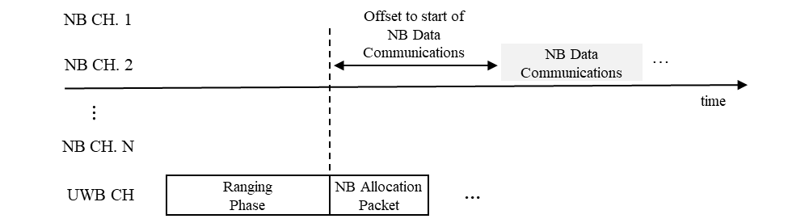
Figure 189—Example of NB data communication triggered by NB Allocation IE packet

CID 972 1012 1013 1378 1379 (Rejected)
Name | Index # | Page | Sub-clause | Line # | Comment | Proposed Change | Disposition Detail
Pooria Pakrooh | 1378 | 173 | 10.43 | 4 | Not clear why this NB data transmission protocol is needed, given the significantly lower data rate relative to UWB, and also higher fading. If many users start to use this protocol, the congestion can be problematic. This can cause interference to unnecessarily longer range. There is no duty cycle limit specified for this feature and the benefits are not clear.  Remove this functionality, or add a proper mandatory channel access mechanism. | Remove this functionality, or add a proper mandatory channel access mechanism. | Rejected  [Note]  Regarding the comment about necessity, please check the following contribution.  https://mentor.ieee.org/802.15/dcn/23/15-23-0243-03-04ab-nb-assisted-data-communications.pptx  Regarding the comment about channel access mechanism,  NB data transmission specific access mechanism is not required. In general, common access mechanism is explained in an independent section. If it's required to specify access mechanism, the section for comment access mechanism can be referred
Pooria Pakrooh | 1379 | 173 | 10.43 | 4 | Benefits of NB usage for ranging has been justified. What is the benefit of using two links with significantly different link budget? what is the application? The data communication associated with this application are for close range cases, which does not need NB. | Remove this functionality, or add a proper mandatory channel access mechanism. | Rejected  [Note]  Regarding the comment about benefit and use case, please check the following contribution.  https://mentor.ieee.org/802.15/dcn/23/15-23-0243-03-04ab-nb-assisted-data-communications.pptx  In general, IEEE PHY/MAC specification doesn't need to specify the detailed reasons and expected application. So no change is required.
Carlos Aldana | 1013 | 173 | 10.43.2 | 15 | NB data communications should use LBT as a baseline channel access mechanism. Please add the followign text at the end of the paragraph: "Channel access using listen before talk shall be used for improved coexistence performance. When used for narrowband assist, SSBD shall use the following control attribute values:  phyCcaDuration should be set as required by local regulations;  macSsbdMinBf and macSsbdMaxBf shall be set to 0;  macSsbdMaxBackoffs shall be set to 0;  macSsbdTxOnEnd shall be set to FALSE;  macSsbdPersistence shall be set to FALSE;  phyCcaMode shall be set to 1 (energy above threshold)  phyCcaEdThreshold shall be set to -67 dBm/MHz - Ptx for channels 0 to 49 and to -74 dBm/MHz - Ptx for channels 50 to 249, where Ptx is the equipment’s instantaneous transmit power in dBm." | As in comment | Rejected  [Note]  This section is not about how to access in NB channel. This section provides a way to allocate NB resource. The comments is related to general access method of NB.  If there is a section for general/baseline access rule for NB transmission, it doesn't need be included in this section repeatedly. If it's required to specify access mechanism, the section for comment access mechanism can be referred
Carlos Aldana | 1012 | 173 | 10.43.2 | 17 | When does the NB data packet(s) end? That should be communicated to ensure it does not overlap with the next ranging round. | please clarify | Rejected  [Note]  Regarding the comment about necessity, please check the following contribution.  https://mentor.ieee.org/802.15/dcn/23/15-23-0243-03-04ab-nb-assisted-data-communications.pptx  It depends on the application protocol. No rationale and needs to limit the end of NB data packet.
Carlos Aldana | 972 | 173 | 10.43.3 | 19 | There is text missing associated with this section. Either remove section or add text. | As in comment | Rejected  [Note]  No need to add text like other section 10.32.9, 10.39.6

