IEEE P802.15
Wireless Personal Area Networks

Project | IEEE P802.15 Working Group for Wireless Personal Area Networks (WPANs)
Title | Proposed Resolution for Discovery
Date Submitted | February 2025
Sources | Larry Zakaib (Spark Microsystems), Kangjin Yoon  Yoons.2k15@gmail.com
Re:
Abstract | Kangjin’s proposed Resolutions for CIDs 745, 746, 752, 753 754
Purpose | To propose resolution for “P802.15.4ab™/D01 Draft Standard for Low-Rate Wireless Networks”
Notice | This document does not represent the agreed views of the IEEE 802.15 Working Group or IEEE 802.15.4ab Task Group. It represents only the views of the participants listed in the “Sources” field above. It is offered as a basis for discussion and is not binding on the contributing individuals. The material in this document is subject to change in form and content after further study. The contributors reserve the right to add, amend or withdraw material contained herein.

Tero Kivinen | 745 | 163 | 10.40.4.1 | 9 | The text "Addressing Mode field shall be set to same mode as indicated by the AC IE" does not make sense. AC IE does not have modes indicating the address mode fields, and if it is trying to say that use same source and destination addressing modes than what was used to AC IE then that does not work, as the if the AC IE is using short address then the device transmitting association request can't use short address, as it has not yet been given short address. | Specify how the source and destination addressing fields are to be used in association request command. | Revise
Disposition details:
Change "set to the same mode as indicated by the AC IE in the control message" to "set to match the mode used for the control message" in line 9.

When Controlees use short addresses for association request message, they should generate the short address. The procedure is well described in the second paragraph of 10.40.3.

Tero Kivinen | 746 | 163 | 10.40.4.1 | 17 | The macShortAddress cannot be used before device has been associated and given a short address, using this mac command. | Source address needs to be extended address always as device do not yet have short address. | Revise
Tero Kivinen | 752 | 165 | 10.40.4.2 | 11 | Status value 2 does not make any sense, as this is association request, thus by definition device does not yet have short address, that could be updated. | Remove status value 2. | Revise
Tero Kivinen | 753 | 165 | 10.40.4.2 | 11 | Status value 3 does not make any sense, as this is association request, thus by definition device does not yet have short address, that could be duplicate as the request does not provide short address request. | Remove status value 3. | Revise
Disposition details:
When Controlees use short addresses for association request message, they should generate the short address. The procedure is well described in the second paragraph of 10.40.3.
Change “a controlee shall generate a short address and use the short address for the HRP UWB Association Request command. How to generate the short address is out of scope of this standard.” in page 162 line 12
to “a controlee shall use a short address which is set according to the address specified by the corresponding primitive.”
Add “ShortAddress” below “HoppingSequenceRequest” in MLME-ASSOCIATE.request in page 33 line 23.
Insert below row into Table 10-104.
Name | Type | Valid range | Description
ShortAddress | Integer | 0x0000-0xffff | The short address generated by controlee.

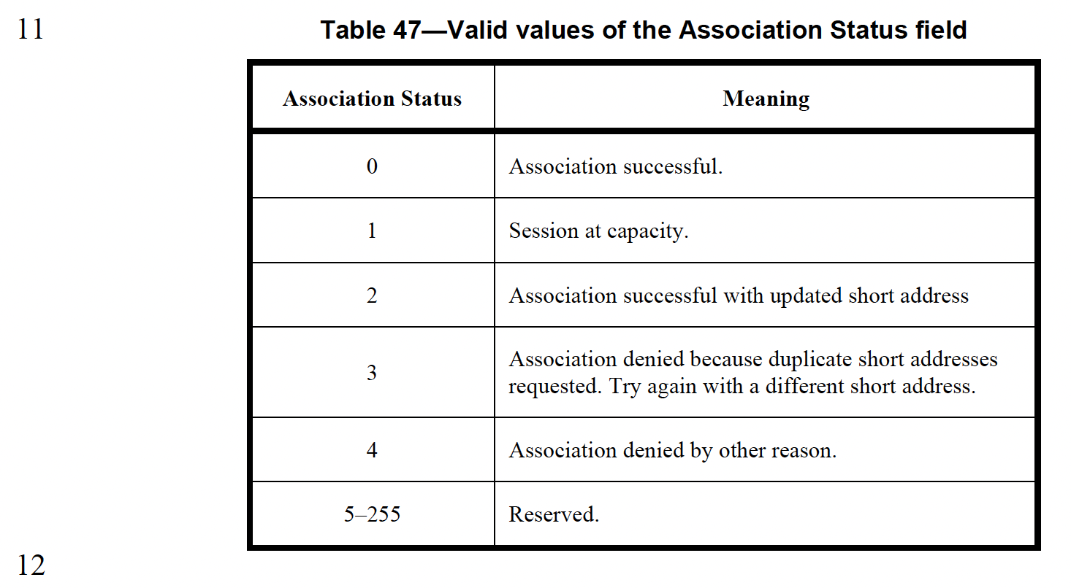

[2nd paragraph of 10.40.3]
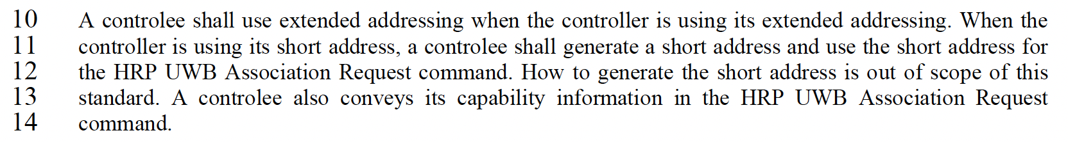

Tero Kivinen | 754 | 165 | 10.40.4.2 | 9 | The response command should include the short address the controller assigned to the controlee not just updated short address. | Change "Updated Short Address" to "Short Address". | Reject
Disposition details:
Controller already uses short address in MAC header. There is no reason to repeat.

