**IEEE 802.15**

**Wireless Personal Area Networks**

|  |  |  |
| --- | --- | --- |
| Project | IEEE P802.15 Working Group for Wireless Personal Area Networks (WPANs) | |
| Title | **Proposed Text for Draft 1.0 Comment Resolution – Part 4** | |
| Date Submitted | February 11, 2025 | |
| Sources | Youngwan So (SAMSUNG Electronics)  [youngwan.so@samsung.com](mailto:youngwan.so@samsung.com) |  |
| Re: |  | |
| Abstract |  | |
| Purpose | To propose resolution for miscellaneous hyper block related comments for “P802.15.4ab™/D1.0 Draft Standard for Low-Rate Wireless Networks” . | |
| Notice | This document does not represent the agreed views of the IEEE 802.15 Working Group or IEEE 802.15.4ab Task Group. It represents only the views of the participants listed in the “Sources” field above.It is offered as a basis for discussion and is not binding on the contributing individuals. The material in this document is subject to change in form and content after further study. The contributors reserve the right to add, amend or withdraw material contained herein. | |

Rev 0: Initial version. Solutions are suggested for the following CIDs. (Totally 3 )

443, 948, 1434

***Comment Indices in 15-24-0371-01-04ab-consolidated-comments-draft-1.0:***

|  |  |  |  |  |  |  |  |
| --- | --- | --- | --- | --- | --- | --- | --- |
| **Name** | **Index#** | **Pg** | **Sub-Clause** | **line** | **Comment** | **Proposed Change** | **Disposition** |
| Tero Kivinen | 443 | 67 | 10.38.3 | 13 | Provide message sequence chart of how to start new session while using coordination, i.e., scanning channel, listening for acquisition compact frames (how are those frames sent from the MAC to next higher layer, i.e., what MLME call is used for them etc). | Add message sequence chart. | Revised |

**Disposition Detail:**

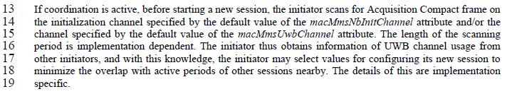

Editor’s Note: “*This is a complicated figure without proper text description, and not correct. It is using MLME-SCAN which looks for beacons. I think it is better not to put this in until we have descriptive text and corrected figure, following the style used in the base standard*.”

I admit the figure was incomplete and complicated as it was. Here the update with more simplified flow and description text are provided.

**Proposed text changes on P802.15.4ab™/Draft 1.0 :**

***Insert below Figure and text after P67L20;***

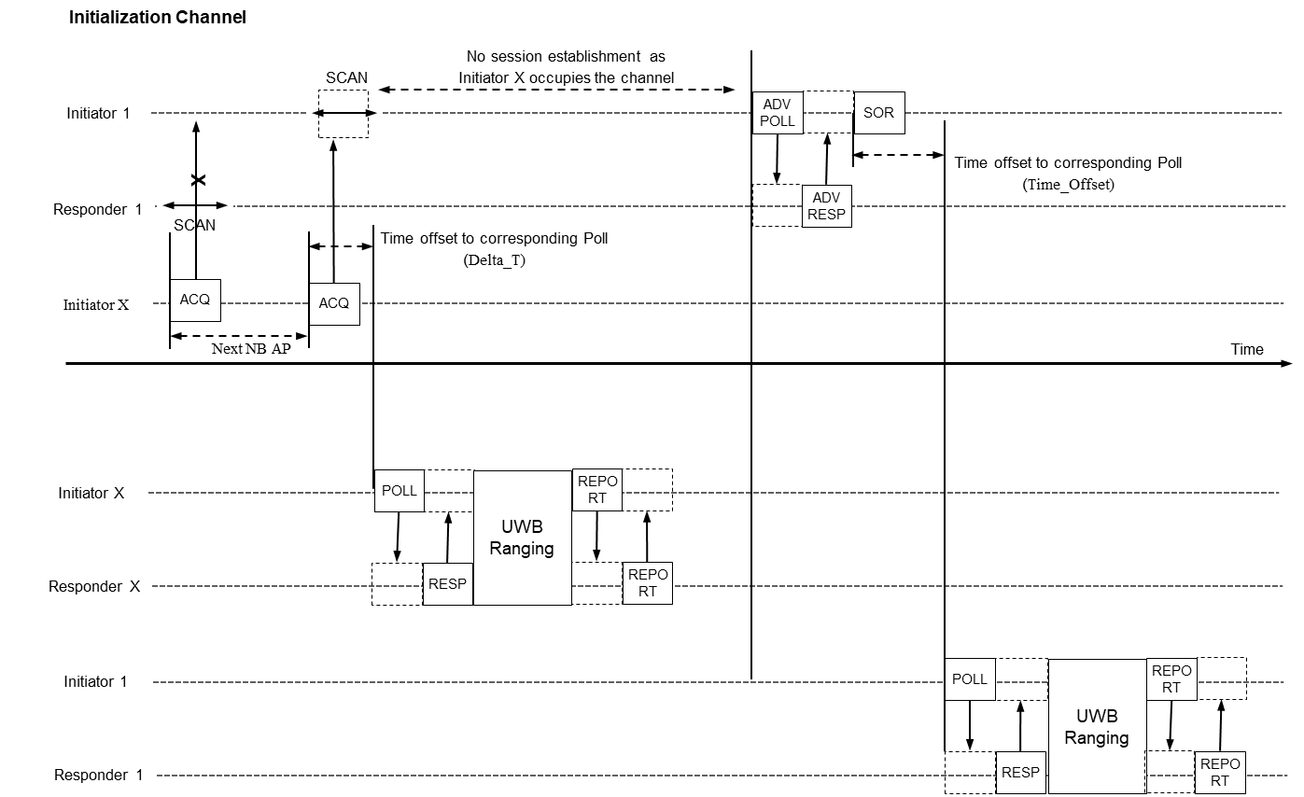

**Figure 34-1. Example session initialization when coordination in help of acquisition compact frame is considered**

The Figure 34-1 shows an example of session initialization when the acquisition compact frame helps coordination. The Initiator 1 is an UWB controller who wants to range with Responder 1. The Initiator X is another UWB controller nearby who doesn’t have any relation with Initiator 1 and Responder 1. The Initiator X tries to send Acquisition compact frame to around, anticipating its UWB channel usage information in it can help other nearby controllers can refer. The controller who received Acquisition compact frame can recognize how the UWB channel resource nearby is used. Based on this, controller can setup its own session avoiding interfering channels.

The Initiator X tries to send acquisition compact frame so to announce its UWB channel resource usage information. But it’s not delivered to nearby initiators (Initiator 1) as no one was in receiving mode. After Next NB AP passes, another acquisition is sent from Initiator X and it is successfully received to Initiator 1 as it was in receiving (=scanning) mode fortunately. The Acquisition compact frame include Delta T field indicating the time in RSTU to the start of the next ranging block relative to the start of the current Acquisition compact frame. As the Acquisition compact frame tells how Initiator X will use up UWB channel, the Initiator 1 who received it avoid to use that UWB channel resources so to avoid conflict.

The UWB ranging happening in UWB channel is comprised of POLL and RESP handshake for sync and configuration, UWB packet transmission itself and finally REPORT transaction to exchange ranging result.

Once Initiator 1 knows Initiator X finished using the UWB channel, it sends ADV-POLL so to trigger transaction with Responder 1. The Responder replies with ADV-RESP and SOR sent by Initiator 1 designate the beginning timing of UWB ranging.

Figure 34-2 shows a Message sequence chart in case acquisition compact frame helps. It is what happens in Figure 34-1.

The Initiator X tries to send Acquisition compact frame so to announce its UWB channel usage. It can be periodic or aperiodic. To do that, MLME-SET.request and MLME-SET.confirm is used by higher layer. in second trial, Acquisition compact frame transmission succeeds as the Initiator 1 was in scanning mode at that moment. Then after Delta T passes, Initiator X begins its UWB ranging session . During this period, Initiator 1 avoid to use that UWB channel resources.

After the UWB ranging session between Initiator X and Responder X finishes, Initiator 1 establishes session with Responder 1 and starts ranging.

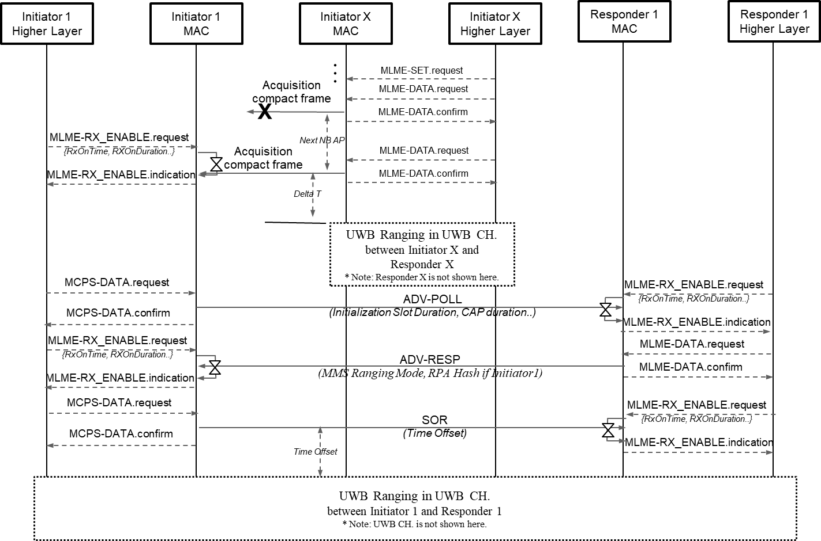

**Figure 34-2. Message sequence chart in case of acquisition compact frame is considered**

***Comment Indices in 15-24-0371-01-04ab-consolidated-comments-draft-1.0:***

|  |  |  |  |  |  |  |  |
| --- | --- | --- | --- | --- | --- | --- | --- |
| **Name** | **Index#** | **Pg** | **Sub-Clause** | **line** | **Comment** | **Proposed Change** | **Disposition** |
| Youngwan So | 948 | 77 | 10.38.8.4.3 | 4 | Only Initiator operation is described. There's no responder operation description. Need to specify responder operation. | Change   From "The control phase uses the UWB channel and starts with the transmission by the initiator of either a One-to many Poll Compact Frame or a frame that carries the Scheduling IE (10.32.9.10)."  To  "The control phase uses the UWB channel and starts with the transmission by the initiator of either a One-to many Poll Compact Frame or a frame that carries the Scheduling IE (10.32.9.10) to the responders. Based on the control phase, the transmissions of responders may be scheduled." | Accepted |

**Disposition Detail:**

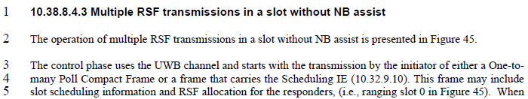

**CID#948**

Accepted.

**Proposed text changes on P802.15.4ab™/Draft 1.0 :**

***Change 10.38.8.4.3 P77L4 as below ;***

3 The control phase uses the UWB channel and starts with the transmission by the initiator of either a One-to

4 many Poll Compact Frame or a frame that carries the Scheduling IE (10.32.9.10) to the responders. Based on the control phase, the transmissions of responders may be scheduled. This frame may include

5 slot scheduling information and RSF allocation for the responders, (i.e., ranging slot 0 in Figure 45). When

6 the Scheduling IE is used, the Scheduling List Type field value is set to four. After receiving the frame

7 from the initiator, each responder replies with either a One-to-many Response Compact Frame or a frame

8 that carries the MMRC IE, (i.e., ranging slots 1 and 2 in Figure 45)

***Comment Indices in 15-24-0371-01-04ab-consolidated-comments-draft-1.0:***

|  |  |  |  |  |  |  |  |
| --- | --- | --- | --- | --- | --- | --- | --- |
| **Name** | **Index#** | **Pg** | **Sub-Clause** | **line** | **Comment** | **Proposed Change** | **Disposition** |
| Lei HUANG | 1434 | 87 | 10.38.9.3.15 | 28 | The SOR Time Offset field indicates the time offset between the start of the Advertising Confirmation Compact frame and the start of the Start of Ranging Compact frame. | Change "the start of the Advertising Poll Compact frame, or the Public Advertising Poll Compact frame" to "the start of the Advertising Confirmation Compact frame". | Accepted |

**Disposition Detail:**



**CID1434**

Accepted.

**Proposed text changes on P802.15.4ab™/Draft 1.0 :**

***Change 10.38.9.3.15 P87L28 as below ;***

26 **10.38.9.3.15 The SOR Time Offset field**

27 This is a four-octet, 32-bit field that specifies the time offset in 1/499.2 MHz resolution between the start of

28 the Advertising Confirmation Compact frame, or the Public Advertising Confirmation Compact frame, and the start of the

29 Start of Ranging Compact frame.