**IEEE P802.15**

**Wireless Personal Area Networks**

|  |  |
| --- | --- |
| Project | IEEE P802.15 Working Group for Wireless Personal Area Networks (WPANs) |
| Title | **Comment resolution - 75** |
| Date Submitted | Feb 6th, 2025 |
| Sources | Riku Pirhonen (NXP) |
| Abstract | Comment resolution for 75 |
| Purpose | Propose resolutions to comments received on IEEE P802.15.4ab/D01, June 2024. |
| Notice | This document does not represent the agreed views of the IEEE 802.15 Working Group or IEEE 802.15.4ab Task Group. It represents only the views of the participants listed in the “Sources” field above.It is offered as a basis for discussion and is not binding on the contributing individuals. The material in this document is subject to change in form and content after further study. The contributors reserve the right to add, amend or withdraw material contained herein. |
|  |  |

Resolution proposal

## CID 75 – Accept

|  |  |  |  |  |  |  |  |
| --- | --- | --- | --- | --- | --- | --- | --- |
| **Name** | **Index #** | **Category** | **Page** | **Sub-clause** | **Line #** | **Comment** | **Proposed Change** |
| Mickael Maman | 75 | Technical | 125 | 10.38.10.1 | 1 | Poll and Resp slot are mandatory. Then the range of macMmsRcpPollNslots and macMmsRcpRespNslots shall start at 1 | as in comment |

**Proposed resolution:** Accept

Replace macMmsRcpPollNSlots and macMmsRcpRespNSlots value ranges 0-15 with 1-15 as shown below.

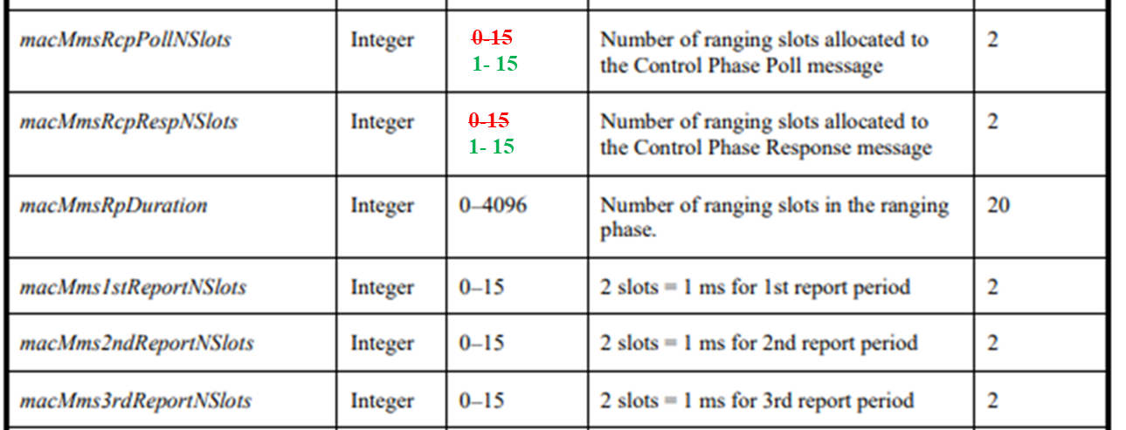

Part of table 20, MMS related MAC PIB attributes, page 125