**IEEE P802.15**

**Wireless Personal Area Networks**

|  |  |
| --- | --- |
| Project | IEEE P802.15 Working Group for Wireless Personal Area Networks (WPANs) |
| Title | **Comment resolution - 75** |
| Date Submitted | Jan 30th, 2025 |
| Sources | Riku Pirhonen (NXP) |
| Abstract | Comment resolution for 75 |
| Purpose | Propose resolutions to comments received on IEEE P802.15.4ab/D01, June 2024. |
| Notice | This document does not represent the agreed views of the IEEE 802.15 Working Group or IEEE 802.15.4ab Task Group. It represents only the views of the participants listed in the “Sources” field above.It is offered as a basis for discussion and is not binding on the contributing individuals. The material in this document is subject to change in form and content after further study. The contributors reserve the right to add, amend or withdraw material contained herein. |
|  |  |

Resolution proposal

## CID 75 – Reject

|  |  |  |  |  |  |  |  |
| --- | --- | --- | --- | --- | --- | --- | --- |
| **Name** | **Index #** | **Category** | **Page** | **Sub-clause** | **Line #** | **Comment** | **Proposed Change** |
| Mickael Maman | 75 | Technical | 125 | 10.38.10.1 | 1 | Poll and Resp slot are mandatory. Then the range of macMmsRcpPollNslots and macMmsRcpRespNslots shall start at 1 | as in comment |

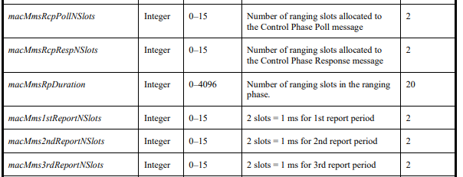

Part of table 20, MMS related MAC PIB attributes, page 125

**Discussion:** It is true that the Control Phase POLL and RESP are mandatory for the NB assisted UWB to acquire timing and frequency synchronization. In the mandatory NBA UWB configuration the POLL is required to be 2 ms before the first initiator MMS fragment and the RESP 1.5 ms before the first responder fragment. With ranging slot duration of 600 RSTU (500 us), the default value of 2 for both *macMmsRcpPollNSltots* and *macMmsRcpRespNSlots* matches this, and is also the smallest feasible value.

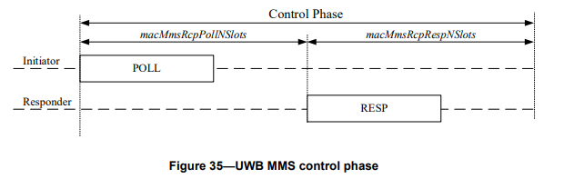

Regarding the UWB driven case. In discussions preceding the Draft 01 it was noted that a simple case of single RIF ranging packet can be seen as a split 4z SP3 packet, with SHR and STS sent in two separate slots to boost power. It was preferred to call this combination a MMS packet. As consequence of this, the SHR (SYNC+SFD) fragment used for time and frequency acquisition is defined to be part of the ranging phase, and the the UWB MMS packet alignment with control and ranging phases is different in the NB assisted and UWB driven modes as seen e.g. in the updated figure 198 presented in IEEE P802.15-24-0552-03-04ab, copied below.

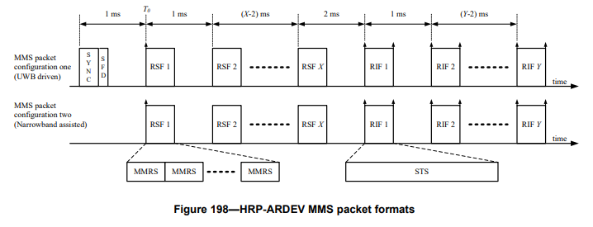

On the other hand, this means that in the UWB driven mode a control packet is not necessarily needed to provide timing and frequency synchronization, the SYNC+SFD fragement of the UWB driven MMS packet is used for those.

It was also decided that separate control payload packets would be UWB modulated SP0 packets, which becomes a performance bottleneck and vulnerable point for ranging. The SP0 packet would have to be sent at about 3 dB lower power than the MMS fragments. Therefore some use cases may want to avoid use of the SP0 control packet. In many use cases SP0 will be used.

RcpPollSlots and RcpResponseSlots are parameters in the Management MAC Configuration Field. These are exchanged during the Initialization and Setup phase. The mandatory requirement is to support the abovementioned 2 ms and 1.5 ms offsets from poll and response to ranging fragments, which corresponds to the default value of 2. **If the devices do not want to use 0 length control phase, or any other non-default length value, the configuration can be rejected.** Keeping length 0 as a possible value is does not do any harm and does not limit use of the other values.

**Proposed resolution:** Reject